2.7—Pocket Response Plan (PReP) Template

The Pocket Response Plan (PReP), created by the Council of State Archivists (CoSA), is a concise document for recording essential information needed by staff in case of an emergency. It is NOT intended to be a substitute for a REAP (Records Emergency Action Plan).
CoSA and other organizations have developed several variations of the PReP template to fit specific types of agencies or organizations. Two are illustrated in this handout:
- The government agencies version is generic, designed for use by any state agency and other governmental entities at any level of government.
- The local government version incorporates elements specific to county and municipal governments.
Copies of both of these PReP templates are available as editable Word documents on the IPER Resource Center along with other versions, including one for state archives and another for collections (e.g., nongovernment libraries, archives, and museums).
For more information on the PReP, including detailed instructions for creating and completing a PReP, refer to the PReP page on CoSA’s website at: http://www.statearchivists.org/prepare/framework/prep.htm

PReP Template for Government Agencies, Side A (Communications)
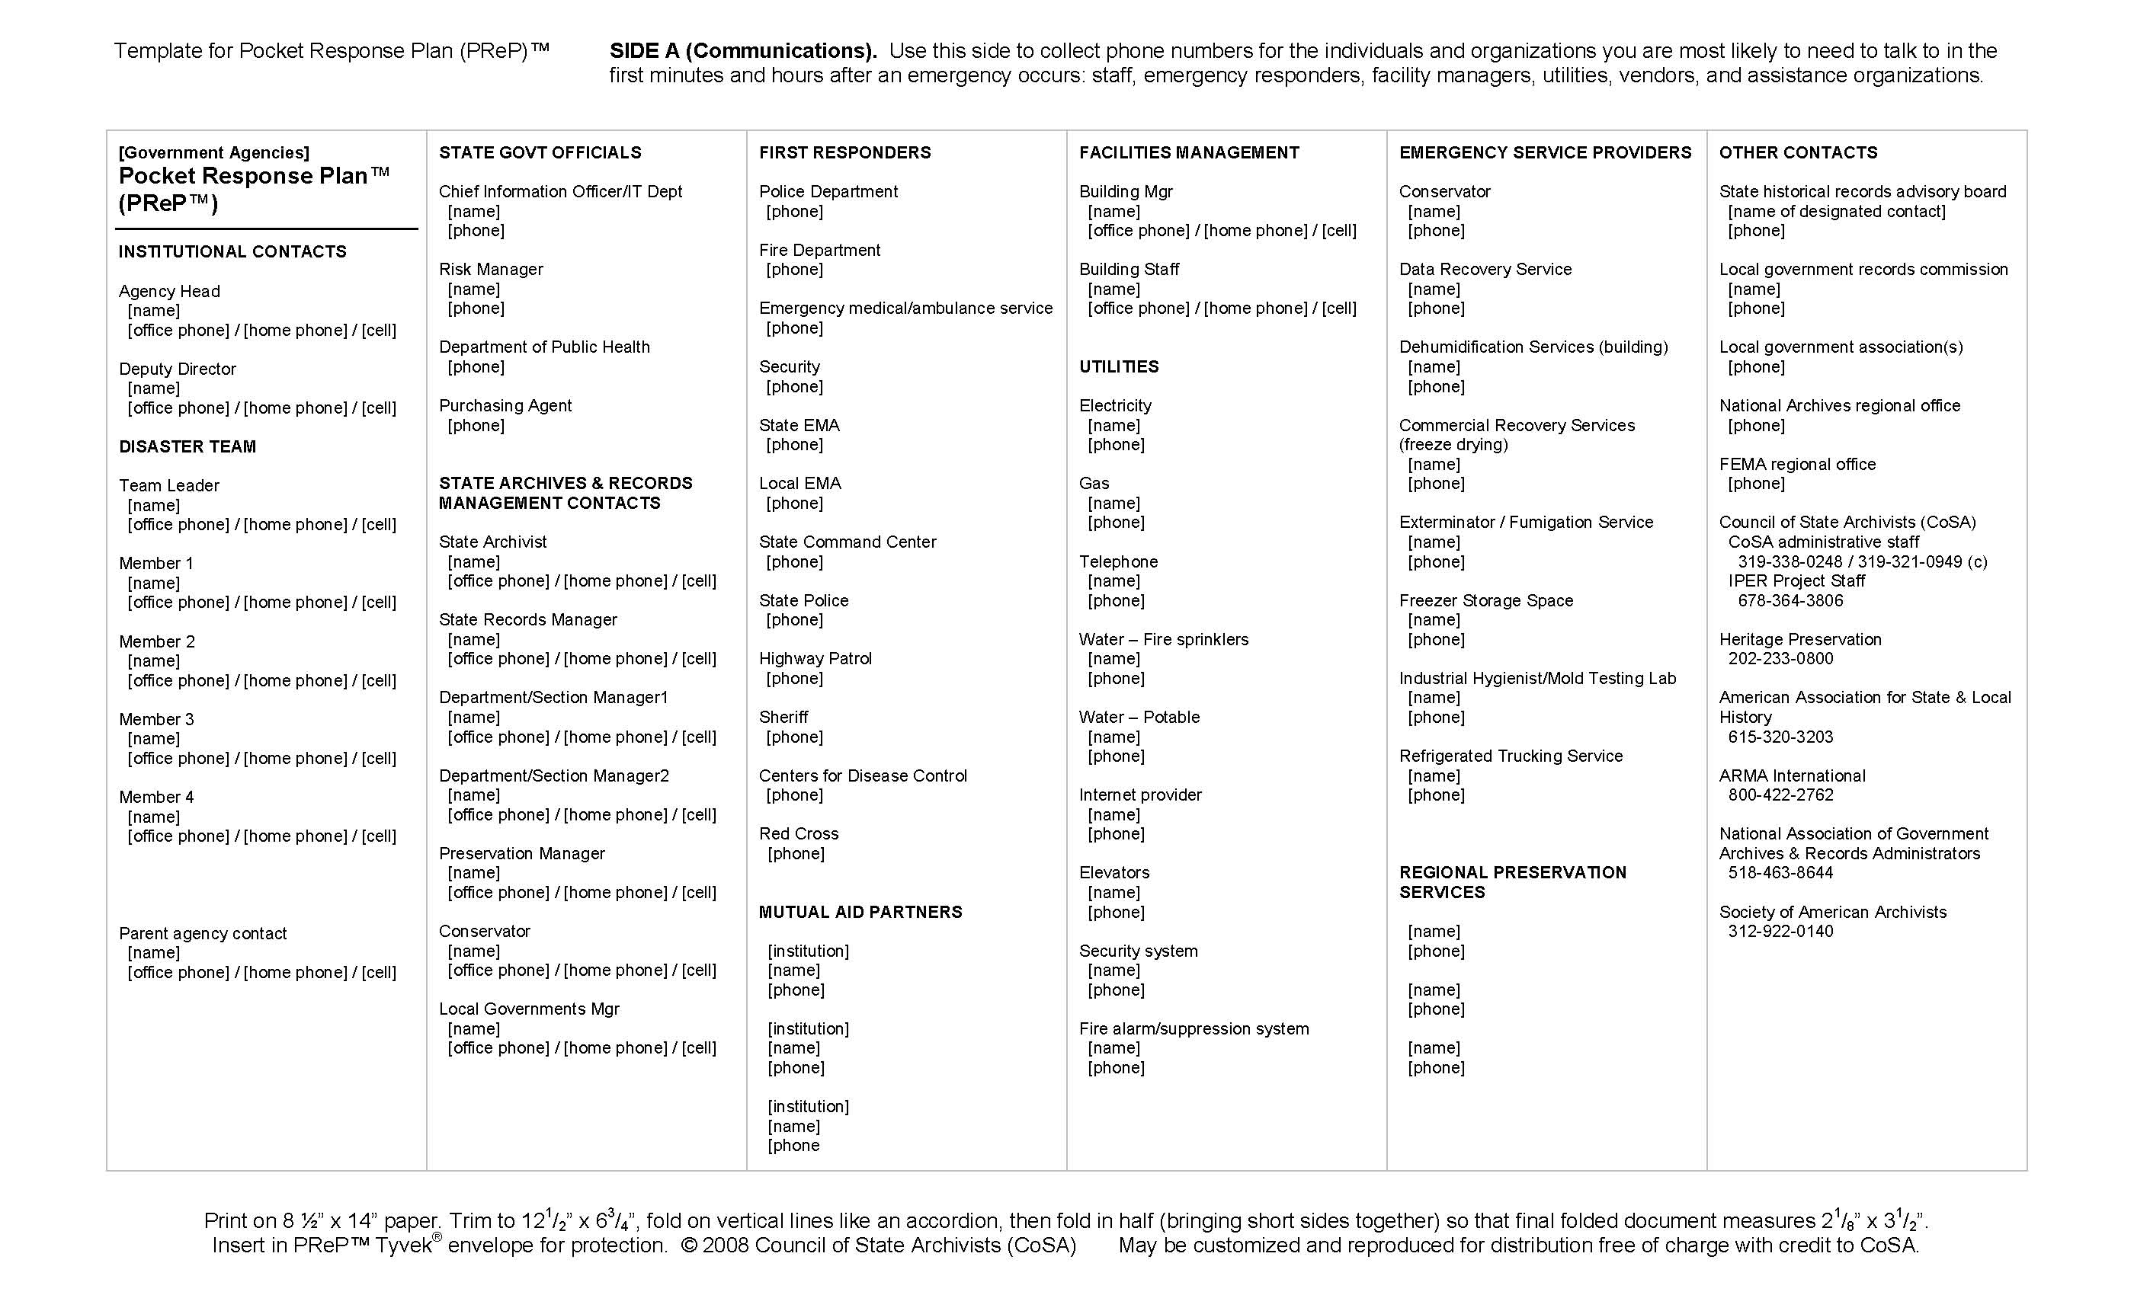

PReP Template for Government Agencies, Side B (Actions)
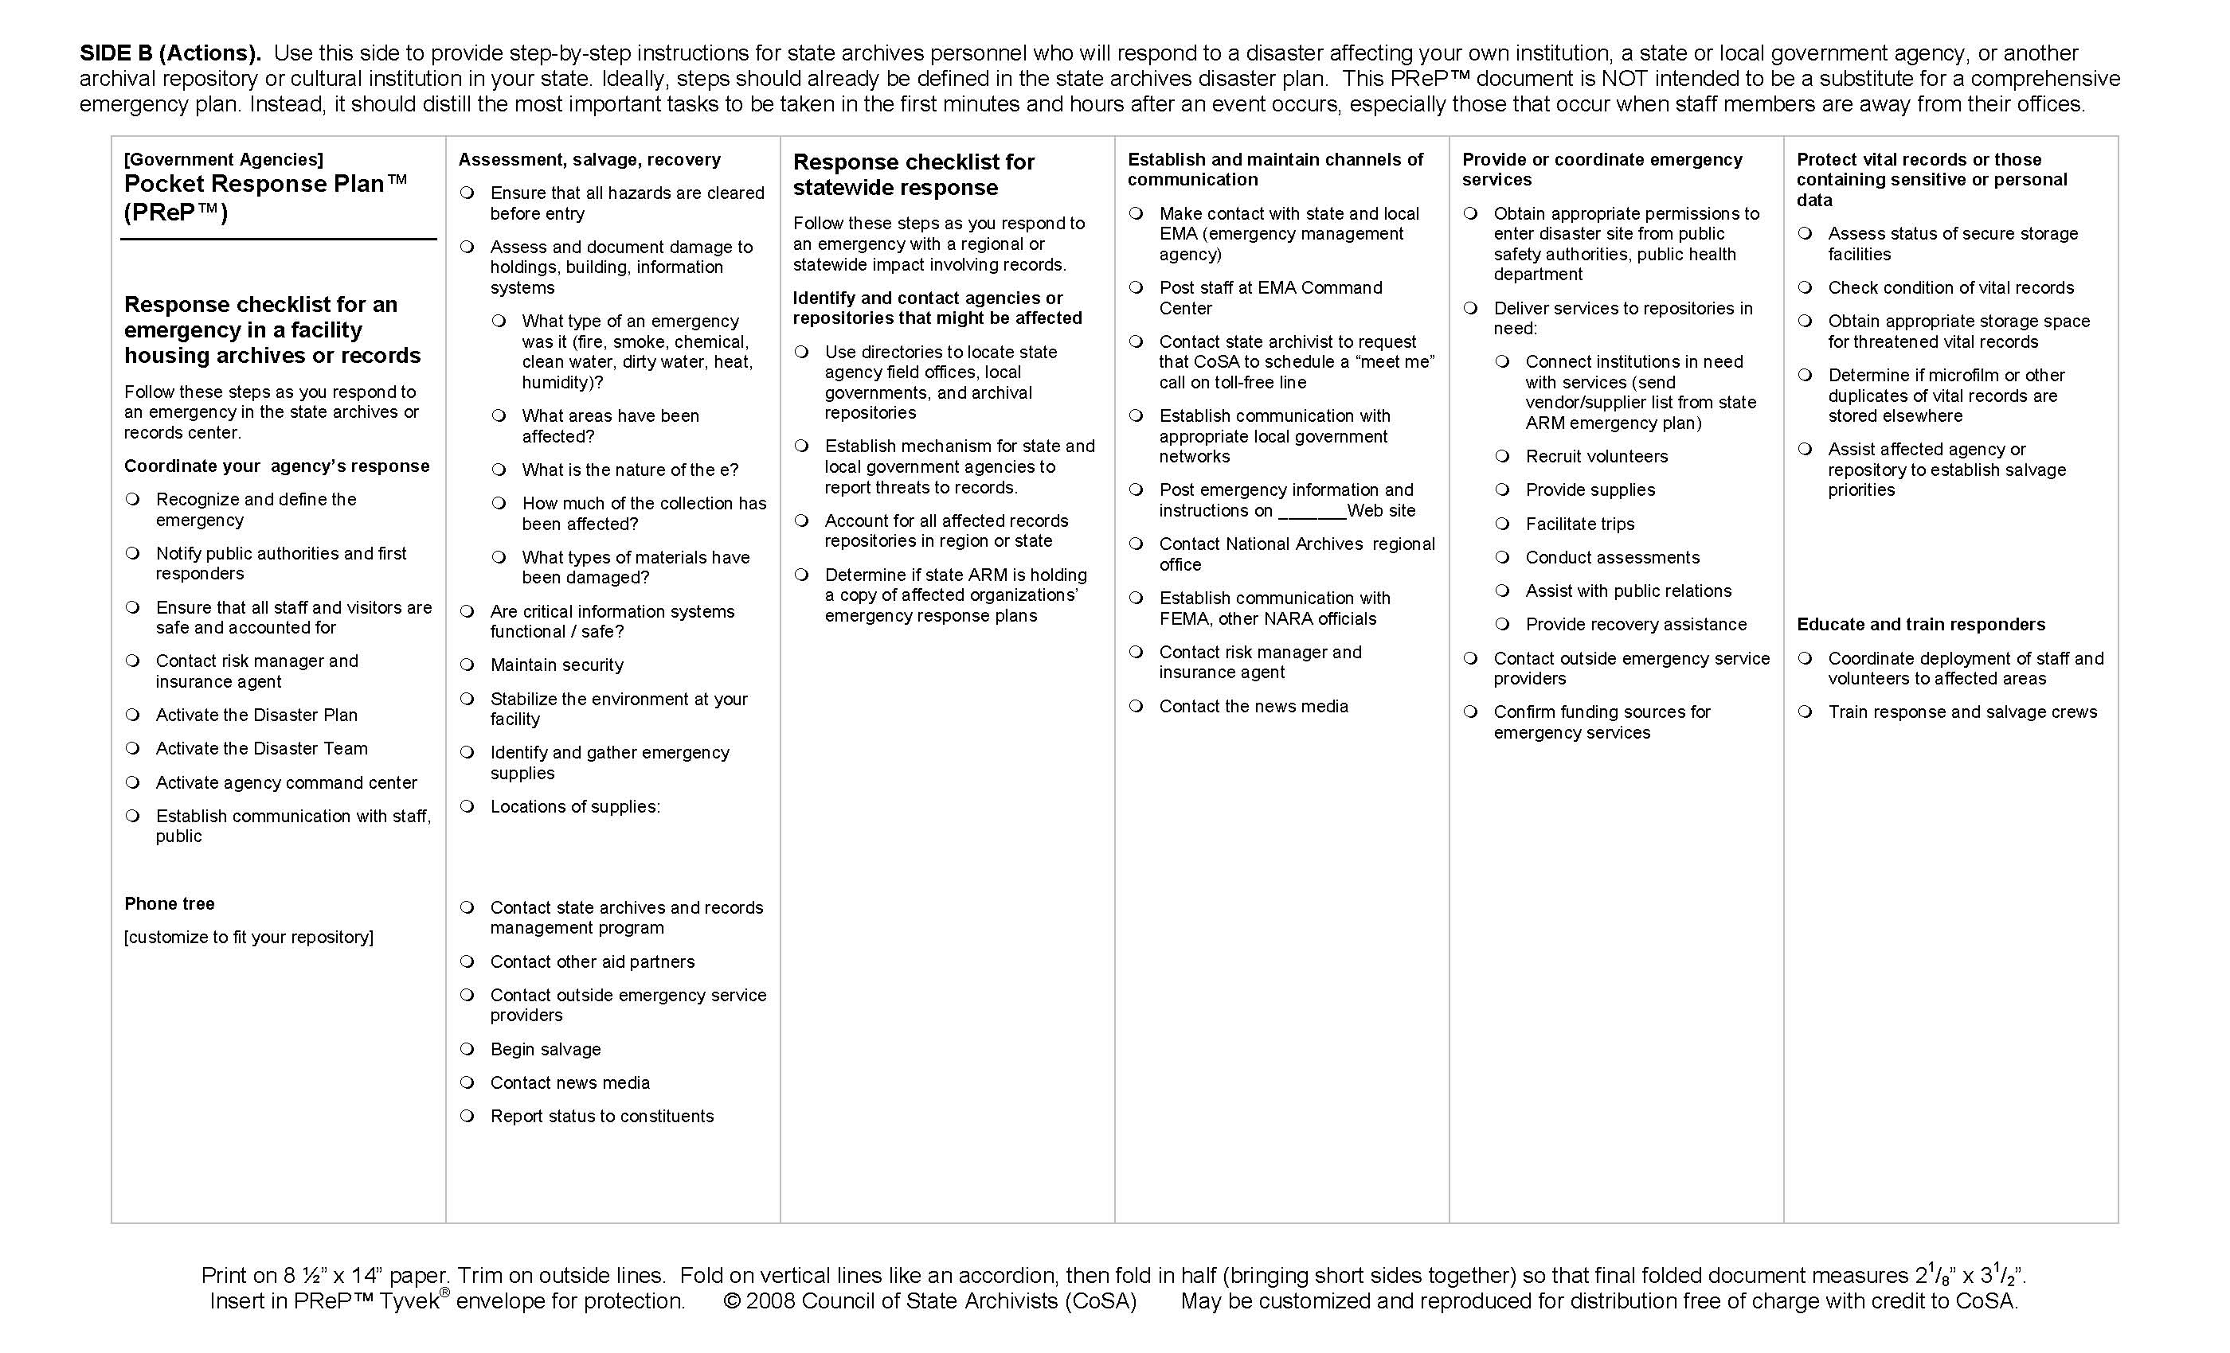

PReP Template for Local Governments, Side A (Communications)
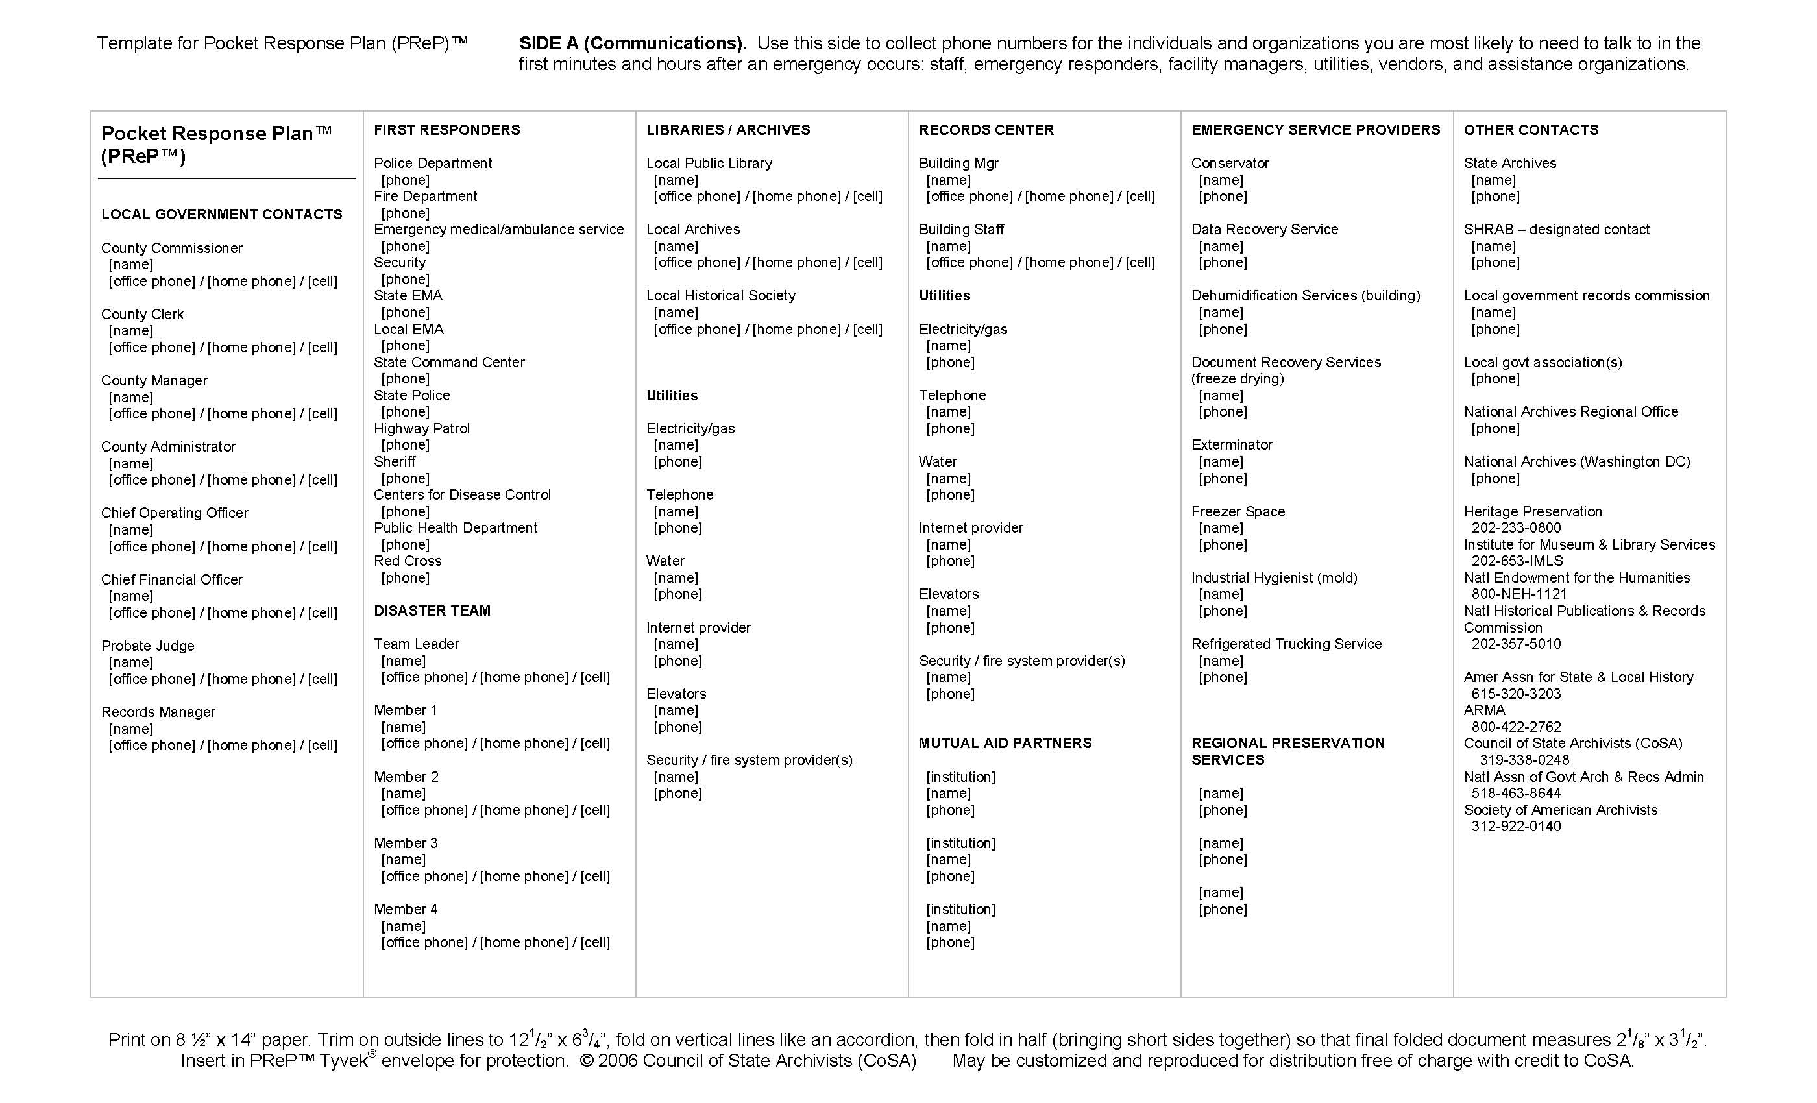

PReP Template for Local Governments, Side B (Actions)
