Report on the

November 2007 Pilot Program for Early Voting

Prepared for the 123rd Maine Legislature

February 25, 2008



Prepared by the Department of the Secretary of State
Secretary of State Matthew Dunlap

February 25, 2008

Honorable Lisa T. Marraché
Chair, Joint Standing Committee on Legal and Veterans Affairs
100 State House Station
Augusta, Maine 04333-0100

Honorable John L. Patrick
Chair, Joint Standing Committee on Legal and Veterans Affairs
100 State House Station
Augusta, Maine 04333-0100

Dear Senator Marraché, Representative Patrick and Members of the Committee:

In the First Regular Session of the 123rd Legislature, pursuant to Resolves 2005 Chapter 70 – Resolve, Directing the Secretary of State To Design a Pilot Program for Early Voting, my office submitted an Early Voting pilot plan to the Joint Standing Committee on Legal and Veterans Affairs. Following a review of the plan, Resolves 2005 Chapter 70 was amended to allow for the pilot to be implemented in November, 2007. Early Voting pilots were conducted in Bangor, Portland and Readfield. I am now pleased to submit the attached Report on the November 2007 Pilot Program for Early Voting.

The Early Voting pilots were a success and were enthusiastically embraced by voters and municipal clerks alike. This report provides an overview of the pilots along with recommendations for constitutional and statutory changes necessary for full implementation. I am confident that Early Voting, implemented with the appropriate procedures to assure the integrity of our elections, can provide voters with enhanced access to their democracy, while at the same time alleviating some of the Election Day burden on municipal election workers.

I look forward to working with you to implement the report’s recommendations. If you would like more information, I would be pleased to provide a detailed presentation to the Joint Standing Committee on Legal and Veterans Affairs. As always, you may also contact me at 626-8400 if I can provide you with any additional materials, answer any questions, or assist you in any way.

Sincerely,

Matthew Dunlap
Secretary of State

Table of Contents

I. Executive Summary page 1

II. Introduction page 2

III. Description of the 2007 Early Voting Pilot page 3

IV. Discussion and Analysis of Issues page 5

V. Recommendations page 10

Appendix A: Early Voting Pilot Plans for November 2007 page 11

Appendix B: Sample Forms Used in Early Voting Pilot page 21

Appendix C: Sample of Early Voting Survey Form page 29

Appendix D: Early Voting Pilot – Voter Survey Results page 31

- EXECUTIVE SUMMARY

Based on the Secretary of State’s presentation of the 2007 “Report and Pilot Program for Early Voting”, the 123rd Legislature authorized an Early Voting Pilot to be conducted at the November 6, 2007, Referendum Election. The pilot, conducted in three municipalities - Bangor, Portland and Readfield – was a tremendous success.

Over 1,800 voters and the municipal election officials from the three pilot municipalities enthusiastically embraced Early Voting, as demonstrated by the results of surveys completed by the participating voters and reports from election officials in the pilot municipalities. Early Voting was shown to provide convenience and ease of access to voters, while at the same time alleviating some of the demands on municipal election officials as they contend with processing increasing numbers of absentee ballots.

As a result of this success, the Secretary of State recommends taking the necessary steps for adoption of Early Voting. As originally noted in the 2007 report, there is a constitutional issue that should be considered prior to the implementation of Early Voting. The issue involves a provision in Article II of Maine’s Constitution specific to the timing of State candidate elections. The report indicated that “[i]f the Legislature decides to adopt early voting statewide, following implementation of the pilot recommended in this study, it may be appropriate to consider amending Maine’s Constitution…in order to eliminate the risk that an early voting statute would be challenged…”

Following additional review of Maine’s Constitution and relevant case law, it is highly recommended that Article II, section 4 of Maine’s Constitution be amended prior to proceeding with Early Voting for candidate elections. To fully implement Early Voting, the Secretary of State recommends: that a Constitutional Amendment question be placed on the November 4, 2008, General Election ballot; that if the question is adopted, the 124th Legislature enact enabling legislation; and that the Secretary of State, in consultation with the Attorney General, provide the Legislature with recommended language for the Constitutional Amendment and the enabling statutory language.

- Introduction

The 122nd Maine Legislature, in the Resolves of 2005, c. 70, directed the Secretary of State to design a pilot program for Early Voting. The Secretary of State established the Early Voting Study Group to analyze the process of Early Voting and identify the factors to be considered when conducting a pilot program in Maine.

The Study Group submitted its report to the Legislature, entitled “Report and Pilot Program for Early Voting”, on April 1, 2007. In the report, the Study Group defined “Early Voting” to be a time period before an election during which voters would have the opportunity to cast a ballot at a designated voting place within the voter’s municipality, in the same manner as on Election Day. The Study Group recommended a plan for conducting a pilot and raised statutory and constitutional issues needing consideration prior to full implementation of Early Voting.

The Study Group also made the following recommendations regarding changes to current absentee voting processes and moving forward with an Early Voting pilot:
- Establish cutoff dates for in-person absentee voting and issuing absentee ballots;
- Allow early processing of absentee ballots (municipal option);
- Conduct a pilot program for Early Voting during the November 6, 2007, Referendum Election; and
- Require the Secretary of State to report to the Legislature by January 15, 2008, about the pilot program.

The Legislature did not adopt the first recommendation in the report, but did implement legislation to allow the early processing of absentee ballots (second recommendation) and authorized the Secretary of State to conduct a pilot program for Early Voting during the November 6, 2007, Referendum Election (third recommendation). Although the Legislature did not set a reporting requirement, this report is intended to provide the Legislature with an account of the pilot and recommendations of the Secretary of State for further implementation of Early Voting.

- DESCRIPTION OF THE 2007 EARLY VOTING PILOT

The Secretary of State followed the Pilot Plan and the Uniform Guidelines for Early Voting, proposed in Recommendation 3 of the “Report and Pilot Program for Early Voting”, in designing and conducting the Early Voting Pilot for the November 6, 2007, Referendum Election.

The municipalities of Bangor, Portland and Readfield expressed an interest in participating in the pilot and were selected as the pilot municipalities. Portland and Bangor are the largest and third largest municipalities in terms of the number of registered voters (with about 55,000 and 20,400 active and inactive registered voters respectively), and have both experienced a dramatic increase in absentee voting activity over the past several years. Both municipalities use optical scan tabulating machines to count their paper ballots. The Town of Readfield represents a small municipality (with about 2,100 registered voters) that hand-counts its paper ballots.

In the early fall of 2007, the Elections Division staff began to work with the pilot municipalities to review the Uniform Guidelines for Early Voting and help them draft an Early Voting Plan specific to each municipality. Copies of the final Early Voting Plans are found in Appendix A of this report. These plans were drafted and refined through a series of in-person meetings and telephone conference calls. The plans addressed several important issues, as follows:

- The times for Early Voting. All three municipalities offered Early Voting from Monday, October 29th through Friday, November 2nd (the week before the election) and on Monday, November 5th (the day before Election Day). Bangor’s hours were 8 a.m. to 6 p.m. each day; Portland’s hours were 8 a.m. to 4:30 p.m. each day; and Readfield was open from 8:30 a.m. to 4:30 p.m., except on Wednesday, when they were open from 12 p.m. to 6 p.m. Bangor and Portland also offered Early Voting from 8 a.m. to 12 p.m. on the Saturday before Election Day.

- The location for Early Voting. Each municipality had to choose a single location for Early Voting that was available for the entire Early Voting time, was of adequate size to handle estimated turnout, and was accessible to people with disabilities. Portland and Readfield conducted Early Voting in their municipal building, in close proximity to or in the clerk’s office, while Bangor conducted Early Voting at the Bangor Civic Center.

- The security measures to be used. Each municipality had to ensure the security of all ballots, ballot boxes and tabulators before, during and after the times when Early Voting took place, and describe those measures in the Early Voting plan. Some of these measures included: securing materials (when not in use) in a locked area with access only by the clerk; use of numbered seals on ballot boxes or tabulators, and recording of those seal numbers; and assurances that voting materials were always accompanied by at least two persons. Bangor had to employ additional security measures for the transport of voting equipment and materials between City Hall and the Civic Center each day.

- Reconciliation of ballots cast. The Elections Division and the pilot municipalities designed several forms and checklists that provided audit and reconciliation of the number of ballots cast. The procedures were described in the Early Voting plans. The process and forms used for Readfield were different from those used in Bangor and Portland to reflect the differences between the hand-counted voting process and the optical scan tabulating voting process. However, there was an “Opening Checklist”, a “Closing Checklist” and an “Audit Log” for all municipalities, and for Bangor and Portland, a “Machine Verification” form. Copies of these forms are found in Appendix B of this report.

- Staffing. The municipal clerk was the supervisor of the Early Voting process. Readfield made sure that there was a deputy clerk or at least one other office staff present when Early Voting was occurring. Bangor utilized at least two staff from the clerk’s office and at least four other city employees or election workers during the Early Voting hours. Since Bangor had been offering its in-person absentee voting at the Civic Center before the last couple of elections, the clerk was accustomed to providing the staffing needed for Early Voting. Portland initially planned for three staff from the clerk’s office and four other city employees or election workers. At the start of Early Voting, before there was media coverage of the effort, this staffing was more than needed, but as people became aware and more people started Early Voting, there were times when the additional staff was needed.

- Notice of Early Voting. The Elections Division accepted the Early Voting plans as proper notice for Early Voting. The Secretary of State conducted media interviews just before Early Voting started to let the public know about the process. In the future, if Early Voting is continued, the Early Voting plans will be posted on the Secretary of State’s publicly accessible website as soon as possible after the final plans are accepted. The Secretary of State also will use public service announcements and other media releases to make more voters aware of Early Voting.

- Early Voting procedures. The procedures used for Early Voting were essentially the same as on Election Day. The provisions for Election Day activities found in Title 21-A, Maine Law on Elections, governed the process. Some of these laws include: the provisions for political activities at the voting place, petitioners, poll watchers, candidates and challenges. Early voters who were not already registered were allowed to register and vote (either a regular ballot or, if the voter could not provide sufficient proof of identity or residency, a challenged ballot). Voters were checked in before voting, using an Incoming Voting List produced from the Central Voter Registration System (CVR). Voters did not have to complete an application form; instead, they were asked to sign the voting list beneath their name. Municipal election officials were required to enter into the CVR which voters cast an early ballot. There were no programming changes made to the CVR to accommodate Early Voting, in the event that the Legislature chose not to expand Early Voting beyond the pilot. However, early voted ballots were coded using the designation “state blank absentee ballots”, which is a code in CVR that is not used for Referendum elections. This allowed the municipalities to distinguish between in-person absentee ballots and early voted ballots and obtain a separate report of those voters who cast a ballot during the Early Voting process. Each municipality also had an accessible voting device available in close proximity to the Early Voting area, to ensure that voters with disabilities had an opportunity to cast an early voted ballot with privacy and independence, as required by the Help America Vote Act (HAVA).
- Discussion and AnalySis of Issues

Election Official Perspective

The State and pilot municipality election officials are in agreement that the Early Voting Pilot was a successful venture. The total of early votes cast was 1,844 - with 1,203 votes cast early in Bangor, 579 votes cast early in Portland and 62 votes cast early in Readfield. The higher number of early voters in Bangor can be attributed to several factors. The most important one is that Bangor has conducted in-person absentee voting at the Bangor Civic Center for the last few elections, and it has generally been called “Early Voting”. Thus, for Bangor voters, this pilot did not seem like anything new or unusual. Second, there initially was more media coverage about Early Voting in the Bangor area. Finally, Bangor held a well-advertised flu shot clinic at the Bangor Civic Center on Wednesday during the Early Voting times. That fact can account for the higher turnout in Bangor on Wednesday.

The following is an analysis of the factors that were part of the Early Voting Plans for each pilot municipality.

- The times for Early Voting. Since Readfield conducted Early Voting during the regular town office hours, the clerk would be willing to expand Early Voting in the future for the entire time that absentee ballots are available before an election (usually about 45 days). Bangor and Portland, however, thought that it would be difficult to staff and maintain oversight for the Early Voting process for that length of time. These clerks agreed that the week before Election Day was a sufficient length of time to conduct Early Voting. The larger municipalities have many more election preparations to complete before an election, which would be more difficult to accomplish while also maintaining Early Voting for several weeks. Since in-person absentee voting is at its highest during the week and even the day before the election, offering Early Voting for this one-week period is most likely to be of value to the voters and provide the most effective process for the clerks.

- The location for Early Voting. Due to the need for staffing and maintaining security over the ballots and other voting materials, including tabulating machines and ballot boxes, all three clerks agreed that a single location in each municipality is best for Early Voting. Portland and Readfield each had an adequate space for Early Voting in their municipal building as well as a vault into which the voting materials were placed at the conclusion of Early Voting each day. Since Bangor does not have sufficient space within City Hall to offer Early Voting, the clerk would like to continue conducting Early Voting at the Bangor Civic Center. However, the use of an offsite location necessitated the transport of tabulating machines, ballots and other materials between City Hall and the Civic Center daily. For future Early Voting, Bangor would like to have approval for a secure storage location at the Civic Center, which would be accessible to only the clerk’s staff, and would allow the staff to leave some of the materials there during the week of Early Voting. Although the sealed, unused ballots and tabulating machines would be kept in the secure storage location at the Civic Center, the Bangor election officials would still transport the voted ballots daily, to be stored in the vault at City Hall. This would ensure the integrity of the process, even in the event of a disaster.
- The security measures to be used. The security procedures that were included in each municipality’s Early Voting Plan seemed to cover the issues that arose on Election Day. Because this was a pilot, a significant effort was made to draft procedures tailored to each municipality. The State and municipal election officials did discuss the following items related to security, to see if improvements could be made:

  - The clerks and the State agreed that developing and using a standard form for the Early Voting Plan, which participating municipalities could simply fill in as applicable to their municipality, would streamline the preparations for future Early Voting periods. Likewise, all participants agreed that the State should develop two sets of procedures/security plans (one for municipalities with tabulating machines, and one for hand-count municipalities), with standard items that could be checked off by each municipality, and a place to request approval for exceptions from a specific item. This would streamline the procedure for municipalities to file an Early Voting Plan as well as the Secretary of State’s review and approval of the plans.
  - Portland and Bangor both followed a practice of removing ballots from the “not fully counted bin” of the ballot box, and sealing them in green tamper-proof containers for further processing after the polls closed on Election Day. Bangor thought this method worked fine, while Portland would like to keep the ballots locked and sealed in the bin of the ballot box, until after the polls close on Election Day, whereupon they would remove the ballots from the bin and process them as applicable. Readfield thought it was cumbersome to remove the ballots from the ballot box each day and seal them in tamper-proof containers. The Readfield clerk would like the ability to keep the ballots in the ballot box, but have a seal as well as a lock on the ballot box. The ballot box would not be opened until after the polls close on Election Day, when the seal would be broken, the ballot box unlocked, and the ballots removed for counting.
  - The clerks also suggested that the step of having the voters sign the Incoming Voting List (IVL) was unwieldy. Although the State and municipalities agreed that it was wise to have the security of each early voter’s signature, it was difficult to have the voters sign the IVL itself. Either the voter was asked to sign upside-down, or the election officials had to keep turning the IVL around to allow the voters to sign right-side-up under their printed name. One suggestion was to have a blank Early Voting log for each voter to sign, rather than to sign the IVL. After signing the Early Voting log, the election official would check the voter’s name off the IVL as having early voted. In addition to making it easier to obtain the voters’ signatures, this change would provide the benefit of the clerks being able to seal the IVL at the conclusion of voting, and allow them to use the signature log as the way to verify that all early voters’ names have been entered into the CVR.

- Reconciliation of ballots cast. The clerks agreed that the paperwork for Early Voting needed to be consolidated or streamlined, and were willing to work with the State to suggest improvements to the forms and documentation. Portland and Bangor thought that the Early Voting Machine Verification and the Audit Log for Early Voting could be combined and simplified. All three municipalities thought that the Opening and Closing Checklists could be retained as a guide for the major procedural steps for Early Voting, without requiring the signatures of the election officials for each item on the list; i.e. use the forms as checklists rather than as procedural documentation.

- Staffing. The clerks all agreed it was better to over-staff than to be caught short during busy times. As we gain more experience with Early Voting, it may be possible to understand the pattern of turnout and provide a more tailored staffing pattern. Until then, however, the clerks need to be prepared to have enough staff to handle the flow of voters, keeping lines and waiting times as short as possible, while providing for additional staff to provide adequate break times. One irony to Early Voting’s popularity in the future may be that the waiting time during some Early Voting hours exceeds the waiting time on Election Day. This already occurs with in-person absentee voting on the last few days before the election.

- Notice of Early Voting. Portland’s and Readfield’s turnout at the beginning of Early Voting was lower than Bangor’s, likely due to the delay in media coverage in the Portland and Augusta areas. If the Legislature approves an extension of Early Voting, the State and the clerks are in agreement that providing more notice to the voters, through advance media coverage, is essential to increased utilization of Early Voting.

- Early voting procedures. The Election Day procedures in Title 21-A, Maine Law on Elections, were adequate to handle Early Voting. The pilot municipalities selected Early Voting locations that met the requirements for physical accessibility for voters with disabilities as well as providing the Accessible Voting System (AVS) at the Early Voting location for voters who wished to use it. Petitioners and poll watchers were accommodated at the voting place as well. The State created an acceptable work-around for tracking early voted ballots in the CVR that did not require application changes in the software. The CVR vendor has developed software to handle Early Voting for one of its other state users (West Virginia), which could easily be implemented in Maine if the Legislature makes Early Voting a permanent voting method.

Voter Perspective

Along with their ballots, voters opting to participate in Early Voting were provided with a survey designed to help policy makers and administrators evaluate the pilots. To assure both the clarity and validity, the survey design and results analysis were conducted in consultation with faculty from the University of Maine at Augusta: Daylin Butler, Ph.D - Professor of Business and Public Administration and Carol Kontos, M.A. - Associate Professor of English. A copy of the survey form is found in Appendix C of this report.

Across all three municipalities 1,844 citizens – approximately 10% of those who voted in that election in those municipalities – participated in the pilots, casting their ballots early. Of those voters, 1,602, or 87%, returned their survey forms (fully or partially completed). Responses indicate that the pilots were successful and, generally, enthusiastically embraced by those participating. Responses also offer valuable insight on why voters participated, what they liked or disliked and how any future Early Voting efforts can enjoy the same or greater success.

Survey responses revealed several interesting trends. While citizens chose to early vote in significant numbers throughout all available days and times, the peak voting days were the Wednesday, Friday and Monday preceding Election Day; and the peak voting hours were late morning (10-12) followed by early afternoon (12-2).

Voters were asked “How did you hear about Early Voting?” and were encouraged to select all options that applied. Nearly one-third of voters indicated they had heard of Early Voting by newspaper, and only slightly fewer had heard of Early Voting on television. Other significant sources of public awareness included: municipal officials (14%), friends (14%), radio (10%), and road signs (6%).

Perhaps most interesting, voters were asked to indicate “Why did you choose Early Voting?” and were encouraged to select all options that applied. A full two-thirds of voters cited “convenience to my schedule” as a reason for voting early. Nearly one-fifth indicated they were going to be “away on Election Day”. Additionally, nearly a third of voters indicated that they chose early voting to “avoid the polls on Election Day”. Although small in numbers, it is worth noting that of those selecting “Other”: 41 were either poll workers or campaign workers, 13 preferred the Early Voting location to their polling place, and 11 cited mobility issues or other disability causing an aversion to lines or crowds and therefore a preference for Early Voting.

Voters who responded that they had voted by absentee ballot in person at the town office in the past, were asked to compare that process with the Early Voting process. Ninety-nine percent of respondents found the process of Early Voting more convenient (74%) or as convenient (25%) as absentee voting. Ninety-seven percent of respondents rated the Early Voting process as providing more confidentiality/privacy (59%) or the same (38%) as absentee voting.

Nearly 60% of the survey respondents provided narrative answers to the question “What did you like about this Early Voting experience?”, and repeated key themes of convenience, the lack of or shortness of lines, the lack of waiting and references to the process being quick or fast. In response to the question “What would you like to see changed?”, over half of the respondents indicated that nothing needed to change, while one-third of the respondents indicated a desire for expansion of Early Voting opportunities.

The full summary of the survey responses is included in this report as Appendix D.

Constitutional Issues

As noted in the April 1, 2007 Study Group Report on the Pilot Program for Early Voting, there is a constitutional issue with regard to Early Voting that should be addressed if the Legislature wishes to adopt this as a practice for candidate elections statewide. The issue concerns the following provision in Article II of Maine’s Constitution on the timing of State candidate elections:

Section 4. Time of state election; absentee voting. The election of Senators and Representatives shall be on the Tuesday following the first Monday of November biennially forever and the election of Governor shall be on the Tuesday following the first Monday of November every 4 years. The Legislature under proper enactment shall authorize and provide for voting by citizens of this State and for voting by other citizens absent or physically incapacitated for reasons deemed sufficient. (Emphasis added).

By specifying that candidate elections for state offices “shall be held on the Tuesday following the first Monday in November,” the Constitution does not appear to leave the Legislature the latitude to permit voting on any day but the Tuesday following the first Monday of November. Article II, section 4 clearly authorizes the Legislature to provide a system of absentee voting for those who are absent or physically incapacitated on Election Day, but Early Voting is a different concept.

Maryland’s Early Voting statute was challenged on the grounds that it conflicted with a provision in that state’s constitution similar to Maine’s, and the Maryland Court of Appeals struck it down on those, as well as other, grounds. Lamone v. Capozzi, 912 A.2d 674 (Md. 2006). In essence, the court found that Maryland’s Constitution recognized only two methods of voting – in person voting and absentee balloting – rejecting the argument that Early Voting was a form of absentee balloting since Early Voting was not limited to people who would be absent or otherwise unable to get to the polls on Election Day.

This appears to be the only court decision addressing this constitutional issue, and it is not binding precedent in Maine. Nonetheless, given the similarity of our state’s constitutional provisions on the timing of candidate elections, Maine courts might well follow the reasoning of the Maryland Court of Appeals if an Early Voting statute were challenged here. Accordingly, the prudent course would be for the Legislature to propose an amendment to Article II, section 4 for adoption by the voters at the next general election. With voter approval, this would mean that Early Voting in candidate general elections could be implemented as early as 2010.

- RECOMMENDATIONS

Based on the analysis of the successful Early Voting process by the pilot municipalities, as well as the favorable survey data from participating voters, the Secretary of State recommends full implementation of Early Voting. To accomplish this, the following steps should be taken:

- The 123rd Legislature should adopt a Constitutional Resolution placing a question on the November 4, 2008, General Election ballot, to amend the Maine Constitution so that the Legislature, under proper enactment, may authorize and provide for Early Voting in candidate elections.

- Assuming such a Resolution and the subsequent question are adopted, the 124th Legislature should enact enabling legislation during the First Regular Session.

- The Secretary of State, in consultation with the Attorney General, should provide the 123rd Legislature with recommended language for a Constitutional Amendment.

- The Secretary of State, in consultation with the Attorney General, should provide the 124th Legislature with enabling statutory language.

Appendix A

Early Voting Pilot Plans for November 2007
(Bangor, Portland and Readfield)

Early Voting Plan for City of Bangor
for the Pilot Conducted November 6, 2007

Early Voting Location:

Bangor Civic Center, 100 Dutton, Bangor
The “G” Room

- Size: The location is of adequate size to serve as an early voting place pursuant to Title 21-A, section 627, and will be set up like a polling place on Election Day, as nearly as practicable. The space is also of sufficient size to allow the presence of at least one pollwatcher from each of the qualified parties, to provide an opportunity, as permitted by law, for observing the process, checking who has voted, and challenging.

- Availability: The location is available for the entire early voting period as outlined in the schedule contained in this plan.

- Physical Accessibility: The location meets the ADA accessibility requirements for a polling place.

- Accessible Voting System (AVS): The AVS will be set up within the guardrail enclosure of the early voting location, and voters who choose to use the AVS will be able to cast an early voted ballot that is marked by the AVS.

Schedule for Early Voting:

Monday, October 29, 2007 8 a.m. – 6:00 p.m.
Tuesday, October 30, 2007 8 a.m. – 6:00 p.m.
Wednesday, October 31, 2007 8 a.m. – 6:00 p.m.
Thursday, November 1, 2007 8 a.m. – 6:00 p.m..
Friday, November 2, 2007 8 a.m. – 6:00 p.m.
Saturday, November 3, 2007 8 a.m. – noon
Monday, November 5, 2007 8 a.m. – 6:00 p.m.

Staffing:
Two (2) City Clerk staff and at least four (4) other city employees or election staff will be working during the early voting hours, according to the schedule determined by the Clerk.

Notice:
The Secretary of State will give notice to the parties and the public for the pilot.

Security/Early Voting Procedures:
These are detailed in the attached “Early Voting Pilot Program Procedures (Bangor)”

Bangor City Clerk signature: __________________________________

Deputy Secretary of State signature: _________________ Date Plan approved: _________
Early Voting Pilot Program Procedures (Bangor)

City Hall Staff
- Enter information into the CVR immediately as voted in person, select the “Ballot Request Type” as “State Blank Absentee Ballot” (if CVR is down, check paper lists to verify voter information, then keep a log of each voter voting and enter into CVR ASAP)
- If voter is not registered or requires an update of their information, process the registration or update. Give new voters or voters who have changed voting districts a certificate to use at check-in
- Allow voter to vote

Election Staff
- Check off each voter on Incoming Voting List (IVL) as s/he enters the voting area, write EV next to the voter, rather than a line or check mark, in red ink
- Note the date voted under the voters name in red ink
- Have the voter sign the IVL, next to the date voted, in black ink
- If voter is not on the list, collect the certificate and manually add to the supplemental list (ABC List), and mark “EV” next to the hand-written name, have the voter sign next to the hand-written name
- Give the voter the appropriate ballot and direct them to the voting booth
- Give the voter the Early Voting Survey to complete. Have the voter place the completed survey in the drop box provided when they are done voting.

Start each Early Voting Day with
- Incoming Voting List, verify seal each day
- Unvoted ballots (verify that all are sealed in shrink wrap, and loose ballots are unvoted)
- Ballot Box (for machines)
  - Verify that it is empty
- Machine (one for each ballot style i.e. ref, candidate, municipal)
  - Verify Counter and seal
- Voter Registration materials
- Fill out Opening Checklist

Polling Place Activities
- Regulations are identical to Election Day for candidates, poll watchers, petition signature gatherers, etc.

At closing
- Secure unvoted ballots in cardboard boxes & seal, have D & R sign over tape
- Secure IVL in manila envelope & seal with Certification slip
- Secure voted ballots in blue (state) or red (city) tamper-proof boxes, lock & seal
- Secure auxiliary ballots, unread ballots, and place each in separate envelopes labeled by date, noting the total number of ballots in each envelope, and place in a green tamper-proof box each day (you may use a separate green container per day)
- Secure machine, and note machine counter total, & seal number on memory pack
- Return completed voter registration cards to Registrar
- Fill out Closing Checklist
- Fill out Machine Verification
- Fill out Certificate of Sealed Ballot Container (please note blue, red or green tamper proof boxes on top, fill out a separate sheet for each day)

Security
- D & R attests to machine count, and secure voted & unvoted ballots, & IVL
- D & R ensures seals, locks, etc. at opening are as they were at closing on the previous day
- Either the City Clerk or Deputy City Clerk will transport secure materials between the Civic Center & City Hall, and will be accompanied by a Police Officer or Constable
- All secured materials will be locked in the vault at City Hall at the conclusion of early voting each day
- Voted ballots, which will be locked & sealed in tamper-proof containers, will remain in the City Clerk’s vault.
- Auxiliary, red-lined & write-in ballots that have been sealed in green tamper-proof containers will remain in the vault until Election Day, when they will be transported to the Civic Center for Central processing to take place at the close of the polls.
- Machines from early voting will be delivered to the Civic Center on Election Day, for Central processing to take place at the close of the polls.

Audit Log for Early Voting (Machine Ballots)
- After all early voters have been entered into the CVR, print Absentee Voter Report from CVR, selecting on “State Blank Absentee Ballots” and the date of early voting as the date issued and received. This will provide an alphabetical list of all early votes entered in that day. Obtain the number of voters who cast early votes that day, and put that number in Column B on the “Audit Log for Early Voting (Machine Ballots)”. In Column A of the form, copy the number from the “Total Votes Cast Today” column of the “Early Voting Machine Verification”. Subtract the number in Column B from the number in Column A of the Audit Log and enter it into Column C, date and initial each day. If the discrepancy is 5% or more of the lower number in Column A or B, then the clerk must check the List of Absentee (EV) Voters for that day against the Incoming Voting List for voters who have been designated as voting that day, to resolve the discrepancies. A copy of the log must be faxed each day to the Secretary of State (Division of Elections) at 287-5428.

On Election Day
- Absentee ballots will be processed centrally at the Civic Center through the day on Election Day. At the close of the polls on Election Day, the machines that have counted the absentee ballots will be totaled and the auxiliary, red-lined & write-in votes will be hand tallied.
- After all absentee ballots have been counted, sorted & sealed, and all paperwork is completed, Early Voting ballots will be processed centrally at the Civic Center, by totaling out the machines that have been used for early voting, & hand tallying auxiliary ballots, red-lined ballots and write-in races from the green tamper-proof containers.
- Once all the early voted ballots have been counted, sorted & sealed, and all paperwork is completed, the totals from the absentee ballots tally sheets and early voted ballots tally sheets will be added together and reported as Central Total.

Early Voting Plan for City of Portland
for the Pilot Conducted November 6, 2007

Early Voting Location:
City Hall, 389 Congress St., Portland
State of Maine Room (2nd floor)

- Size: The location is of adequate size to serve as an early voting place pursuant to Title 21-A, section 627, and will be set up like a polling place on Election Day, as nearly as practicable. The space is also of sufficient size to allow the presence of at least one pollwatcher from each of the qualified parties, to provide an opportunity, as permitted by law, for observing the process, checking who has voted, and challenging.

- Availability: The location is available for the entire early voting period as outlined in the schedule contained in this plan.

- Physical Accessibility: The location meets the ADA accessibility requirements for a polling place.

- Accessible Voting System (AVS): Because a dedicated fax line is not available in the State of Maine Room for this election, the AVS will be set up in the City Clerk’s Office, which is adjacent to the State of Maine Room. Any voter who wishes to cast a ballot using the AVS during the period of early voting will be guided to the City Clerk’s Office, where the City Clerk’s staff will orient the voter to the AVS and make the system available for the voter’s use. The voter will be asked to seal the ballot in an absentee envelope, and sign the affidavit on the envelope, so the ballot can be cast as an in-person absentee ballot, rather than an early voted ballot.

Schedule for Early Voting:
Monday, October 29, 2007 8 a.m. – 4:30 p.m.
Tuesday, October 30, 2007 8 a.m. – 4:30 p.m.
Wednesday, October 31, 2007 8 a.m. – 4:30 p.m.
Thursday, November 1, 2007 8 a.m. – 4:30 p.m.
Friday, November 2, 2007 8 a.m. – 4:30 p.m.
Saturday, November 3, 2007 8 a.m. – noon
Monday, November 5, 2007 8 a.m. – 4:30 p.m.

Staffing:
Three (3) City Clerk staff and four (4) other city employees or election staff will be working during the early voting hours, according to the schedule determined by the Clerk.

Notice:
The Secretary of State will give notice to the parties and the public for the pilot.

Security/Early Voting Procedures:
These are detailed in the attached “Early Voting Pilot Program Procedures (Portland)”

Portland City Clerk signature: __________________________________
Deputy Secretary of State signature: _________________ Date Plan approved: _________
Early Voting Pilot Program Procedures (Portland)

City Hall Staff
- Enter information into the CVR immediately as voted in person - Select the “Ballot Request Type” as “State Blank Absentee Ballot.” (if CVR is down, check paper lists to verify voter information, then keep a log of each voter voting and enter into CVR ASAP)
- If voter is not registered or requires an update of their information, send to Clerk’s office to Deputy Registrars, who will give new voters or voters who have changed voting districts a certificate to use at check-in
- Allow voter to vote

Election Staff In Red
- Check off each voter on Incoming Voting List (IVL) as s/he enters the voting area, write EV next to the voter, rather than a line or check mark
- Note the date voted under the voters name
- Have the voter sign the IVL, next to the date voted In Black
- If voter is not on the list, collect the certificate and manually add to the supplemental list in the back of the book and mark “EV” next to the hand-written name, have the voter sign next to the hand-written name
- Give the voter the appropriate ballots and direct them to the voting booth
- Give the voter the Early Voting Survey to complete. Have the voter place the completed survey in the drop box when done voting

Start each Early Voting Day Use Opening Checklist
- Incoming Voting List, verify seal each day
- Unvoted ballots (verify that all are sealed in shrink wrap, and loose ballots are unvoted)
- Ballot Box (for machines)
  - Verify that it is empty
- Machine (one for State/County and one for Municipal)
  - Verify Counter and seal only on the State/County machine

Polling Place Activities
- Regulations are identical to Election Day for candidates, poll watchers, petition signature gatherers, etc.

At closing Use Closing Checklist
- Secure unvoted ballots in cardboard boxes & seal, have D & R sign over tape
- Secure IVL in cardboard box & seal with Certification slip
- Secure voted ballots in blue (state) or red (city) tamper-proof boxes, lock & seal
- Secure voted County ballots in original cardboard boxes
- Secure auxiliary, unread and write-in ballots, and place in envelope labeled by date, noting the total number of ballots in each envelope, and place in a green tamper-proof box each day (you may use a separate green container per day)
- Secure machine, and note machine counter total, & seal number on memory pack. Turn off and unplug machine.
- Fill out Closing Checklist
- Fill out Machine Verification
- Fill out Certificate of Sealed Ballot Container (please note blue, red or green tamper proof boxes on each line, fill out a separate sheet for each day)

Security
- D & R attests to machine count, and secure voted & unvoted ballots & IVL
- D & R ensures seals, locks, etc. at opening are as they were at closing on the previous day
- All secured materials will be locked in the vault at the conclusion of early voting each day
- Voted ballots, which will be locked & sealed in tamper-proof containers, will remain in the City Clerk’s vault.
- Auxiliary, red-lined & write-in ballots that have been sealed in green tamper-proof containers will remain in the vault until Election Day, when they will be returned
to the State of Maine Room and processed after 8:00 P.M.

Audit Log for Early Voting (Machine Ballots)

After all early voters have been entered into the CVR, print the Absentee Voter Report from CVR, selecting on “State Blank Absentee Ballots” and the date of early voting as the date issued and received. This will provide an alphabetical list of all early votes entered in that day. Obtain the number of voters who cast early votes that day, and put that number in Column B on the “Audit Log for Early Voting (Machine Ballots)”. In Column A of the form, copy the number from the “Total Votes Cast Today” column of the “Early Voting Machine Verification”. Subtract the number in Column B from the number in Column A of the Audit Log and enter it into Column C, date and initial each day. If the discrepancy is 5% or more of the lower number in Column A or B, then the clerk must check the List of Absentee (EV) Voters for that day against the Incoming Voting List for voters who have been designated as voting that day, to resolve the discrepancies. A copy of the log must be faxed each day to the Secretary of State (Division of Elections) at 287-5428.

On Election Day
- Absentee ballots will be processed centrally in the State of Maine Room through the day on Election Day. At the close of the polls on Election Day, the machines that have counted the absentee ballots will be totaled and the auxiliary, red-lined & write-in votes will be hand tallied.
- After all absentee ballots have been counted, sorted & sealed, and all paperwork is completed, Early Voting ballots will be processed centrally in the State of Maine Room, by totaling out the machines that have been used for early voting, & hand tallying auxiliary ballots, red-lined ballots and write-in races from the green tamper-proof containers.
- Once all the early voted ballots have been counted, sorted & sealed, and all paperwork is completed, the totals from the absentee ballots tally sheets and early voted ballots tally sheets will be added together and reported as Central Total.
Early Voting Plan for Town of Readfield
for the Pilot Conducted November 6, 2007

Early Voting Location:

Town Office, 8 Old Kent’s Hill Rd, Readfield
Municipal Clerk’s Office

- Size: The location is of adequate size to serve as an early voting place pursuant to Title 21-A, section 627, and will be set up like a polling place on Election Day, as nearly as practicable. The space is also of sufficient size to allow the presence of at least one pollwatcher from each of the qualified parties, to provide an opportunity, as permitted by law, for observing the process, checking who has voted, and challenging.

- Availability: The location is available for the entire early voting period as outlined in the schedule contained in this plan.

- Physical Accessibility: The location meets the ADA accessibility requirements for a polling place.

- Accessible Voting System (AVS): Because a dedicated fax line is not available in the Clerk’s Office for this election, the AVS will be set up in the polling place which is in the same building and accessible by elevator. Any voter who wishes to cast a ballot using the AVS during the period of early voting will be guided to the polling place, where the Clerk’s staff will orient the voter to the AVS and make the system available for the voter’s use. The voter will be asked to seal the ballot in an absentee envelope, and sign the affidavit on the envelope, so the ballot can be cast as an in-person absentee ballot, rather than an early voted ballot.

Schedule for Early Voting:
Monday, October 29, 2007 8:30 a.m. – 4:30 p.m.
Tuesday, October 30, 2007 8:30 a.m. – 4:30 p.m.
Wednesday, October 31, 2007 Noon – 6:00 p.m.
Thursday, November 1, 2007 8:30 a.m. – 4:30 p.m.
Friday, November 2, 2007 8:30 a.m. – 4:30 p.m.
Monday, November 5, 2007 8:30 a.m. – 4:30 p.m.

Staffing:
Two (2) Clerk staff will be working at all times during the early voting hours.

Notice:
The Secretary of State will give notice to the parties and the public for the pilot.

Security/Early Voting Procedures:
These are detailed in the attached “Early Voting Pilot Program Procedures (Readfield)”

Readfield Town Clerk signature: __________________________________

Deputy Secretary of State signature: __________________Date Plan approved: _________
Early Voting Pilot Program Procedures (Readfield)

City Hall Staff
- Enter information into the CVR immediately as voted in person – select the “Ballot Request Type” as “State Blank Absentee Ballot”. (if CVR is down, check paper lists to verify voter information, then keep a log of each voter voting and enter into CVR ASAP)
- If voter is not registered or requires an update of their information, process the registration or update. Give new voters or voters who have changed voting districts a certificate to use at check-in
- Allow voter to vote

Election Staff
- Check off each voter on Incoming Voting List (IVL) (in red ink) as s/he enters the voting area, write EV next to the voter, rather than a line or check mark
- Note the date voted (in red ink) under the voters name
- Have the voter sign the IVL (in black ink), next to the date voted
- If voter is not on the list, collect the certificate and manually add to the supplemental list (ABC List), and mark “EV” next to the hand-written name, have the voter sign next to the hand-written name
- Give the voter the appropriate ballot and direct them to the voting booth
- Give the voter the Early Voting Survey to complete. Have the voter place the completed survey in the drop box provided when they are done voting.

Start each Early Voting Day with
- Incoming Voting List, verify seal each day
- Unvoted ballots (verify that all are sealed in shrink wrap, and loose ballots are unvoted)
- Ballot Box - verify that it is empty
- Voter Registration materials
- Fill out Opening Checklist

Polling Place Activities
- Regulations are identical to Election Day for candidates, poll watchers, petition signature gatherers, etc.

At closing
- Secure unvoted ballots in cardboard boxes & seal, have 2 election officials sign certificate and seal with tape over the seal
- Secure IVL in manila envelope & seal with Certification slip
- Secure voted ballots - At the end of each day of Early Voting, remove the ballots from the ballot box, without unfolding them or reviewing any votes cast. The officials must record the number of State ballots that were processed (but not the votes cast on these ballots) and indicate this number in Column A on the “Audit Log for Early Voting (Hand-Count Ballots)”. Place the ballots in an envelope labeled by date and place the envelope in a green tamper-proof box each day (you may use a separate green container per day).
- Return completed voter registration cards to Registrar
- Fill out Closing Checklist
- Fill out Certificate of Sealed Ballot Container

Security
- 2 election officials attest to the secure voted & unvoted ballots, & IVL
- 2 election officials ensure seals, locks, etc. at opening are as they were at closing on the previous day
- All secured materials will be locked in the vault at Town Hall at the conclusion of early voting each day
- Voted ballots that have been sealed in green tamper-proof containers will remain in the vault until Election Day, when they will be transported to the polling place for counting to take place at the close of the polls.

Audit Log for Early Voting (Hand-count Ballots)

- After all early voters have been entered into the CVR, print the Absentee Voter Report from CVR, selecting on “State Blank Absentee Ballots” and the date of early voting as the date issued and received. This will provide an alphabetical list of all early votes entered in that day. Obtain the number of voters who cast early votes that day, and put that number in Column B on the “Audit Log for Early Voting (Hand-Count Ballots)”. In Column A of the form, enter the number of voted State ballots you removed from the ballot box at the end of the day. Subtract the number in Column B from the number in Column A of the Audit Log and enter it into Column C, date and initial each day. If the discrepancy is 5% or more of the lower number in Column A or B, then the clerk must check the List of Absentee (EV) Voters for that day against the Incoming Voting List for voters who have been designated as voting that day, to resolve the discrepancies. A copy of the log must be faxed each day to the Secretary of State (Division of Elections) at 287-5428.

On Election Day
- Absentee ballots will be processed centrally through the day on Election Day.
- After the polls have closed on Election Day, and after all voters have voted and all additional absentee ballots have been processed into the ballot box, the Clerk/Warden must verify that the seal/lock on each green tamper-proof container (with Early Voted ballots) matches the ones recorded on the Certificate of Sealed Ballot Container. The Clerk/Warden must then open the tamper-proof containers bearing the uncounted Early Voted ballots and remove the ballots for counting.
- The election clerks will combine the Election Day and processed absentee ballots with the Early Voted ballots and put them in lots of 50, and count them as required by law and the Uniform Counting Procedures provided by the Secretary of State.

Appendix B

Sample Forms Used in Early Voting Pilot

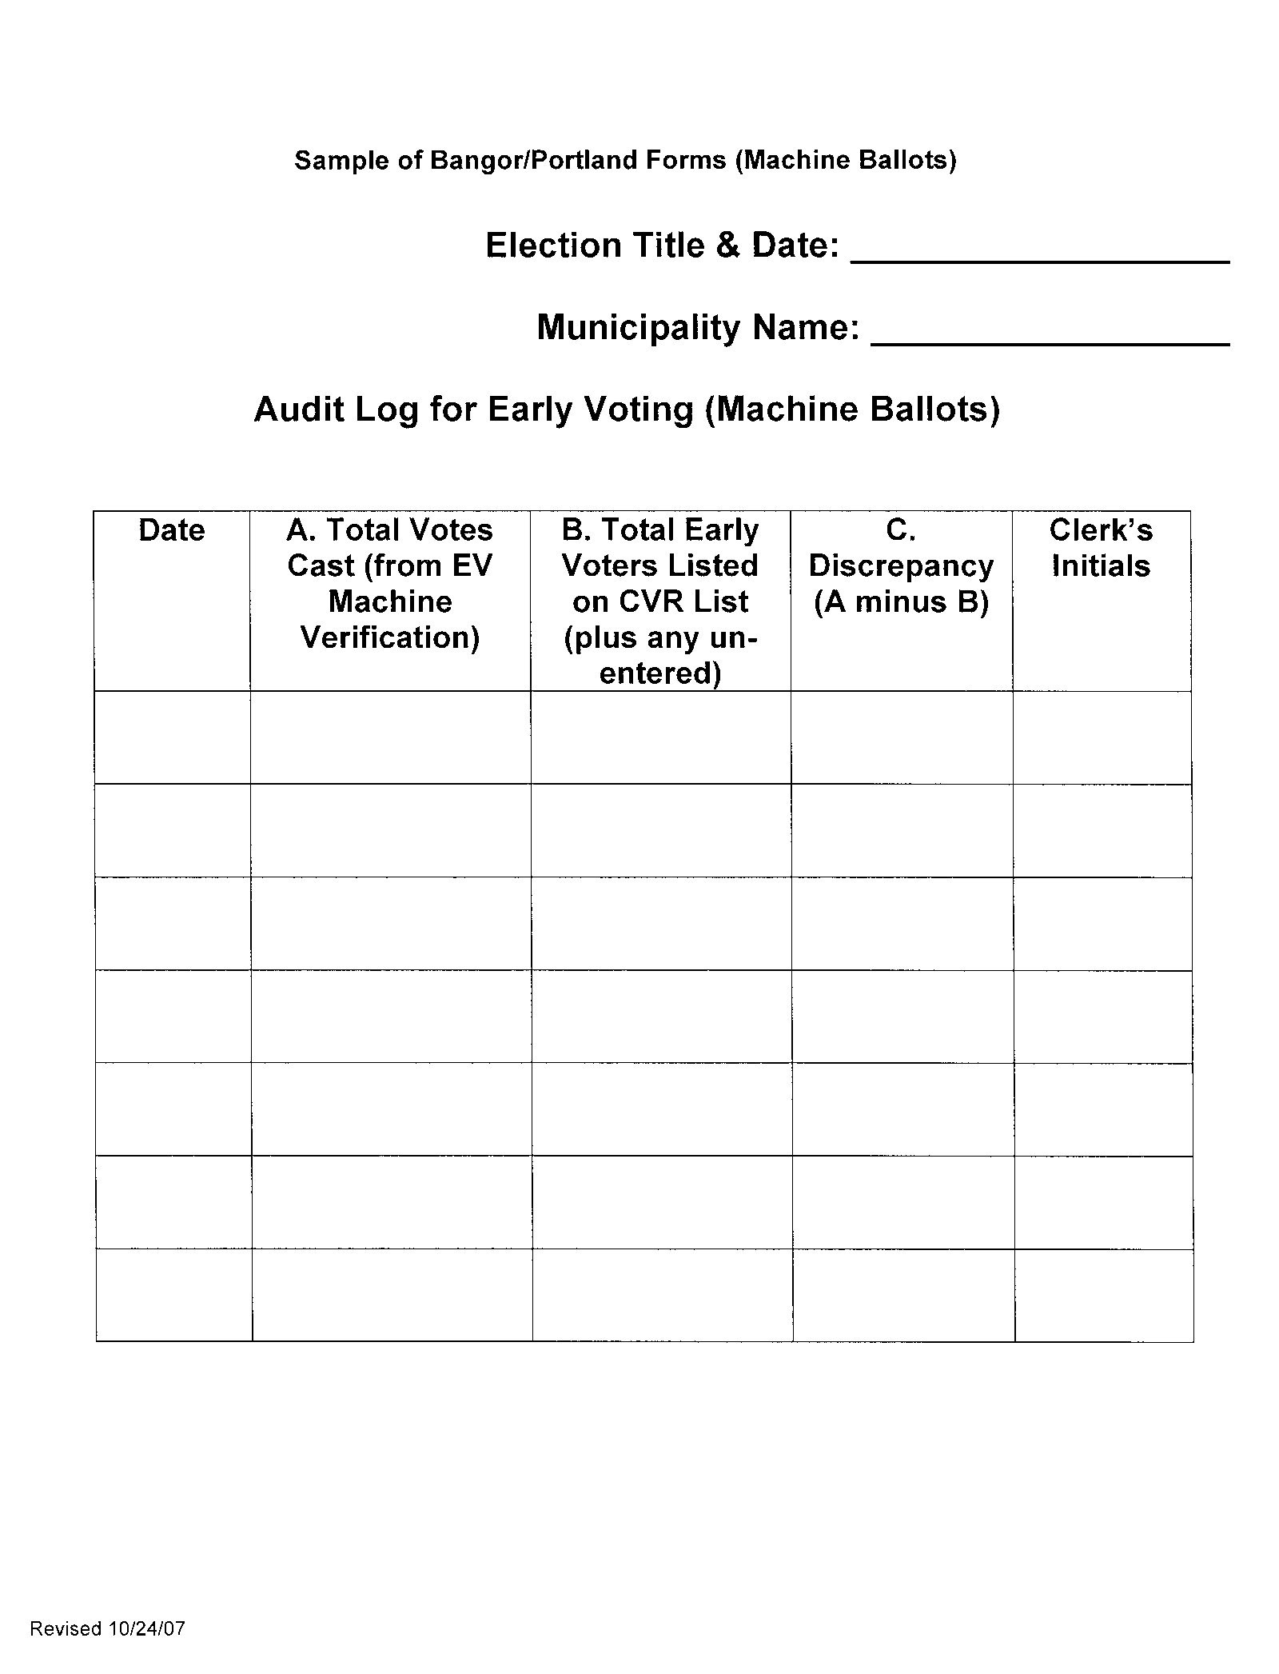

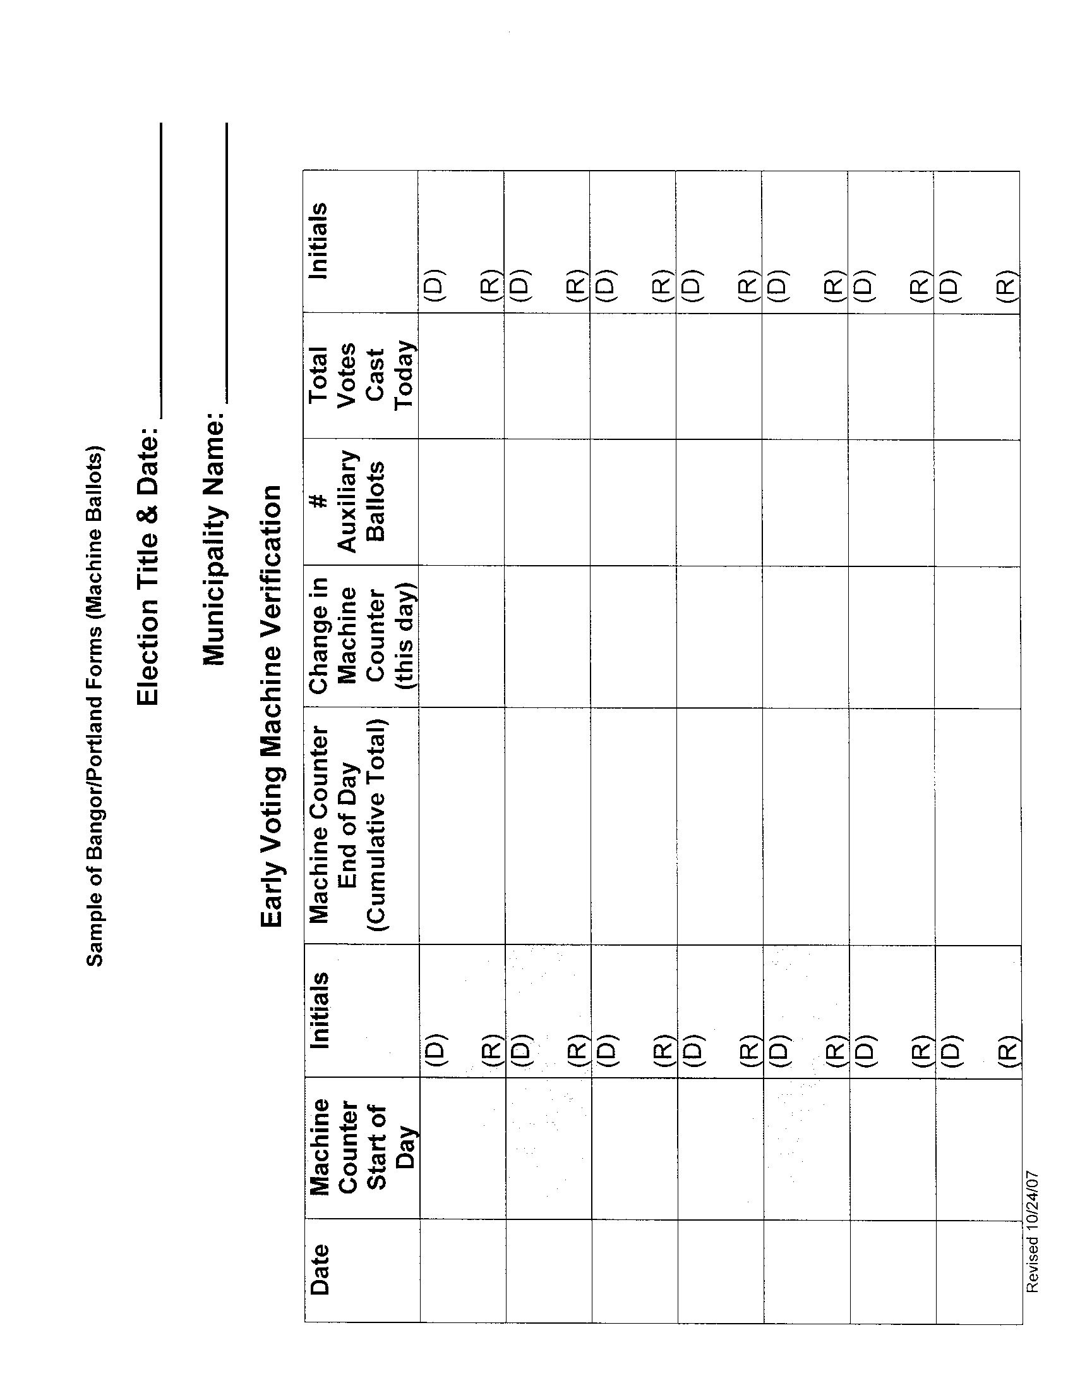

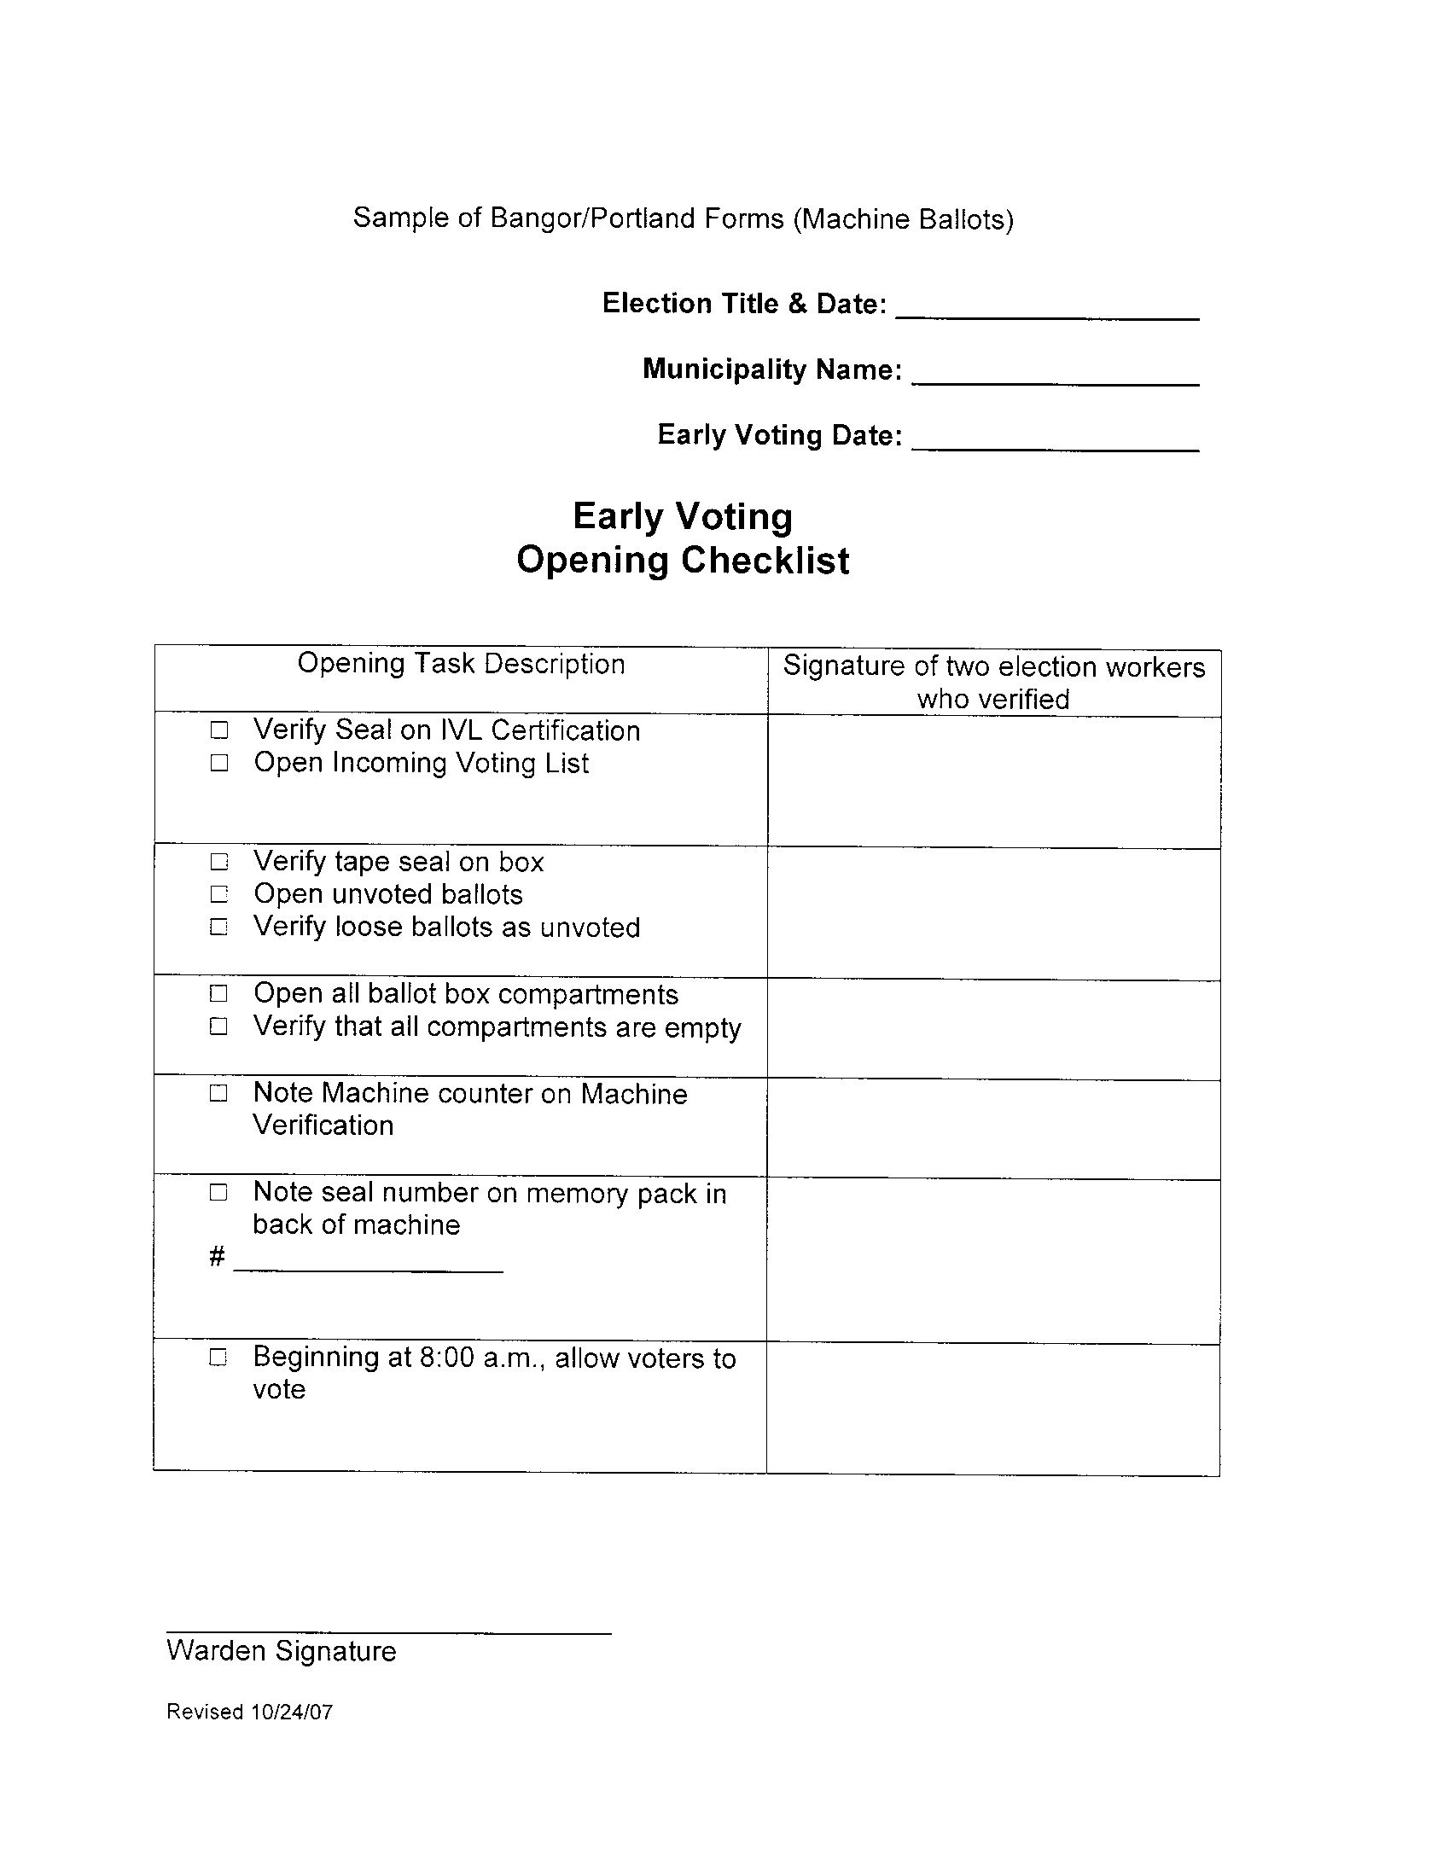

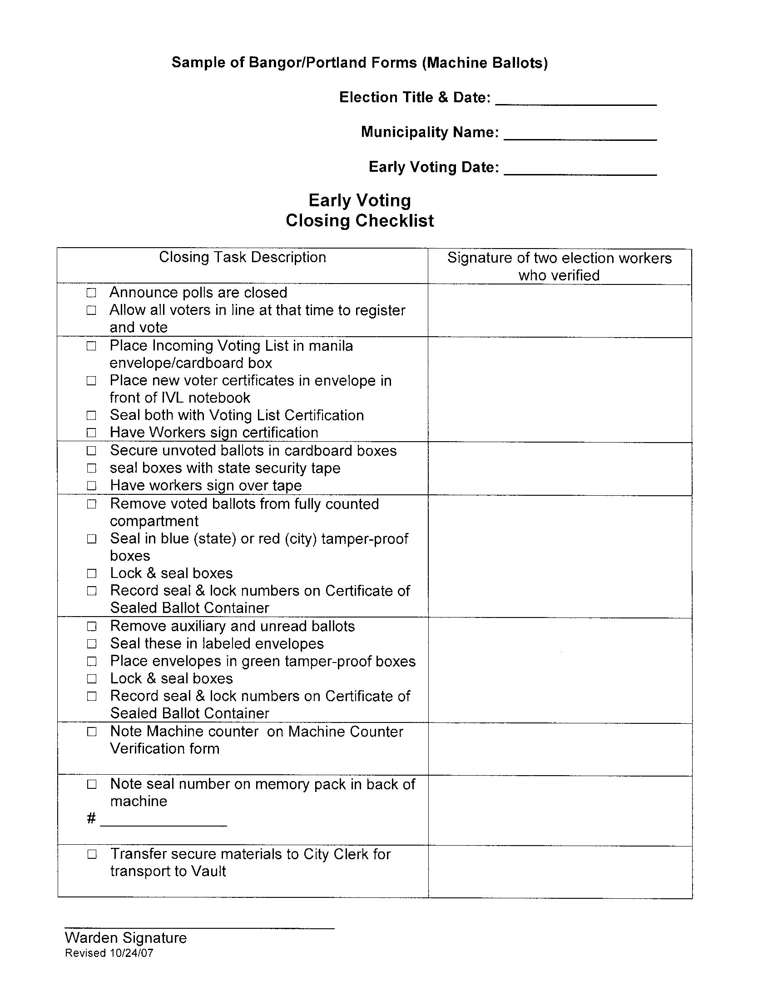

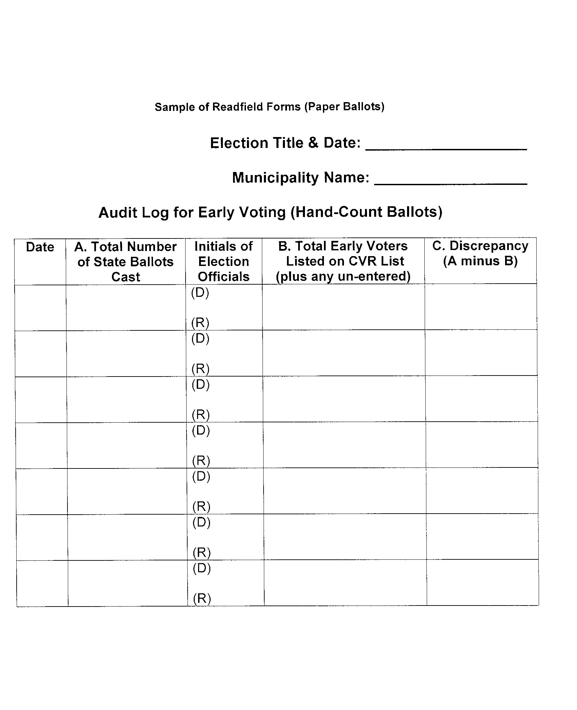

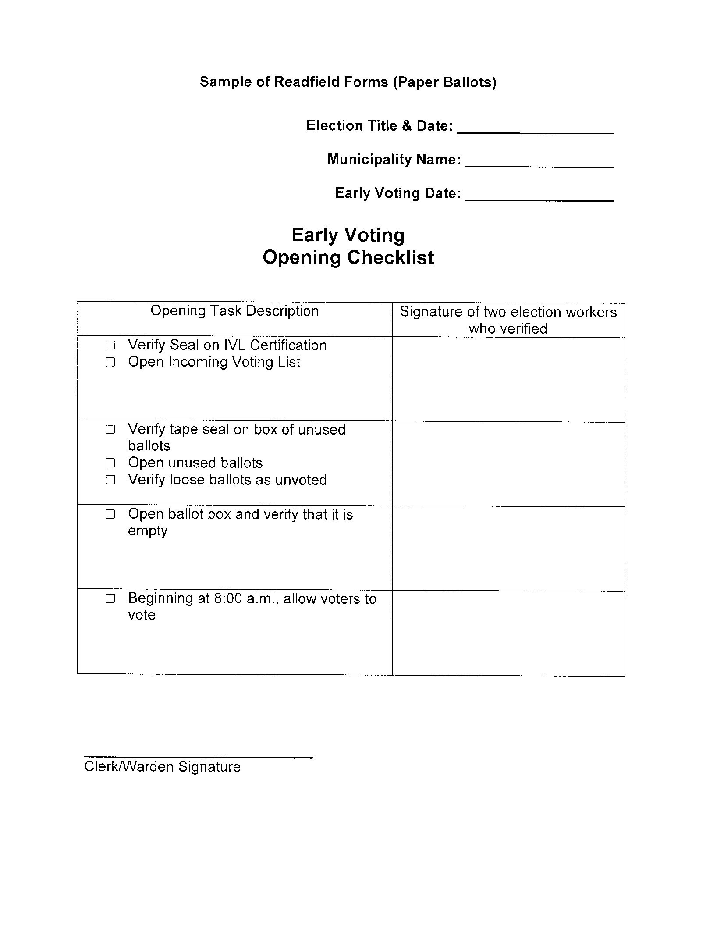

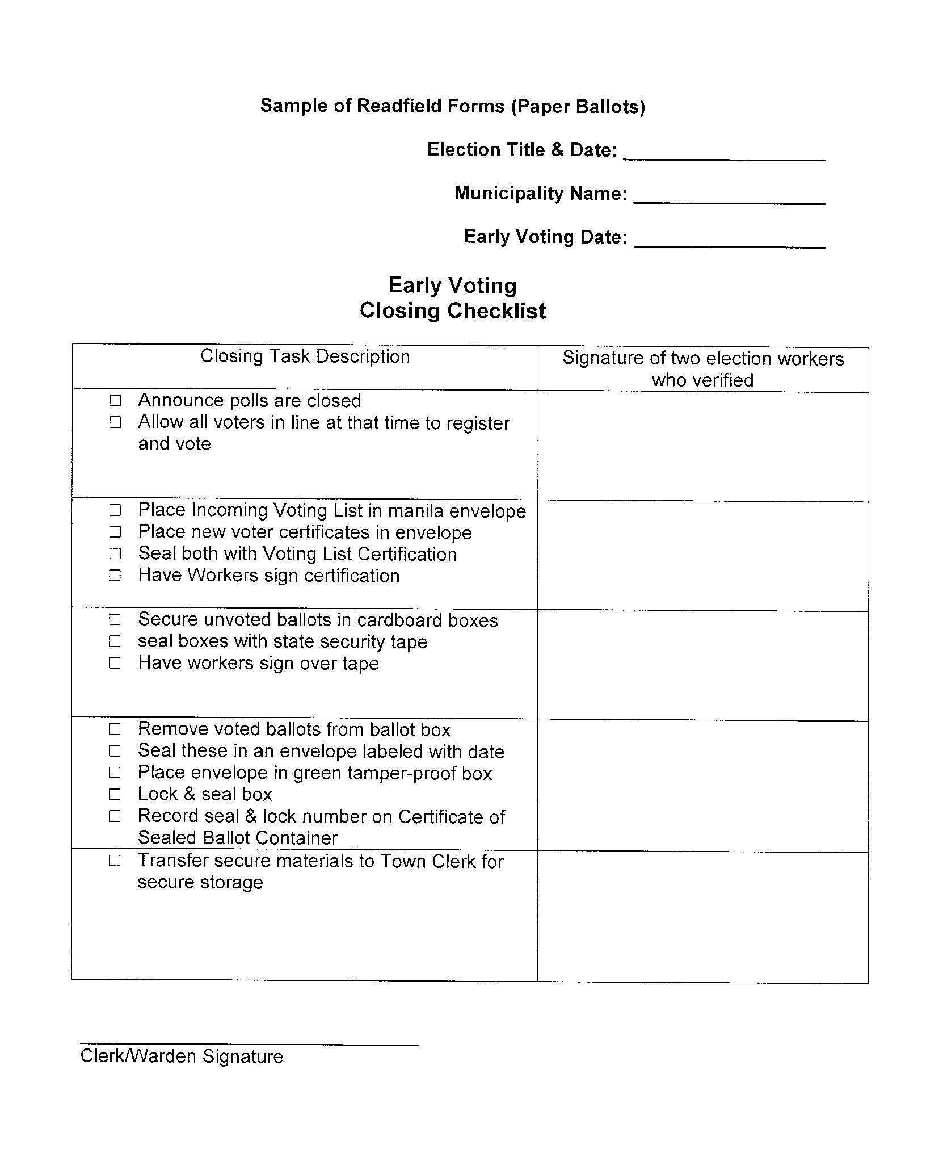

Appendix C

Sample of Early Voting Survey Form

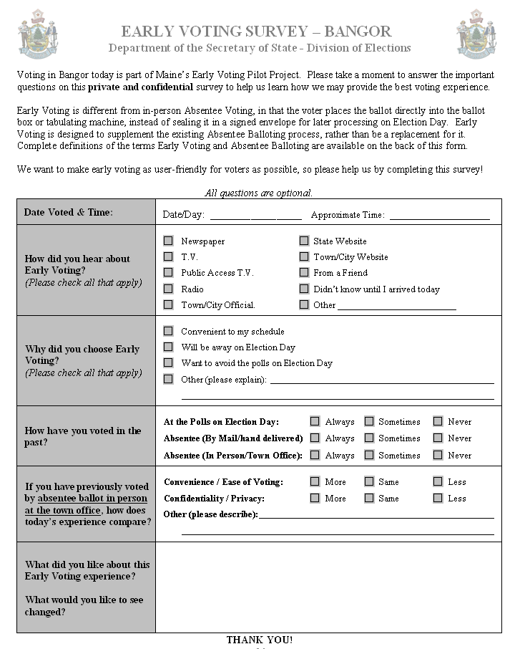

Appendix D

Early Voting Pilot – Voter Survey Results

EARLY VOTING PILOT
VOTER SURVEY RESULTS

OVERVIEW

Three municipalities (Bangor, Portland, and Readfield) conducted Early Voting Pilots in the days preceding the November 6, 2007 Referendum Election. Along with their ballots, voters opting to participate in the Early Voting were provided with a survey designed to help policy makers and administrators evaluate the pilots.

Across all three municipalities 1,844 citizens – approximately 10% of those who voted in that election in those municipalities – participated in the pilots, casting their ballots early. Of those voters, 1,602, or 87%, returned their survey forms (fully or partially completed). Responses indicate that the pilots were successful and, generally, enthusiastically embraced by those participating. Responses also offer valuable insight on why voters participated, what they liked or disliked and how any future Early Voting efforts can enjoy the same or greater success.

The following is a summary of the survey results.

EARLY VOTING PREVALENCE AND SURVEYS

Municipality | Total Ballots Cast | Early Voters (EV) | EV % of Total Ballots Cast | Survey Responses | % of EV Responding
Bangor | 5,120 | 1,203 | 23% | 1,012 | 84%
Portland | 13,142 | 579 | 4% | 544 | 94%
Readfield | 662 | 62 | 9% | 46 | 74%
TOTAL | 18,924 | 1,844 | 10% | 1,602 | 87%

DATES AND TIMES OF EARLY VOTING

Day & Time Voted: All Pilot Municipalities

Date / Time Voted | 8-10 | 10-12 | 12-2 | 2-4 | 4-6 | Unspecified Time | Total Votes
10/29/2007 Monday | 5 | 20 | 18 | 16 | 17 | 6 | 82
10/30/2007 Tuesday | 9 | 34 | 25 | 33 | 21 | 2 | 124
10/31/2007 Wednesday | 46 | 66 | 93 | 52 | 33 | 10 | 300
11/01/2007 Thursday | 29 | 58 | 42 | 43 | 35 | 8 | 215
11/02/2007 Friday | 31 | 66 | 61 | 62 | 50 | 4 | 274
11/03/2007 Saturday | 34 | 81 | 9 | 2 | 2 | 2 | 130
11/05/2007 Monday | 59 | 79 | 97 | 44 | 18 | 4 | 301
Unspecified Day | 1 | 2 | 4 | 1 | 1 | 167 | 176
ALL DAYS | 214 | 406 | 349 | 253 | 177 | 203 | 1602

PUBLIC AWARENESS / OUTREACH

Voters were asked “How did you hear about Early Voting?” and were encouraged to select all options that applied. 1,575 answered this question, selecting one or more options.

*The ‘Other’ category included 85 responses from Bangor voters who indicated they had seen road signs advertising Early Voting.

WHY VOTERS CHOSE TO EARLY VOTE

Voters were asked to indicate “Why did you choose Early Voting?” and were encouraged to select all options that applied. A full two thirds of voters cited “convenience to my schedule” as a reason for voting early. Nearly one fifth indicated they were going to be “away on Election Day”. Additionally, nearly a third of voters indicated that a desire to “avoid the polls on Election Day” was one of the reasons they chose to vote early. Although small in numbers, it is worth noting that of those selecting “Other”: 41 were either poll workers or campaign workers, 13 preferred the Early Voting location to their polling place, and 11 cited mobility issues or other disability causing an aversion to lines or crowds and therefore a preference for Early Voting. 1,595 answered this question, selecting one or more options.

VOTERS PREVIOUS VOTING METHODS

How have you voted in the Past?
 | Always | Sometimes | Never
At the Polls on Election Day | 857 | 567 | 15
Absentee (By Mail/hand delivered) | 42 | 342 | 142
Absentee (In Person/Town Office) | 88 | 494 | 96

COMPARISON TO PRIOR VOTING
Voters were asked “If you have previously voted by absentee ballot in person at the town office, how does today’s experience compare?” 935 voters answered the Convenience / Ease of Voting section of this question and 636 answered the Confidentiality / Privacy section of this question.
(*These numbers do not correlate with the 582 voters indicating that they had previously voted Absentee (In Person/Town Office); and therefore reflects some confusion on the question.)

LIKES

Voters were asked “What did you like about this Early Voting experience?” Responses were narrative. Of the 934 voters who responded to this question, responses include:

- 319 references to the convenience
- 174 references to the lack of lines, shortness of lines, or lack of waiting
- 146 references to the ease of Early Voting
- 99 references to the process as being quick or fast
- 68 references to the lack of crowds
- 128 descriptions such as great, good, wonderful or excellent

CHANGES

Voters were asked “What would you like to see changed?” Responses were narrative. Of the 223 voters who responded to this question:

- 126 actually indicated that nothing needed to change
- 10 indicated a desire for Early Voting to be offered in future elections
- 71 recommended some type of change, as follows:
  - 22 seeking increased publicity and advertising of the Early Voting opportunities
  - 13 seeking expanded times
  - 12 seeking facilities enhancements (parking, temperature, privacy, etc)
  - 8 seeking expanded or different locations
  - 16 other suggestions
- 11 included comments unrelated to Early Voting
- 3 opposed Early Voting

