19-498 Chapter 22

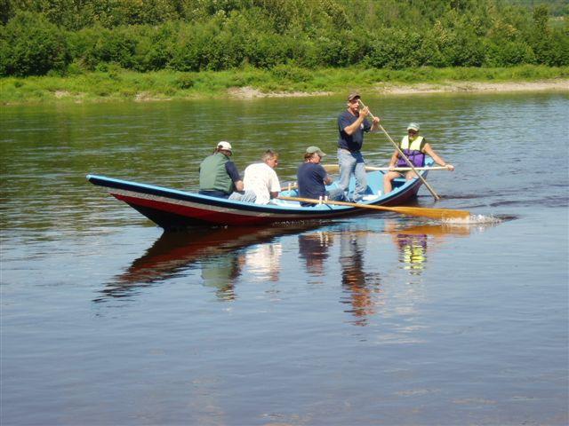

State of Maine
2008 Riverfront Community Development Bond Program
Final Rules


RCDB
“Healthy Rivers Equal Healthy Communities”

Office of Community Development
111 Sewall Street
59 State House Station
Augusta, ME 04333-0059
Phone: (207) 624-7484 TTY: (207) 287-2656
19-498 CMR DEPARTMENT OF ECONOMIC AND COMMUNITY DEVELOPMENT
CHAPTER 22 RIVERFRONT COMMUNITY DEVELOPMENT BOND PROGRAM RULES

Table of Contents

Summary Page 3

Basis Statement Page 3

§1 Definitions Page 3

§2 Eligible Uses Page 5

§3 Ineligible Uses Page 5

§4 Eligible Project Sites Page 6

§5 Prohibition of Multiple Grant Awards Page 6

§6 Matching Funds Requirements Page 7

§7 Maximum Fund Grant Awards Page 7

§8 Application Process Page 7

§9 Selection Process Page 8

§10 Scoring Criteria Page 8

§11 Project Development Phase Page 9

§12 Applicability of State Laws Page 9

§13 Waiver of Rule Page 9

19-498 CMR DEPARTMENT OF ECONOMIC AND COMMUNITY DEVELOPMENT
CHAPTER 22 RIVERFRONT COMMUNITY DEVELOPMENT BOND PROGRAM RULES

Summary

These rules set forth allowable activities for the Riverfront Community Development Bond program (the Fund), definitions, prioritization of allowable projects, the process for determining project eligibility and selection process for financial assistance. In accordance with Title 5, chapter 375, subchapter 2-A the Department of Economic and Community Development (DECD) will hold a public hearing regarding the development of these rules.

Basis Statement

The Riverfront Community Development Bond Program, established under 5 MRSA §13083-T and referred to in this section as "the Fund" is established within the Department of Economic and Community Development (DECD) to assist and encourage communities along the State's rivers to revitalize their riverfronts in an environmentally sustainable manner and to promote river-oriented community development and enhancement projects. The DECD shall administer the program in conjunction with the Maine Municipal Bond Bank (MMBB) to provide funding for the rehabilitation, revitalization and enhancement of riverfront communities and river ecosystems in the State.

§ 1. Definitions

As used in these rules, unless the context otherwise indicates, the following terms have the following meanings:
- Bank: “Bank” shall mean the Maine Municipal Bond Bank.

- Comprehensive Plan: “Comprehensive Plan” shall mean a plan that is determined by the Executive Department, State Planning Office to be consistent with 30-A MRSA §4326 subsections 1 to 4 and that has been adopted by the municipality.

- Department: “Department” shall mean the Department of Economic and Community Development.

- Downtown: “Downtown shall mean the central business district of a community that serves as the center for socioeconomic interaction in the community and is characterized by a cohesive core of commercial and mixed-use buildings, often interspersed with civic, religious and residential buildings and public spaces, typically arranged along a main street and intersecting side streets, walkable and served by public infrastructure; or an area identified as a downtown in a comprehensive plan adopted pursuant to chapter 187, subchapter II.

- Eligible Applicant: “Eligible Applicant” shall mean a Maine town, city or plantation located on a Maine River as identified in Number 8 below; further to be considered an “Eligible Applicant” the community must have received written approval from the Department that the community’s Letter of Intent with attached letter of sponsorship from a State Agency, was received, by the stated due date. Multiple eligible applicants may join together to submit a multi-jurisdictional application providing that each benefitting community is located on a Maine River.

- Fund: “Fund” shall mean the Riverfront Community Development Bond.

- Letter of Intent: “Letter of Intent” shall mean a form that is provided by the Department to all potential applicants to the Fund and which must be completed and returned to the Department by the stated due date established by the Panel. All Letters of Intent must comply with §8(1)(a-c) of this Rule.

- Maine River: “Maine River” shall mean one of the following Maine recognized rivers as identified in Title 38, Chapter 3, Subchapter 1, Article 4-A, §467 that are in the river basins listed below having a drainage area greater than 100 square miles: Androscoggin River Basin: Androscoggin River, Little Androscoggin River, Cupsuptic River, Kennebago River, Rapid River, Magalloway River, Bear River, Sabattus River, Webb River, Swift River, Nezinscot River, Wild River; Dennys River Basin; Dennys River; East Machias River Basin; East Machias River; Kennebec River Basin: Kennebec River, Carrabassett River, Dead River, Moose River, Sandy River, Sebasticook River; Machias River Basin; Machias River; Medomak River Basin; Medomak River; Mousam River Basin; Mousam River; Narraguagus River Basin; Narraguagus River; Penobscot River Basin: Penobscot River, Seboeis River, Stillwater River, Mattawamkeag River, Piscataquis River, Pleasant River, Passadumkeag River; Pleasant River Basin: Pleasant River; Eastern Little River; Presumpscot River Basin: Presumpscot River, Crooked River; Narraguagus River Basin; Narraguagus River; Royal River Basin; Royal River; Saco River Basin: Saco River, Little Ossipee River, Ossipee River; St. Croix River Basin; St. Croix River; St. George River Basin; St. George River; St. John River Basin: St. John River, Allagash River, Aroostook River, Little Machias River, Little Madawaska River, Machias River, Fish River, Meduxnekeag River, Big Black River; Salmon Falls River Basin; Salmon Falls River; Sheepscot River Basin; Sheepscot River; Union River Basin; Union River. Communities wishing to apply for a project located on a river not listed above must receive permission from DECD prior to the submission of the Letter of Intent.

- Panel: The “Panel” shall mean the Riverfront Community Development Review Panel, established to evaluate proposals and determine funding under the program. The Panel will consist of:

a. The Commissioner of Economic and Community Development or designee;

b. The Commissioner of Conservation or designee;

c. The Director of the State Planning Office within the Executive Department or designee; and

d. Four members of the public, one with expertise in economic and community development, one with expertise in environmental conservation, one with expertise in tourism and ecotourism development and promotion and one with expertise in park and trail design and development. Two of these members are appointed by the President of the Senate and two by the Speaker of the House.

- Project: The "Project" shall mean the scope of work for which financial assistance is sought by a municipality from the fund as well as all work critical to the completion of the project which is funded by other sources.

- Project Site: The “Project Site” is the location of the work to be performed with assistance from the Fund or other sources and must always take place on a Maine River.

- State Agency: “State Agency” shall mean one of the following Maine State Agencies which may sponsor a Riverfront Community Development Bond application for an eligible applicant: Maine Department of Conservation, Maine Department of Agriculture, Maine Department of Economic & Community Development, Maine Department of Environmental Protection, Maine Department of Inland Fisheries and Wildlife, Maine Department of Marine Resources, Maine Housing, Maine State Planning Office, Maine Department of Transportation, Maine Historic Preservation Commission, Maine Arts Commission and Bureau of General Services. A letter of sponsorship does not influence project merit or need determination.

§ 2. Eligible Uses

Eligible uses of the Riverfront Community Development Bond (the Fund) are set forth in this section. Activities may include but are not limited to: acquisition, demolition, site work, design, construction, and renovations in support of the following project types:

  - Rehabilitation of run-down or abandoned buildings and related sites, such as former mills, warehouses or other commercial or industrial facilities;

  - Restoration and improvement of habitat for fish and wildlife;

  - Development of public access points for boating and fishing;

  - Creation of riverfront parks, walking trails and other recreational amenities;

  - Development of facilities in support of the arts, local agriculture and crafts relating to furthering the Creative Economy along Maine’s Rivers.

§ 3. Ineligible Uses

Ineligible uses of the Riverfront Community Development Bond (the Fund) are set forth in this section. The following activities may not be funded by the Riverfront Community Development Bond (the Fund):

  - Construction or repair of bridges or dams, with the exception of the construction or repair of bridges for the primary purpose of walking, or bicycling and is required for walking or bicycling trail connectivity;

  - Planning and Feasibility Studies;

  - Any work related to municipal water, sewer or road projects;

  - Improvements to private residences;

  - Construction of parking garages or decks of any type;

  - Golf Courses;

  - Marinas;

  - On-going maintenance of existing buildings or facilities;

  - Program administration, salaries, lobbying and related expenditures;

  - Repayment of existing debt;

  - Supplanting loan or grant funds from other state or federal programs such as but not limited to, Rural Development, CDBG, EDA, EPA or revenue bonds already approved by the municipality.

  - Any project that damages a river or its riparian habitat or that violates any state or federal environmental laws or regulations; and

  - A project otherwise required by any regulatory license of permit condition or any form of mandated mitigation or remediation activity.

§ 4. Eligible Project Sites

To be eligible to receive assistance from the Fund ownership of all Project Sites must be clearly established at the time of submission of the Letter of Intent in one of the following ways:

  - Municipally Owned;

  - Owned by a recognized not-for-profit organization such as a 501(C)(3) and designated for a public use;

  - Secured by a minimum 75 year lease for a public use, unless otherwise expressly covered under an existing state statute;

  - In the case of assistance to run-down or abandoned buildings such as former mills, warehouses or other commercial or industrial facilities, the property may be privately owned if it is located in a defined downtown area or another area on a Maine River that is part of a growth area designated in a Comprehensive Plan adopted by the municipality and approved by the State Planning Office under the Growth Management Act, and so long as a public benefit such as provision of municipal recreational opportunities, affordable housing, public open space or access or is realized as a long-term benefit of the project.

§ 5. Prohibition on Multiple Grant Awards

Eligible applicants for the Fund as defined in §1(5) of this Rule may not apply for, or benefit through a multi-jurisdictional application from more than one grant unless it is determined by the Department that there is insufficient interest in the program after the initial application due date.

§ 6. Matching Funds Requirements

All applicants must certify that they will provide at least two dollars in matching funds for each one dollar expended from the Fund. This is referred to as a 2 to 1 match. The following requirements apply to all matching funds:

  - A minimum 75% of all matching funds must be in new, readily available cash commitments to be expended on the Project;

  - A maximum of 25% of all matching funds may be in the form of firmly documented in-kind contributions or funds expended on the Project during the 12 months prior to the date of application submission. All non-cash match must directly relate to the Project for which assistance from the Fund is sought;

  - The costs associated with the purchase of property on which the Project will take place, or the value of donated non-public property on which the Project will take place may be counted as cash commitments.

  - Matching funds may be provided by state, federal, local or private sources.

§ 7. Maximum Fund Grant Awards

The maximum Fund grant award will be $750,000.

§ 8. Application Process

The Department will conduct an application process consisting of the following steps:

  - Submission of a Letter of Intent from all interested applicants. Submitted with the Letter of Intent must be a letter of sponsorship from a State Agency as defined in §1(12) of this Rule. A completed Letter of Intent must be received by the Department no later than the announced due date set by the Panel. The Letter of Intent must include the following:

a. Demonstrate the capacity to undertake the project with a reasonable prospect of bringing it to a successful conclusion. In assessing an applicant's ability to meet the requirements of this paragraph, the panel may consider all relevant factors, including but not limited to the applicant's level of debt; fund-raising ability; past economic and community development activities; grants from federal, state or local sources; previous environmental conservation, restoration or enhancement activity; organizational history; scope of economic or environmental vision; and evidence of success in previous efforts.

- A general description of the proposed project, projected project timeline, and design work completed to date.

- Identification of anticipated sources of matching funds and description of the timeframe for final commitment.
  - In order to continue in the process an eligible applicant must receive written approval from the Department. Applicants deemed by the Department to have an incomplete or non-compliant Letter of Intent will receive written confirmation of the fact and will not continue in the competition;

  - All eligible applicants wishing to do so must prepare and submit a full application and required attachment to the Department no later than the announced due date;

  - Incomplete or non-compliant applications will be rejected by the Department.

§ 9. Selection Process

The selection process shall consist of the following steps:

  - Department staff shall undertake the initial threshold review of applications;

  - A subcommittee appointed by the panel to score applications shall review and determine the final score of the proposals;

  - A subcommittee appointed by the panel to nominate finalists shall review all of the applications, identify issues for full review and discussion by the Panel and recommend finalists to the full Panel for detailed review and consideration;

  - The Panel shall review all applications submitted, select finalists and allocate funding.

§ 10. Scoring Criteria

The Panel will use the following scoring criteria and point totals for making awards:

- The economic significance of the proposed project to the immediate vicinity and to the State as a whole: 10 points

- The level of compatibility with clean and healthy river ecosystems: 15 points

- The value of the proposed project with respect to downtown revitalization: 10 points

- The value of the proposed project with respect to environmental protection and ecological restoration: 10 points

- The value of the proposed project with respect to recreational uses: 10 points;

- The degree of community support for the proposed investment: 15 points

- The extent to which the proposed project involves partnerships and meets multiple criteria for benefits: 15 points

In addition to evaluating the proposals using the scoring system established above, the panel shall consider the following criteria and point totals in reviewing a proposal:

- The level to which a proposal supports the open space or recreation objectives, or both, of a local comprehensive plan: 3 points

- The extent to which a project is consistent with an adopted comprehensive plan that meets the standards of the laws governing growth management pursuant to Title 30-A, chapter 187: 3 points

- The current and anticipated demand for use and diversity of uses of the site: 3 points

- The local and regional community planning and support for river protection, enhancement and restoration: 3 points

- Any additional benefits that contribute to scenic landscape values, including the character of the town or region in which the project is situated, the rehabilitation or renovation of riverfront mill and other buildings and the ability to secure public access for conservation, recreation, wildlife and education uses: 3 points

§ 11. Project Development Phase

Following notification of funding by the Panel a specialist from the Department will be assigned by the Department to work with all successful applicants. The specialist will assist the community in the Project Development Phase consisting of the following steps:

- Providing the Department with written documentation to satisfy the requirements of MRSA Title 30-A, section 5203;

- Documenting compliance with all applicable local, state and federal environmental laws, requirements and permits;

- For all applicable projects to be undertaken in floodplains or flood prone areas, documentation of participation in the National Flood Insurance Program, in good standing, with an up to date floodplain management ordinance in effect. Pursuant to Executive Order 11988, all Fund expenditures must comply with FEMA requirements.

- Submission of plans and specifications and other documents required by the Department;

- Completion of contract documents;

- Successful applicants have a maximum six month period after notification of funding to complete the Project Development Phase. Failure to meet this timeframe may result in the notification of funding being revoked.

§ 12. Applicability of State Laws

All state laws, rules and regulations will apply to Projects receiving assistance from the Fund.

§ 13. Waiver of Rule

The Department may waive any requirement of this rule, except to the extent that the requirement is mandated by the Act, in cases where deviation from the rule is insubstantial. Any requests for waiver of the rule shall be made prior to the execution of a grant agreement.

FOR MORE INFORMATION OR TO REQUEST THIS DOCUMENT IN AN ALTERNATIVE FORMAT PLEASE CONTACT:

MICHAEL D. BARAN, ACTING DIRECTOR
OFFICE OF COMMUNITY DEVELOPMENT
111 SEWALL STREET
59 STATE HOUSE STATION
AUGUSTA, MAINE, 04333-0059
TELEPHONE (207) 624-7484
TTY 1-800-437-1220
mike.baran@maine.gov

www.meocd.org
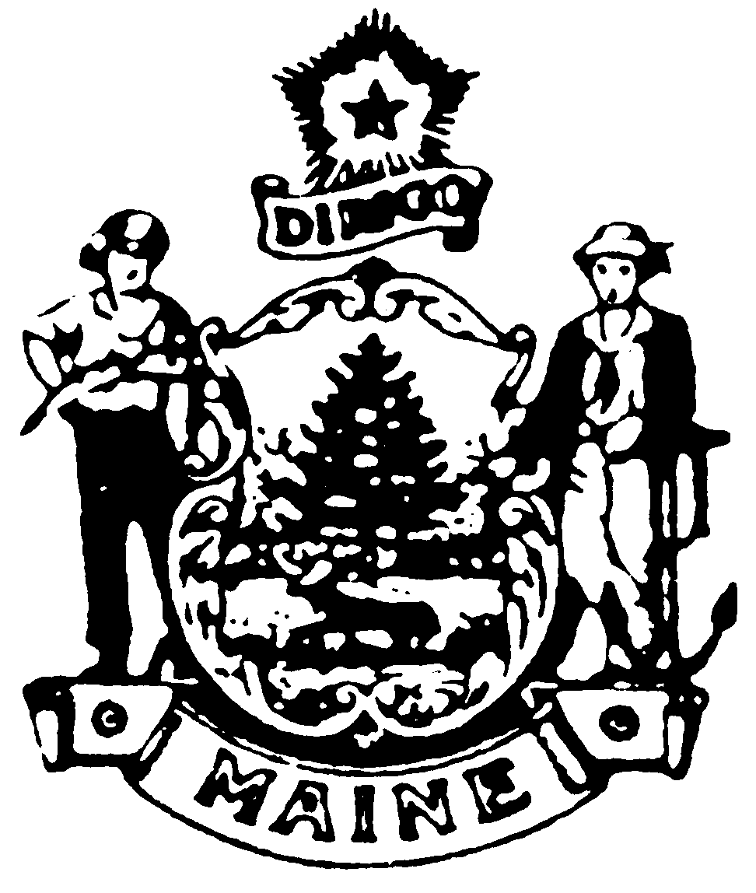

EFFECTIVE DATE: August 25, 2008 – filing 2008-371

