10-144 DEPARTMENT OF HUMAN SERVICES

BUREAU OF HEALTH

Chapter 296: "FILLINGS: THE CHOICES YOU HAVE - MERCURY AMALGAM AND OTHER FILLING MATERIALS"

EFFECTIVE DATE: November 4, 2002 - filing 2002-354

DEPARTMENT OF HUMAN SERVICES

Angus S. King, Jr., Governor

Kevin W. Concannon, Commissioner

Printed under appropriation #: 014-10A-2565-022

In accordance with Federal laws, the Maine Department of
Human Services does not discriminate on the basis of sex,
age, color, national origin or disability in admission or
access to or treatment or employment in its programs and
activities. The Department's Affirmative Action Coordinator
has been designated to coordinate our efforts to comply
with and implement these Federal laws and can be con-
tacted for further information at 221 State Street, Augusta,
Maine 04333. (207) 287-3488, or 1-800-332-1003 (TDD).

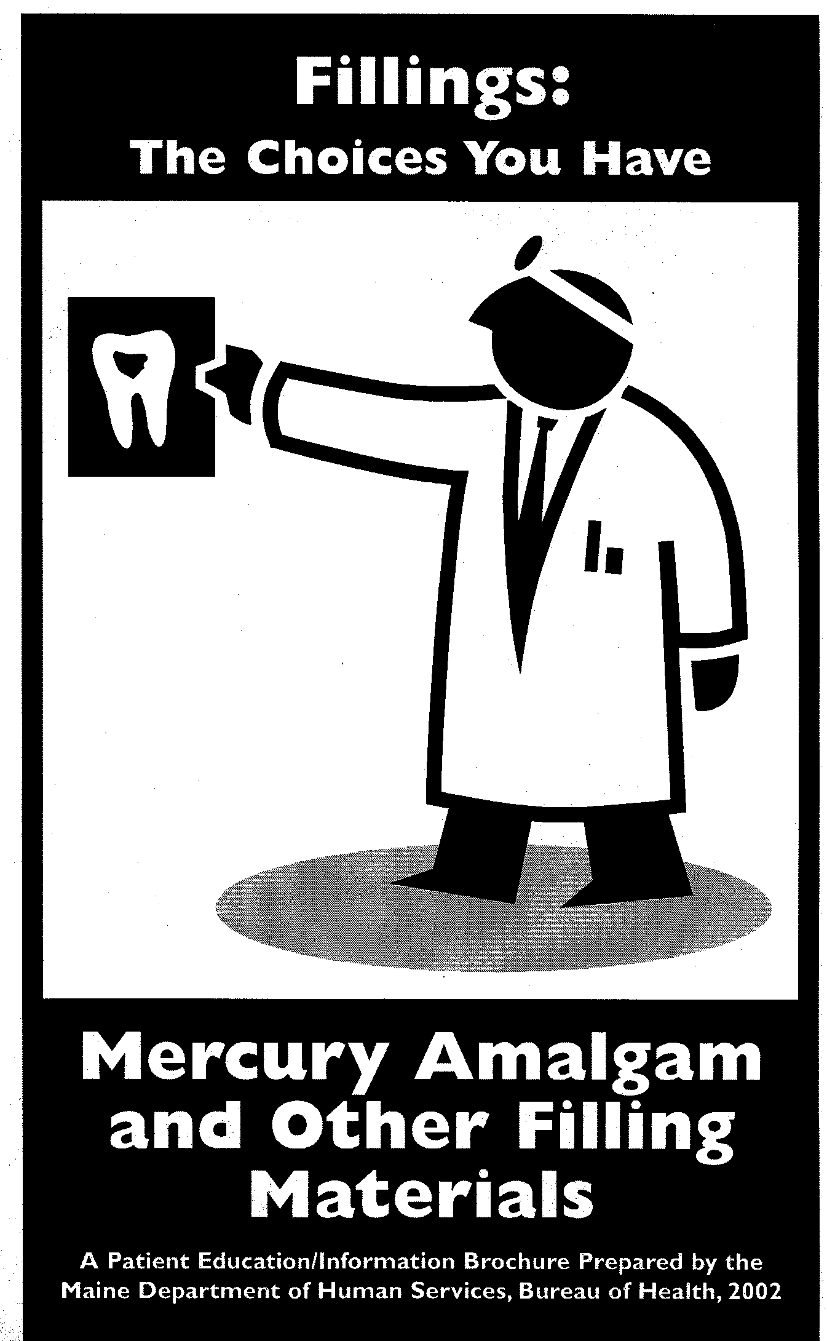

About this Brochure

In 2001, the Maine State Legislature passed a law telling the Maine Bureau of Health to make a brochure about the advantages and disadvantages to human health and the environment of using mercury amalgam fillings in dental work. The same kind of information is included for other filling materials, to help patients in choosing what will be best for them.

Mercury is a heavy metal. It is found in nature. Mercury is found in different forms. Too much mercury in your body can hurt you. Many years of burning coal along with using mercury in batteries, thermometers, fluorescent lights, electrical switches, and other products have caused too much mercury to get into the environment.

The State of Maine is concerned about the effects of mercury on human health and our environment. Maine’s policy is to reduce how much mercury is released into the environment. Maine is a leader among states in removing mercury from products.

Because amalgam fillings mostly contain mercury, we are concerned about possible effects on human health and the environment.

This booklet will tell you more about:

- Mercury in amalgam fillings
- Health and environmental concerns with using amalgam fillings
- Cavities and dental decay and what you can do to avoid fillings
- Talking with your dentist about getting a tooth filled
- Choices you have for filling materials

Amalgam Fillings and Mercury

Amalgam fillings are also called dental amalgams or mercury amalgams. They are 40 to 50 percent mercury. These fillings give off mercury vapor. How much vapor is given off depends on how many fillings you have. It also depends on how much time you spend chewing, grinding your teeth, and drinking hot liquids. Mercury vapor can be inhaled and enter the bloodstream. It can then be carried throughout the body. For people with a number of fillings, this can be the major way mercury gets into their body. Any mercury from amalgam fillings we swallow is very poorly absorbed and mostly does not enter our bloodstream.

Health Concerns

There is a lot of debate about health effects from the mercury in amalgam fillings. Current studies cannot confirm if amalgam fillings cause health problems. Some people have allergic reactions to mercury. Too much mercury can damage the kidneys, nerves, and the brain. The brains of babies and infants that are starting to form and grow are most at risk.

To be careful, Canada and several countries in Europe recommend limits on the use of mercury amalgam. They advise that pregnant women should not have amalgam fillings placed in or removed from their teeth. Some of these countries issue the same warning for nursing women and people with kidney problems. Some countries advise limits on using amalgam fillings with young children and people with braces. The US Public Health Service thinks such advice is not needed. They say amalgam fillings are safe for most people. No country says people who do not have signs of mercury effects should have their fillings removed.

Environmental Concerns

Some countries limit the use of amalgam fillings to help reduce mercury pollution. Waste is made when new fillings are put in teeth or when fillings are removed. This waste contains mercury. It can pollute the environment. Your dentist can reduce this pollution by using traps and filters to collect the mercury for recycling. Amalgam fillings cause our body’s waste (urine and feces) to have mercury. When these mercury-containing wastes enter sewers, they can add to the pollution of our waters.

Once mercury enters our waters, it can change to methylmercury. This builds up in fish. Many states, including Maine, have issued Safe Eating Guidelines on eating fish due to mercury pollution. Mercury used in dentistry is not the major cause of our mercury pollution and resulting fish warnings. It does add to the problem. Wildlife that eat fish, such as eagles, loons and otters, are also at risk of harm from mercury pollution.

What you can do...

The best thing you can do is avoid the need for any fillings by preventing tooth decay in the first place. Because of efforts to prevent tooth decay, most amalgam fillings placed in teeth these days are to replace old ones. Knowing that you may have alternatives to amalgam fillings is another way to reduce the amount of amalgam that ends up in the environment. This brochure is to help you understand your choices for fillings. It is also to help you know what you can do to prevent tooth decay and avoid the need for any fillings.

About Cavities and Dental Decay

A cavity is a hole that forms in a tooth. It is the result of dental decay. Decay starts when there is a breakdown in tooth enamel. Unlike other kinds of injuries to your body, a cavity will not heal by itself. Not all dental decay results in cavities. Early decay can be stopped and even reversed with proper care.

Dental cavities need to be treated by a dentist. If you need a filling, there are different materials and treatment choices that you and your dentist can consider.

Because there are advantages and disadvantages to all filling materials, preventing dental decay from ever starting is very important.

Preventing Dental Decay

Over the past 30 years, successful preventive measures have helped reduce dental disease (tooth decay). Preventing decay is the best way to protect your oral health and your overall health. If you can keep decay from starting, you won’t need fillings, and you’ll be helping to protect the environment.

Follow these steps to help prevent dental disease:

- Brush and floss your teeth every day.
- Eat a balanced diet low in sweet sticky foods.
- Limit sugary sodas and fruit drinks.
- Visit your dentist at least once a year for a regular dental check-up.
- Use fluoride to help strengthen tooth enamel.
- Make sure children get dental sealants on their molar teeth.

Talking with Your Dentist About Getting a Tooth Filled

When you visit your dentist and need to have a tooth filled, let your dentist know about any changes to your health since your last visit. For example:

- Are you pregnant or nursing?
- Do you have any allergies?
- Do you soon plan to have braces?
- Are you taking any medications? What for?
- Do you have any kidney problems or a family history of them?
- Do you have any other health conditions or specific health concerns?

Sharing these facts with your dentist may affect the choice you make for a filling material. If you have questions or concerns about these materials or the kinds of fillings you already have, you should read this brochure and talk with your dentist.

No matter what material is used, a filling is not like a natural tooth. Filling materials are man-made and as such they are foreign materials to your body. Whenever something foreign is put into your body, there is the chance of side effects. All dental materials may cause an allergic reaction in sensitive people. For every filling material, there are a few people who are allergic to it. This is why your dentist needs to know about your allergies.

If you need to have a tooth filled (restored), there are different kinds of materials that can be used. Your dentist will talk with you about the kind of filling material that is best for you and for the tooth that needs to be filled. Each kind of material has advantages and disadvantages. You should know what these factors are so that you can make an informed choice.

What you choose depends on your needs and the best way to repair the cavity in your tooth. There are other factors that may affect the choice of filling material. These include the location of the filling and biting forces in the area of the mouth where the filling is located.

For many years, the only choices for fillings were metals. These are a mixture or “amalgam” of mercury and silver alloys, or gold alloy. In the past 20 to 30 years, other materials have been developed for fillings. These are “tooth colored” rather than silver-colored and gold. They include composite resin, glass ionomer and porcelain.

The rest of this brochure will outline the alternatives that you have and help you make the right choice for you.

The final choice is yours.

Choices in Restorative Materials (fillings):
Advantages, Disadvantages and Concerns

Amalgam

The word “amalgam” means a mix or blend. It can also be a mixture of mercury with another metal or mix of metals.

Dental amalgams include mercury, silver, copper and tin. About 40% to 50% of the filling material is mercury. They have been called “silver fillings” because of their silver color when they are first placed. It is usually used on back teeth. It is one of the oldest filling materials and has been used for over 150 years.

Advantages:

- Amalgam is very strong and lasts a long time.
- Fillings are usually done in one visit.
- This is the least expensive type of filling material.

Disadvantages:

- Amalgam fillings give off mercury vapor. The vapors can then be inhaled and enter your body.
- Current studies cannot confirm if this mercury causes health problems.
- Mercury used in these fillings can add to the mercury pollution problem.
- Amalgam has a silver color that can get darker over time.
- In rare cases there are allergic reactions to amalgam.

Composite (resin)

Composite is a mixture of plastic resin. These fillings are also called plastic or “white fillings.” This type of material may be either self-hardening or may be hardened by exposure to blue light. Composite is used for fillings, inlays and veneers. Sometimes it is used for replacing parts of broken teeth.

Advantages:

- These fillings are the color of natural teeth.
- Composite may be used on either front or back teeth.
- Fillings are usually done in one visit.
- Composite is a relatively strong material.

Disadvantages:

- This type of filling can break and wear out more easily than metal fillings, especially in areas of heavy biting forces. As a result, composite fillings may need to be replaced more often than metal fillings.
- Compared to other fillings, composite fillings are sometimes difficult and time-consuming to place. They cannot be used in all situations.
- Composite has a moderate cost. It costs more than amalgam.
- A chemical called Bisphenol A can be released from composite fillings. This chemical has hormone-like activity. Current studies cannot tell if this is a health problem. No government has recommended limits on its use.
- Allergic reactions are rare.

Glass Ionomer

Glass ionomer is a glass product. It is used for small or temporary fillings. It is also used as a cement for dental crowns. It is usually not used on the chewing surfaces of back teeth.

Advantages:

- These fillings are the color of natural teeth.
- Glass ionomer contains fluoride. This helps prevent further decay.
- Fillings are usually done in one visit.

Disadvantages:

- These fillings will not last as long as other materials.
- Glass ionomer is not recommended for use on the chewing surfaces of back teeth.
- This material has a moderate cost, like a composite.
- Allergic reactions are very rare.

Gold or Gold Alloy

Gold or gold alloy fillings are a mix of gold and other metals such as silver and copper. This material is used for crowns, bridges, inlays and onlays. Fillings made of gold alloy are made in a dental lab and sent back to the dentist to cement into place.

Advantages:

- Gold is extremely strong. Fillings made of gold alloy will last a long time.
- Gold alloy may have porcelain fused to the outside surface to make it tooth colored.
- No toxic or environmental effects have been identified to date.

Disadvantages:

- Gold has a high cost, more than all other materials.
- More that one dental appointment is needed to complete these fillings.
- Fillings are gold colored if not covered with porcelain.
- Allergic reactions are rare.

Porcelain

Porcelain is a mix of glass-like materials. Sometimes it is called ceramic. It is used for tooth colored crowns, bridges, inlays and onlays. Fillings made of porcelain are made in a dental lab and sent back to the dentist to cement into place.

Advantages:

- These fillings are tooth-colored.
- They may be used alone or fused to gold alloy to make them tooth colored.
- Porcelain usually lasts a long time.
- No toxic or environmental effects have been identified to date.

Disadvantages:

- Porcelain is somewhat brittle and may fracture.
- More than one dental appointment is needed to complete the filling.
- Porcelain has a high cost, similar to gold.

The Maine Legislature has required that as of July 1, 2002 all Maine dentists who use dental amalgam, which contains mercury, must provide this brochure to their patients to help explain the advantages or disadvantages of the use of mercury, mercury amalgams or other filling materials used in dental procedures. This brochure explains the possible effects that the use of such fillings may have to your dental health, general health or the environment. This brochure is intended to assist you in making choices regarding your dental and total health needs that are right for you.

For more information on:

U.S. Public Health Service Statement on Amalgam Fillings: www.fda.gov/cdrh/consumer/amalgams.html

ATSDR Toxicological Profile for Mercury:
http://www.atsdr.cdc.gov/toxprofiles/tp46.html

Health Canada Statement on Amalgam Fillings:
www.hc-sc.gc.ca/hpb-dgps/therapeut/zfiles/english/publicat/dental_position.html

Bureau of Health Safe Eating Guidelines for Fish:
www.state.me.us/dhs/etp/fca.htm

Mercury in Maine’s Environment: Department of Environmental Protection Web site
www.state.me.us/dep/mercury
