10-144 DEPARTMENT OF HEALTH AND HUMAN SERVICES

BUREAU OF HEALTH

Chapter 254: OCCUPATIONAL DISEASE REPORTING RULES AND REGULATIONS

SUMMARY: These rules and regulations govern the operation of the State of Maine's Occupational Disease Reporting Program. They set forth criteria for submission of patient information by hospitals, and medical personnel, and establish the objectives, responsibilities, and duties pertinent to the operation of Maine's Occupational Disease Reporting Program.

1. DEFINITIONS

A. Bureau: The Department of Health and Human Services, Bureau of Health.

B. Causative Agent: Substance or factor which is suspected to have precipitated the onset of the disease being reported.

C. Chiropractor. Chiropractor registered and licensed by the Maine State Board of Chiropractic Licensure.

D. Commissioner: The Commissioner of the Department of Health and Human Services, State of Maine.

E. Confidentiality: The extension of an individual's right of privacy; the process of how information once collected will be maintained.

F. Department: The State of Maine Department of Health and Human Services

G. Director: The director of the Bureau of Health.

H. Division: The Department of Health and Human Services, Bureau of Health, Division of Disease Control.

I. Hospital: Any hospital licensed by the Department.

J. Industry: The particular type of activity or business within which the occupation, which resulted in the exposure causing the illness, was found.

K. Physician: Physician registered and licensed by either the Board of Licensure in Medicine, State of Maine or by the Board of Osteopathic Licensure.

L. Physician Extender: A Physician Assistant or Nurse Practitioner registered by the Board of Licensure in Medicine, the Board of Osteopathic Licensure, or other licensing body authorized under Maine law.

M. Occupation; The type of job the individual was engaged in which is believed to have resulted in exposure to the agent causing the illness or injury.

N. Occupational Disease: Any abnormal condition or disorder, including an occupational injury, caused by exposure to environmental factors associated with employment.

O. Reportable Case: Any newly diagnosed patient with a reportable occupational disease or injury.

2. INTRODUCTION

The objectives of the State of Maine's Occupational Disease Reporting Program are to collect case specific data on all persons diagnosed with occupational diseases living in Maine; to tabulate and summarize patient data to determine the frequency and incidence rates for reportable occupational diseases by age, sex, and disease for geographic areas; to evaluate factors which might determine the incidence and prevent the future occurrence of occupational diseases among workers employed in the State of Maine. In accordance with 22 M.R.S.A., Section 1492, this data shall be shared with the Maine Department of Labor who may conduct site visits, inspections, initiate investigations or take other appropriate actions.

3. REPORTABLE DISEASES

Hospitals, Physicians, Physician Extenders, and Chiropractors shall submit the required information described in section (4) on the diseases listed and defined in this section to the Department no later than 30 days from the date of diagnosis (or suspected diagnosis or discharge from a hospital.

The following reportable categories are based mainly on type of occupational exposure except where symptoms could be caused by various agents.

- Any injury associated with agricultural work which results in death or requires care by a Hospital, Physician , Physician Extender, or Chiropractor.
- Asbestosis
- Byssinosis
- Carpal Tunnel Syndrome
- Heavy Metal Poisoning
Arsenic
Cadmium
Lead
Mercury
- Hypersensitivity Pneumonitis
- Mesothelioma
- Occupational Asthma
- Outbreaks

- Pesticide Poisoning
Carbamate Pesticides
Bipyridyl Herbicides
Dinitrophenol Herbicides
Organochlorine Pesticides
Organophosphate Insecticides
Synthetic Pyrethrin Pesticides
Triazine Herbicides
Miscellaneous Pesticides
- Silicosis
- Solvent Toxicity
- Toxic Gas Poisoning
Ammonia
Carbon Monoxide
Chlorine
Hydrogen Sulfide
Miscellaneous

The department maintains a criteria guide which outlines the reportable diseases, their symptomology, their causative agents and their occupational exposures. This guide is updated periodically and is available upon request.

4. REQUIRED DATA

The following information shall be provided with each occupational disease report. (Information may be reported by phone using the Bureau of Health's toll free number 1-800-821-5821, on Department supplied forms, or by writing to the Occupational Disease Program, Maine Bureau of Health, Division of Disease Control, State House Station 11, Augusta, Maine, 04333.)

- Name and phone number of physician/hospital/person making the report
- Name of disease (illness or injury diagnosis)
- Causative agent or mode of injury
- Date of diagnosis
- Attending physician
- Patient's name
- Patient's residence
- Social Security Number
- Mailing address of patient
- Birthdate
- Sex
- Race
- Occupation
- Industry
- Employer name and address
- Any factor known to the physician which is suspected of being a contributing factor to the disease, including, but not limited to, whether or nor the person smokes and, if so, the frequency of smoking.

5. CONFIDENTIALITY OF REPORTED DATA

In accordance with 22 MRSA, Section 1494, individual names and related information which may identify individuals as having an occupational disease shall be confidential and may be released only to other public health officials, agents or agencies, or by court order or by written authorization of the individual on which the report has been filed with the Department.

The Department may contact the reporting authority for further information or for permission to contact the patient.

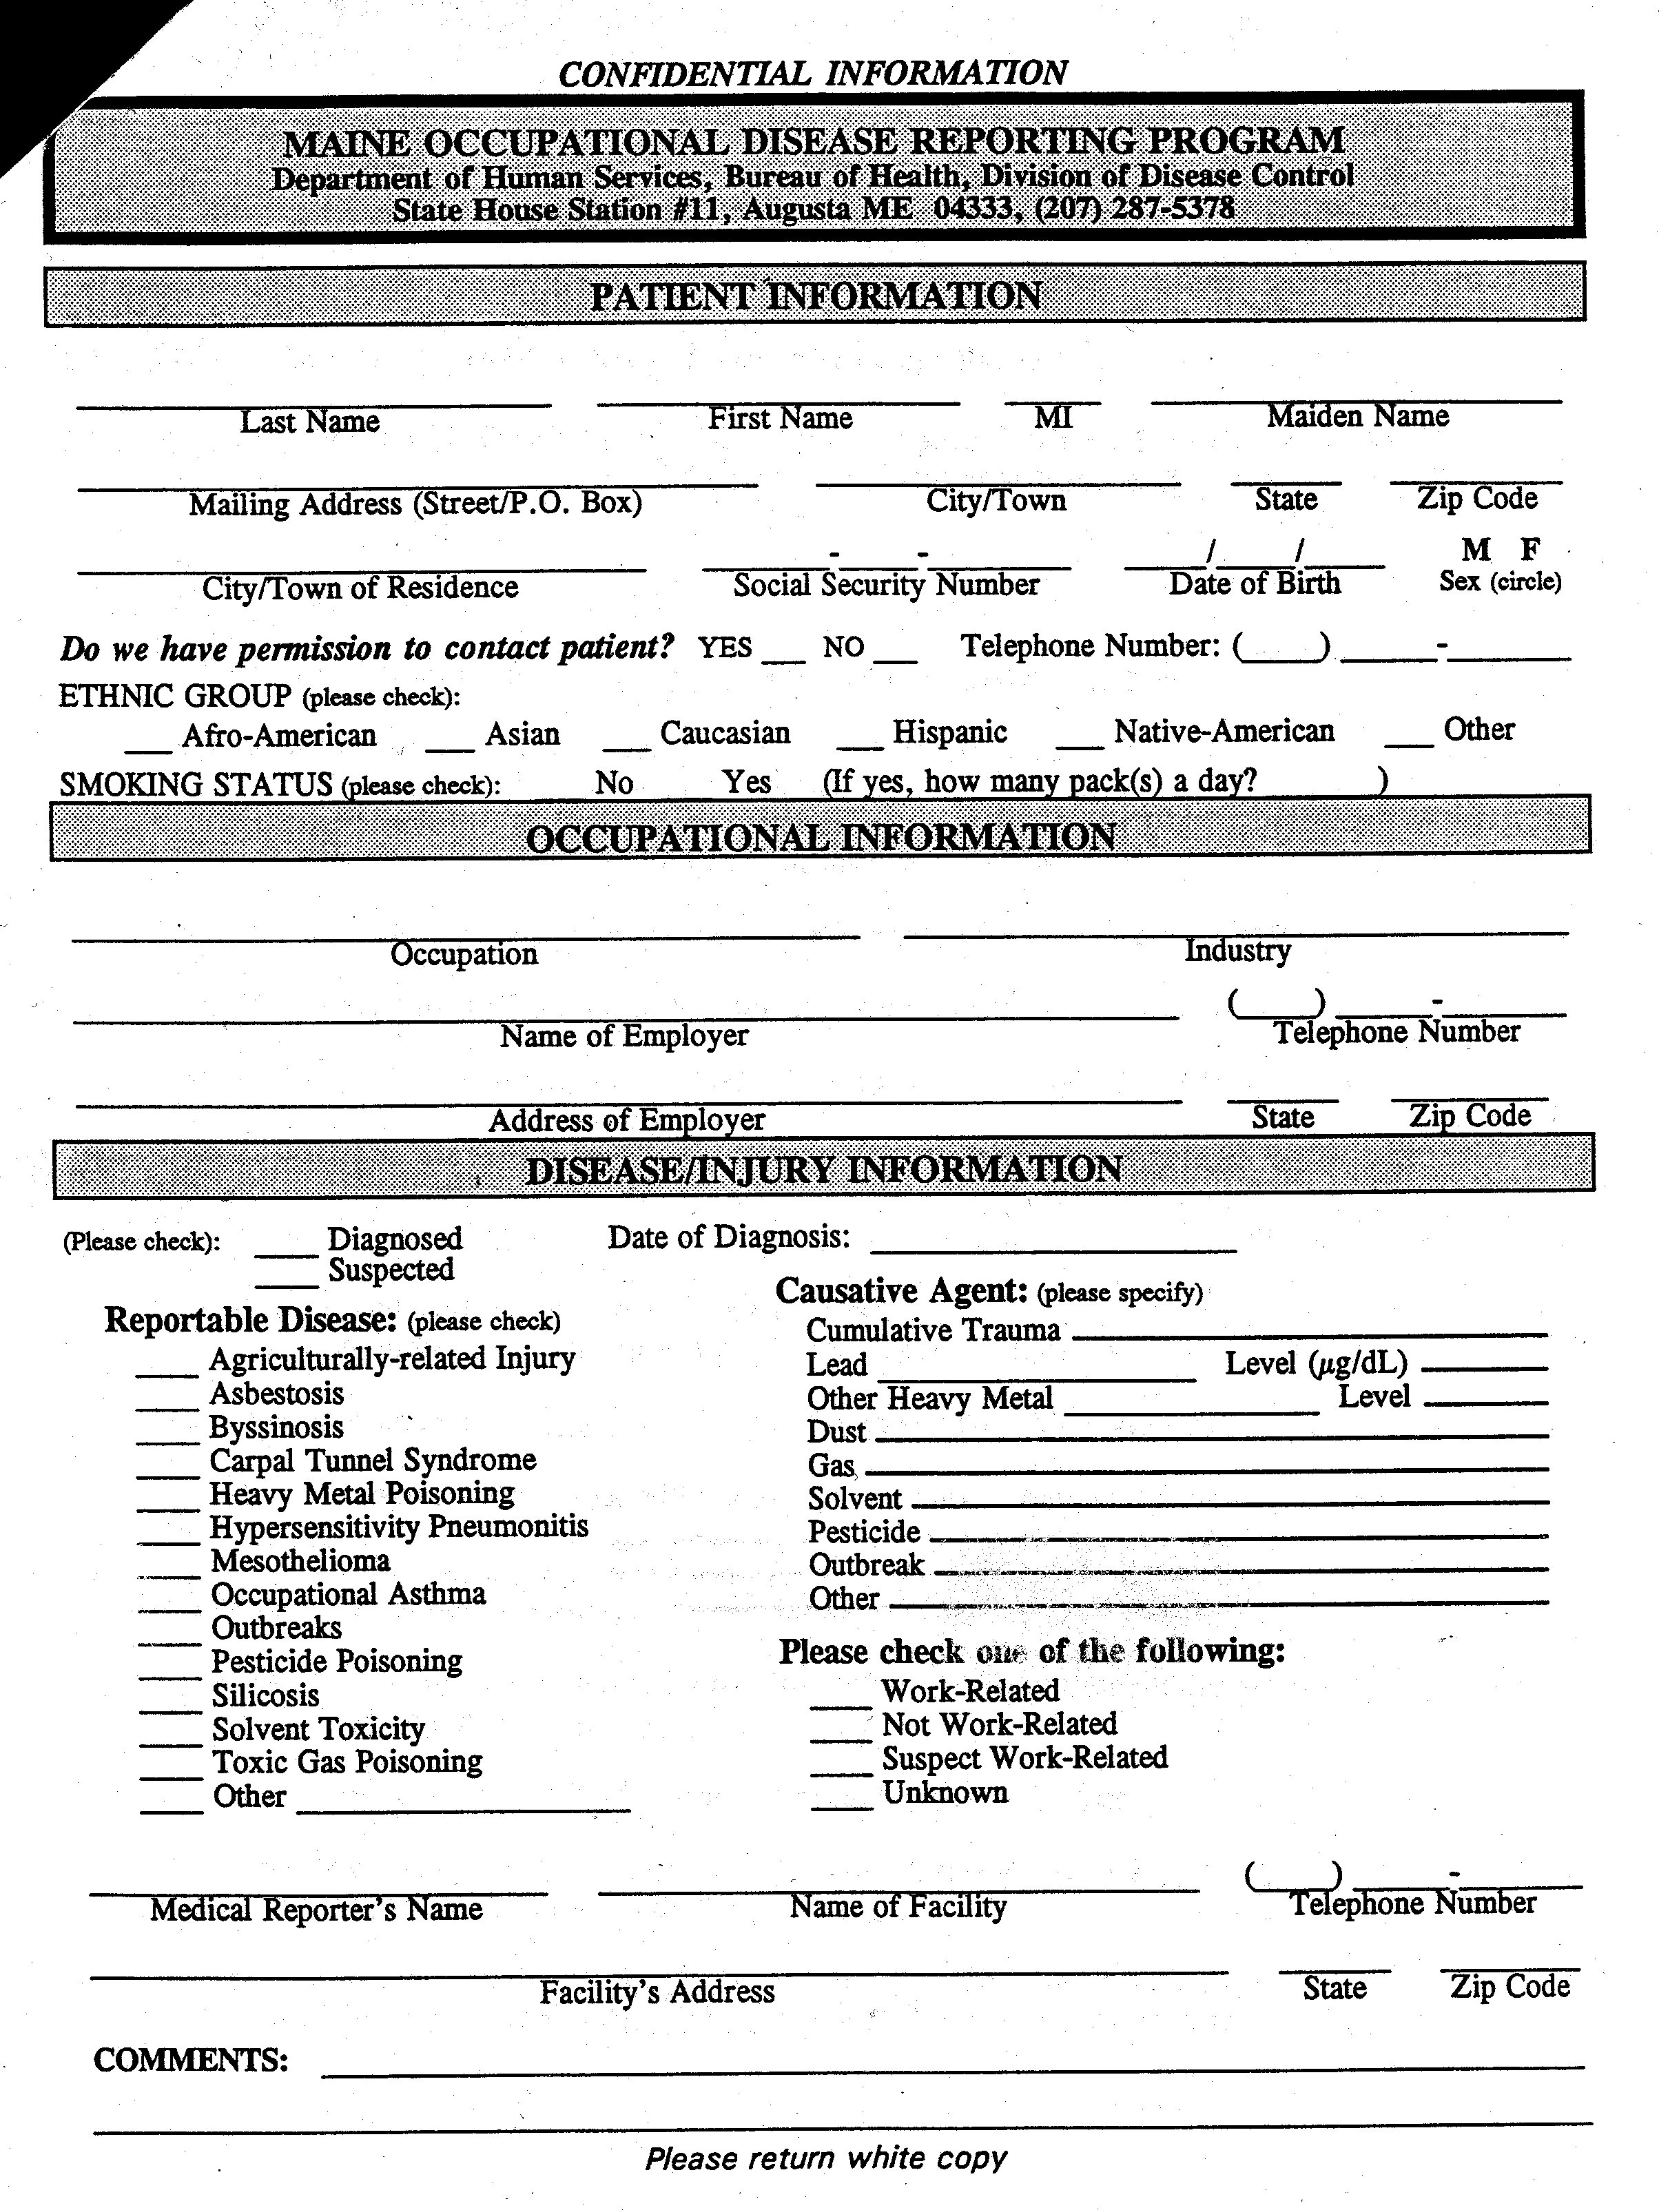

STATUTORY AUTHORITY: 22 M.R.S.A., Section 1491

EFFECTIVE DATE:
March 29, 1986

AMENDED:
November 14, 1989
September 26, 1994, filing 94-389

EFFECTIVE DATE (ELECTRONIC CONVERSION):
May 5, 1996

