17 DEPARTMENT OF TRANSPORTATION

229 OFFICE OF THE COMMISSIONER

Chapter 205: RULES FOR ADMINISTERING THE MAINE TRAVELER INFORMATION SERVICES ACT

SUMMARY: This rule establishes the requirements for the installation and maintenance of official business directional signs, categorical signs and on-premise signs on public ways throughout the State. This Rule sets forth comprehensive standards for eligibility, location, number, design, size, maintenance and permit procedures for the installation and maintenance of such signs.

Section 1. DEFINITIONS

- Categorical sign. A sign bearing a non-commercial message that may be placed in the right of way or adjacent to the right of way with the consent of the property owner under the restrictions set out in Sections 3 and 4 below.

- Clear zone. The total roadside border area, starting at the edge of the traveled way, available for safe use by errant vehicles. This area may consist of a shoulder, a recoverable slope, a non-recoverable slope, and/or a clear run-out area. The desired minimum width is dependent upon corridor priorities, traffic volumes and speeds and on the roadside geometry. Simply stated, it is an unobstructed, relatively flat area beyond the edge of the traveled way that allows a driver to stop safely or regain control of a vehicle that leaves the traveled way. Clear zone distances are defined by the latest MaineDOT Engineering Instructions.
- Commissioner. The Commissioner of the Maine Department of Transportation, as appointed pursuant to 23 M.R.S. §4205.
- Deadly fixed object. Any natural or man-made structure that does not give or break away when hit by a motor vehicle. Examples of deadly fixed objects are trees, ledge, boulders, decorative granite, steel beams, mailbox and sign posts that do not give or break away and planters over 4 inches tall.
- Department. The Maine Department of Transportation. (Also known as MaineDOT)
- General service symbol. A design used to identify traveler services approved for use by the Manual on Uniform Traffic Control Devices or by the Department as set forth in Appendix, Figure 1.
- Island and Median. A traffic control feature used to physically divide or guide traffic in the roadway or within a driveway/entrance to limit access onto the roadway. An island or median can be raised using curbing or flush to the level of the roadway.
- Non-profit historical and cultural institution. A non-profit institution within the state having regular published hours of operation which engages in the cultural, intellectual, scientific, environmental, educational or artistic enrichment of the people of this state, including, but not limited to, aquaria, botanical societies, historical societies, land conservation organizations, libraries, museums, performing arts associations or societies, scientific societies, wildlife conservation organizations and zoological societies. For purposes of this rule, “institution” is defined as a building structure used to house an organization engaged in the activities listed above, “cultural” is defined as the beliefs, customs, arts of a particular society, group, place, or time, and “historical” is defined as the political, social, cultural, and economic setting for a particular idea or event. A municipal body politic and educational institutions or organizations primarily engaged in religious or sectarian activities do not meet the purposes or intent of this definition.
- Non-profit organization. A charitable organization that fosters cultural and social unity to achieve objectives related to public service that has a certificate of good standing as a 501(c)(3) organization from the Internal Revenue Service.
- National Highway System. National Highway System: A portion of the roadway system in Maine deemed to carry inter-state and inter-regional traffic. These roads will be the latest roads shown as NHS in the MaineDOT Mapviewer. Mapviewer can be found at http://medotmaps.maine.gov/MapViewer/
- Official Business Directional Sign. A sign in the state’s right of way licensed by the Department upon application by an eligible business under the restrictions set out in section 2 below. Also known as an OBDS sign.
- Intracommunity/Wayfinding Signs. A system of directional signs that provides general information to inform both motorists and pedestrians of destinations within the local area.
- Point of Interest. A building or facility where a business is carried on or practiced. A point of interest may include storage areas, warehouses and other auxiliary structures or fixtures.
- Public Right of Way. The land shown in a state, county or town roadway layout plan, or in the absence of any layout or monumentation, the land established by roadway use which is considered either the toe of slope in fill sections or the upper back-slope of the ditch in ditch sections. The width of most roadways will be a minimum of 33 feet from the centerline.
- Real Estate Sign. A sign that advertises a property for sale that has been placed by a realtor, real estate agency and/or the owner of the property.
- Sandwich Board. A pair of signboards fastened at their tops and separated at their bases to form a freestanding structure intended for sidewalk or roadside advertising.
- Sight distance. A continuous, unobstructed sight line of sufficient distance needed for a vehicle operator to see an approaching vehicle in order to make a turning maneuver safely. Sight distance measurements are as defined in the Department’s Chapter 299 Highway Driveway and Entrance Rules.
- Sign assembly. A sign assembly is one or more signs on a sign support.
- Temporary On-Premise Sign. A sign installed outside the Right of Way that promotes or advertises for a commercial entity that is performing work on the property.
- Temporary Sign. A sign bearing a noncommercial message that has been placed within the public right-of-way for a limited period of time.
- Travel lanes. The portion of the roadway used for carrying through traffic. For the purpose of these rules, a center two-way left turn lane is considered a travel lane.

Section 2. OFFICIAL BUSINESS DIRECTIONAL SIGNS
After January 1, 2020, applications for non-reflective Official Business Directional Signs are no longer being accepted.
- Sign Eligibility. To qualify for an official business directional sign, the applicant must be one of the following:

  - A lawful business;
  - A point of interest; or
  - A cultural, historic, recreational, educational or religious facility
- Location Requirements and Maximum Number of Signs Allowed

  - General Requirements
    - Signs shall be located within the public right-of-way on approaches to intersections where travelers must change direction from one travel way to another, or at a defined decision point where the motorist must make a decision to leave a roadway to enter a separately named roadway, to reach a business, service, or point of interest, or where appropriate at requested intersections.
    - A business, point of interest, or facility shall not be permitted more than one sign at any one intersection approach. Each place of business, point of interest or facility shall be eligible for a maximum number of six official business directional signs.
    - Destinations having a supplemental guide sign on the interstate and not located on the roadway where the ramps intersect are required to have OBDS continuity signs. These signs do not count toward the overall maximum number of signs described in sub-¶ (2) above.
    - The place of business, point of interest or facility must be within a ten mile radius of the proposed location of the sign.
    - Signs shall be located so as to avoid visual conflict with other signs, to have the least impact on the scenic environment and to take advantage of the natural terrain. Signs shall not be permitted at locations where the directional information contained thereon may be misinterpreted, misleading, or otherwise confusing to the traveling public.
  - Interstate and Controlled Access Highways
Signs shall not be permitted within the right-of-way of the interstate highway system and fully controlled access highways.
  - Lateral Clearances and Vertical Clearances

Lateral and vertical clearances shall conform to the MUTCD.

  - Intersection Sign Placement
    - Signs must be within 2,500 feet of the intersection where a change in direction is required unless a waiver is issued in accordance with this rule.
    - Signs shall be located so as not to interfere with, obstruct, or divert a driver's attention from a traffic control sign or device. Traffic control signs or devices placed at intersection approaches subsequent to the placement of official business directional signs shall have precedence as to location and may require the relocation of official business directional signs. Unless traffic safety is not adversely affected, official business directional signs in general shall be at least 200 feet from traffic control signs or devices.
    - In order to provide continuous guidance to the motorist, if a change in direction is necessary, or if there is a road designation change at any intersection within the direct route to the business that is located between an OBDS sign and the business location, the applicant shall be required to provide additional OBDS at those intersections, not to exceed the maximum allowable number of signs described within section (b).
    - Successive sign assemblies shall be spaced sufficiently apart for drivers to comprehend the messages contained thereon.
  - Official Business Directional Sign Assemblies
There shall be a maximum of three signs per assembly and each sign shall be mounted three inches from the next sign below or above it. Reflectorized and pre-existing non-reflectorized signs may exist on the same sign assembly.
- Materials

Sign panel material shall be high density overlaid plywood a minimum of one-half inch thick or other comparable material. All material furnished under this Section shall be durable and weather resistant. MaineDOT is not responsible for sign material that does not meet these criteria.

- Reflectorized Signs

  - General
    - Reflectorized signs shall be standard in design, color, and reflectorization.
    - Sign legends shall be specific in identifying the name of the appropriate business or other service. Messages, symbols, and logos which interfere with, imitate, or resemble any official traffic control device or serve to advertise rather than identify a business are prohibited.
  - Size
    - Sign sizes, layout, and letter sizes shall conform to the dimensions and details shown in Appendix, Figure 2. To protect highway safety and visual quality, the Department may require signs to be smaller than 12 by 48 inches for certain intersections and areas.
    - Sign sizes at particular locations must be consistent with the visual and aesthetic character of those locations and with sign sizes which have been previously approved.
    - Signs erected prior to the enactment of these rules are not required to meet the new size standards outlined under this sub-section. Replacement of those signs must comply with the new size standards.
  - Color
    - The background color of all signs shall be blue and shall be in accordance with MUTCD Color Specifications (23 CFR §655) Blue-294.
    - All legend and border of all signs shall be white. The edges and back of the signboards shall be sealed and painted a dark shade of brown.
    - Signs erected prior to the enactment of these rules are not required to meet the new color standards outlined under this sub-section. Replacement of those signs must comply with the new color standards.
  - Lettering and Layout
    - All lettering used in the name of the business or service, including the directional legend, shall be Helvetica Bold or Highway Series, Gothic, E Modified font, medium lower-case lettering with initial upper-case. Letter sizes and number of characters per line within the legend shall be as shown in Appendix, Figure 2.
    - The logo or symbol, if used, shall be located on the opposite end of the sign from the directional arrow. Text may be used in lieu of a symbol or a logo within this section of the sign
    - Layout of the signboard and legend including the logo or symbol shall conform to good graphic layout practices.
  - Symbols and Logos
A symbol or logo may be used at the owner's option and may be of any color or colors. If a symbol is used, it shall be identical to the appropriate design as set forth in Appendix, Figure 1. In addition, a specific business logo or text may be used instead of a symbol or logo within the logo section of the sign.
  - Reflectorization
    - The background, sign legend, and border of all signs shall be reflective with high intensity prismatic reflective sheeting with clear overlay and transparent ink to display the same shape and color for both day and night. Reflective sheeting shall consist of a smooth, flat exterior film with spherical glass lens elements embedded beneath the surface and a pre-coated adhesive backing protected by a removable liner. Reflective sheeting must be of a “Federal ASTM-D-4956-99” or “ASTM-D-4956-07” rating. Vinyl overlay is not permitted.
    - Illumination by special interior or exterior supplemental lighting is not permitted.
  - Installation and Maintenance
    - Official business directional signs shall be furnished by the owner or the applicant. The signs shall be installed by the Department at approved locations on sign posts furnished by the Department. The Department shall be responsible for maintenance of the sign supports.
    - Signboards that become lost, stolen, defaced, or otherwise damaged or deteriorated shall be replaced by the owner and reinstalled by the Department. All replacement signs shall meet the current standards of this section.
    - The owners of Official Business Directional Signs that represent businesses, service facilities, or points of interest no longer offering such traveler assistance, or of signs that are no longer applicable because of business name changes, business relocations, or for any other reason, shall notify the Department so that such signs can be removed.
    - Failure to properly maintain the OBDS sign panel by the owner or to notify the Department if OBDS sign is no longer applicable will result in removal of the sign by the Department.
- Businesses or organizations that have an OBDS sign removed because of failure to maintain an active OBDS account due to non-payment shall have no expectation that the former sign location on an OBDS post will be available after any potential reactivation of the cancelled account. In cases where there are waiting lists for the placement of OBDS signs, the Department may deny an appeal to reactivate a lapsed OBDS account and refuse to issue a reinstallation permit.

- Waiver Provisions

  - Whenever the Commissioner determines that the standards for sign assemblies as set forth above will adversely affect highway safety at an intersection or the visual quality of the immediate neighborhood, the Commissioner may impose more stringent standards including prohibition.
  - Whenever the Commissioner determines that a change in the distances, number of signs per assembly, and number of assemblies at an approach to an intersection will not interfere with highway safety nor adversely impact the visual quality of the immediate neighborhood, the Commissioner may waive the requirements contained in Distances and OBDS Sign Assemblies.
  - The Commissioner may waive the specific requirements for location and number of OBDS signs if an applicant can show unusual hardship due to conditions of topography, access or other physical characteristics.
  - In place of Official Business Directional Signs, the Commissioner may order the installation of an Official Information Center to be located within a reasonable distance of the intersection. Once such a center is established, no OBDS sign shall be permitted at such intersection.
  - The Commissioner shall designate to the State Traffic Engineer of the Department the authority to exercise the responsibilities of this section.
- Seasonal Basis

The owner of a business, service, or point of interest that is temporarily or seasonally closed may cover the OBDS sign during the off-season. The cover must be held firmly in place so as not to injure or deface the signboard.

- Administration

This section governs the review and approval of applications, municipal certification requirements, fees for initial applications and for sign renewals, non-transferability of licenses, and variance provisions.

  - Applications
    - Application for an Official Business Directional Sign shall be made on forms furnished by the Department. Applications will be processed and permits issued in the order of receipt of applications by DOT.
    - Any application for an Official Business Directional Sign is subject to review by the Department. The Department shall have final responsibility and authority to determine the specific size and location of any OBDS sign. Signs not deemed to meet the intent and purpose of the law or the criteria established in these regulations shall not be approved or erected.
    - Businesses or organizations that have an OBDS application on a waiting list and have been notified by MaineDOT that they have become eligible for an OBDS sign installation at the requested intersection must submit all necessary applications and required fees within 30 days of the notification. Failure to submit all necessary applications and required fees within 30 days will result in elimination from the waiting list.
  - Conformity with Laws
    - The applicant for an Official Business Directional Sign shall provide certification from an appropriate municipal official that the proposed sign is in conformity with all applicable municipal sign ordinances, unless the OBDS sign is needed for continuity signage for supplemental interstate guide signs or interstate logo signs
    - A municipality may not deny OBDS signage to a business located in another municipality if there is sufficient space to place the sign at any given intersection. The municipality may impose color and size restrictions on any OBDS within their municipality.
  - Application Fees
A $30 refundable application fee will be required for each requested OBDS sign. Applications fees will be used as payment for the first year of program membership for approved applications. Application fees that are submitted with applications that are not ultimately approved will be refunded. MaineDOT shall notify the business if applications are denied for any reason.

  - Renewal Fees
    - Permits for business directional signs are to be renewed annually at a fee determined by the Commissioner.
    - Failure to pay renewal fees within ninety days from the initial billing will result in removal of OBDS signs by the State. Renewal fees are not refundable for installations of less than a full year.
    - A $30 reactivation fee per sign will be charged to businesses/organizations that apply to reactivate a cancelled account. This fee is in addition to the renewal fee.
  - Non-transferability
Permits for the installation of directional signs are not transferable except in the following cases: Business name change, with same ownership; new ownership, but same business name; or change of legend with same ownership.
- Reconsideration
Any interested party with standing (as defined by Maine Law) may request reconsideration of a licensing decision by the State Traffic Engineer, but must do so in writing within 30 business days after notice of the Department’s licensing decision.

The request for reconsideration must set forth the findings and conclusions of the Department to which the person objects, the basis of those objections, the nature of the relief requested, and whether a hearing is requested. If requested and if the State Traffic Engineer determines a hearing is warranted, a hearing will be held ordinarily within 15 business days of receiving the reconsideration request.

The State Traffic Engineer will issue a written decision, ordinarily within 15 business days of receiving the reconsideration request or, if a hearing is held, within 15 business days of the close of the hearing. The decision will set forth the State Traffic Engineer’s reasons for either affirming or modifying the original licensing decision.

The running of the time for appeal pursuant to Part 9 of this rule and the Administrative Procedure Act is tolled by a timely request for reconsideration filed under this section. The full time for appeal commences and is computed from the date of the final Department action addressing the request for reconsideration. The filing of a request for reconsideration, however, is not an administrative or judicial prerequisite for the filing of an appeal under Part 9.
- Appeals
Appeal of final decisions of the State Traffic Engineer must be made in writing to the Commissioner within 15 business days of notice of the licensing or reconsideration decision (whichever is later) of the State Traffic Engineer. The appeal decision of the Commissioner or his or her designee will be considered final agency action.

Judicial review of such final agency action must be in accordance with the Maine Administrative Procedure Act, 5 M.R.S. §11001, et seq. and Rule 80C of the Maine Rules of Civil Procedure.

SECTION 3. CATEGORICAL SIGNS LOCATED WITHIN THE PUBLIC RIGHT OF WAY

- General Requirements. The following signs may be erected and maintained within the public right of way without license or permit so long as they conform to the specifications set forth in Table 1:
Table 1 – Categorical Signs Located Within the Public Right of Way

Categorical Signs | Allowed sizes and locations
Signs erected by a duly constituted governmental body. | Municipal “Gateway” signs may not exceed a maximum of 50 square feet not including decorative frame.
Signs located on or in the rolling stock of common carriers, except those which are determined by the Commissioner to be circumventing the intent of this chapter. Circumvention shall include, but not be limited to, signs which are continuously in the same location or signs that extend beyond the height, width or length of the vehicle. | The size of the sign may not exceed the height, length or width of the vehicle.
Signs on registered and inspected motor vehicles, except those which are determined by the Commissioner to be circumventing the intent of this chapter. Circumvention shall include, but not be limited to, signs which are continuously in the same location or signs that extend beyond the height, width or length of the vehicle. | The size of the sign may not exceed the height, length or width of the vehicle.
Signs identifying stops or fare zone limits of motor buses. | 260 square inches
Hand-held or similar signs not affixed to the ground or buildings. | Allowed within the public right of way and on islands medians greater than 6 feet in width.
Temporary Signs may be erected in the right of way for up to six (6) weeks between January 1st and June 30th and for six (6) weeks between July 1st and December 31st each year. | A Temporary Sign may not be placed within 30 feet of another temporary sign bearing the same or substantially the same message. A Temporary Sign may not exceed 4 feet by 8 feet in size and must include or be marked with the name and address of the individual, entity or organization that placed the sign within the public right-of-way and the date the sign was placed within the public right-of-way.
- Location
  - Categorical Signs
Categorical signs shall be located so as to avoid visual conflict with other signs, to not obstruct sight distance for motorists, to not obstruct pedestrian facilities, to have the least impact on the scenic environment, and to take advantage of the natural terrain. Categorical signs are not allowed on any islands 6 feet or less or in the internal center islands in a rotary or modern roundabout.
  - Interstate and Controlled Access Highways
Categorical signs are not allowed within the limits of a Controlled Access Highway.
  - Lateral Clearance
Except as noted in Table 1, the near edge of Categorical signs shall be located at least ten feet outside the highway shoulder except that in areas where insufficient right-of-way exists to maintain this clearance, or where physical obstructions make such a distance impossible, the near edge shall be located the maximum practical lateral distance from the edge of the traveled way. In urban areas signs shall be a minimum of at least one foot from the curb face.
  - Sign Placement
Categorical signs shall not be mounted on a post containing a traffic control sign or device, a public utility pole or fixture, a rotary or roundabout center traffic island, a tree in a public right-of-way, or within a control-of-access area or any island/median less than 6 feet wide.

  - Categorical Sign Assemblies
The Department reserves the right to require entities allowed signage to share sign posts if there is insufficient room to install sign assemblies.

  - Vertical Distances
Sign assemblies (except Temporary Signs) shall be erected so as to provide a minimum of five feet vertical clearance between the lower edge of the bottom sign and the surface of the highway. Signboards located near pedestrian facilities such as sidewalks and parking areas shall have a vertical clearance of seven feet.

  - Materials

    - Sign panel material shall be high density overlaid plywood a minimum of one-half inch thick, standard aluminum blanks or other material sufficiently stable not to deform under normal conditions of weather and use. All materials furnished under this Section shall be durable and weather resistant.

    - No sign and/or support shall constitute a Deadly Fixed Object.

  - Installation and Maintenance

- Categorical signs are considered private signs and are not installed or maintained by the Department. Entities installing signs pursuant to this subsection are required to notify Dig Safe. Any sign not properly maintained for plumbness or quality shall be removed by the Department. The Department shall have the sole decision making authority as to when a sign does not meet the above criteria.

- All categorical signs installed in the Public Right of Way shall be installed in compliance with 23 MRSA Section 3360-A, Protection of Underground Facilities (a.k.a. “The Dig Safe® Law”) which requires notification to various entities at least three working days prior to making any excavation. Additional information may be found at: http://mutcd.fhwa.dot.gov , http://www.osha.gov/SLTC/trenchingexcavation/, and http://www.digsafe.com respectively.
- MaineDOT Policy on Special Intra-community Signs and Community Way-Finding Signs

Special service signs for local information within individual communities may be erected on State or State Aid highways provided the following conditions are met:

- Requests for signs

Requests for signs must be made by the municipal officers of the town or city where signs are to be erected.

- Eligible Facilities

Signs shall be limited to directing traffic to locations of special interest which include the following:

      - Hospitals which provide emergency service 24 hours each day

      - Public transportation facilities including airports, railroad stations, bus terminals and ferry terminals.

      - Public recreation facilities such as beaches, parks, sport arenas, scenic areas and historical sites.

      - Municipal sub-divisions such as central business districts and villages within municipal boundaries. (i.e. industrial parks, business parks, etc.)

      - Governmental buildings or agencies such as City Halls, county buildings, schools, armories and fire/police stations.

      - Colleges and Universities

- Exclusions

Intra-community wayfinding signs for commercial establishments shall not be permitted.

- Design of Signs

Signs governed by this section shall be rectangular in shape with a white legend on a green background, although white legend on blue background and white legend on brown background may be acceptable at the sole discretion of the Department. The maximum length shall be 48 inches and maximum letter size shall be 4 inches. No more than three lines of copy shall be permitted on one design. Intra-community signs that are intended to direct tourists and other road users to key civic, cultural, visitor and recreational attractions and other destinations shall be made with retro-reflective material (ASTM sheeting type III or greater). Intra-community signs intended to direct pedestrians shall be made with non-reflective materials.

Signs governed by this section must comply with the standards found in the Manual on Uniform Traffic Control Devices (MUTCD) Section 2D.50 Community Wayfinding Signs.

- Installation of Signs

Signs governed by this section shall be provided and installed by the local municipal officials. All sign installations within the MaineDOT designated clear zone shall be on posts considered to be breakaway and shall meet all safety standards required by MaineDOT. The vertical and lateral clearances of such signs shall conform with section 2A-19, 2A-20 and 2A-21 of the “Manual on Uniform Traffic Control Devices”. The signs shall not be erected in conjunction with, nor be in conflict with, official highway signs.

All Categorical Signs installed in the Public Right of Way shall be installed in compliance with 23 M.R.S. Section 3360-A, Protection of Underground Facilities (a.k.a. “The Dig Safe® Law”) which requires notification to various entities at least three working days prior to making any excavation. Additional information may be found at: http://mutcd.fhwa.dot.gov , http://www.osha.gov/SLTC/trenchingexcavation/, and http://www.digsafe.com respectively.

- Restrictions

Special intra-community service signing shall not be permitted on Interstate highways or expressway systems.

SECTION 4. CATEGORICAL SIGNS LOCATED OUTSIDE OF THE PUBLIC RIGHT OF WAY

- General Requirements. The following signs may be erected and maintained by individuals or entities with demonstrated authority/ eligibility to seek signage outside of the public right of way with the consent of the property owner without license or permit so long as they conform to the specifications set forth in Table 2:

Table 2 – Categorical Signs Located Outside of the Public Right of Way
Categorical Signs Outside the Right of Way | Allowed sizes
Non-commercial signs can be installed outside of the public right of way. | 50 square foot maximum.

- Location of Signs – Outside of the Right of Way

- General Requirements
These signs must be located outside of the Public Right of Way with the consent of the property owner.

- Interstate and Controlled Access Highways
All sign entities shown in Table 2 shall not be installed so that the signs are readable anywhere along the limits of a Controlled Access Highway.

- Prohibited practices

None of the signs referred to in this section may be erected or maintained on any traffic control signs or devices, public utility poles or fixtures or upon any trees. None of these signs may be painted or drawn upon rocks or other natural features.

SECTION 5. ON-PREMISE SIGNS

- Sign Eligibility
To qualify for an on-premise sign, the applicant must be one of the following:
  - A lawful business;
  - A point of interest; or
  - A cultural, historic, recreational, educational or religious facility on the land which the sign is being requested.
- Location of On-Premise Signs
  - On-premises signs must be located outside the state’s right of way on the property of the entity placing the sign. Signs for each business on a property shall not number more than 10.
  - On-premises signs shall be located within 1,000 feet of the principal building or structure where the business or facility is carried on or practiced or within 1,000 feet of the point of interest. Storage areas, warehouses and other auxiliary structures and fixtures are deemed to be buildings where the business, facility or point of interest is carried on or practiced.
  - Location, relation to public way. On-premises Unless a license is obtained from the Commissioner pursuant to this subsection, on-premises signs are prohibited:

- Within 33 feet of the center line of any public way;
- Within 20 feet from the outside edge of the paved portion of any public way with more than 2 travel lanes and a total paved portion in excess of 24 feet in width; and
- Within the full width of the right-of-way of any public way.
- Temporary On-Premise Signs - Temporary on-premises signs are allowed for projects such as roofing, landscaping; to include mowing, masonry, moving, building construction or site work that will be completed within a specific duration of time. Temporary On-Premise signs are allowed to be displayed only after the contactor has commenced work on the site. All temporary on-premises signs shall be immediately and permanently removed when the overall project has been completed. Entities that install temporary On—Premise signs that are in violation of this chapter will have 24 hours to comply, also see Section 8 below, Penalties and Enforcement.
- Real Estate Signs- Real Estate signs are allowed to be erected only on property that is for sale. The erection of real estate signs at off-premises locations for directional purposes is prohibited.
- A sign may be installed outside of the right of way but within the boundaries listed within 2.C. (1), (2), if the sign has been granted a license and is installed with a Department approved breakaway system within the sign frame.

- Sandwich Board Signs. Sandwich Board signs are generally not allowed within the Right of Way. If a municipality passes an ordinance to allow Sandwich Boards in the Right of Way contiguous to an business entity, that municipality may grant a waiver for an entity to place a sandwich board sign in front of its property if the sign is set-up and removed daily, is outside the clear zone, does not obstruct the flow of pedestrian travel and placement on the sidewalk still allows ADA standards to be met.

- Licensing Provisions

All license requests pursuant to 23 M.R.S. section 1914 (4) will be reviewed by a panel comprised of MaineDOT personnel that may include the Designee of the Chief Counsel, the State Traffic Engineer, the appropriate Region Engineer, the Right of Way Technician and a Field Investigator. The panel will issue a recommendation to the Commissioner regarding the issuance of a license.
- An entity may ask for a license to be within the designated standards of sub-§2 (C.) above if the sign is located outside the clear zone;
- Deference will be given to requests for licenses when the majority of business signs within 1,000 feet of the proposed location of the sign for which license is sought are within the right of way or within 20 feet of the edge of pavement or when the width of the right of way where the proposed sign will be placed is sufficiently wide.
- Neither the granting of a license nor the installation of a sign within the public way conveys permanent property rights relating to the public way. The Department of Transportation is not responsible for loss or damage to an on-premises sign licensed under this subsection. An on-premises sign under this subsection may be removed by the Department to accommodate highway uses at any time without compensation to the owner of the on-premises sign and at the owner’s expense.
- Interstate highways

  - Not more than one on-premises sign advertising the sale or lease of the property may be permitted on land adjacent to any portion of the interstate system, including ramps and interchange areas, when that land is visible from any portion of the interstate system.

  - Not more than one on-premises sign visible from any portion of the interstate system, including ramps and interchange areas, may be permitted more than 50 feet from the principal building or structure where the business, facility or point of interest is carried on.

  - No on-premises advertisement located more than 50 feet from the principal building or structure where the business, facility or point of interest advertised is carried on may exceed 20 feet in length, width or height or 150 square feet in area, including border and trim, but excluding supports.

  - Any on-premises sign located more than 50 feet from the principal building or structure where the business, facility or point of interest is carried on that displays any trade name referring to or identifying any service rendered or product sold must display the name of the advertised business, facility or point of interest as conspicuously as such trade name.

  - Businesses abutting the interstate may have up to 10 signs, but only one sign may be visible from the interstate highway.

- On-premises signs prohibited. An on-premises sign is prohibited if it:

  - Attempts or appears to attempt to direct the movement of traffic or interferes with, imitates or resembles any official traffic sign, signal or device;
  - Prevents the driver of a vehicle from having a clear and unobstructed view of official signs and approaching or merging traffic;
  - Contains, includes or is illuminated by a flashing, intermittent or moving lights, except as provided in Subsection 9, below;
  - Uses lighting that is of such intensity or brilliance as to cause glare or impair the vision of the operator of any motor vehicle or to otherwise interfere with any driver's operation of a motor vehicle unless, in the opinion of the Commissioner, the lighting is effectively shielded to prevent beams or rays of light from being directed at any portion of the public way; or,
  - Moves, has any animated or moving parts or has the appearance of movement, except as provided in Subsection 9, below.
- Height

The maximum height of on-premises signs is 25 feet above the ground level of land upon which it is located, or if the sign is affixed to or is part of a building, the maximum is 10 feet above the roof of the building.

- Jurisdiction by local authority in compact areas

Except as otherwise provided in this chapter, administration of this chapter for on-premises advertisements located in compact areas of an urban compact municipality, as defined in section 754, is the responsibility of local authority. In compact areas of an urban compact municipality adjacent to the interstate, the Department of Transportation is responsible for the administration of this section.

- Approach signs

Any business or facility whose principal building or structure, or a point of interest is located on a private way more than 1,000 feet from the nearest public way, or is not visible to traffic from the nearest public way, may erect no more than 2 approach signs with a total surface area not to exceed four (4) square feet per sign. These signs are allowed to be located within the public right-of-way limits within 2,500 feet of the junction of the public and private ways.

- Changeable signs

  - Notwithstanding subsection 5, paragraph C, changeable signs are not prohibited as long as the sign complies with all the terms and applicable provisions of this subsection and rules adopted pursuant to this chapter. The Department of Transportation shall administer the provisions of this subsection, except as provided in paragraph B.

  - The display on each side of a changeable sign
- May be changed no more than once every 20 minutes, unless the municipality in which the sign is located adopts an ordinance to the contrary and notifies the Department of Transportation in writing of that ordinance. If a municipal ordinance is adopted, the municipality is responsible for the administration of that ordinance;
- Must change as rapidly as technologically practicable, with no phasing, rolling, scrolling, flashing or blending, unless the municipality in which the sign is located adopts an ordinance to the contrary and notifies the Department of Transportation in writing of that ordinance. If a municipal ordinance is adopted, the municipality is responsible for the administration of that ordinance. Notwithstanding this subparagraph, a municipality may not adopt an ordinance that allows the sign to flash or display continuous streaming of information or video animation; and
- May consist of alphabetic or numeric text on a plain or colored background and may include graphic, pictorial or photographic images unless the municipality in which the sign is located adopts an ordinance to the contrary and notifies the Department of Transportation in writing of that ordinance. If a municipal ordinance is adopted, the municipality is responsible for the administration of that ordinance.

  - Only one changeable sign with 2 sides is allowed for each public way that provides direct vehicular access to the business, facility or point of interest.
  - Changeable signs may not be located so that the message is readable from a controlled-access highway or ramp.
  - The highest point of the display of a changeable sign may not exceed a height of 25 feet above either the centerline of the nearest public way or actual ground level adjacent to the sign, whichever is lower.
  - Changeable message board signs existing in accordance with the requirements of former subsection 11 continue to exist if the signs:
- Are reasonably incapable of being modified or reprogrammed to comply with this section as amended; and
- Are not replaced, substantially rebuilt, reconstructed or repaired beyond routine maintenance.
  - The size, intensity of illumination and acceptable rate of change between the time display and the temperature display of a time and temperature sign must comply with rules adopted by the Department of Transportation, except that time and temperature signs erected prior to September 29, 1995 need not comply with those rules.

SECTION 6. OFFICIAL TOURIST INFORMATION CENTERS
- Eligibility. In order to be eligible for a sign, the entity must prove that they are acknowledged by the Maine Office of Tourism and must have rest room facilities
- Location Requirements and Maximum Number of Signs Allowed
  - General Requirements
Signs shall be located within the public right-of-way on approaches to intersections where travelers must change direction from one public way to another to reach a business, service, or point of interest or where appropriate at the end of T intersections.
  - Interstate and Controlled Access Highways
Signs shall not be permitted within the right-of-way of the interstate highway system and fully controlled access highways.
  - Lateral Clearances and Vertical Clearances
    - Lateral and vertical clearances shall conform to standards outlined by the Department pursuant to federal highway standards.
    - Signs shall be located so as not to interfere with, obstruct, or divert a driver's attention from a traffic control sign or device.

SECTION 7. PENALTIES AND ENFORCEMENT
Any person, firm, corporation or other legal entity who shall erect, maintain or display a sign contrary to and in violation of this chapter, or the rules and regulations promulgated by the Commissioner, shall be punished by a fine of not more than $100 together with the cost of removal of the signs. The unlawful maintenance or display of each sign or advertising structure for any one day shall constitute a separate offense.
In addition to other penalties, the Department , if the illegal sign is located on a state or state aid highway, or the compact municipality, if the illegal sign is located on a town way or state or state aid highway in an urban compact, may institute any appropriate action, injunction or other proceeding to prevent, restrain, correct or abate any violation of this chapter, or any orders or the rules and regulations issued or promulgated hereunder.

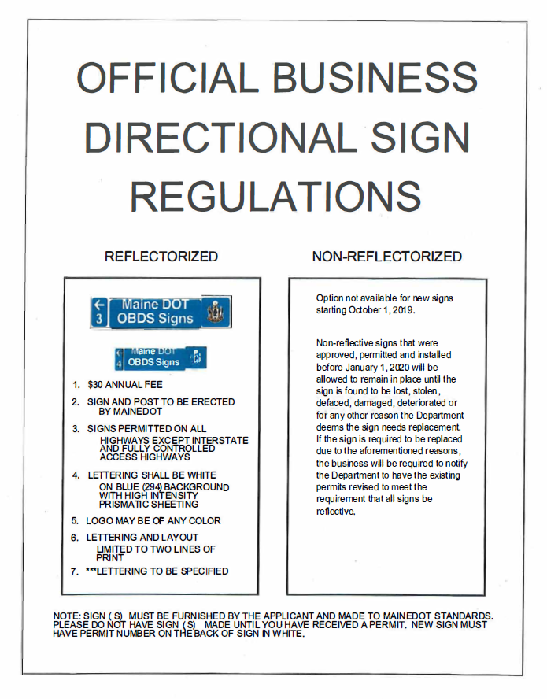

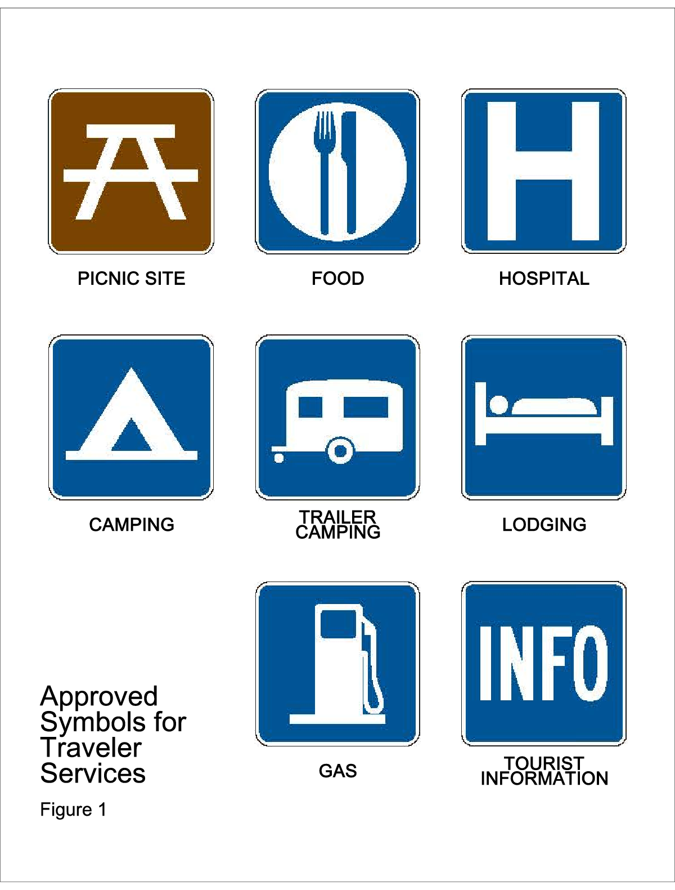
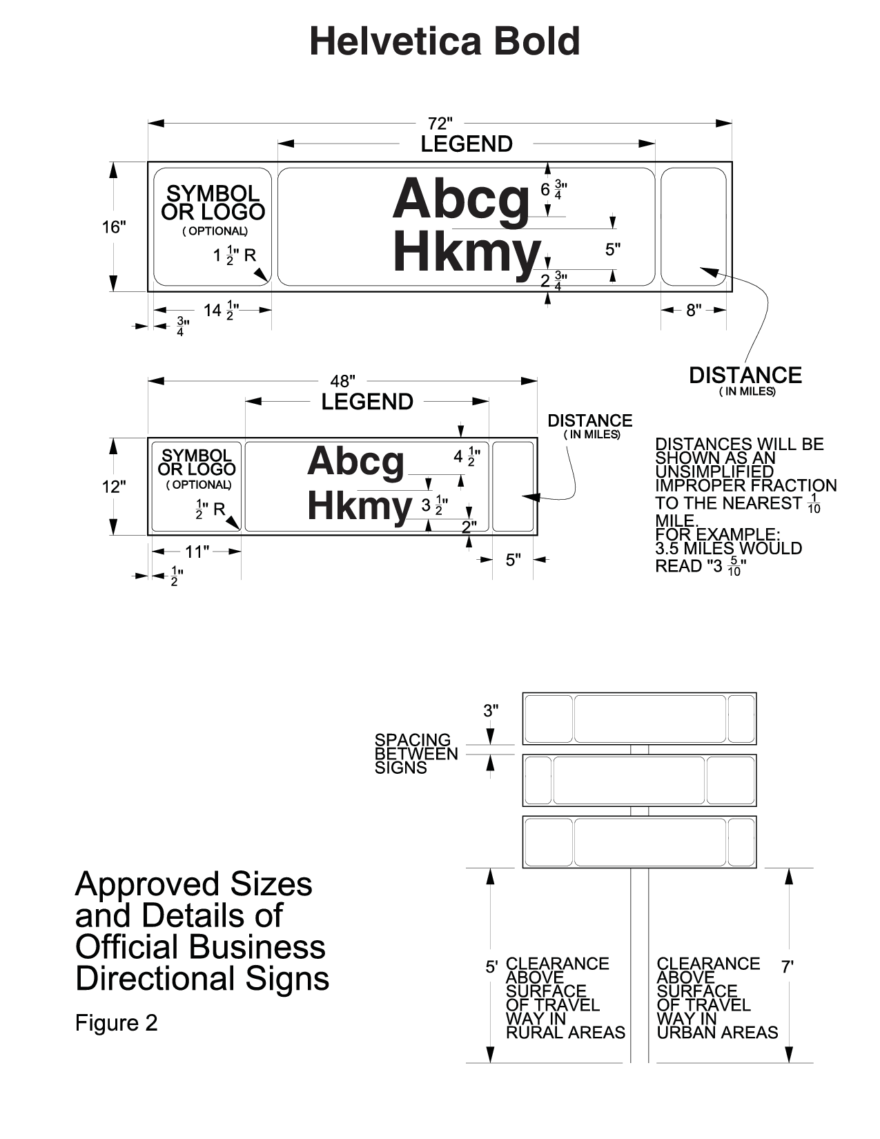
q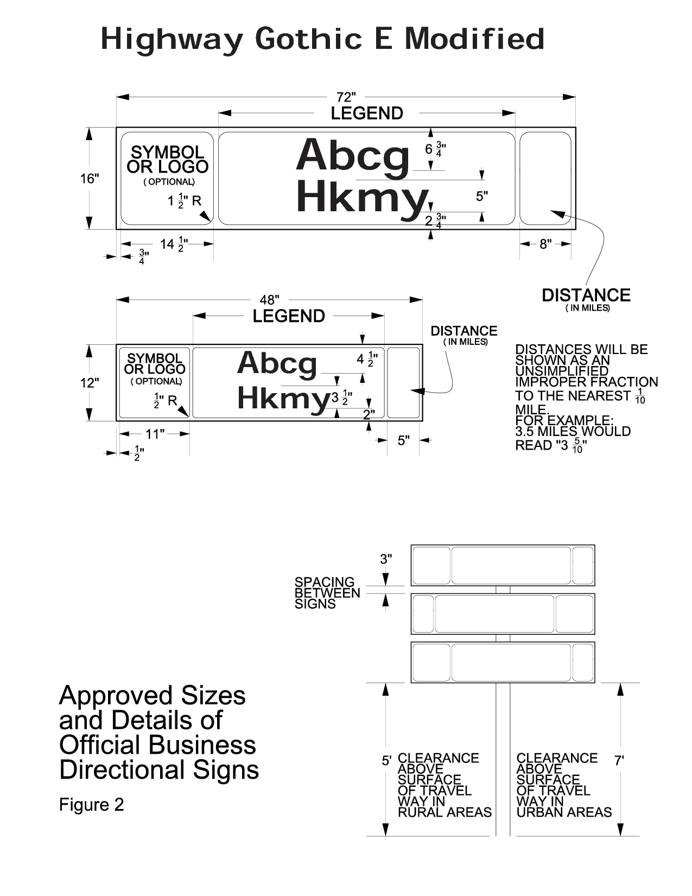

STATUTORY AUTHORITY:
23 M.R.S. §1925, as amended by P.L. 2013 Ch. 529; 23 M.R.S. §52

EFFECTIVE DATE:
July 15, 2015 – filing 2015-128

REPEALED AND REPLACED:
November 8, 2020 – filing 2020-226

