**02 DEPARTMENT OF PROFESSIONAL AND FINANCIAL REGULATION**

**385 MANUFACTURED HOUSING BOARD**

**Chapter 900: USED MANUFACTURED HOME INSTALLATION STANDARD**

**Summary**: These rules are drafted pursuant to 10 M.R.S. §9061 and implement 10 M.R.S. §§ 9062-9070 of the *Maine Manufactured Housing Act*. This chapter sets forth minimum requirements for the installation of used manufactured homes.

**Subchapter A - General**

1. **Administration**

A. **Scope**

These installation standards provide minimum requirements for the installation of used manufactured homes, wherever located in the State of Maine.

B. **Intended Usage for Used Manufactured Homes Covered Under this Standard**

The provisions of this standard are intended to apply to used manufactured homes (single section, multiple section or expanded types) for use as a single family dwelling.

**Note 1:** This standard does not apply to manufactured housing used for other than dwelling purposes.

**Note 2:** This standard does not apply to recreational vehicles as defined in NFPA 1192, *Standard on Recreational Vehicles*, or to park model trailers as defined in the ANSI A119.5, Park Model Recreational Vehicle Standard.

C. **Types of Structures Covered**

The used manufactured homes covered under this standard are defined in Subchapter A(II)(M) to this Chapter.

D. **Applicability**

This standard is applicable only to used manufactured homes and does not apply to state certified modular homes or other types of manufactured dwellings. The standard is designed for the safety and health of manufactured home users. It is intended to apply to all used manufactured homes. This standard provides useful technical data for improvements to existing sites falling within its scope and such is encouraged. However, manufactured housing community pads, which are now licensed, and all homes currently installed on private lots that may not comply with all design and construction standards of these rules, shall be deemed acceptable if capable of being maintained and operated in a safe and sanitary condition. This standard shall not be construed as relieving the installers of a used manufactured home of responsibility for compliance with the manufacturer's installation instructions, state and local ordinances, codes, and regulations. This standard does not relieve the manufactured home owner or occupant from responsibilities for the proper use and maintenance of a used manufactured home.

1. **Definitions**
2. **Anchor assembly**: “Anchor assembly” means any device or other means designed to transfer home anchoring loads to the ground.
3. **Anchoring** **equipment**: “Anchoring equipment” means ties, straps, cables, turnbuckles, chains, and other approved components, including tensioning devices, that are used to secure a manufactured home to anchor assemblies.
4. **Anchoring system**: “Anchoring system” means a combination of anchoring equipment and anchor assemblies that will, when properly designed and installed, resist the uplift, overturning, and lateral forces on the manufactured home and on its support and foundation system.
5. **Data plate**: “Data plate” means an information sheet located in the home

that identifies the manufacturer, serial number, wind zone, roof load zone, and climatic zone for which the home was constructed.

1. **Diagonal tie**: “Diagonal tie” means a tie intended to resist horizontal or shear forces, but which may resist vertical, uplift, and overturning forces.
2. **Footing**: “Footing” means that portion of the support system that transmits loads directly to the soil.
3. **Foundation** **system**: “Foundation system” means a site-built or site assembled system of stabilizing devices which are capable of transferring design dead loads and live loads and other design loads unique to local home sites due to wind, seismic, and water conditions, that are imposed by or upon the structure into the underlying soil bedrock without failure.
4. **Ground anchor**: “Ground anchor” means a specific anchoring assembly device designed to transfer manufactured home anchoring loads to the ground.
5. **HUD**: “HUD” means United States Department of Housing and Urban Development, a federal governmental agency.
6. **Installation**: “Installation” means the placing of manufactured housing on a foundation or supports at a building site and the assembly and fastening of structural components of manufactured housing, including the completed roof system, as specified in the manufacturer’s installation instructions. Installation also includes the connection to existing services, including but not limited to electrical, oil, water, sewage and similar systems that are necessary for the use of the manufactured housing for dwelling purposes.

K. **Installation instructions**:“Installation instructions” means DAPIA-approved instructions provided by the home manufacturer and detail the home manufacturer requirements for support and anchoring systems, and other work completed at the installation site.

1. **Installer**: “Installer” means any licensed manufacturer or dealer or an employee of a licensed manufacturer or dealer, or a person licensed as a mechanic who engages in the process of affixing, assembling or setting up of manufactured housing on foundations or supports at a building site.

M. **Manufactured home**: “Manufactured home” means a structural unit or units designed to be used as a dwelling or dwellings and constructed in a manufacturing facility and then transported by the use of its own chassis to a building site. For purposes of this standard two types of manufactured housing are included. They are:

1. HUD-code homes, which are those units constructed after June 15, 1976 that the manufacturer certifies are constructed in compliance with the HUD standard, meaning structures, transportable in one or more sections that, in the traveling mode, are 8 body feet or more in width and 40 body feet or more in length or, when erected on site, are 320 or more square feet, and are built on a permanent chassis and designed to be used as dwellings, with or without permanent foundations, when connected to the required utilities, including the plumbing, heating, air-conditioning and electrical systems contained therein; except that such term shall include any structure that meets all the requirements of this paragraph except the size requirements and with respect to which the manufacturer voluntarily files a certification required by the Secretary of the United States Department of Housing and Urban Development and complies with the standards established under the National Manufactured Housing Construction and Safety Standards Act of 1974, 42 *United States Code* 5401, *et seq.*;

2. Pre-HUD-code homes, which are those units constructed prior to June 15, 1976, meaning structures, transportable in one or more sections, that are 8 body feet or more in width and are 32 body feet or more in length and are built on a permanent chassis and designed to be used as dwellings, with or without permanent foundations, when connected to the required utilities, including the plumbing, heating, air-conditioning or electrical systems contained therein.

N. **Mechanic**: “Mechanic” means an individual engaged in the installation or servicing of HUD-code or pre-HUD-code homes.

O. **Pad**: “Pad” means that area which has been established for the placement of a manufactured home.

P. **Perimeter blocking**: **“**Perimeter blocking” means regular spaced piers supporting the sidewalls and marriage wall of the home. Some homes require perimeter blocking in addition to supports under the home’s frame.

Q. **Pier**: “Pier” means that portion of the support system between the footing and the manufactured home, exclusive of caps and shims.

R. **Set**-**up**: “Set-up” means the work performed and operations involved in the placement and securing of a manufactured home or any portion thereof and includes the connection of existing electrical, oil, gas, water, sewage, and similar systems.

S. **Shall**: “Shall” indicates a mandatory requirement.

T. **Should**: “Should” indicates a recommendation which is advised but not required.

U. **Site**: “Site” means a designated parcel of land designed for the accommodation of one manufactured home, its accessory buildings or structures, and accessory equipment for the exclusive use of the occupants.

V. **Skirting**: “Skirting” means a weather-resistant material used to enclose the perimeter, under the living area of the home, from the bottom of the manufactured home to grade.

W. **Stabilizing** **devices**: “Stabilizing devices” means all components of the anchoring and support systems, such as piers, footings, ties, anchoring equipment, anchoring assemblies, or any other equipment, materials and methods of construction, that support and secure the manufactured home to the ground.

X. **Support** **system**: “Support system” means pilings, columns, footings, piers, foundation walls, caps, shims, and any combination thereof that, when properly installed, support the manufactured home.

Y. **Tie**:“Tie” means straps, cable, or securing devices used to connect the manufactured home to anchoring assemblies.

Z. **Uncontrolled** **fill**: “Uncontrolled fill” means fill materials that are placed without control of the content of the fill materials or without adequate compaction to assure a bearing capacity without undue settlement. For purposes of this standard, uncontrolled fills shall mean fill materials containing organic matter or fills which are placed without compaction necessary to provide a uniform bearing capacity of 1000 lbs./ft.

AA. **Wind zone**:“Wind zone” means the areas designated on the Basic Wind Zone Map, set forth in the *Manufactured Home Construction and Safety Standards*, part 3280, as further defined in Appendix A to this Chapter.

**Subchapter B - Foundation Systems and Site Preparations**

1. **General**

This subchapter prescribes standards for the installation of manufactured home foundation systems, site preparation, and design. This subchapter is applicable to used manufactured homes, when and wherever newly installed at a home site. Prior to the installation of a used manufactured home the installer is to verify that the design and construction of the manufactured home is suitable for the site location where the home is to be installed.

1. **Wind Zone**

Used manufactured homes must not be installed in a wind zone that exceeds the design wind loads for which the home has been designed, as evidenced by the wind zone indicated on the home’s data plate. Maine wind zones are described in Appendix A to this Chapter.

1. **Roof Load Zone**

Used manufactured homes must not be located in a roof load zone that exceeds the design roof load for which the home has been designed as evidenced by the roof load zone indicated on the home’s data plate. Maine roof load zones are described in Appendix A to this Chapter.

1. **Foundation Systems**

A manufactured home foundation system shall be constructed on each manufactured home site.

**Exception 1**. Sites which have been licensed by the Maine Manufactured Housing Board in accordance with rules governing the licensing of manufactured housing communities prior to March 1, 1993.

**Exception 2**. Sites for the installation of manufactured housing to provide temporary relief from fire, flood or other disasters. The site is exempted from the provisions of Subchapter B for a period of two years from the date of the installation of the home.

1. A foundation system for used manufactured homes shall be constructed in accordance with one of the following:

1. The manufacturer's installation instructions; or

2. Appendix B to this Chapter; or

3. A foundation design prepared by a licensed professional engineer or licensed architect for the site.

1. Homes installed on sites exempted from the requirements of Subchapter B shall be installed and the sites maintained in a manner which is not detrimental to the functions of any of the systems in the home. Homes which require perimeter support/marriage wall support shall be blocked at locations required in the manufacturer’s installation instructions, or Appendix D to this Chapter.
2. **Site Considerations**
3. **Evaluation**

Each site shall be evaluated by the person assuming responsibility to determine if it is suitable for its intended use and if such hazards as flood erosion, sediment deposition, or other hazards exist that might impair the use or utility of the site. When, during preparation of the site, such unforeseen factors as rock formation, high groundwater levels, springs, biologically generated gases, etc., are encountered, corrective works shall be taken during the site preparation of the manufactured home.

1. **Site Drainage**

All drainage must be diverted away from the home and must slope a minimum of one-half inch per foot away from the foundation for the first ten feet. Where property lines, walls, slopes, or other physical conditions prohibit this slope, the site must be provided with drains or swales or otherwise graded to drain water away from the structure.

1. **Soil Considerations**
2. **Footings**

It shall be determined when natural soils or controlled fill (free of grass and organic material) are used, that the footing shall support the loads imposed by the support system of the manufactured home placed thereon.

1. **Anchoring**

Homes installed on sites in Washington and Hancock counties (wind zone II) and are occupied by someone other than the home owner shall be installed with a properly designed anchoring system. Refer to the manufacturer’s installation instructions or Appendix B to this Chapter.

1. **Placement**
2. **Clearance** **Under Home**

A minimum clearance of 12 in. must be maintained beneath the lowest member of the main frame (I-beam or channel beam) and the grade under all areas of the home.

1. **Elevated Manufactured Homes**

When the manufactured home is installed on a basement or split entry type foundation over a habitable lower-level area, or when more than one-fourth of the area of the manufactured home is installed so that the bottom of the main frame members are more than 3 ft. above ground level, the foundation system shall be designed by a licensed professional engineer or licensed architect. Appendix B to this Chapter cannot be used for any elevated installation or in combination with the manufacturer’s installation instructions.

1. **Removal of Manufactured Home Transportation Components at the Time of Installation**

No portion of a manufactured home shall be removed when located on its home site unless it is designed to be removed in accordance with HUD's and the manufacturer's installation instruction.

1. **Crawlspace Ventilation**
2. A crawlspace with skirting must be provided with ventilation openings. The minimum net area of ventilation openings must not be less than one square foot (ft.2) for every 150 square feet (ft.2) of the home’s floor area. The total area of ventilation openings may be reduced to one square foot (ft.2) for every 1,500 square feet (ft.2) of the home’s floor area, where a uniform 6-mil polyethylene sheet material or other acceptable vapor retarder is installed on the ground surface beneath the entire floor area of the home.
3. Ventilation openings must be placed as high as practicable above the ground.
4. Ventilation openings must be located on at least two opposite sides to provide cross-ventilation.
5. Ventilation openings must be covered for their full height and width with a perforated corrosion and weather-resistant covering that is designed to prevent the entry of rodents. In areas subject to freezing, the coverings for the ventilation openings must also be of the adjustable type, permitting them to be in the open or closed position, depending on the climatic conditions.
6. Access opening(s) not less than 18 inches in width and 24 inches in height and not less than three square feet (ft.2) in area must be provided and must be located so that any utility connections under the home are accessible.
7. Dryer vents and combustion air inlets must pass through the skirting to the outside. Any surface water runoff from the furnace, air conditioning, or water heater drains must be directed away from under the home or collected by other methods.
8. **Skirting**
9. Skirting, if used, must be of weather-resistant materials or provided with

protection against weather deterioration at least equivalent to that provided by a coating of zinc on steel of not less than 0.30 oz./ft.2 of surface coated.

1. Skirting must not be attached in a manner that can cause water to be trapped

between the siding and trim or forced up into the wall cavities trim to which it is attached.

1. All wood skirting within 6 inches of the ground must be pressure-treated in accordance with AWPA Standard U1 for Use Category 4A (UC4A), ground contact applications, or be naturally resistant to decay and termite infestations.
2. Skirting must not be attached in a manner that impedes the contraction and expansion characteristics of the home’s exterior covering.

**Subchapter C - Plumbing**

1. **General Requirements**

**Note**: Where this standard differs from the current adopted edition of the *Uniform Plumbing Code* (UPC), the current code shall prevail.

1. **Need for Plumbing and Utility Connections**

Each manufactured home pad shall be provided with water supply and sewer located and arranged to permit attachment to the manufactured home in a workmanlike manner.

1. **Location of Plumbing and Utility Connections**

The plumbing and utility connections shall be located under the manufactured home.

1. **Water Supply**
2. **Water-Riser Pipes, Size, and Protection**

Water-riser pipes shall be a minimum of 3/4 in. nominal diameter. Water-riser pipes shall extend a minimum of 6 in. above ground elevation. Water riser pipes shall be terminated with a threaded plug, hose bib, or cap when a manufactured home does not occupy a site. Surface drainage shall be diverted from the location of the riser pipe.

1. **Water Supply Shutoff Valves**

An accessible shutoff valve shall be provided on the water-riser pipe serving the manufactured home. The system shall be protected from backflow for single family residences on shared wells.

1. **Protection Against Freezing**

Provision shall be made to protect the water supply piping and valves, including the riser.

1. Frost-proof valves shall be installed where necessary and shall be listed for backflow protection.

2. In areas subject to heaving and thawing, the piping shall be adequately protected to prevent damage.

3. Heat cables and tapes, when used for protection of plumbing components against freezing, shall be listed and labeled.

4. Installed in accordance with the manufacturer's instructions and listing requirements.

D. **Location of Wells**

A well shall not be located within the boundaries of a manufactured home pad.

**Subchapter D - Mechanical Equipment**

1. **Exterior Mechanical Equipment**

Mechanical equipment shall not be installed in a manner that would obstruct any means of required egress. Mechanical equipment shall not be installed in window openings which are part of an exiting system and shall not obstruct sidewalks or other means of egress from the home.

**Subchapter E - Fuel Supply**

1. **General**

All fuel piping systems serving manufactured homes, which are not part of the manufactured home shall be designed and constructed in compliance with the rules adopted by the Maine Fuel Board.

**Subchapter F - Electrical**

**Site Electrical Equipment and Installations**

Sites provided with an electrical service shall have all electrical equipment and installations designed and constructed in accordance with the current adopted edition of the National Fire Prevention Association (NFPA) 70, *National Electrical Code*.

**Subchapter G - Life and Fire Safety**

1. **Firebreaks**

No portion of a manufactured home, excluding the hitch, shall be located closer than 10 feet (3 meters) side to side, 8 feet (2.4 meters) end to side, or 6 feet (1.8 meters) end to end horizontally from any other manufactured home or community building unless the exposed composite walls and roof of either structure are without openings and constructed of materials that will provide a 1 hour fire-resistance rating or the structures are separated by a 1 hour fire-rated barrier.

**Appendix A to Chapter 900**

**I. Roof Load Zones**

A. **40 psf (North) Roof Load Zones**

The following counties are deemed to be within the 40 psf roof load zone:

1. Washington, Hancock, Aroostook, Somerset, Waldo, Knox, Penobscot, and Piscataquis.

B. **30 psf (Middle) Roof Load Zones**

The following counties are deemed to be within the 30 psf roof load zone:

1. York, Cumberland, Kennebec, Sagadahoc, Lincoln, Franklin, Oxford and Androscoggin.

**II. Wind Zones**

A. **Wind Zone I**

The following counties are deemed to be within Wind Zone I:

1. Aroostook, Somerset, Waldo, Franklin, Penobscot, Oxford, Piscataquis,

York, Cumberland, Kennebec, Sagadahoc, Knox, Lincoln, and Androscoggin.

B. **Wind Zone II…100 mph**

The following counties are deemed to be within Wind Zone II:

1. Hancock and Washington.

**III. Installation Zones**

A. Sites prepared in Washington, Hancock, Aroostook, Somerset, Waldo, Knox, Penobscot, and Piscataquis counties require 24 inches of compacted fill.

B. Sites prepared in York, Cumberland, Kennebec, Sagadahoc, Lincoln, Franklin, Oxford and Androscoggin counties require 18 inches of compacted fill.

**Appendix B to Chapter 900**

**I**. **General Requirements**

A. **Home Site Selection**

Home sites shall not be constructed on mud, organic silt or uncontrolled fill. Home sites shall not be constructed in any naturally occurring seasonal drainage swale.

B. **Home Site Preparation**

Site soil conditions shall be evaluated. Home sites shall be prepared as required by Appendix C(I) General Specifications for Site Preparation and Appendix D(I) Site Preparation Detail I or Appendix D(II) Site Preparation Detail II.

C. **Footing Requirements**

1. Footings shall consist of a concrete pad constructed in accordance with Appendix D(VI) Concrete Slab Detail when:

A. The home requires perimeter support/marriage wall support; or

B. The home is located in Washington and Hancock counties (wind zone II) and the home is to be rented or occupied by someone other than the home owner.

2. Footings for homes other than those identified in Requirement (1)(A) shall be constructed in accordance with Appendix D(III) Footing Detail I, Appendix D(IV) Footing Detail II or Appendix D(VI) Concrete Slab Detail.

3. An approved footing shall be installed at each support location.

4. Footings shall be centered within 1" of the required support location.

5. Footing surface shall be level within ¼" on the top surface after the home has been installed.

D. **Location of Supports**

1. Used homes for which the manufacturer’s installation instructions are available shall be supported where required by those instructions.

2. Used homes for which manufacturer’s installation instructions are not available shall be supported at locations indicated in Appendix D(VII) Support Location Detail I or Appendix D(VIII) Support Location Detail II.

3. Each section in multi section homes shall be supported as a separate section in accordance with this chapter.

1. For purposes of this standard, required marriage wall support shall be the same as required for perimeter blocking support.

E. **Pier Requirements**

1. Piers shall be constructed at all support locations under the main steel frame of the home.

2. Piers constructed under the main frame shall be constructed in accordance with Appendix D(V) Pier Detail.

3. Continuous perimeter blocking or support, where required, shall be constructed in accordance with Appendix D(IX) Continuous Perimeter Blocking Detail.

4. Piers shall be centered on the footing within 1".

5. Piers shall be centered under the main frame within 1" of required support locations.

F. **Leveling Requirements**

The home shall be leveled so that all doors and windows operate as intended and plumbing drains function in a safe and sanitary manner.

G. **Tie Down Requirements**

Tie downs shall be installed in accordance with Appendix D(VI) Concrete Slab Detail on all used homes that are:

1. Located in Washington and Hancock counties (wind zone II); and

2. Rented or occupied by someone other than the home owner.

**Appendix C to Chapter 900**

1. **General Specifications for Site Preparation**

A. Compacted fill shall consist of gravel or sand which contains less than 5% (by

weight) grains that will pass a #200 sieve. Gravel fill shall contain no rocks or boulders larger than 3" in diameter. Compacted fill shall contain no organic matter. Compacted fill shall not be frozen when placed or compacted.

B. Compacted fill shall be compacted in a maximum of 6" lifts. Each lift shall be

compacted sufficiently so that when 1000 lbs. is applied to a 3½" x 3½" block placed on top of the fill, the block will not sink more than 3/8" into the fill. Refer to Recommended Compaction Test Procedure below.

C. Compacted fill shall be placed on undisturbed and unfrozen soil. The site shall be free of topsoil and organic matter prior to the placement of fill.

D. Crushed rock shall consist of clean, washed rock, and may range in size from pea

gravel to 3/4". All crushed rock shall be retained by a #4 sieve.

E. The perimeter of foundation sites shall be graded to prevent the flow of surface

water under the home and to prevent the accumulation of surface water within 10 (ten) feet of the perimeter of the home.

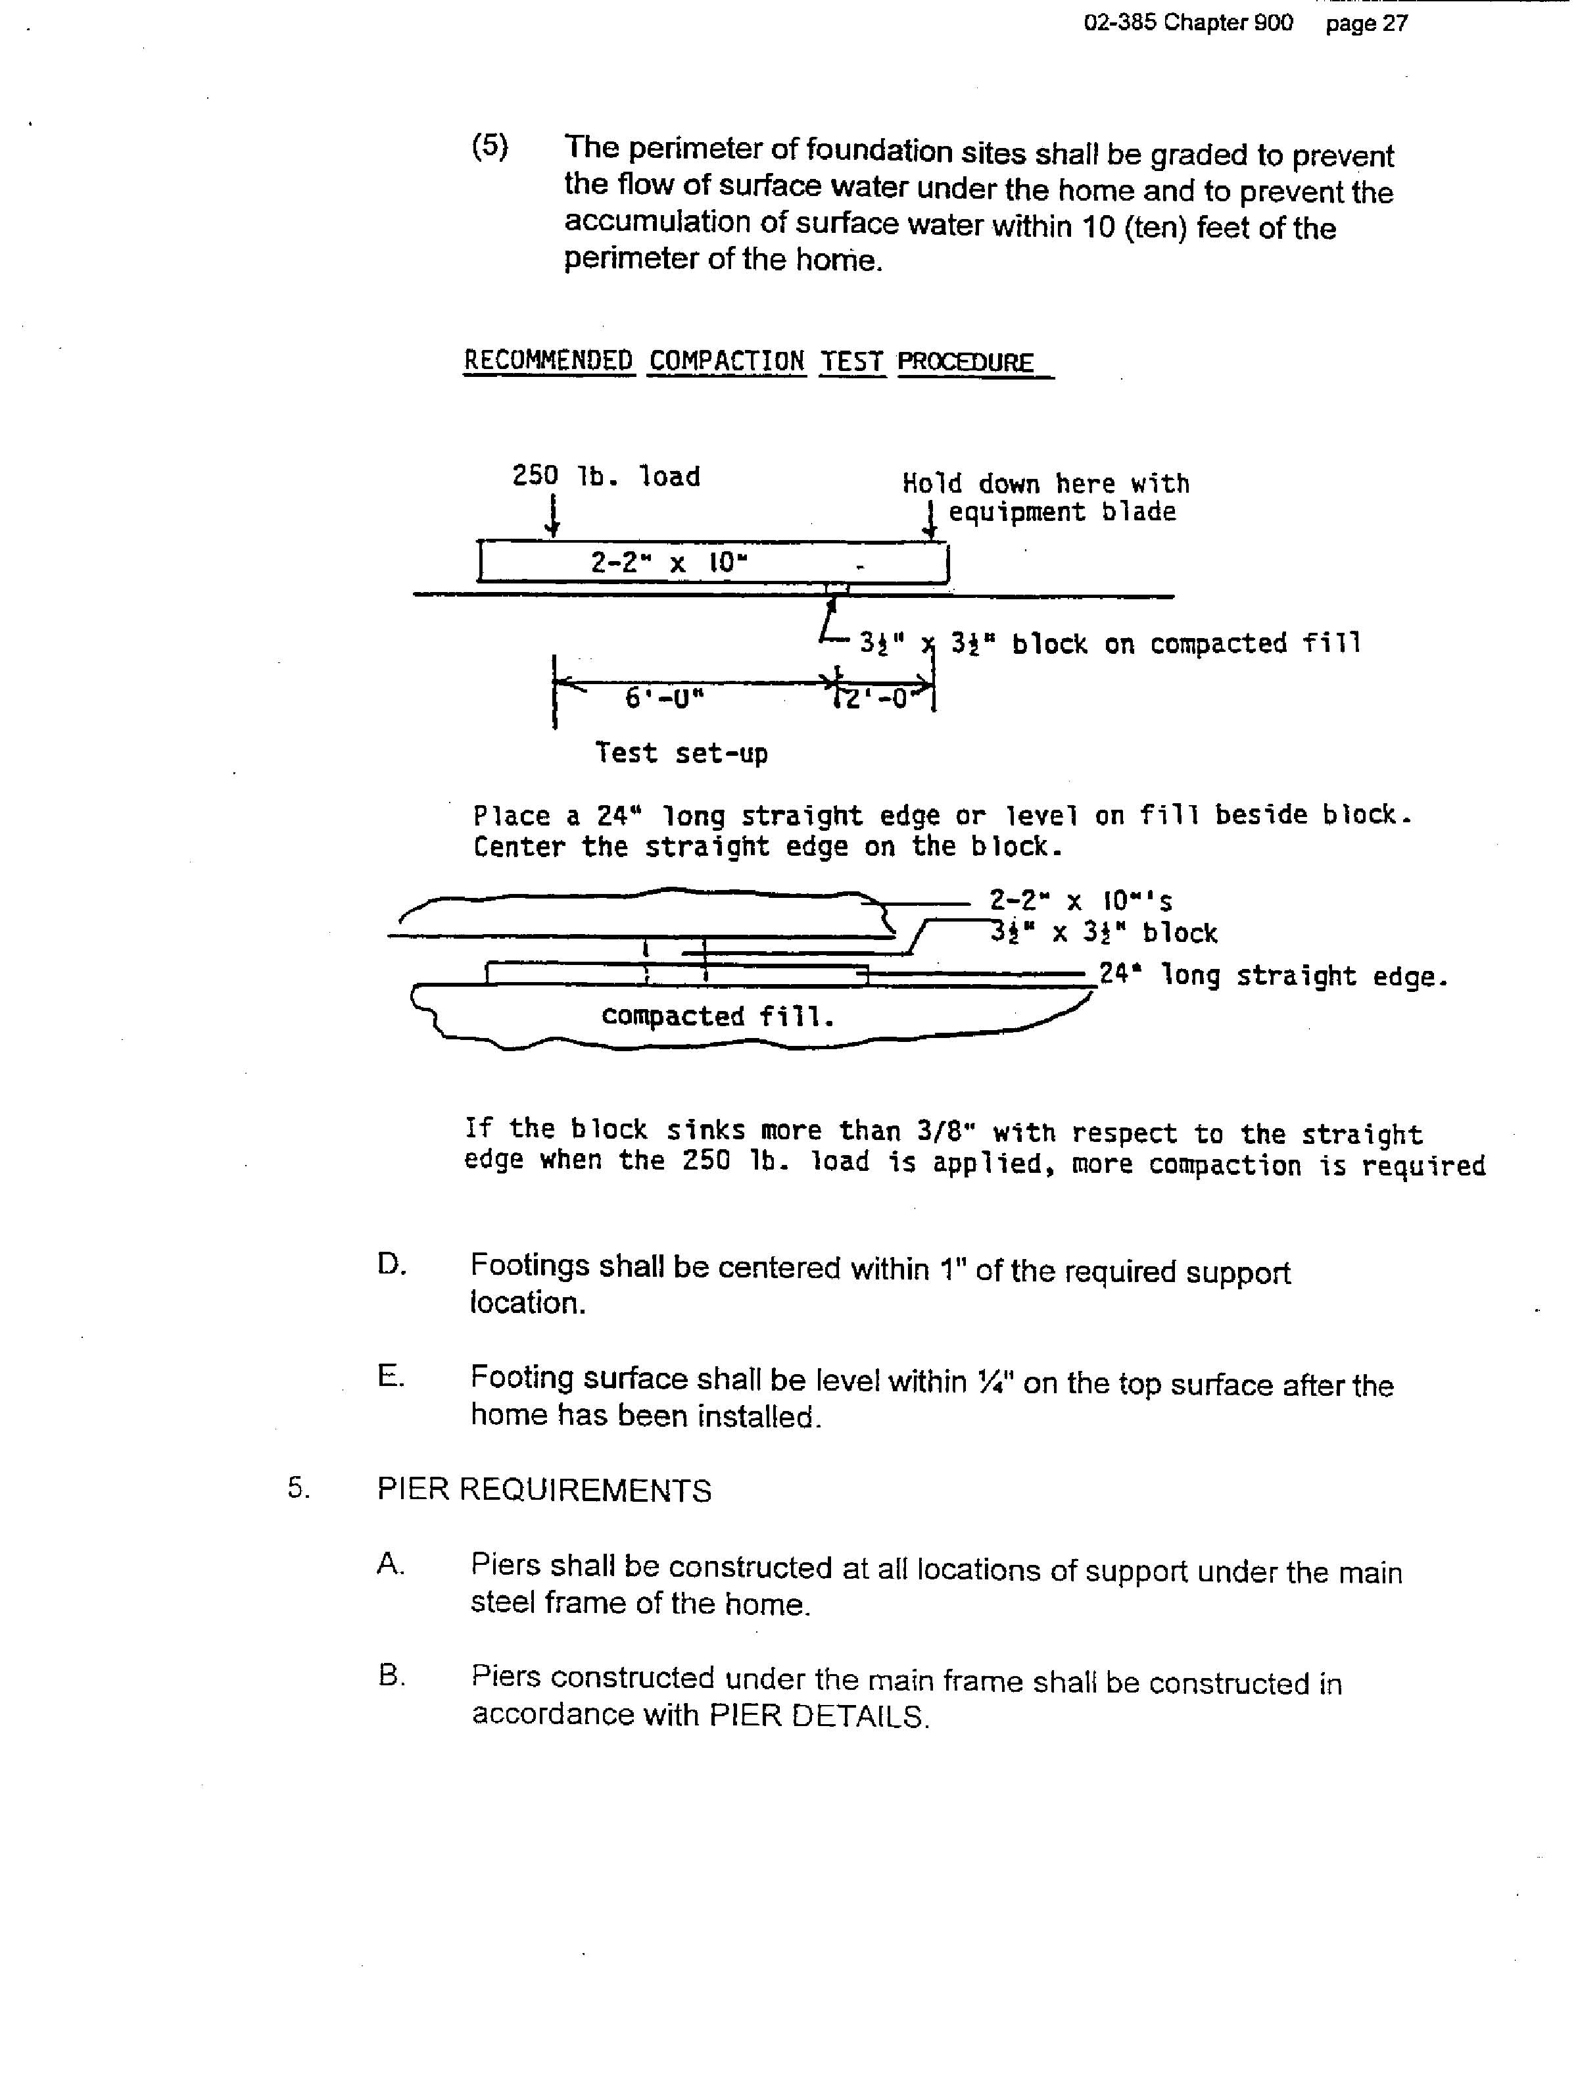

**Appendix D to Chapter 900**

1. **Site Preparation Detail I**

A. This detail may be used on any foundation site that:

1. Does not contain any mud, organic silt or uncontrolled fill; and

2. The highest ground water table is more than 24" below the finish grade.

B. Refer to Appendix A(III) Installation Zones to determine the required compacted fill depth under the footings or slab.

C. Construction may be placed on naturally occurring soils after all organic material has been removed from the construction site.

1. Compacted fill may be placed below the original site grade only if a drainage

system is installed in the fill to prevent the accumulation of water within 24" of the bottom of the footing.

1. Finish grade shall be loamed and seeded with grass or otherwise finished to



prevent erosion of compacted fill.

**II. Site Preparation Detail II**

A. This detail may be used on any foundation site that:

1. Does not contain any mud, organic silt or uncontrolled fill; and

1. The highest ground water table is within 24" of the finish grade

B. If a concrete slab is to be constructed on this site, crushed rock must be installed under the entire concrete slab.

C. A drainage swale at least 6" deep and within 10' of the sidewalls of the home must be constructed around the home. The swale shall have an unobstructed discharge allowing water to flow away continuously from the perimeter of the home.

D. The 4" drainage system shall provide for free flow of water from the rock pads and shall prevent the accumulation of any water.

1. Finish grade shall be loamed and seeded with grass or otherwise finished to

prevent erosion of compacted fill.

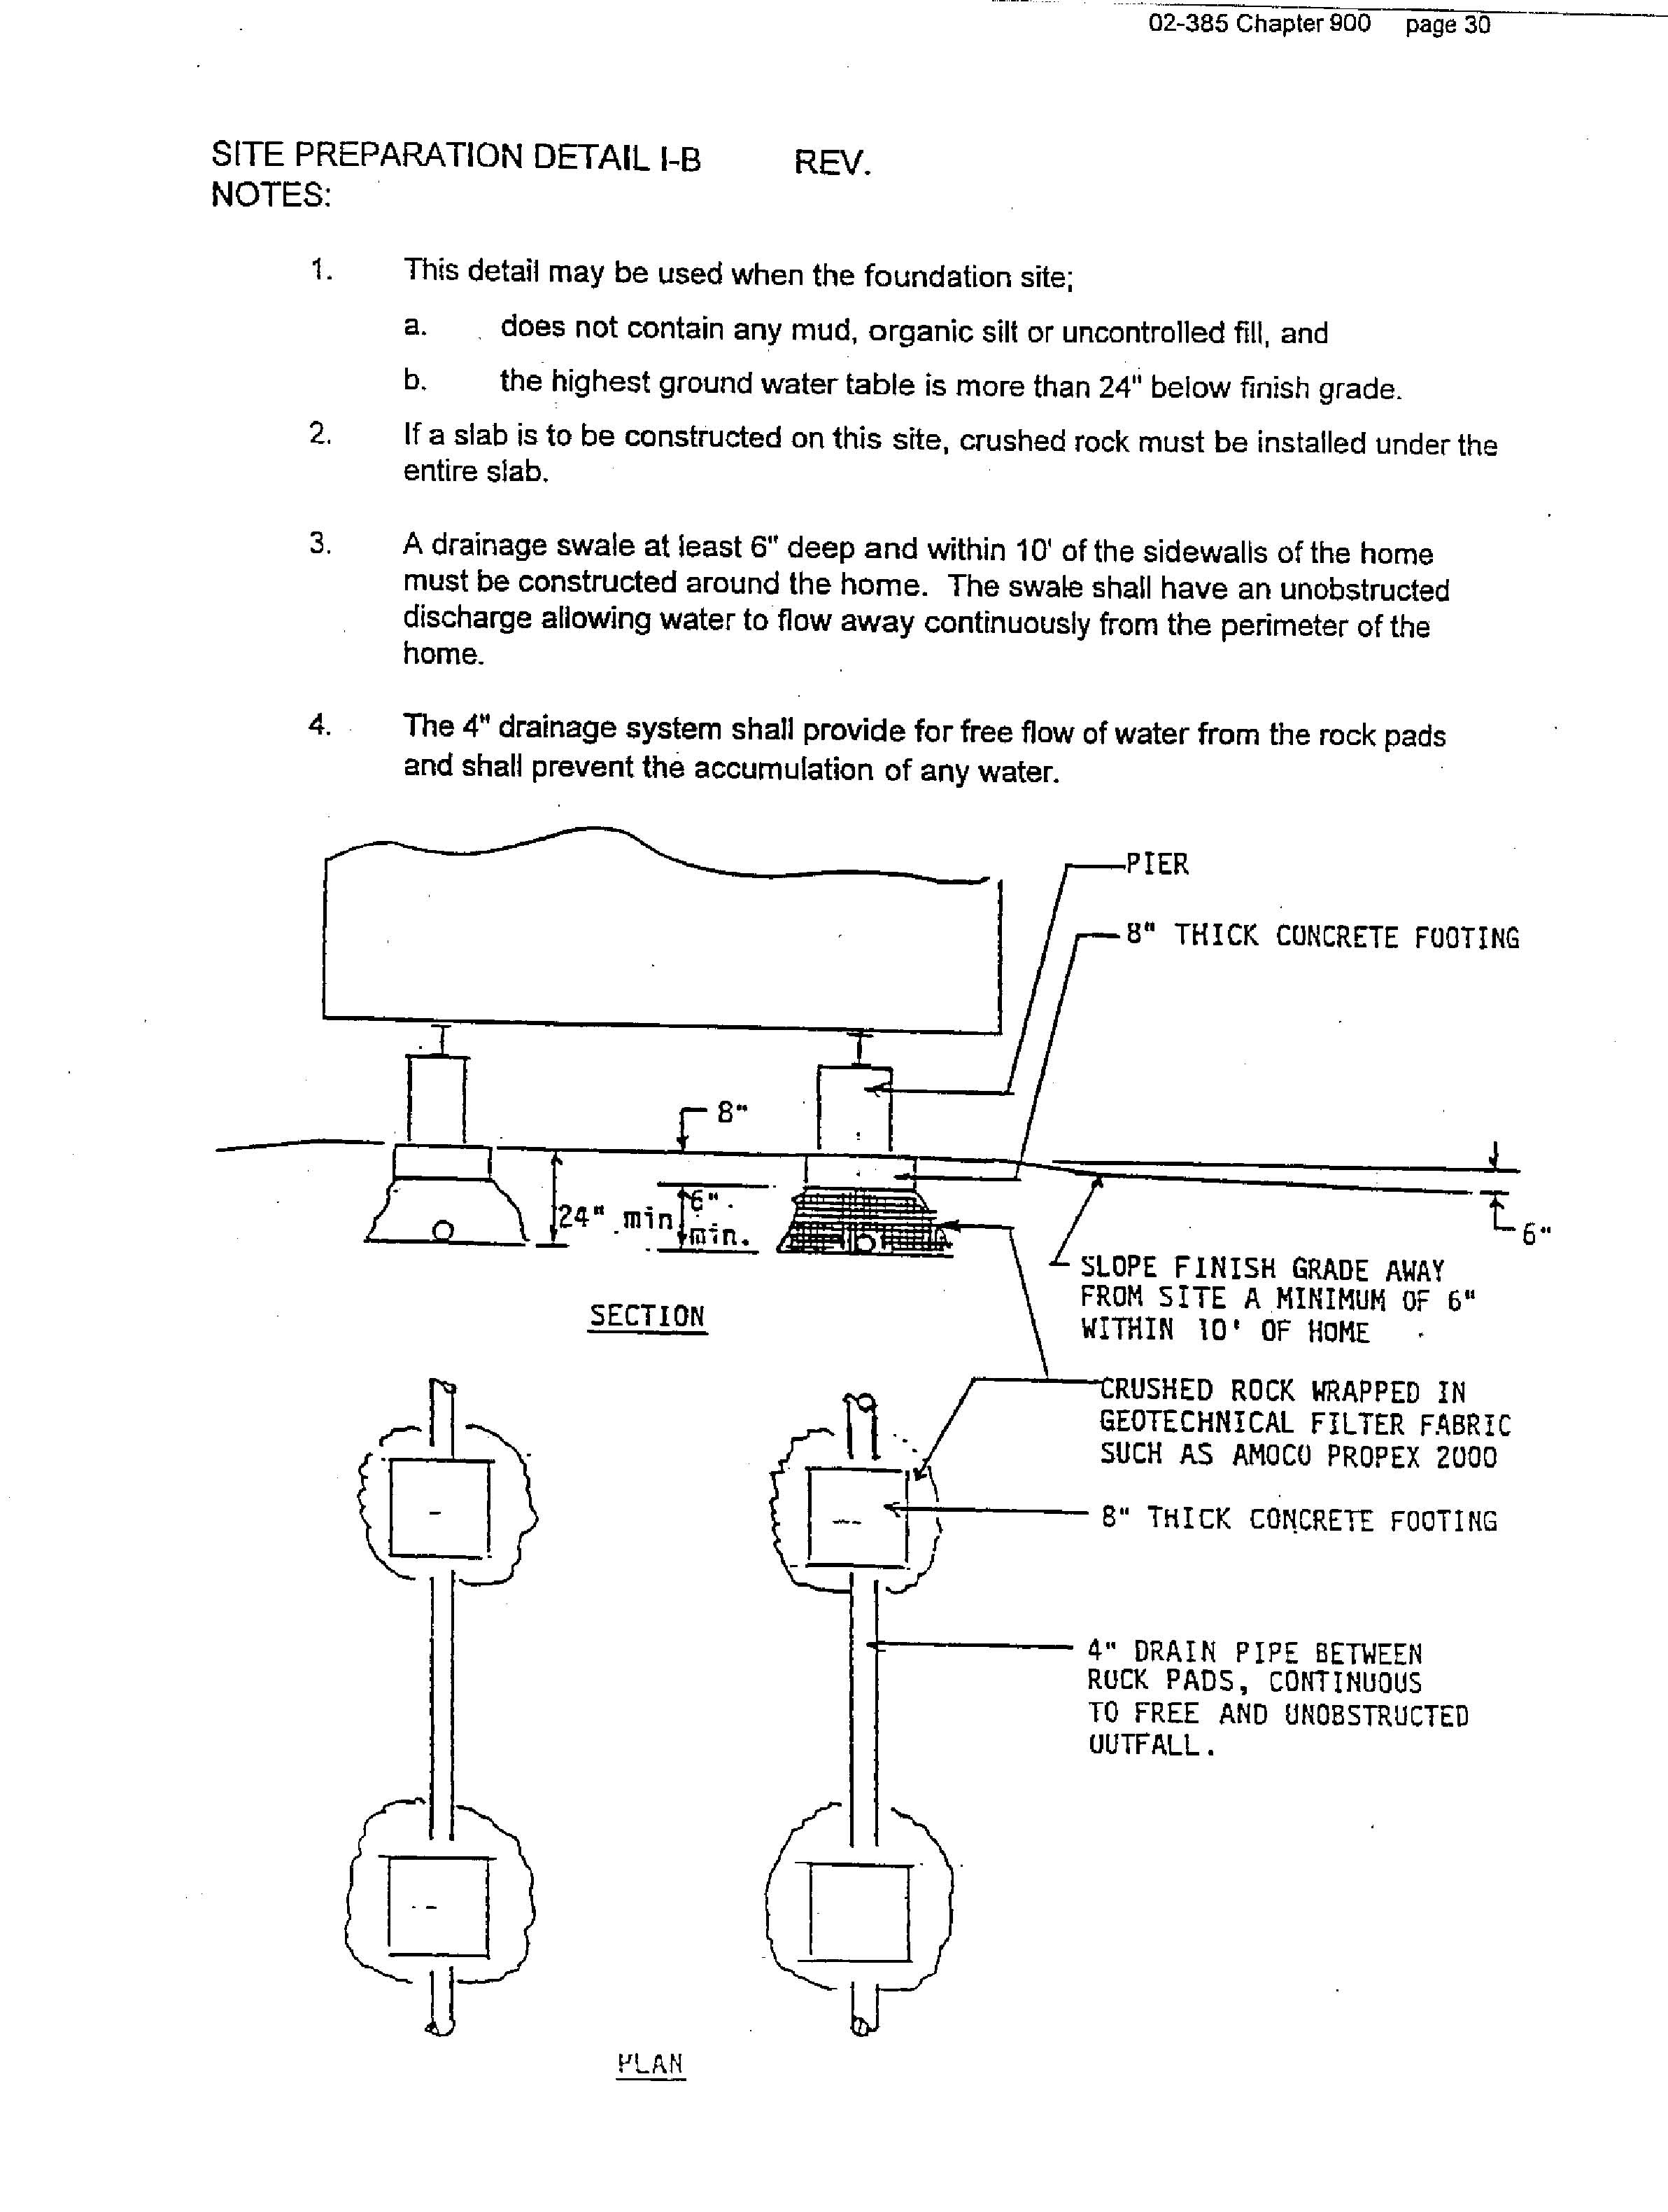

**III. Footing Detail I**

A. Concrete shall have a minimum compressive strength of 3000 psi at 28 days

B. Concrete shall be protected from freezing for the first 7 days after it has been cast.

C. Footing pads may be cast on site or precast and delivered to the site for placing.

D. Footing pads which are precast for later placement shall be cured at least 7 days prior to handling.

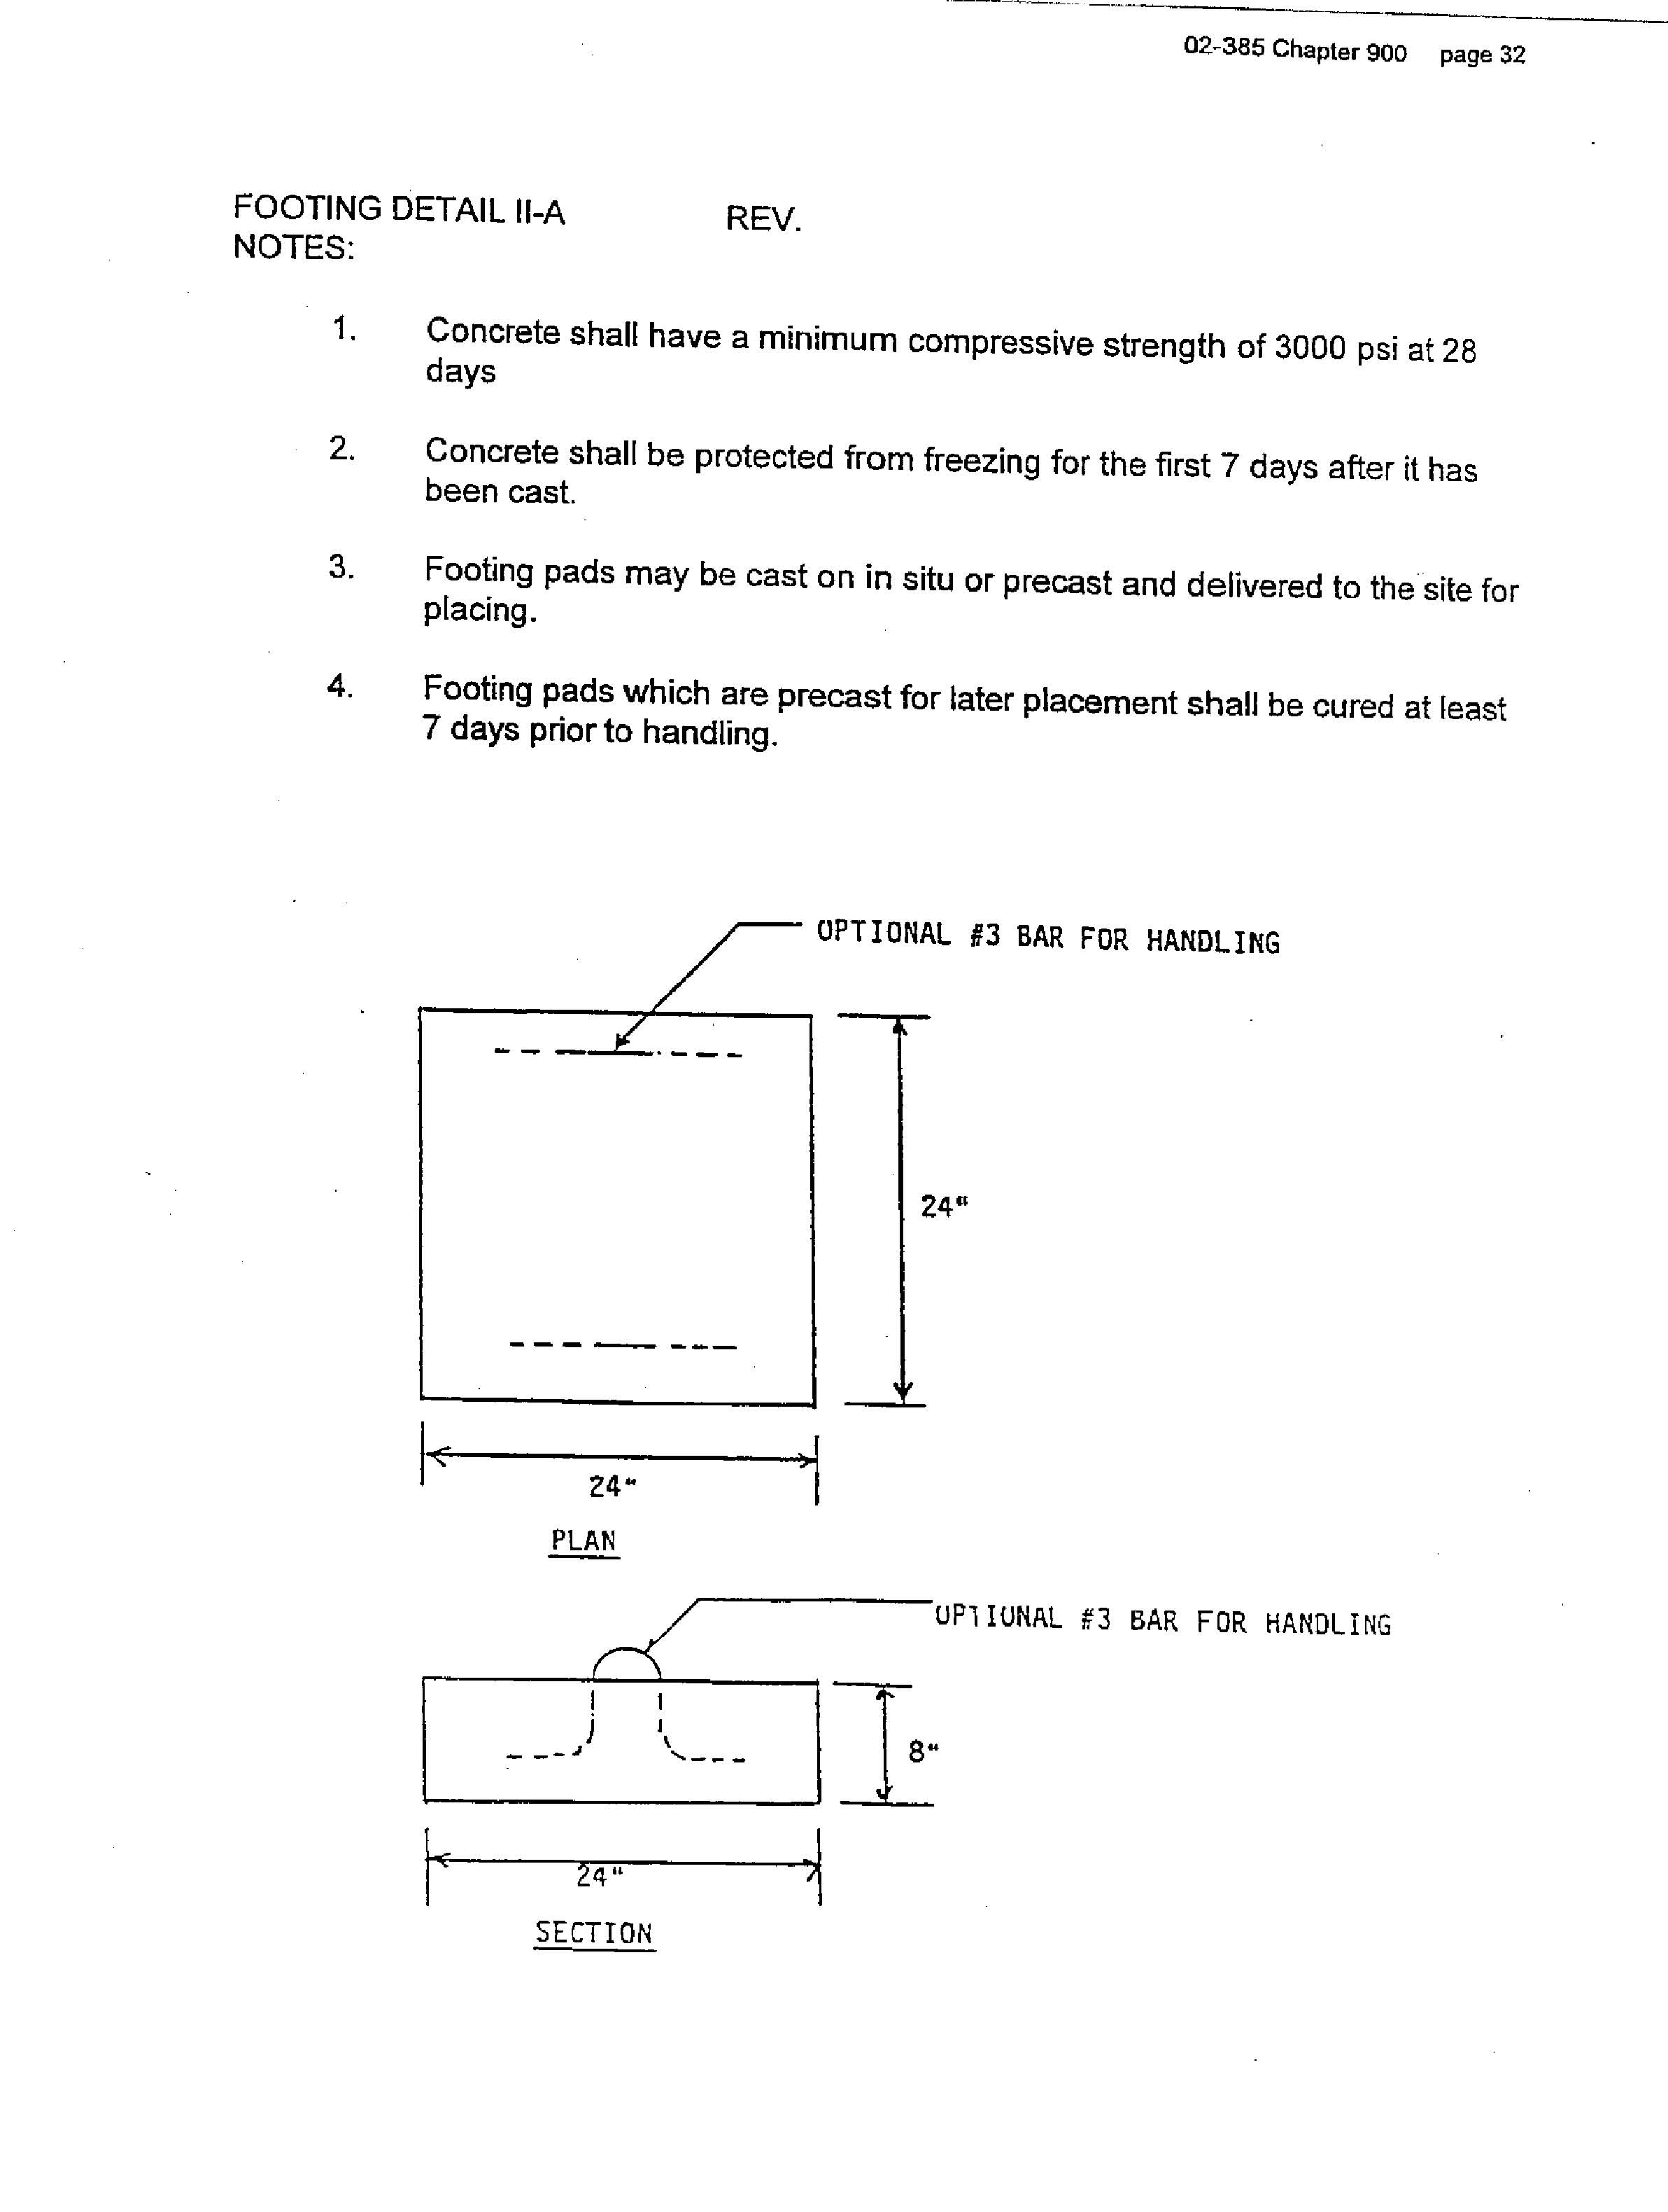

**IV.** **Footing Detail II**

A. This detail is of a wood isolated footing to be placed on a prepared site. This detail may be used when pier height does not exceed 30".

B. Wood used in this detail must be southern yellow pine, #2, pressure treated with water-borne preservatives in accordance with AWPA Standard U1 to the requirements of UC4, ground contact applications.

C. Pier concrete blocks shall be centered on the wood footing with the 16” dimension parallel to the (3) 2” x 8” pressure-treated boards.



**V. Pier Detail**

A. This detail applies to piers which are a maximum of 24" high from the top of the footing.

B. Masonry units in this detail shall comply with ASTM C90.

C. Wood block shall be of a structurally graded lumber with the 12" dimension centered under the main frame. No more than 2 wood blocks may be stacked.

D. Shims shall provide contact between the main frame and the 2" x 10" for at least 6".



**VI.** **Concrete Slab Detail**



**VII. Support Location Detail I**

A. This detail may be used for home support locations when:

1. The manufacturer's installation instructions are not available; and

2. The home’s floor frame is constructed with 2" x 8" or wider floor joists; or

1. The home’s floor frame is 12’ or less wide

B. Support locations are required within 2' of the end of the main frame and at no more than 8' o.c. under the main frame.



**VIII. Support Location Detail II**

A. This detail may be used for home support locations when:

1. The manufacturer's installation instructions are not available; and

2. The home’s floor frame is constructed with 2" x 4" or 2" x 6" floor joists; or

1. The home’s floor frame is more than 12’ wide

B. Support locations are required within 2' of the end of the main frame and at no more than 8' o.c. under the main frame. Continuous perimeter support is required under side walls of the unit. See Exception below.



1. **Continuous Perimeter Blocking Detail**

A. This detail applies where continuous perimeter blocking or support is required.

B. Ventilation openings shall be provided through sheathing as required by Subchapter B(VII) to this Chapter.

C. Access openings shall be provided to the underside of the home as required by Subchapter B(VII)(E) to this Chapter.

D. Pressure-treated lumber shall be treated in accordance with AWPA Standard U1 to the requirements of UC3, above ground applications.

E. Sheathing shall be provided with protection against weather deterioration.

**Appendix E to Chapter 900:**

1. **Ground Level Installation of Used Manufactured Homes (Floor at Grade)**

A. Ground level installations refer to used manufactured homes installed over an open excavation where the supporting foundations are below finished ground level.

B. All required permits shall be obtained.

C. Retaining walls to resist the lateral displacement of soil and other materials should be designed to resist the lateral pressure of the retained material in accordance with accepted engineering practice. Retaining walls, if fastened to the manufactured home at the time of installation, should not degrade the stabilizing system of the home. When a retaining wall is not used as a foundation, it should not be attached to the home. Retaining walls should be constructed of treated foundation grade wood, concrete, masonry, other approved materials or combinations of these materials.

1. All fill and backfill soil surrounding the home should be compacted. Grading around the home shall be done in such a manner that will divert water away from the home and must slope a minimum of one-half inch per foot away from the foundation for the first ten feet.

STATUTORY AUTHORITY:

10 M.R.S.A. Part 11, Chapter 951, Subchapter 1, Section 9006, Paragraph I and Resolve #26 of 1989.

EFFECTIVE DATE:

February, 1. 1993

EFFECTIVE DATE (ELECTRONIC CONVERSION):

January 11, 1997

AMENDED:

June 22, 2009 – filing 2009-257

February 5, 2018 - filing 2018-019