John J. McKernan, Jr.  Governor  Susan M. Collins  Commissioner | DEPARTMENT OF PROFESSIONAL AND FINANCIAL REGULATION  BUREAU OF CONSUMER CREDIT PROTECTION  STATE HOUSE STATION 35  AUGUSTA, MAINE 04333-0035  (207)582-8718  Telecopier: 582-5415 | William N. Lund  Superintendent  Harry W. Giddinge  Deputy Superintendent  Principal Examiners:  Paul Karass  Del Pelton  Outreach/Research:  Michael Brown  Senior Examiners:  Leslie Washburn  Richard Howard  Constance Berthiaume  Examiner:  Douglas Stark
October 31, 1989

MAINE FAIR CREDIT REPORTING ACT ADVISORY RULING 89-1

Re: Explanation of Extenuating Circumstances

Dear :

You have asked whether credit reporting agencies in Maine must comply with a consumer’s request to include an “explanation of extenuating circumstances” in the consumer’s file.

For reasons set forth below, I am taking a more consumer- oriented tack than has been adopted by the Federal Trade Commission in its Proposed FTC Commentary, and I am ruling that such an explanation of extenuating circumstance must be included in the consumer's file.

Maine law authorizes the Superintendent of the Bureau of Consumer Credit Protection to "issue advisory rulings designed to clarify the applicability of any statutory provision," 10 M.R.S.A.
§1328(1) (E).

Maine's statute requires that, following reinvestigation of a dispute, credit reporting agencies "permit the consumer to file a statement containing the nature of the dispute," 10 M.R.S.A. §1317{5){B).

The statute further requires that consumer reporting agencies maintain reasonable procedures enabling consumers to correct any information which is "materially incomplete," 10 M.R.S.A. §1317(1).

These two requirements are consistent with the legislative findings set forth in Section 1311-A of the Act, which establish that "[t]here is a need to ensure that consumer reporting agencies exercise their grave responsibilities with fairness [and] impartiality….”

Prior to issuance of the Proposed Commentary, members of the FTC legal staff appeared equally divided on the issue of whether the provisions of the Federal Act mandated inclusion of statements

ADVISORY RULING 89-1
Page Two

of circumstance, as opposed to statements disputing accuracy of the raw data listed. For example, an informal opinion letter dated October 20, 1983 by Attorney Clarke Brinckerhoff of the Division of Credit Practices, was addressed to a consumer who was upset that delays in insurance payments had resulted in negative credit notations. Brinckerhoff opined:

If ...insurers were slow in processing the paperwork and paying your claims, you would appear to be disputing the "completeness" of these items. Unless the bureau can show that the dispute is frivolous or irrelevant to interpretation of this information, it must within a reasonable period of time reinvestigate and record the current status of that information.

Similarly, a June 10, 1983 letter from Attorney Norman E. Oliver addressed a hypothetical situation in which a credit reporting agency reported only a Chapter 7 Bankruptcy, and deleted references to prior good-faith efforts of the debtor to repay the debts. Oliver was of the opinion that

[t]he consumer could dispute the completeness or accuracy of referring only to the Chapter 7 filing and could supply the missing information by filing a statement of dispute under §611(c) [the Federal Act's dispute section].

See also Opinion Letters dated March 20, 1977 and July 19, 1974.
On the other hand, certain informal FTC letters took an opposite position. A letter from Anne P. Fortney, Associate Director for Credit Practices, dated December 23, 1983, revealed that in her opinion,

the better interpretation ...is that if a consumer failed to pay a bill, and if the report accurately reflects the fact that the consumer failed to pay, the consumer's explanation that the failure was attributable to a sudden illness or lay-off does not cast doubt upon the accuracy or completeness of the item of information being reported.

(However, Fortney's correspondence went on to say that she "understand[s] that as a practical matter, many reporting agencies may choose to permit consumers to add such explanatory statements to their files, not only to avoid the ire of consumers but as a service to those creditors who may be interested in such information. " ).

ADVISORY RULING 89-1
Page Three

The Proposed FTC Commentary (Section 611(4)) adopts the Fortney approach, stating as follows:
Although a consumer reporting agency is not required to accept a consumer dispute statement that does not challenge the accuracy or completeness of an item in the consumer's file, it may accept such a statement...

BUREAU OPINION:
Despite the position proposed in the Commentary, it is my opinion that either under a "dispute" theory, or under a "completeness" theory, a statement of circumstance must be included in a consumer's report, if requested by the consumer following reinvestigation of the specific item involved.
In effect, the matter is disputed. The consumer feels that the excuse he or she has provided for default or non-payment, should result in removal of the item from the credit history. The creditor disagrees. A dispute as to the significance of the circumstantial event clearly exists. A reinvestigation by the credit reporting agency confirms that the creditor is still of the opinion that such an excuse should not result in deletion of the item. The consumer therefore has the right to insert a statement of up to 200 words (100 words under the federal statute), explaining the dispute.

Likewise, credit reporting agencies operate under a requirement to maintain complete records. Maine law equates incompleteness with inaccuracy, see 10 M.R.S.A. §13l7(1). If a consumer feels that the complete record of non-payment includes the reasons for that non-payment, the consumer deserves the right to explain the surrounding circumstances. The creditor is then free to make a determination based on the full record contained in the report. The burden upon the credit reporting agency is minimal compared to the equity and fairness inherent in allowing the consumer to have input into the final report.

For that reason, in the State of Maine, explanations of extenuating circumstances shall be considered to be statements of dispute and/or elements of completeness, and shall be included in the consumer's file upon request.

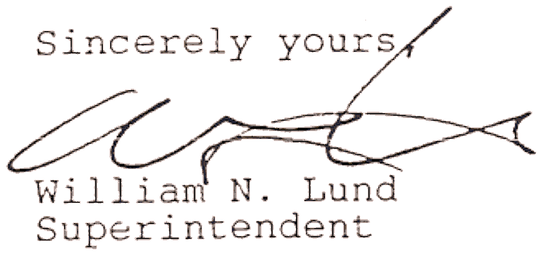

WNL/bas

