Maine PUC Long-term Contact RFP -
Instructions for Submitting Stage 2 Proposals

Rather than sending Stage 2 Proposal files via email, files should be uploaded by bidders to the secure site as described below. Files posted to the site will be accessible only to the Maine PUC.

Please include your company and/or project identification as part of the name(s) of all files submitted.
For example – “CompanyAProjectBProposal.doc”

File upload instructions:

Go to the website: https://mom01.secure.maine.gov/webmailbox

Bidders will log into the site using the account name and password provided. (Please contact Faith Huntington at faith.huntington@maine.gov if you have not received account name and password information.)

Upon entering the website a login box will appear. Bidders will login using the account name and password provided.

After logging into the system the following page will display. Bidders will need to click the Upload Files button.

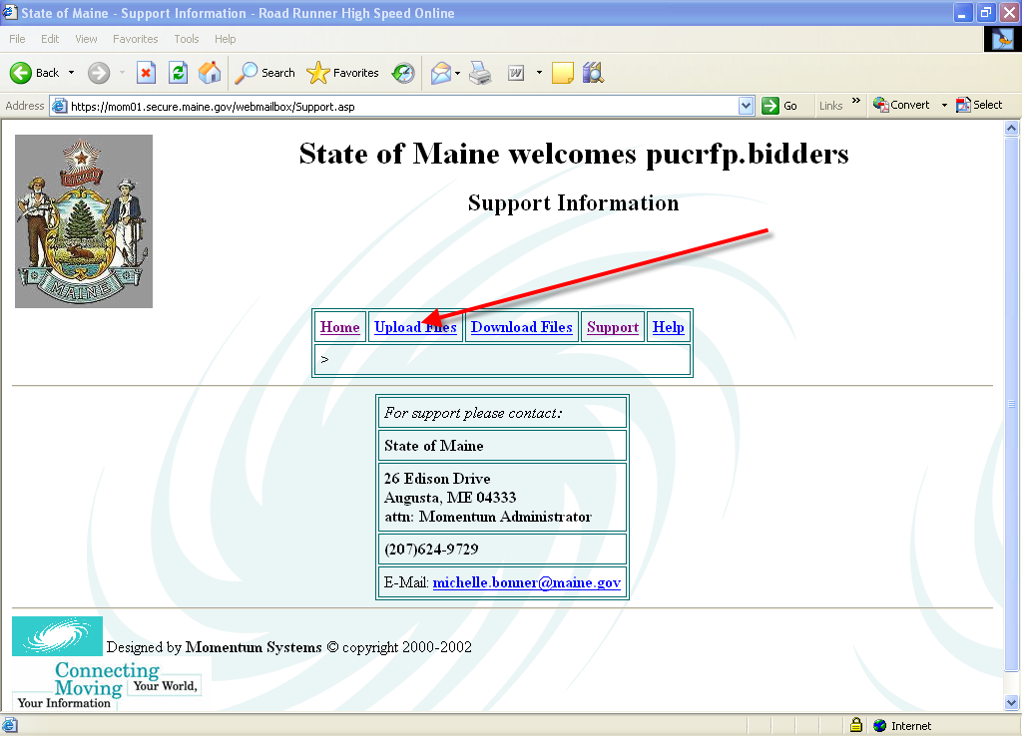

This will bring up the following page that will allow bidders to select files to upload and press the upload button.

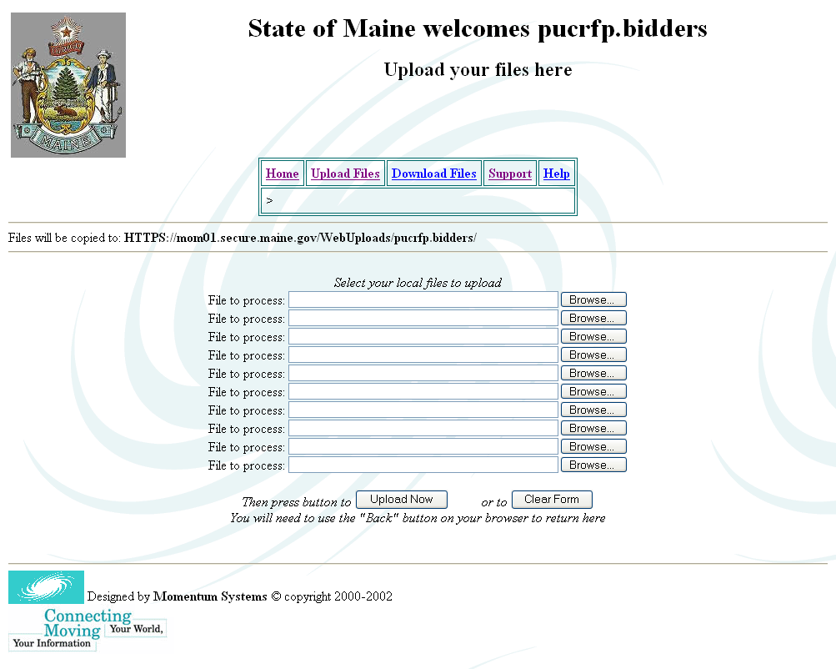

After pressing the Upload Now button, the following screen will appear which confirms a successful transmission.

