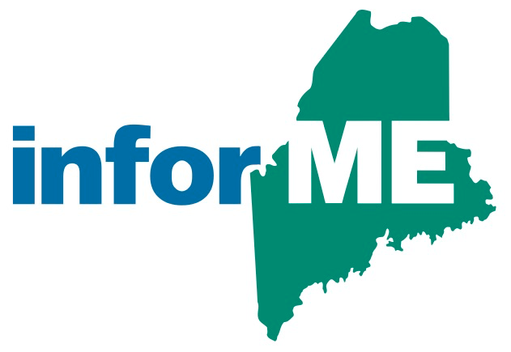

InforME Board Meeting Minutes
Meeting Date: October 26, 2023
Meeting Time: 1:00 PM - 3:00 PM
Meeting Location: Virtual Meeting

Attendees

Board Members Present:
Shenna Bellows
Jeremy Cluchey
Adam Fisher
Anne Head
Sam Foster (non-voting member)

Guests and State Agency Members:
Dawnna Pease

InforME Staff:
Kimberly Duplisea
Tony Brodie

The meeting was started at 1:05 PM.
  - Welcome & Introductions

  - Adoption of Minutes

Adoption of the meeting minutes was tabled due to lack of quorum.

  - Third Quarter General Manager’s Report

Sam Foster provided a summary of the third quarter General Manager’s report. Sam provided service updates including that the rapid renewal service processed its 3 millionth transaction online, that several projects are in testing in the project queue, and that Engagement Builder platform has allowed us to spin up new digital services in record-time. Sam also provided an update on the Maine Data Center migration. Several services have been migrated, and several are in testing.

Sam also provided Tyler company-wide updates including details about Prompt Pay, a service that allows agencies to send a text message containing links to secure payment pages, about Data Collect Mobile, which is being used to unify inspections across divisions, and Managed Detection and Response Services, which is a suite of services that monitor partner networks 24/7 for behavior that could pose risks to an environment.

  - Net Promoter Score (NPS) Survey Results

Sam Foster gave an overview that the Net Promoter survey is designed to gauge customer satisfaction with Tyler Maine. This tool asked 72 users across state agencies a series of questions. Of those 72 users, 31 users responded to the survey. The survey showed us that agencies need to have more educational opportunities, timely communication, and a feeling that we truly understand needs.

  - Next Board Meeting Dates

TBD

