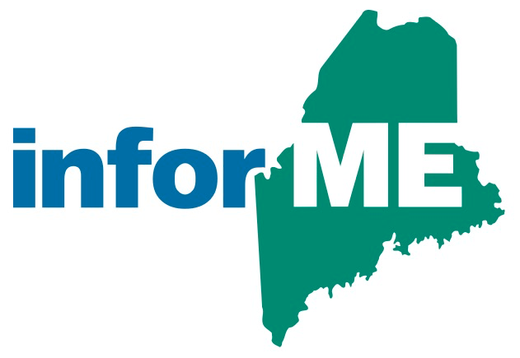

InforME Board Meeting Minutes
Meeting Date: August 24, 2023
Meeting Time: 1:00 PM - 3:00 PM
Meeting Location: Virtual Meeting

Attendees

Board Members Present:
Nicholas Marquis
Shenna Bellows
Michael Cyr
Kathy Montejo
Chris Pinkham
Jeremy Cluchey
David Simsarian
Adam Fisher
Anne Head
Sam Foster (non-voting member)

Guests and State Agency Members:
Dawnna Pease

InforME Staff:
Kimberly Duplisea

The meeting was called to order at 1:02 PM.
  - Welcome & Introductions

  - Adoption of Minutes

Motion: Chris PInkham motioned to adopt the minutes.
Second: Shenna Bellows

Vote: Unanimous

  - Strategic Plan Discussion

Nick Marquis introduced the strategic plan. Some of the dates must be updated on the plan, and assignments should be made for tasks within the plan. The board action item will be to create a work session to reacquaint members with the plan contents as well as to assign out new dates and priorities.

  - Disaster Recovery Plan Update

Sam Foster provided an update on the disaster recovery plans in place for InforME’s primary Virginia Data Center. A full data center disaster recovery exercise will be scheduled for September. More details will be provided as the exercise is scheduled, as well as details of the exercise.

  - Award Highlight

Tyler Technologies was awarded one of the best places to work in Maine for 2023. An award ceremony will be held in October at the Augusta Civic Center.

  - Adjournment

Motion: Shenna Bellows motioned to adjourn the meeting.
Second: Nicholas Marquis

Vote: Unanimous

  - Next Board Meeting Dates

Sam Foster will poll the board regarding the date and time for the September board meeting.

