Board of Trustees
MAINE CRIMINAL JUSTICE ACADEMY

CERTIFICATION OF ACADEMY TRAINING COURSES

Specification S-5

Purpose:

The purpose of establishing minimum standards for training course offerings is to ensure the quality, effectiveness and efficiency of courses presented through the Board of Trustees. In recognition of in-service training requirements as prescribed in M.R.S. 25, Chapter 341, the Board of Trustees will maintain a system of course certification and presentation.

- Certification of Academy training courses will generally be considered based on information provided on forms approved for that purpose. Any course submitted for approval by the Board shall have an accompanying lesson plan and a recommendation from an Academy staff member to approve the training course. Any course approved by the Board which has been significantly changed must be resubmitted for Board approval with an accompanying lesson plan.

B. Certification of training courses will be offered based on on-site inspection conducted by Academy staff members. Such inspection may be conducted at the discretion of the Academy staff member according to guidelines established by the Board and will include, but are not limited to, examination of instruction, facilities, and course administration.

C. Maine Criminal Justice Academy Training Coordinators will supervise courses identified as follows:
1. Courses approved for certification through legislative requirements or trustee action.
- Curriculum developed by Academy staff or subject matter experts (SME’s).
- Approval by the Board of Trustees prior to conducting the training.
- Course Certification Request Form and lesson plan is required.

2. Special training courses developed by an interested criminal justice agency and cosponsored by the Academy.
- Course Certification Request Form and lesson plan is required.
b. Approval by the Board of Trustees prior to conducting the training. Courses may be submitted to the Board for approval after the course has been completed if there are extenuating circumstances.

3. Special needs courses identified as being pertinent for law enforcement or corrections officers in the performance of their duties.
a. Course Certification Request Form and lesson plan is required.
b. Approval by the Board of Trustees prior to conducting the training. Courses may be submitted to the Board for approval after the course has been completed if there are extenuating circumstances.

Procedures:

A. Agencies requesting training course certification shall communicate in writing with the Board, through the MCJA Training Coordinator assigned to the region or program, describing the training offered. A Course Certification Request Form and lesson plan is required before being submitted to the Board for approval.

B. Agencies conducting Board certified training should forward to the Academy, within 30 days, a roster of individuals attending the training.

Adopted: 01/11/2005
Amended: 09/13/2019
Review Date: 09/13/2022

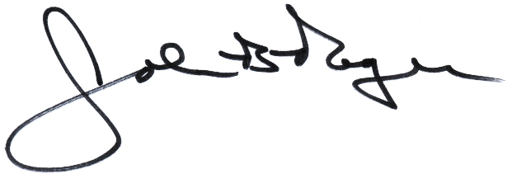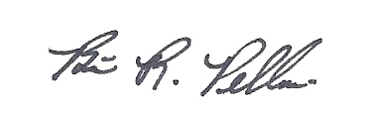
____________________________ __________________________
John B. Rogers, Director Brian R. Pellerin, Chair
Maine Criminal Justice Academy MCJA Board of Trustees

