Board of Trustees
MAINE CRIMINAL JUSTICE ACADEMY

BASIC LAW ENFORCEMENT TRAINING PROGRAM

Specification S-1

The following requirements are specified for the certification of Basic Law Enforcement Training Program graduates. The Director, with the approval of the Board of Trustees, sets standards for successful completion. If a student fails to meet any of the requirements described below, the student and the student’s agency may petition the Board for a waiver or modification of the requirements in question.

Requirements:

A. As a requirement for the successful completion of the Basic Law Enforcement Training Program (BLETP), each student must attend all sessions of the school, except absences approved by the Training Supervisor. No student will be certified when his or her absences exceed 10% of the prescribed curriculum, except if a student has successfully completed at least 14 weeks of the 18-week session, passed all requirements at that point and has left the session for either the Family Medical Leave Act or military commitment. The student and the student’s agency may petition the Director to complete the remainder of the unfinished session in the next available session of the BLETP. The BLETP curriculum approved by the Board is 720 hours.

B. As a requirement for the successful completion of the BLETP, each student shall successfully pass all weekly and major academic exams with a minimum score of at least 75% and shall achieve a minimum cumulative academic average of 75% or greater. If a student fails an exam, no more than two make-up exams will be offered.

C. As a requirement for the successful completion of the BLETP, each student shall achieve a passing professional score of 80% or greater at the conclusion of the program. This score is a reflection of the Professional Value System, as outlined in the BLETP Cadet Orientation and Curriculum Guide.

D. As a requirement for the successful completion of the BLETP, each student shall demonstrate competency and safety in the handling of his or her service weapons. Each student shall achieve at minimum, proficiency over a course of fire approved by the Director. This score is a reflection of the Firearms Course, as outlined in the BLETP Cadet Orientation and Curriculum Guide. The proficiency standard is 80%.

E. As a requirement for the successful completion of the BLETP, each student shall demonstrate proficiency in the Emergency Vehicle Operations Course (EVOC), by successfully completing a program approved by the Board. This score is a reflection of the Emergency Vehicle Operations Course, as outlined in the BLETP Cadet Orientation and Curriculum Guide. The proficiency standard is 70%.

F. As a requirement for the successful completion of the BLETP, each student shall demonstrate proficiency in the Mechanics of Arrest, Restraint and Control (MARC) Course by successfully completing a program approved by the Board, which test counts for 80% of the final grade. The student must pass a MARC scenario at the end of the program, which counts for 20% of the final grade. If a student fails the MARC scenario, no more than two make-up scenarios’ will be offered. This total score is a reflection of the MARC Course, as outlined in the BLETP Cadet Orientation and Curriculum Guide. The proficiency standard is 80%.
G. As a requirement for the successful completion of the BLETP, each student shall fully participate in all aspects of firearms and MARC training. Each student must also attend at least 75% of these skills training, not withstanding the requirement outlined in Requirement 1 above.

H. As a requirement for the successful completion of the BLETP, each student shall meet the physical fitness exit standard at the 50th percentile according to age and gender normed standards, as approved by the Board.

Certification:

A. All students who attend the BLETP shall have met the Board’s preservice requirements, per 25 M.R.S. §2804-B, if they are employed as a full-time law enforcement officer. These officers will be given a provisional Certificate of Eligibility to act as a full-time law enforcement officer in the State of Maine upon being hired. All other students who attend the BLETP that are nonsworn employees of a law enforcement agency or any tuition student will not be given a provisional Certificate of Eligibility to act as a full-time law enforcement in the State of Maine.

B. As a requirement for the successful completion of the BLETP, each student shall successfully take and pass the certification exam, which is administered at the end of the course, with a minimum score of 75%. All students who pass this certification exam will be given a Certificate of Eligibility to act as a law enforcement officer in the State of Maine, except any tuition student that has not been hired as a fulltime law enforcement officer.

C. Tuition students who have successfully completed all of the above listed requirements will receive a Certificate of Completion of the BLETP. Upon the Academy’s receipt of the Notice of Employment form indicating that a tuition student has been hired as a full-time law enforcement officer by a law enforcement agency, the tuition student will receive a Certificate of Eligibility to act as a full-time law enforcement officer in the State of Maine.

Recertification:

A. To maintain a Certificate of Eligibility to act as a full-time officer in the State of Maine, a law enforcement officer must complete the annual mandatory in-service training, per 25 M.R.S §2804-E by December 31st of each calendar year.

Adopted: 06/18/2004
Amended: 09/13/2019
Review Date: 09/13/2022
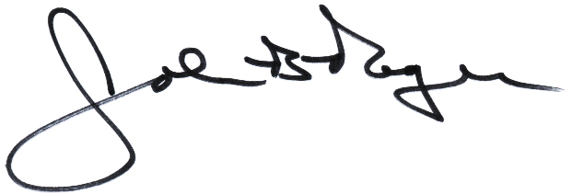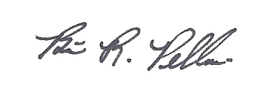
____________________________ __________________________
John B. Rogers, Director Brian R. Pellerin, Chair
Maine Criminal Justice Academy MCJA Board of Trustees

