Board of Trustees
MAINE CRIMINAL JUSTICE ACADEMY

CANINE (K-9) TEAM TRAINER CERTIFICATION

Specification S-19

The following requirements are specified for the certification of K-9 Team Trainers K-9 Team Trainers will be utilized for the training and evaluation of K-9 Teams, as specified in Specification S-17 and Specification
S-18.

Certification:

A-1. Be employed as one of the following: a law enforcement officer, a corrections officer, a staff
member of the Office of the Chief Medical Examiner; or

A-2. Be a former certified MCJA K-9 Team Trainer who held active status in good standing as a MCJA
certified K-9 Team Trainer for a minimum of 2 years at the time of separation or has attained
equivalent law enforcement certification as approved by the Academy, and;

B. Be designated by the Chief Executive Officer or his/her designee of a criminal justice agency as a
K-9 Team Trainer.

C. Have been certified by the Board as a K-9 Handler Team for a period of at least five (5) years. A waiver of this requirement may be granted by the Board in cases of documented equivalent training and experience.

D. Provide to the MCJA Board documentation of continuing and progressive experience in K-9 training.

- Have completed a Methods of Instruction course or its equivalent.

- A Patrol K-9 Trainer applicant must assist in a minimum of five hundred (500) hours in a Patrol
K-9 Team training capacity under the supervision of a MCJA Certified K-9 Team Trainer with
experience in Patrol K-9 training. Four hundred (400) hours must be attained in the classroom and
practical phases of the basic training of Patrol K-9 Teams. The remaining one hundred (100) hours
may be in the planning and conducting of in-service training. The Patrol K-9 Team Trainer
applicant must assist in the training of three (3) active Patrol K-9 Teams that have successfully met
Patrol K-9 certification.

- Detector K-9 Trainer applicant must assist in a minimum of three hundred (300) hours in a Detector K-9 Team training capacity under the supervision of a MCJA Certified K-9 Team Trainer with experience in Detector K-9 Training. Two hundred (200) hours must be attained in the classroom and practical phases of the basic training of Detector K-9 Teams. The remaining one hundred (100) hours may be in the planning and conducting of in-service training. The Detector K-9 Team Trainer applicant must assist in the training of two (2) active Detector K-9 Teams that have successfully met Detection K-9 Team certification.

- For the purposes of 5 and 6 above, the term “K-9 Team” will not include the applicant and the applicant’s K-9.
- K-9 Team Trainer applicants who receive their training or certification other than in a MCJA program will be reviewed for acceptance by the Academy K-9 Advisory Committee for equivalency.

Recertification:

A-1. Be employed as one of the following: a law enforcement officer, a corrections officer, a staff
member of the Office of the Chief Medical Examiner; or

A-2. Be a former certified MCJA K-9 Team Trainer who held active status in good standing as a MCJA
certified K-9 Team Trainer for a minimum of 2 years at the time of separation or has attained equivalent law enforcement certification as approved by the Academy, and;

B. Be designated by the Chief Executive Officer or his/her designee of a criminal justice agency as a
K-9 Team Trainer.

C. Annual recertification requirements shall be met by December 31st of each calendar year.

- The K-9 Trainer shall annually provide documentation on the appropriate MCJA forms of continuous education and experience in K-9 training. The K-9 Trainer shall provide documentation on the appropriate MCJA forms that the K-9 Trainer has conducted at least two hundred (200) hours of training for individual K-9s and/or K-9 teams annually. If the K-9 Trainer is also K-9 Handler, up to one hundred (100) hours of the Trainer’s K-9 Team in-service training can be used towards this requirement.

- The Academy Training Coordinator will review the documentation at the end of the calendar year and make appropriate recommendations to the Academy Director, as outlined in Specification S-19.

- The Academy Director will forward all certification recommendations to the Board.

Adopted: 12/05/2008
Revised: 09/13/2019
Review Date: 09/13/2022

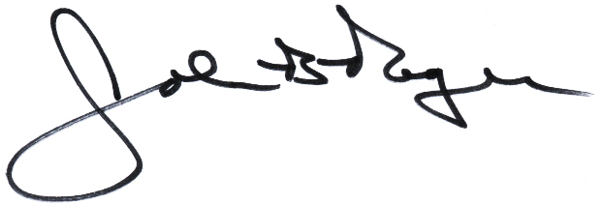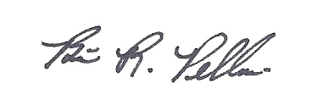
__________________________ ________________________
John B. Rogers, Director Brian R. Pellerin, Chair
Maine Criminal Justice Academy MCJA Board of Trustees

