Spring 2025 Survey Schedule
*Select a day below to see a chart of the area (jpg Files, 1059KB to 2125KB), with tow locations, loran bearings, and latitude/longitude. Note that loran coordinates in the table data inserted on the charts may be slightly off.
Week 1 Region 1 – April 28th – May 2nd – New Hampshire to Saco Bay
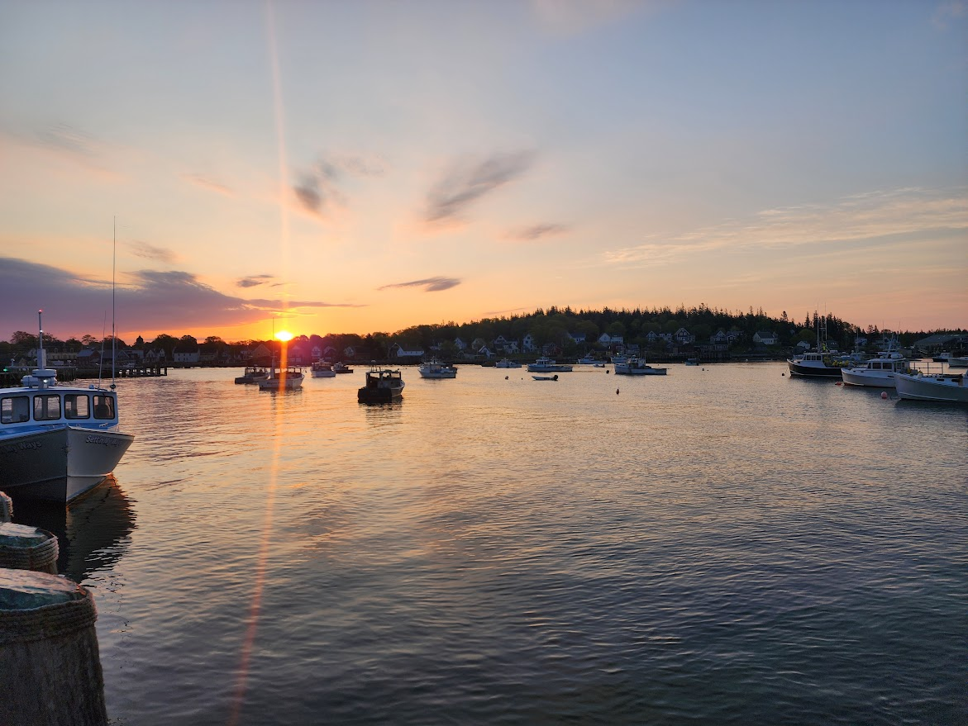 |  | - Day 1, tentatively April 28th – Offshore Saco Bay to Cape Neddick  - Day 2, tentatively April 29th – SE to SW of Isles of Shoals  - Day 3, tentatively April 30th – SE to SW of Boon Island  - Day 4, tentatively May 1st –Offshore Cape Neddick to Saco Bay  - Day 5, tentatively May 2nd - Saco Bay
Week 2 Region 2 – May 5th – May 9th – Casco Bay to Muscongus Bay
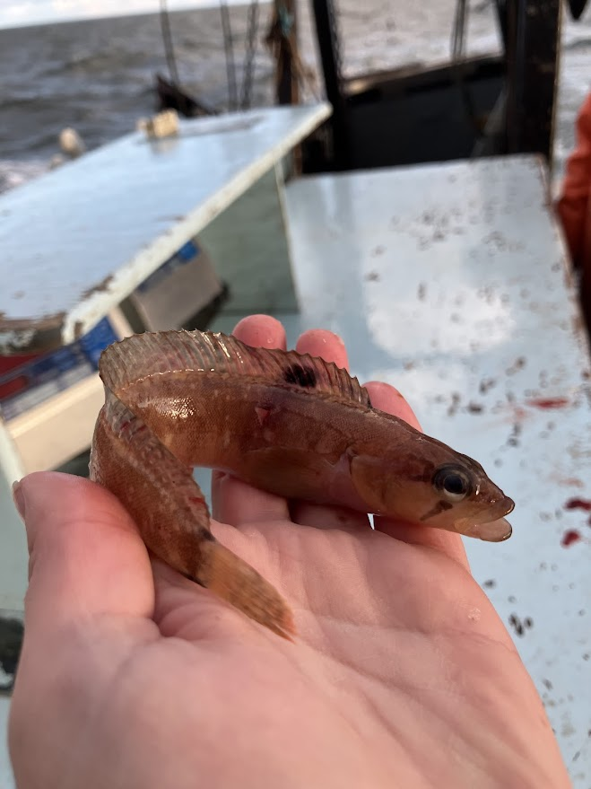 |  | - Day 6, tentatively May 5th – Offshore Casco Bay  - Day 7, tentatively May 6th –Inside Casco Bay to Seguin Island  - Day 8, tentatively May 7th – Sheepscot Bay to S. of Seguin  - Day 9, tentatively May 8th –Offshore SE Outer Pumpkin Ledge  - Day 10, tentatively May 9th –Boothbay Harbor to Muscongus Bay
Week 3 Region 3 – Mat 12th – May 16th –Penobscot Bay Area
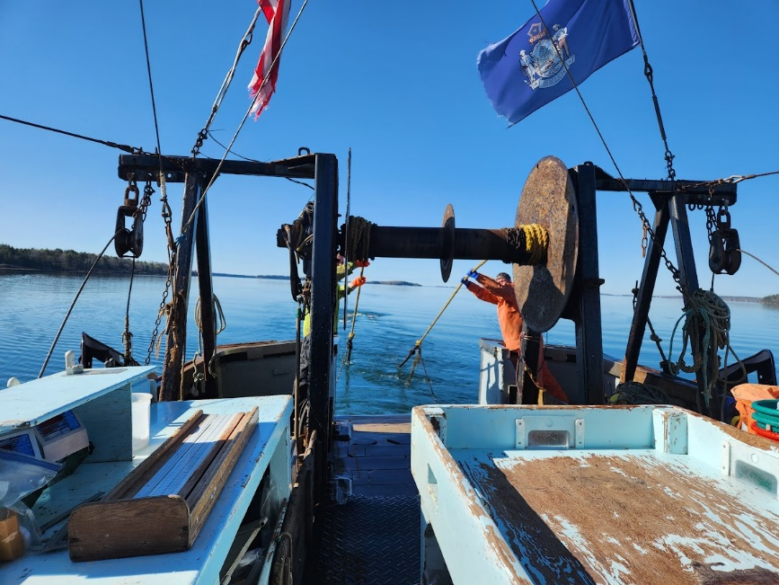 |  | - Day 11, tentatively May 12th – SE of Metinic Island to NW of Matinicus  - Day 12, tentatively May 13th – Inner Penobscot Bay  - Day 13, tentatively May 14th – Offshore E of Monhegan past Matinicus Rock  - Day 14, tentatively May 15th –Offshore SW of Isle Au Haut  - Day 15, tentatively May 16th –Isle au Haut Bay
Week 4 Region 4 – May 19th – May 23rd – Isle Au Haut to Frenchman’s Bay
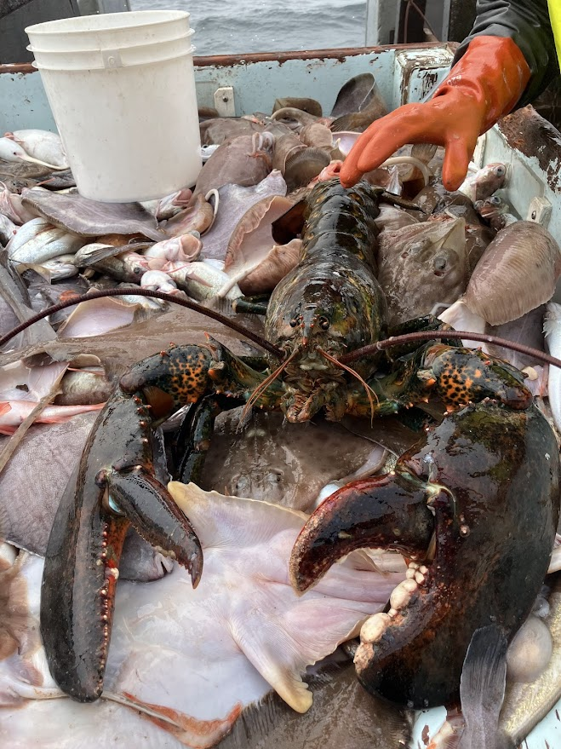 |  | - Day 16, tentatively May 19th – Offshore SE of Isle Au Haut  - Day 17, tentatively May 20th –Jerico Bay to S of Swans to W to N of Great Duck Island  - Day 18 tentatively May 21st – Offfshore S to SE of Swans  - Day 19, tentatively May 22nd – Offshore Schoodic  - Day 20, tentatively May 23rd – Bass Harbor to Blue Hill Falls
Week 5 Region 5 – May 26th – May 30th – Schoodic to Grand Manan Channel
 | - Day 21, tentatively May 26th – Inshore Petit Manan  - Day 22, tentatively May 27th –Offshore Petit Manan  - Day 23, tentatively May 28th - Offshore S. of Great Wass Island  - Day 24, tentatively May 29th –Offshore E to W of Machias Bay  - Day 25, tentatively May 30th - Grand Manan Channel

