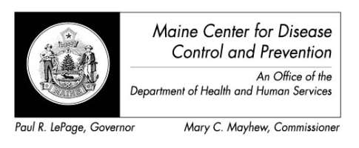

Maine Weekly Arboviral Surveillance Report
August 18, 2014

January 1, 2014 – August 16, 2014:

Humans
 | Number Tested | WNV positive | EEE Positive
Current Week | 3 | 0 | 0
2014 Year to Date | 27 | 0 | 0
Human arboviral testing performed at Maine’s Health and Environmental Testing Laboratory (HETL); testing may be performed year round

Animals
 | Number Tested | WNV positive | EEE Positive
Current Week | 0 | 0 | 0
2014 Year to Date | 0 | 0 | 0
Animal arboviral testing may be performed at HETL or through the National Veterinary Services Laboratory (NVSL); testing may be performed year round

Mosquitoes
 | Pools Tested | WNV positive | EEE Positive
Current Week | 48 | 0 | 0
2014 Year to Date | 112 | 0 | 0
Mosquito arboviral testing performed at HETL; mosquito collection begins July 1 and continues through September 30

Only completed testing is included in this report.

WNV = West Nile Virus
EEE = Eastern Equine Encephalitis

