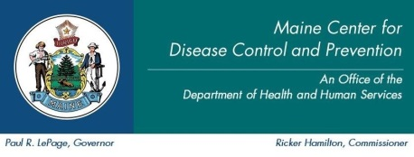
Maine CDC Lyme Disease Awareness Poster Contest: No ticks for ME
Release Waiver

Maine CDC would like to issue a press release announcing the winners of the 2018 Lyme Disease Awareness Poster contest. Also, we will post links to copies of the winning posters on our website http://www.maine.gov/lyme . Your student ____________________________ has entered the Lyme Disease Awareness Poster contest and we are requesting your permission to release their name, school, and poster if they win. If you do not grant permission, the poster may still be used without any identifying information.

- I give permission for my student’s name to be released if they are a winner of the 2018 Lyme Disease Poster contest

- I do not give permission for my child’s name to be released if they are a winner of the 2018 Lyme Disease Poster Contest

Student’s Name: _____________________________________________
Student’s School Name: _______________________________________
Parent / Guardian Name: _______________________________________
Parent / Guardian Signature: ____________________________________ Date: _____________

Thank you for participating!

