STATE OF MAINE
Department of Agriculture, Conservation & Forestry
Bureau of Parks & Lands / Lands Division

RFP# 202403068

Gravel Road Maintenance – Square Lake

RFP Coordinator | All communication regarding the RFP must be made through the RFP Coordinator identified below.  Name: Jacob Guimond Title: Regional Land Manager  Contact Information: Jacob.guimond@maine.gov
Submitted Questions Due | All questions must be received by the RFP Coordinator identified above by:  Date: April 10, 2024, no later than 11:59 p.m., local time
Proposal Submission Deadline | Proposals must be received by the Division of Procurement Services by:  Submission Deadline: April 22, 2024, no later than 11:59 p.m., local time.  Proposals must be submitted electronically to: Proposals@maine.gov

TABLE OF CONTENTS
 | Page
PUBLIC NOTICE | 4
RFP DEFINITIONS/ACRONYMS | 5
PART I INTRODUCTION | 6
- PURPOSE AND BACKGROUND
- GENERAL PROVISIONS
- ELIGIBILITY TO SUBMIT BIDS
- CONTRACT TERMS
- NUMBER OF AWARDS
PART II SCOPE OF SERVICES TO BE PROVIDED | 8
PART III KEY RFP EVENTS | 13
- BIDDERS’ CONFERENCE
- QUESTIONS
- AMENDMENTS
- SUBMITTING THE PROPOSAL
PART IV PROPOSAL SUBMISSION REQUIREMENTS | 15
PART V PROPOSAL EVALUATION AND SELECTION | 18
- EVALUATION PROCESS – GENERAL INFORMATION
- SCORING WEIGHTS AND PROCESS
- SELECTION AND AWARD
- APPEAL OF CONTRACT AWARDS
PART VI CONTRACT ADMINISTRATION AND CONDITIONS | 20
- CONTRACT DOCUMENT
- STANDARD STATE CONTRACT PROVISIONS
PART VII RFP APPENDICES AND RELATED DOCUMENTS | 21
APPENDIX A – PROPOSAL COVER PAGE
APPENDIX B – DEBARMENT, PERFORMANCE, and
NON-COLLUSION CERTIFICATION
APPENDIX C – QUALIFICATIONS and EXPERIENCE FORM
APPENDIX D – ORGANIZATION EQUIPMENT LIST
APPENDIX E – COST PROPOSAL FORM
APPENDIX F – SUBMITTED QUESTIONS FORM
APPENDIX G – VICINITY MAP
APPENDIX H – SINGLE PIPE INSTALLATION
APPENDIX I – RIP RAP INSTALLATION ON CULVERTS
WITH BACKSLOPES > 2:1
APPENDIX J – TYPES AND FUNCTIONS OF DRAINAGE FEATURES
APPENDIX K – WATER TURNOUT DESIGN
APPENDIX L – CULVERT INSTALLATION FOR STREAM CROSSING

TABLE OF CONTENTS
(continued)

APPENDIX M – INSTALLATION BMP DIAGRAM 1
APPENDIX N – INSTALLATION BMP DIAGRAM 2
APPENDIX O – DESIREABLE MINIMUM DIMENSIONS OF
LOW VOLUME GRAVEL ROAD
APPENDIX P – GRAVEL PIT MANAGEMENT STANDARDS
APPENXID Q – SEEDING AND MULCHING STANDARDS
APPENDIX R – SPILL CONTROL AND REPRTING PROCEDURES
APPENDIX S – ROAD MAINTENANCE CONTRACTOR
EVALUATION REPORT

PUBLIC NOTICE

*************************************************

State of Maine
Department of Agriculture, Conservation & Forestry
RFP# 202403068
Gravel Road Maintenance – Square Lake Unit

The State of Maine is seeking proposals for annual maintenance on gravel roads on the Public Lands’ Square Lake Unit in the Northern Region.

A copy of the RFP, as well as the Question & Answer Summary and all amendments related to the RFP, can be obtained at: https://www.maine.gov/dafs/bbm/procurementservices/vendors/rfps

Proposals must be submitted to the State of Maine Division of Procurement Services, via e-mail, at: Proposals@maine.gov. Proposal submissions must be received no later than 11:59 p.m., local time, on April 22, 2024. Proposals will be opened the following business day. Proposals not submitted to the Division of Procurement Services’ aforementioned e-mail address by the aforementioned deadline will not be considered for contract award.

*************************************************

RFP TERMS/ACRONYMS with DEFINITIONS

The following terms and acronyms, as referenced in the RFP, shall have the meanings indicated below:

Term/Acronym | Definition
Department | Department of Agriculture, Conservation & Forestry
RFP | Request for Proposal
State | State of Maine
Bureau | Bureau of Parks & Lands
BMP | Best Management Practices
DEP | Department of Environmental Protection
OSHA | Occupational Safety and Health Administration

State of Maine - Department of Agriculture, Conservation & Forestry
Bureau of Parks & Lands / Northern Region
RFP# 202403068
Gravel Road Maintenance – Square Lake Unit

PART I INTRODUCTION

- Purpose and Background

The Department of Agriculture, Conservation & Forestry (Department) is seeking gravel road maintenance services as defined in this Request for Proposal (RFP) document. This document provides instructions for submitting proposals, the procedure and criteria by which the awarded Bidder will be selected, and the contractual terms which will govern the relationship between the State of Maine (State) and the awarded Bidder.

- General Provisions

  - From the time the RFP is issued until award notification is made, all contact with the State regarding the RFP must be made through the RFP Coordinator. No other person/ State employee is empowered to make binding statements regarding the RFP. Violation of this provision may lead to disqualification from the bidding process, at the State’s discretion.
  - Issuance of the RFP does not commit the Department to issue an award or to pay expenses incurred by a Bidder in the preparation of a response to the RFP. This includes attendance at personal interviews or other meetings and software or system demonstrations, where applicable.
  - All proposals must adhere to the instructions and format requirements outlined in the RFP and all written supplements and amendments (such as the Summary of Questions and Answers), issued by the Department. Proposals are to follow the format and respond to all questions and instructions specified below in the “Proposal Submission Requirements” section of the RFP.
  - Bidders will take careful note that in evaluating a proposal submitted in response to the RFP, the Department will consider materials provided in the proposal, information obtained through interviews/presentations (if any), and internal Departmental information of previous contract history with the Bidder (if any). The Department also reserves the right to consider other reliable references and publicly available information in evaluating a Bidder’s experience and capabilities.
  - The proposal must be signed by a person authorized to legally bind the Bidder and must contain a statement that the proposal and the pricing contained therein will remain valid and binding for a period of 180 days from the date and time of the bid opening.
  - The RFP and the awarded Bidder’s proposal, including all appendices or attachments, will be the basis for the final contract, as determined by the Department.
  - Following announcement of an award decision, all submissions in response to this RFP will be public records, available for public inspection pursuant to the State of Maine Freedom of Access Act (FOAA) (1 M.R.S. § 401 et seq.).
  - The Department, at its sole discretion, reserves the right to recognize and waive minor informalities and irregularities found in proposals received in response to the RFP.
  - All applicable laws, whether or not herein contained, are included by this reference. It is the Bidder’s responsibility to determine the applicability and requirements of any such laws and to abide by them.
- Contract Term

The Department is seeking a cost-efficient proposal to provide services, as defined in the RFP, for the anticipated contract period defined in the table below. Please note, the dates below are estimated and may be adjusted, as necessary, in order to comply with all procedural requirements associated with the RFP and the contracting process. The actual contract start date will be established by a completed and approved contract.

Contract Renewal: Following the initial term of the contract, the Department may opt to renew the contract for up to four renewal periods, as shown in the table below, and subject to continued availability of funding and satisfactory performance.

The term of the anticipated contract, resulting from the RFP, is defined as follows:

Period | Start Date | End Date
Initial Period of Performance | 6/1/2024 | 5/31/2025
Renewal Period #1 | 6/1/2025 | 5/31/2026
Renewal Period #2 | 6/1/2026 | 5/31/2027
Renewal Period #3 | 6/1/2027 | 5/31/2028
Renewal Period #4 | 6/1/2028 | 5/31/2029

- Number of Awards

The Department anticipates making one (1) award as a result of the RFP process.

PART II SCOPE OF SERVICES TO BE PROVIDED

The road maintenance project consists of maintaining approximately 18 miles of gravel road in the Square Lake Unit (see Appendix G – location map). The focus of the project is road grading, ditching, spot graveling and culvert replacement.

- Grading shall take place by October 1 of each year of the contract.
- Basis for Renewal – the annual renewal of the contract will be based on several performance measures, including attaining an average score of 90 on the Road Maintenance Contractor Evaluation Reports (Appendix S) at the end of each year, completing the project on time, and an analysis of the staff time commitment needed to achieve the desired results.
- Completion of Work: All annual maintenance work, other than grading, shall be substantially completed by August 31 of each year.
- Prior to a contract being awarded, the selected contractor shall have at least one operator on-site be certified by DEP in sedimentation erosion control. Proof of this certification is mandatory.
- All activities must follow State of Maine regulations:
https://legislature.maine.gov/ros/maine-constitution-statutes-and-law/9574
- Work shall be done in accordance with the following specifications and descriptions:

Culvert Specifications

- Culverts will be established or replaced in such locations as the Contract Administrator directs, if deemed necessary. The State will supply culverts, gravel, seed, and hay.
- The old culverts and debris from the previous structure shall be excavated and buried on site outside of the roadway with minimal disturbance or disposed of in a location chosen by the Contract Administrator.
- Excavation will develop a trench to the depth, width and side slopes as specified in Appendix H - Single Pipe Installation. All mulch, organic material and any wood shall be removed. The culvert shall be placed in a trench with the invert at the same elevation as the ditch bottom.
- A bedding blanket of loose granular fill meeting the specification of backfill shall be placed under the culvert on undisturbed soil to the width equal to twice the diameter of the culvert. The thickness of the bedding blanket shall be a minimum of 4 inches.
- All culverts should have a minimum slope of ¼ inch per foot. See Appendix I – Rip Rap Installation on Culverts with BackSlopes>2:1.
- All cross-drainage culverts installed on a slope in the road shall be installed at approximately a 60-degree angle downslope from a line perpendicular to the center line of the road. A rock armored berm shall be constructed in the ditch at the invert to direct water into the culvert. See Appendix J – Types and Functions of Drainage Features. Rock armor specifications shall be the same as for rip rap as described below.
- Any culverts that require collars shall have the bolted portion of the collar placed on the lower half of the pipe.
- A minimum of 24 cubic yards of gravel or ledge shall be imported from Bureau pits for each culvert installation. All culverts shall be covered to the full width of the road with clean gravel which shall not contain stones or rock fragments larger than 4 inches, and to a depth over their top no less than half the diameter of the pipe or 12 inches, whichever is greater. The finished grade over the culvert shall be slightly higher (3-4 inches maximum) than the existing road to allow for settling. Extra backfill shall be tapered over the culvert such that there is no abrupt change in grade. In addition, backfill shall not contain sod, frozen material or organic matter. See Appendix H - Single Pipe Installation.
- Taildrains shall grade away from the outlet of the culvert a minimum of 1% to a point where the water is able to disperse onto undisturbed ground. Taildrains shall be graded to the extent that puddles will not form. In no case shall water be allowed to back up into the outlet of the culvert. Taildrains shall be shaped and sloped per ditching specifications.
- Both inlet and outlet ends of the pipe shall be rip rapped with stone, as shown in Appendix I – Rip Rap Installation on Culverts with BackSlopes>2:1. Material used for rip rap shall consist of a mix of stone, which shall weigh from 10 pounds to 50 pounds (or a D50 of 12 inches). Stone shall be laid from the toe of the slope to a point above the culvert top to a slope of 2:1, and so that the pieces interlock, have a minimum of voids and are reasonably stable. Stones shall not be placed so as to protrude above the elevation of the road surface. Rip rap shall also be placed in the same manner as above on any berm that is required to direct water into the culvert.
- All exposed mineral soil shall be stabilized at the completion of the project with seed and mulch per specifications in Appendix Q - Seeding and Mulching.

Stream Crossing Specifications

- Stream crossings will only be installed under the direct supervision of the Contract Administrator.
- Disturbance of the stream channel shall be limited to the portion of the stream that is intersected by the road profile. Debris immediately upstream from the culvert inlet that may plug the culvert shall be removed if it can be done without disturbing the stream channel.
- When installing culverts, backfill materials are to be clean, non-erodible and non-toxic to aquatic life.
- Culverts less than or equal to 30 inches in diameter will be placed at least 8 inches deeper than the stream bed and larger culverts will be placed at a depth specified by the Contract Administrator.
- Culverts will be placed on the same slope (gradient) as the stream and in no case shall the cut in the stream bed exceed the depth required in number 4 above.
- Sides of the culvert will be compacted in 6-inch lifts with a vibrating compactor or jumping jack compactor provided by the contractor at the compactor and labor bid rates.
- On stream crossing installations, enough gravel shall be placed over the culvert to ensure that the road surface at the culvert location is higher than the road surface 25 feet either side of the culvert.
- Culvert inlets and outlets will be armored to reduce bank and channel erosion and sedimentation. Geotextile will be placed under rip rap and will be provided by the Bureau of Parks & Lands.
- All exposed mineral soil shall be stabilized at the end of each day’s work with seed and mulch per specifications in Appendix Q - Seeding and Mulching.

Spot Graveling

- Any spot graveling shall consist of placing suitable gravel from Bureau-owned pits in potholes, washouts and other areas selected by the Contract Administrator in order to restore a typical road section as shown in Appendix O – Desirable Minimum Dimensions of a Low-Volume Gravel Road.
- Payment for spot graveling shall be made on a per cubic yard truck measure basis. Payment shall be made at the bid cubic yard price, which price shall be full compensation for the extraction, loading, hauling, spreading, compacting and shaping of material as required to complete the work. Stripping of material from the pit shall be paid for under equipment rental. Measurement will be made in the truck by the volume and will be determined by truck count and substantiated by the owner’s tally, taken on site.
- Gravel required for culvert installation or other pay items shall not be paid for in this item but be included in the other items.
- The aggregate material shall be spread evenly in one layer to a depth that will ensure the required depth after being compacted.
- Gravel placed will be adequately compacted and smoothed so as to provide a smooth driving surface matching the profile shown in Appendix O – Desirable Minimum Dimensions of a Low-Volume Gravel Road.
- When screening is required, it will be paid for separately.
- Material will be supplied from the Bureau pits at no gravel stumpage cost to the contractor. Should gravel not owned by the Bureau of Parks & Lands be required, the Bureau will pay all stumpage costs and the ‘Spot Gravel’ rate will be re-negotiated if there is a significant difference in the haul distance from the Bureau pit.
- Gravel Pit Management shall be adhered to as described in Appendix P - Gravel Pit Management Standards.

Grading and Rock Raking

- Grading and raking shall consist of sufficient passes by a grader and attached rock rake to cut to the bottom of all potholes and washboards, restore a crown, smooth the wearing surface of the road, and to develop the shape in accordance with Appendix O – Desirable Minimum Dimensions of a Low-Volume Gravel Road.
- Grading and raking shall be paid for at a per mile rate. Payment shall be made at the bid rate per mile, which price shall be full compensation for all grading, shaping, crowning, raking and incidental work necessary to shaping and crowning of the road in accordance with the specifications. Payment will be made to the nearest foot. No payment will be made for equipment moving costs. Removal and disposal of excessive hazardous materials, such as rocks and brush, shall be paid for under Equipment Rental, not under this pay item.
- It is intended that the annual grading prior to October 1 each year. Failure to comply with this schedule may be cause for termination of the contract due to non-compliance. Grading may occur during other time periods depending on road conditions.
- In no case shall any gravel be pulled onto a bridge through the process of grading and raking.
- Grader and rake work will extend inward from the edge of each ditch.
- The existing road shall be cut such that all potholes are cut out to the bottom, not filled in.
- Material pulled into the road shall be used to crown the road ¼” – ½” per foot of lane width.
- In some cases, minor ditching may be required with the grader.
- Rock raking will be accomplished by towing the rake behind the grader if appropriate, or behind another prime mover as a separate pass.
- All organic material and large rocks shall be raked off the low side of the road upon completion of the grading, not into the ditch. If this is not possible because the road is lower than the adjacent ground on both sides, then the material shall be placed in a location approved by the Contract Administrator and paid for under the equipment rental.
- In no case shall a berm be formed and left between the shoulder and the ditch.

Ditching

- Ditching work shall consist of reestablishing ditch lines on existing gravel roads with an excavator to a road profile show in Appendix O – Desirable Minimum Dimensions of a Low-Volume Gravel Road. It shall include grubbing, which consists of the removal and disposal of all stumps, roots, bushes, grass, turf or other objectionable material.
- Payment for ditching shall be made at the bid lineal foot price, which price shall include full compensation for excavation, insloping, backsloping, placement of ditch material (either in a truck or on the opposite side of the road), leveling of ditch material and soil stabilization. Payment will be made based on linear footage of ditching done as measured along the bottom of the ditch. It shall not include trucking of excavated material when required but will include leveling of such material. Trucking will be paid for under equipment rental.
- All ditches will be shaped with no hard transitions in slopes. The shape should be rounded (parabolic) to minimize erosion and water velocities. V-ditches are unacceptable.
- The grade of ditch flow lines should have a minimum of 1% and shall never be less than 0.5%. Ditches shall be graded to the extent that puddles will not form.
- If the depth of base gravel is unknown, then the ditch should be a minimum of 18 inches below the shoulder elevation.
- All slopes will be no steeper than 2:1 (Horizontal to Vertical), unless trees larger than 2 inches at the stump are encountered along the backslope. In that case, a steeper slope will be accepted. Ditching within 75 feet of a stream must be 2:1 without exception per Land Use Planning Commission’s regulations. Slopes shall not be smoothed so that they might accept seed and mulch more effectively. If slopes are smoothed, they will require raking per Maine Department of Transportation specs prior to seeding.
- No gravel, sod berm or windrow will be left in between the road and the ditch slope.
- Excavated material shall be placed on the low side of the road outside of the travel surface and leveled to an elevation lower than the road shoulder. Ditched borrow shall be used to cover grubbed debris. If this is not possible, then the material will be hauled to a site designated by the Contract Administrator with trucking paid for under equipment rental rates.
- All exposed soil shall be seeded and mulched at the completion of the project per Appendix Q - Seeding and Mulching. Seed and mulch shall be provided by the Contract Administrator.
- Water turnouts will be paid for under ditching. Work will include installation of water turnouts so as to comply with the specifications shown in Appendix K - Water Turnout Design. The grade should be such that all water exits the excavated area and does not “stand” in the turnout. Special attention shall be paid to rip rapping a berm that diverts the water from the ditch to the water turnout. Material used for rip rap shall consist of a mix of stone which shall weigh from 10 pounds to 30 pounds (or a D50 of 12 inches). The berm height must be 6 inches below the top of the ditch so that any overflow continues down the ditch and not down the road.

Miscellaneous Equipment Rental

- This shall consist of furnishing, operating, maintaining and supervising the use of construction equipment when and where authorized by the Contract Administrator to carry out incidental work not included in other items of the contract.
- The equipment shall conform to the following minimum requirements:
- The bulldozer shall be crawler type with a six-way push blade and shall be 8-ton minimum operating weight.
- Large bulldozer shall be crawler type with 15-ton minimum operating weight
- Tracked Excavator: it is anticipated that the majority of the work not done on a per unit basis will be accomplished with an excavator. This must have a hydraulically adjustable thumb and shall be 13-ton or 25-ton operating weights.
- The truck shall have a dump body with a 14 cubic yard capacity.
- Truck & Lowbed: lowbed must be a minimum of 50 feet in length.
- The compactor shall have a 23-inch x 16-inch plate minimum and a 200 pound total weight maximum.

General Specifications

- Maintenance activities will be suspended during rain events resulting in greater than ½ inch of rain.
- Maintenance will be allowed to resume after conditions dry as determined by the Contract Administrator.
- Weekly quality reviews will be exercised by the Contract Administrator to evaluate contractor performance and BMP conformance. (See Appendix S – Road Maintenance Contractor Evaluation Report.)
- Road maintenance will only be allowed Monday through Friday during daylight hours, no weekends or nights.
- Work will only be performed when requested by the Contract Administrator.
- Road maintenance will cease if a 12 inch or greater snowfall event occurs, unless otherwise specified by the Contract Administrator.
- Any work that is not authorized will not be paid for.
- The road grading will be deemed finished when the surface is smooth and crowned and ready for traffic. If the material is too saturated to smooth with the grader or if the road is frozen, the contractor will return at a later date to spread the dry road surface and crown the road (in dry conditions). This may require coming back with a grader to complete the road project.
- No litter or garbage is to be left on site or along the road.
- The Contract Administrator shall have the right to temporarily stop any and all activities under the resulting agreement in the event it is deemed necessary to protect roads, soils, water, growth or other resources. In such case, the Bureau shall not be liable for any damage, lost profits or consequential damage that the contractor may incur.
- Safety – contractor will follow all Federal OSHA requirements, found at https://www.osha.gov/dcsp/osp/stateprogs/maine.html
- All contractors must abide by Spill Control and Reporting Procedures as described in Appendix R.

PART III KEY RFP EVENTS

- Questions

  - General Instructions: It is the responsibility of all Bidders and other interested parties to examine the entire RFP and to seek clarification, in writing, if they do not understand any information or instructions.
    - Bidders and other interested parties should use Appendix E (Submitted Questions Form) for submission of questions. The form is to be submitted as a WORD document.
    - The Submitted Questions Form must be submitted, by e-mail, and received by the RFP Coordinator identified on the cover page of the RFP as soon as possible but no later than the date and time specified on the RFP cover page.
    - Submitted Questions must include the RFP Number and Title in the subject line of the e-mail. The Department assumes no liability for assuring accurate/complete/on time e-mail transmission and receipt.

  - Question & Answer Summary: Responses to all questions will be compiled in writing and posted on the following website no later than seven (7) calendar days prior to the proposal due date: Division of Procurement Services RFP Page. It is the responsibility of all interested parties to go to this website to obtain a copy of the Question & Answer Summary. Only those answers issued in writing on this website will be considered binding.

- Amendments

All amendments released in regard to the RFP will also be posted on the following website: Division of Procurement Services RFP Page. It is the responsibility of all interested parties to go to this website to obtain amendments. Only those amendments posted on this website are considered binding.

- Submitting the Proposal

  - Proposals Due: Proposals must be received no later than 11:59 p.m. local time, on the date listed on the cover page of the RFP.
    - Any e-mails containing original proposal submissions or any additional or revised proposal files, received after the 11:59 p.m. deadline, will be rejected without exception.

  - Delivery Instructions: E-mail proposal submissions are to be submitted to the State of Maine Division of Procurement Services at Proposals@maine.gov.
    - Only proposal submissions received by e-mail will be considered. The Department assumes no liability for assuring accurate/complete e-mail transmission and receipt.
      - Proposal submission e-mails that are successfully received by the proposals@maine.gov inbox will receive an automatic reply stating as such.
    - E-mails containing links to file sharing sites or online file repositories will not be accepted as submissions. Only e-mail proposal submissions that have the actual requested files attached will be accepted.
    - Encrypted e-mails received which require opening attachments and logging into a proprietary system will not be accepted as submissions. Please check with your organization’s Information Technology team to ensure that your security settings will not encrypt your proposal submission.
    - File size limits are 25MB per e-mail. Bidders may submit files separately across multiple e-mails, as necessary, due to file size concerns. All e-mails and files must be received by the due date and time listed above.
    - Bidders are to insert the following into the subject line of their e-mail proposal submission: “RFP# 202403068 Proposal Submission – [Bidder’s Name]”
    - Bidder’s proposals are to be submitted as a single PDF file and include the following:
  - Appendix A (Proposal Cover Page)
  - Appendix B (Debarment, Performance and Non-collusion Certification
  - Appendix P (Gravel Pit Management Standards)
  - Appendix Q (Seeding and Mulching Standards)
  - Appendix R (Spill Control and Reporting Procedures)
  - Appendix C (Organization Qualifications and Experience Form)
  - Appendix D (Equipment List)
  - Appendix E (Cost Proposal Form)

PART IV PROPOSAL SUBMISSION REQUIREMENTS

This section contains instructions for Bidders to use in preparing their proposals. The Department seeks detailed yet succinct responses that demonstrate the Bidder’s qualifications, experience, and ability to perform the requirements specified throughout the RFP.

The Bidder’s proposal must follow the outline used below, including the numbering, section, and sub-section headings. Failure to use the outline specified in PART IV, or failure to respond to all questions and instructions throughout the RFP, may result in the proposal being disqualified as non-responsive or receiving a reduced score. The Department, and its evaluation team, has sole discretion to determine whether a variance from the RFP specifications will result either in disqualification or reduction in scoring of a proposal. Rephrasing of the content provided in the RFP will, at best, be considered minimally responsive.

Bidders are not to provide additional attachments beyond those specified in the RFP for the purpose of extending their response. Additional materials not requested will not be considered part of the proposal and will not be evaluated. Include any forms provided in the submission package or reproduce those forms as closely as possible. All information must be presented in the same order and format as described in the RFP.

Proposal Format and Contents

Section I Preliminary Information

  - Proposal Cover Page
Bidders must complete Appendix A (Proposal Cover Page). It is critical that the cover page shows the specific information requested, including Bidder address(es) and other details listed. The Proposal Cover Page must be dated and signed by a person authorized to enter into contracts on behalf of the Bidder.

  - Debarment, Performance and Non-Collusion Certification
Bidders must complete Appendix B (Debarment, Performance and Non-Collusion Certification Form). The Debarment, Performance and Non-Collusion Certification Form must be dated and signed by a person authorized to enter into contracts on behalf of the Bidder.

  - Gravel Pit Management Standards Sign-off Form
Bidders must complete Appendix P (Gravel Pit Management Standards). The Gravel Pit Management Standards sign-off form must be signed and dated by a person authorized to enter into contracts on behalf of the Bidder.

  - Seeding and Mulching Sign-off Form
Bidders must complete Appendix Q (Seeding and Mulching Standards). The Seeding and Mulching Standards sign-off form must be signed and dated by a person authorized to enter into contracts on behalf of the Bidder.

  - Spill Control and Reporting Procedures Sign-off Form
Bidders must complete Appendix R (Spill Control and Reporting Procedures). The Spill Control and Reporting Procedures sign-off form must be signed and dated by a person authorized to enter into contracts on behalf of the Bidder.

Section II Organization Qualifications and Experience

  - Overview of the Organization
Bidders must complete Appendix C (Qualifications and Experience Form) describing their qualifications and skills to provide the requested services in the RFP. Bidders must include three examples of projects which demonstrate their experience and expertise in performing these services as well as highlighting the Bidder’s stated qualifications and skills.

  - Subcontractors
If subcontractors are to be used, Bidders must provide a list that specifies the name, address, phone number, contact person, and a brief description of the subcontractors’ organizational capacity and qualifications.

  - Organizational Chart
Bidders must provide an organizational chart. The organizational chart must include the project being proposed. Each position must be identified by position title and corresponding to the personnel job descriptions.

  - Litigation
Bidders must attach a list of all current litigation in which the Bidder is named and a list of all closed cases that have closed within the past five (5) years in which the Bidder paid the claimant either as part of a settlement or by decree. For each, list the entity bringing suit, the complaint, the accusation, amount, and outcome.

  - Certificate of Insurance
Bidders must provide a certificate of insurance on a standard ACORD form (or the equivalent) evidencing the Bidder’s general liability, professional liability and any other relevant liability insurance policies that might be associated with the proposed services.

Section III Cost Proposal

  - General Instructions
- Bidders must submit a cost proposal that covers the period starting June 1, 2024 and ending on May 31, 2029. The initial period will be covered on Appendix E (Cost Proposal Form) and subsequent contract periods will be subject to the Price Escalator Clause as outlined on the Cost Proposal Form.
- The cost proposal must include costs necessary for the Bidder to fully comply with the contract terms and conditions and RFP requirements.
- No costs related to the preparation of the proposal of the RFP, or to the negotiation of the contract with the Department, may be included in the proposal. Only costs to be incurred after the contract effective date that are specifically related to the implementation of or operation of contracted services may be included.

  - Cost Proposal Form Instructions
Bidders must complete Appendix E following the instructions. Failure to provide the requested information and to follow the required cost proposal format provided may result in the exclusion of the proposal form consideration, at the discretion of the Department.

Section IV Organization Equipment List

- Bidders must complete Appendix D (Equipment List) according to the instructions on the form. Failure to provide the requested information may result in the exclusion of the proposal from consideration, at the discretion of the Department.

PART V PROPOSAL EVALUATION AND SELECTION

Evaluation of the submitted proposals will be accomplished as follows:

- Evaluation Process – General Information

  - An evaluation team, composed of qualified reviewers, will judge the merits of the proposals received in accordance with the criteria defined in the RFP.
  - Officials responsible for making decisions on the award selection will ensure that the selection process accords equal opportunity and appropriate consideration to all who are capable of meeting the specifications. The goals of the evaluation process are to ensure fairness and objectivity in review of the proposals and to ensure that the contract is awarded to the Bidder whose proposal provides the best value to the State of Maine.
  - The Department reserves the right to communicate and/or schedule interviews/presentations with Bidders, if needed, to obtain clarification of information contained in the proposals received. The Department may revise the scores assigned in the initial evaluation to reflect those communications and/or interviews/presentations. Changes to proposals, including updating or adding information, will not be permitted during any interview/presentation process and, therefore, Bidders must submit proposals that present their rates and other requested information as clearly and completely as possible.

- Scoring Weights and Process

  - Scoring Weights: The score will be based on a 100-point scale and will measure the degree to which each proposal meets the following criteria.

Section I. Preliminary Information (No Points)
Includes all elements addressed above in Part IV, Section I.

Section II. Organization Qualifications and Experience (15 points)
Includes all elements addressed above in Part IV, Section II.

Section III. Cost Proposal (75 points)
Includes all elements addressed above in Part IV, Section III.

Section IV. Equipment List (10 points)
Includes all elements addressed above in Part IV, Section IV.

  - Scoring Process: For proposals that demonstrate meeting the eligibility requirements in Section I, the evaluation team will use a consensus approach to evaluate and score Sections II & IV above. Members of the evaluation team will not score those sections individually but, instead, will arrive at a consensus as to assignment of points for each of those sections. Section III, the Cost Proposal, will be scored as described below.

  - Scoring the Cost Proposal: The total cost proposed for conducting all the functions specified in the RFP will be assigned a score according to a mathematical formula. The lowest bid will be awarded 75 points. Proposals with higher bids values will be awarded proportionately fewer points calculated in comparison with the lowest bid.

The scoring formula is:

(Lowest submitted cost proposal / Cost of proposal being scored) x 75 = pro-rated score

No Best and Final Offers: The State of Maine will not seek or accept a best and final offer (BAFO) from any Bidder in this procurement process. All Bidders are expected to provide their best value pricing with the submission of their proposal.

  - Negotiations: The Department reserves the right to negotiate with the awarded Bidder to finalize a contract. Such negotiations may not significantly vary the content, nature or requirements of the proposal or the Department’s Request for Proposal to an extent that may affect the price of goods or services requested. The Department reserves the right to terminate contract negotiations with an awarded Bidder who submits a proposed contract significantly different from the proposal they submitted in response to the advertised RFP. In the event that an acceptable contract cannot be negotiated with the highest ranked Bidder, the Department may withdraw its award and negotiate with the next-highest ranked Bidder, and so on, until an acceptable contract has been finalized. Alternatively, the Department may cancel the RFP, at its sole discretion.

- Selection and Award

  - The final decision regarding the award of the contract will be made by representatives of the Department subject to approval by the State Procurement Review Committee.
  - Notification of conditional award selection or non-selection will be made in writing by the Department.
  - Issuance of the RFP in no way constitutes a commitment by the State of Maine to award a contract, to pay costs incurred in the preparation of a response to the RFP, or to pay costs incurred in procuring or contracting for services, supplies, physical space, personnel or any other costs incurred by the Bidder.
  - The Department reserves the right to reject any and all proposals or to make multiple awards.

- Appeal of Contract Awards

Any person aggrieved by the award decision that results from the RFP may appeal the decision to the Director of the Bureau of General Services in the manner prescribed in 5 M.R.S.A. § 1825-E and 18-554 Code of Maine Rules Chapter 120. The appeal must be in writing and filed with the Director of the Bureau of General Services, 9 State House Station, Augusta, Maine, 04333-0009 within 15 calendar days of receipt of notification of conditional contract award.

PART VI CONTRACT ADMINISTRATION AND CONDITIONS

- Contract Document

  - The awarded Bidder will be required to execute a State of Maine Service Contract with appropriate riders as determined by the issuing department.

The complete set of standard State of Maine Service Contract documents, along with other forms and contract documents commonly used by the State, may be found on the Division of Procurement Services’ website at the following link: Division of Procurement Services Forms Page

  - Allocation of funds is final upon successful negotiation and execution of the contract, subject to the review and approval of the State Procurement Review Committee. Contracts are not considered fully executed and valid until approved by the State Procurement Review Committee and funds are encumbered. No contract will be approved based on an RFP which has an effective date less than fourteen (14) calendar days after award notification to Bidders. (Referenced in the regulations of the Department of Administrative and Financial Services, Chapter 110, § 3(B)(i).)

This provision means that a contract cannot be effective until at least 14 calendar days after award notification.

  - The State recognizes that the actual contract effective date depends upon completion of the RFP process, date of formal award notification, length of contract negotiation, and preparation and approval by the State Procurement Review Committee. Any appeals to the Department’s award decision(s) may further postpone the actual contract effective date, depending upon the outcome. The contract effective date listed in the RFP may need to be adjusted, if necessary, to comply with mandated requirements.

  - In providing services and performing under the contract, the awarded Bidder must act as an independent contractor and not as an agent of the State of Maine.

- Standard State Contract Provisions

  - Contract Administration
Following the award, a Contract Administrator from the Department will be appointed to assist with the development and administration of the contract and to act as administrator during the entire contract period. Department staff will be available after the award to consult with the awarded Bidder in the finalization of the contract.

  - Payments and Other Provisions
The State anticipates paying the Contractor on the basis of net 30 payment terms, upon the receipt of an accurate and acceptable invoice. An invoice will be considered accurate and acceptable if it contains a reference to the State of Maine contract number, contains correct pricing information relative to the contract, and provides any required supporting documents, as applicable, and any other specific and agreed-upon requirements listed within the contract that results from the RFP.

PART VII LIST OF RFP APPENDICES AND RELATED DOCUMENTS

Appendix A – Proposal Cover Page

Appendix B – Debarment, Performance, and Non-Collusion Certification

Appendix C – Qualifications and Experience Form

Appendix D – Equipment List

Appendix E – Cost Proposal Form

Appendix F – Submitted Question Form

Appendix G – Vicinity Map

Appendix H – Single Pipe Installation

Appendix I – Rip Rap Installation on Culverts with Backslopes > 2:1

Appendix J – Types and Functions of Drainage Features

Appendix K – Water Turnout Design

Appendix L – Culvert Installation for Stream Crossing

Appendix M – Culvert Installation BMP Diagram 1

Appendix N – Culvert Installation BMP Diagram 2

Appendix O – Desirable Minimum Dimensions of a Low-Volume Gravel Road

Appendix P – Gravel Pit Management Standards Sign-off Form

Appendix Q – Seeding and Mulching Standards Sign-off Form

Appendix R – Spill Control and Reporting Procedures Sign-off Form

Appendix S – Road Maintenance Contractor Evaluation Report

APPENDIX A
State of Maine
Department of Agriculture, Conservation & Forestry

PROPOSAL COVER PAGE
RFP# 202403068
Gravel Road Maintenance – Square Lake

Bidder’s Organization Name:
Chief Executive - Name/Title:
Tel: |  |  | E-mail:
Headquarters Street Address:
Headquarters City/State/Zip:
(Provide information requested below if different from above)
Lead Point of Contact for Proposal - Name/Title:
Tel: |  |  | E-mail:
Headquarters Street Address:
Headquarters City/State/Zip:

- This proposal and the pricing structure contained herein will remain firm for a period of 180 days from the date and time of the bid opening.
- No personnel currently employed by the Department or any other State agency participated, either directly or indirectly, in any activities relating to the preparation of the Bidder’s proposal.
- No attempt has been made, or will be made, by the Bidder to induce any other person or firm to submit or not to submit a proposal.
- The above-named organization is the legal entity entering into the resulting contract with the Department if they are awarded the contract.
- The undersigned is authorized to enter contractual obligations on behalf of the above-named organization.

To the best of my knowledge, all information provided in the enclosed proposal, both programmatic and financial, is complete and accurate at the time of submission.
Name (Print): | Title:
Authorized Signature: | Date:

APPENDIX B

State of Maine
Department of Agriculture, Conservation & Forestry
DEBARMENT, PERFORMANCE, and NON-COLLUSION CERTIFICATION
RFP# 202403068
Gravel Road Maintenance – Square Lake

Bidder’s Organization Name:

By signing this document, I certify to the best of my knowledge and belief that the aforementioned organization, its principals and any subcontractors named in this proposal:
- Are not presently debarred, suspended, proposed for debarment, and declared ineligible or voluntarily excluded from bidding or working on contracts issued by any governmental agency.
- Have not within three years of submitting the proposal for this contract been convicted of or had a civil judgment rendered against them for:
  - Fraud or a criminal offense in connection with obtaining, attempting to obtain, or performing a federal, state, or local government transaction or contract.
  - Violating Federal or State antitrust statutes or committing embezzlement, theft, forgery, bribery, falsification or destruction of records, making false statements, or receiving stolen property.
- Are not presently indicted for or otherwise criminally or civilly charged by a governmental entity (Federal, State or Local) with commission of any of the offenses enumerated in paragraph (b) of this certification.
- Have not within a three (3) year period preceding this proposal had one or more federal, state, or local government transactions terminated for cause or default.
- Have not entered into a prior understanding, agreement, or connection with any corporation, firm, or person submitting a response for the same materials, supplies, equipment, or services and this proposal is in all respects fair and without collusion or fraud. The above-mentioned entities understand and agree that collusive bidding is a violation of state and federal law and can result in fines, prison sentences, and civil damage awards.
Name (Print): | Title:
Authorized Signature: | Date:

APPENDIX C

State of Maine
Department of Agriculture, Conservation & Forestry

QUALIFICATIONS and EXPERIENCE FORM
RFP# 202403068
Gravel Road Maintenance – Square Lake

Bidder’s Organization Name:

Present a brief statement of qualifications. Describe the history of the Bidder’s organization, especially regarding skills pertinent to the specific work required by the RFP and any special or unique characteristics of the organization which would make it especially qualified to perform the required work activities. You may expand this form and use additional pages to provide this information.

APPENDIX C (continued)

Provide a description of projects that occurred within the past five years which reflect experience and expertise needed in performing the functions described in Part II – Scope of Services to be Provided of the RFP. Please note that contract history with the State of Maine, whether positive or negative, may be considered in rating proposals even if not provided by the Bidder.

If the Bidder has not provided similar services, note this, and describe experience with projects that highlight the Bidder’s general capabilities.

Project One
Client Name:
Client Contact Person:
Telephone:
E-Mail:
Brief Description of Project

Project Two
Client Name:
Client Contact Person:
Telephone:
E-Mail:
Brief Description of Project

Project Three
Client Name:
Client Contact Person:
Telephone:
E-Mail:
Brief Description of Project

APPENDIX D
State of Maine
Department of Agriculture, Conservation & Forestry

ORGANIZATION EQUIPMENT LIST
RFP# 202403068
Gravel Road Maintenance – Square Lake

The Cost Proposal Form-Bid Sheet (Appendix E) both specifies the size and type of equipment the Department requires for the project. The information provided on Appendix D – Equipment List will assist the Department in assessing the capabilities for completing the project. Bidders can add rows to this form if need be. Bidders must specify the year, make and model of all equipment relative to maintaining gravel roads, paying particular attention to those items requested on the Cost Proposal Form.

Equipment Description (Year, Make, Model)

Company Name: _____________________________________________________

Contractor Name: ____________________________________________________

APPENDIX E

State of Maine
Department of Agriculture, Conservation & Forestry

COST PROPOSAL FORM
RFP# 202403068
Gravel Road Maintenance – Square Lake

Price Escalator Clause: The Bureau recognizes that contract prices bid for road construction equipment cannot be expected to remain fixed for an extended period, therefore, the prices bid and approved for the first year of a contract will be adjusted annually, as appropriate, based on the bid date of the contract by the following method: Unit prices for each hourly pay item will be adjusted by increasing or decreasing the unit price by the Implicit price Deflator for the Gross Domestic Product (commonly called the GDP), as published annually by the U.S. Government.
Item # | Approximate Quantities | Description | Unit Prices Bid  (In Words - Example: Ten dollars and fifty cents) | Unit Prices Bid  (In numbers - Example: $10.50) | Pay Item Total  (In numbers, quantity x unit price)
1 | 18 miles | First Grading with Rake (32 thousand pounds minimum)
2 | 5,280 feet | Re-establish ditches with excavator
3 | 80 hours | Tracked Excavator Rental (25 ton minimum)
4 | 20 hours | Tracked Excavator Rental (13 ton minimum)
Item # | Approximate Quantities | Description | Unit Prices Bid  (In Words - Example: Ten dollars and fifty cents) | Unit Prices Bid  (In numbers - Example: $10.50) | Pay Item Total
5 | 40 hours | Dump Truck Rental  (14 square yard minimum)
6 | 20 hours | Bulldozer Rental  (8 ton minimum)
7 | 20 hours | Bulldozer Rental  (15 ton minimum)
8 | 8 hours | Compactor 23-inch x 16-inch plate minimum, 200-pound total weight max.
9 | 8 hours | Truck & Lowbed Rental
10 | 20 hours | Grader Rental  (140 horse-power minimum)
Item # | Approximate Quantities | Description | Unit Prices Bid  (In Words - Example: Ten dollars and fifty cents) | Unit Prices Bid  (In numbers - Example: $10.50) | Pay Item Total
11 | 8 hours | Labor (Including power/hand tools)
12 | 8 hours | Grader Rental  (140 horse-power minimum)
 |  |  |  | Total | $

TOTAL: (Sum of ‘Pay Item Total’ Column in Words)

___________________________________________________________________________

TOTAL: (In numerals)

$_________________.______

APPENDIX F

State of Maine
Department of Agriculture, Conservation & Forestry

SUBMITTED QUESTIONS FORM
RFP# 202403068
Gravel Road Maintenance – Square Lake

This form should be used by Bidders when submitting written questions to the RFP Coordinator as defined in Part III of the RFP.

If a question is not related to any section of the RFP, enter “N/A” under the RFP Section & Page Number. Add additional rows as necessary.

Organization Name:

RFP Section & Page Number | Question

APPENDIX G – VICINITY MAP

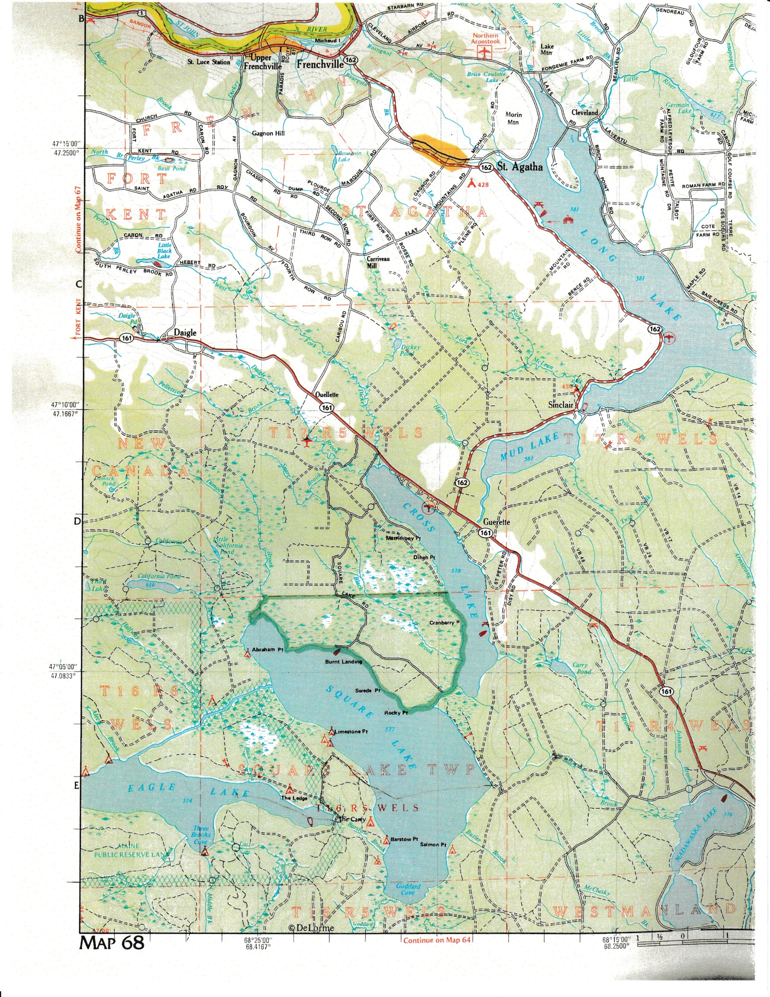

APPENDIX H – SINGLE PIPE INSTALLATION

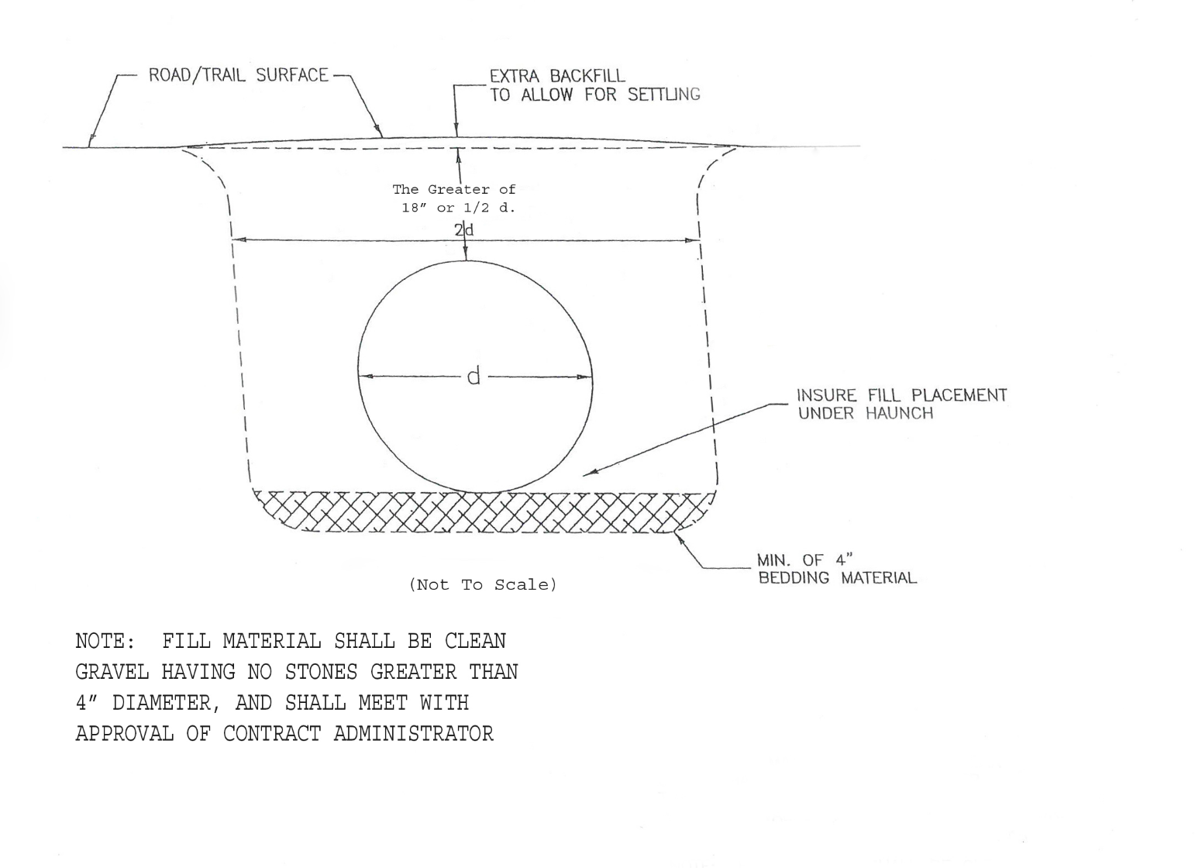

APPENDIX I – RIP RAP INSTALLATION ON CULVERTS WITH BACKSLOPES > 2:1

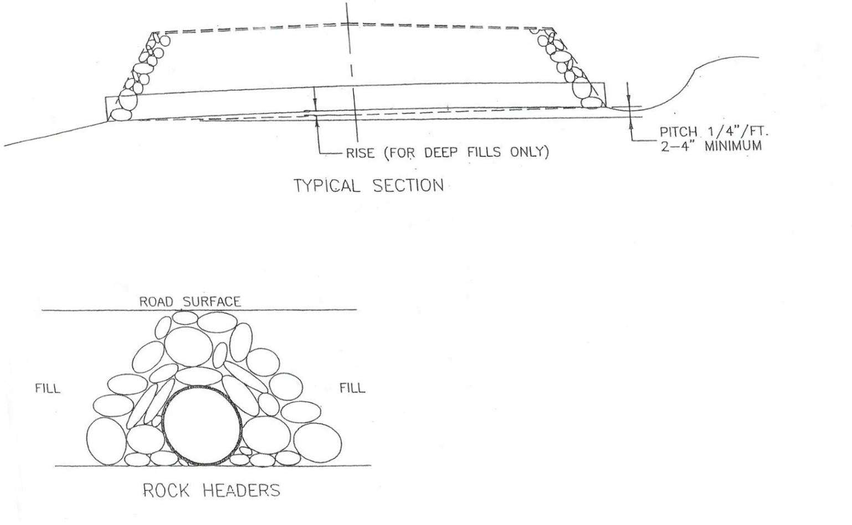

APPENDIX J – TYPES AND FUNCTIONS O F DRAINAGE FEATURES

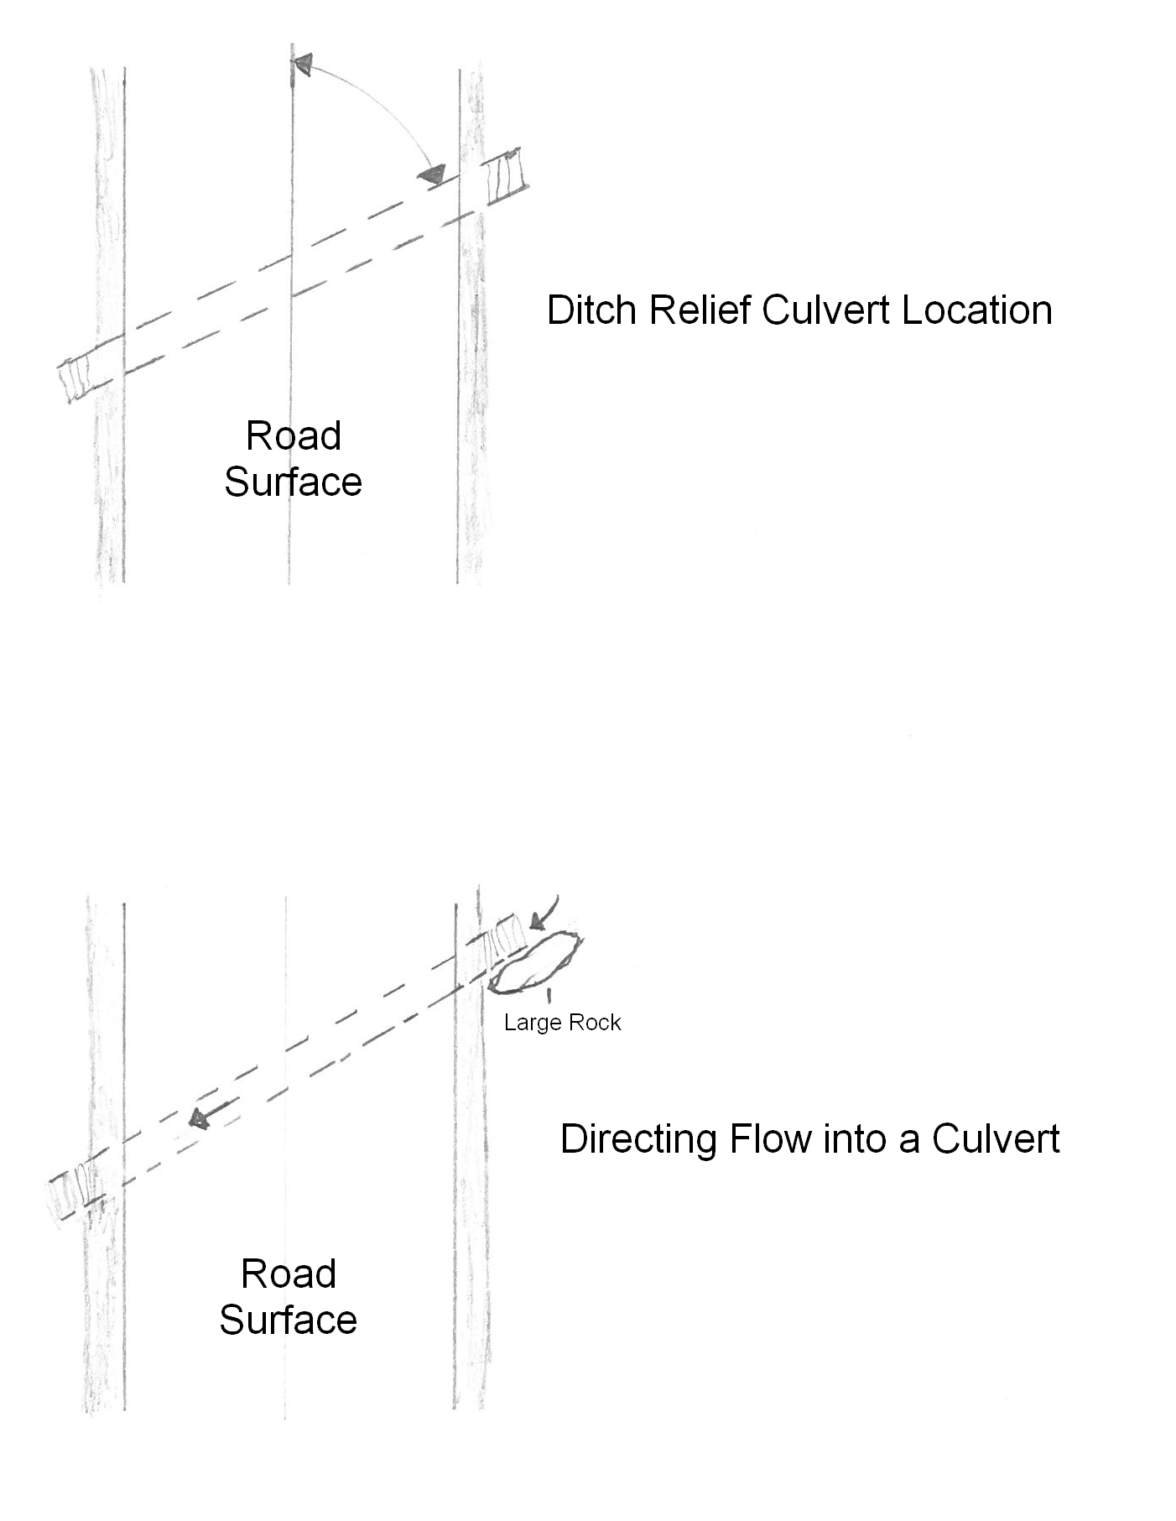

APPENDIX K – WATER TURNOUT DESIGN

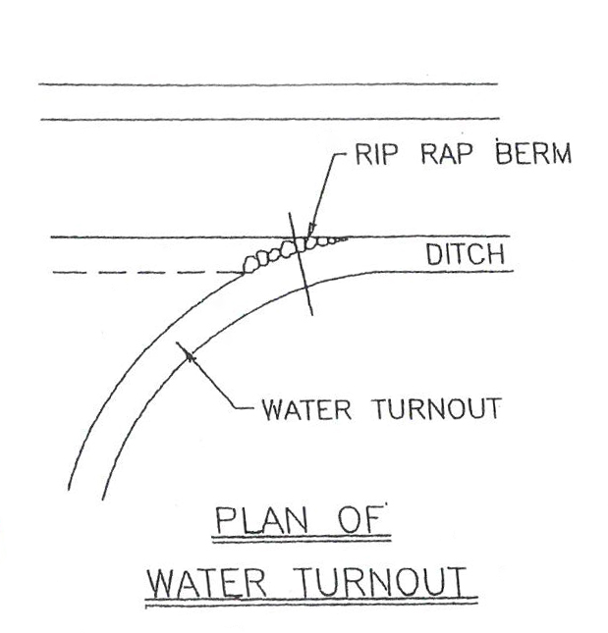

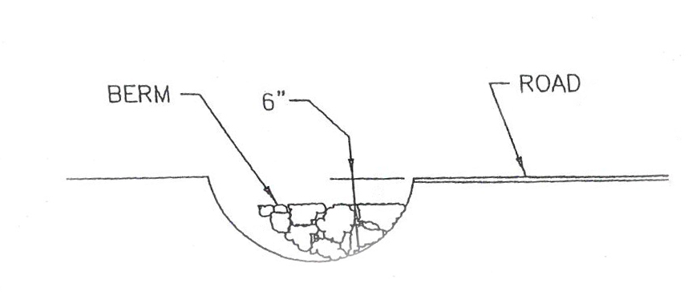

APPENDIX L – CULVERT INSTALLATION FOR STREAM CROSSING

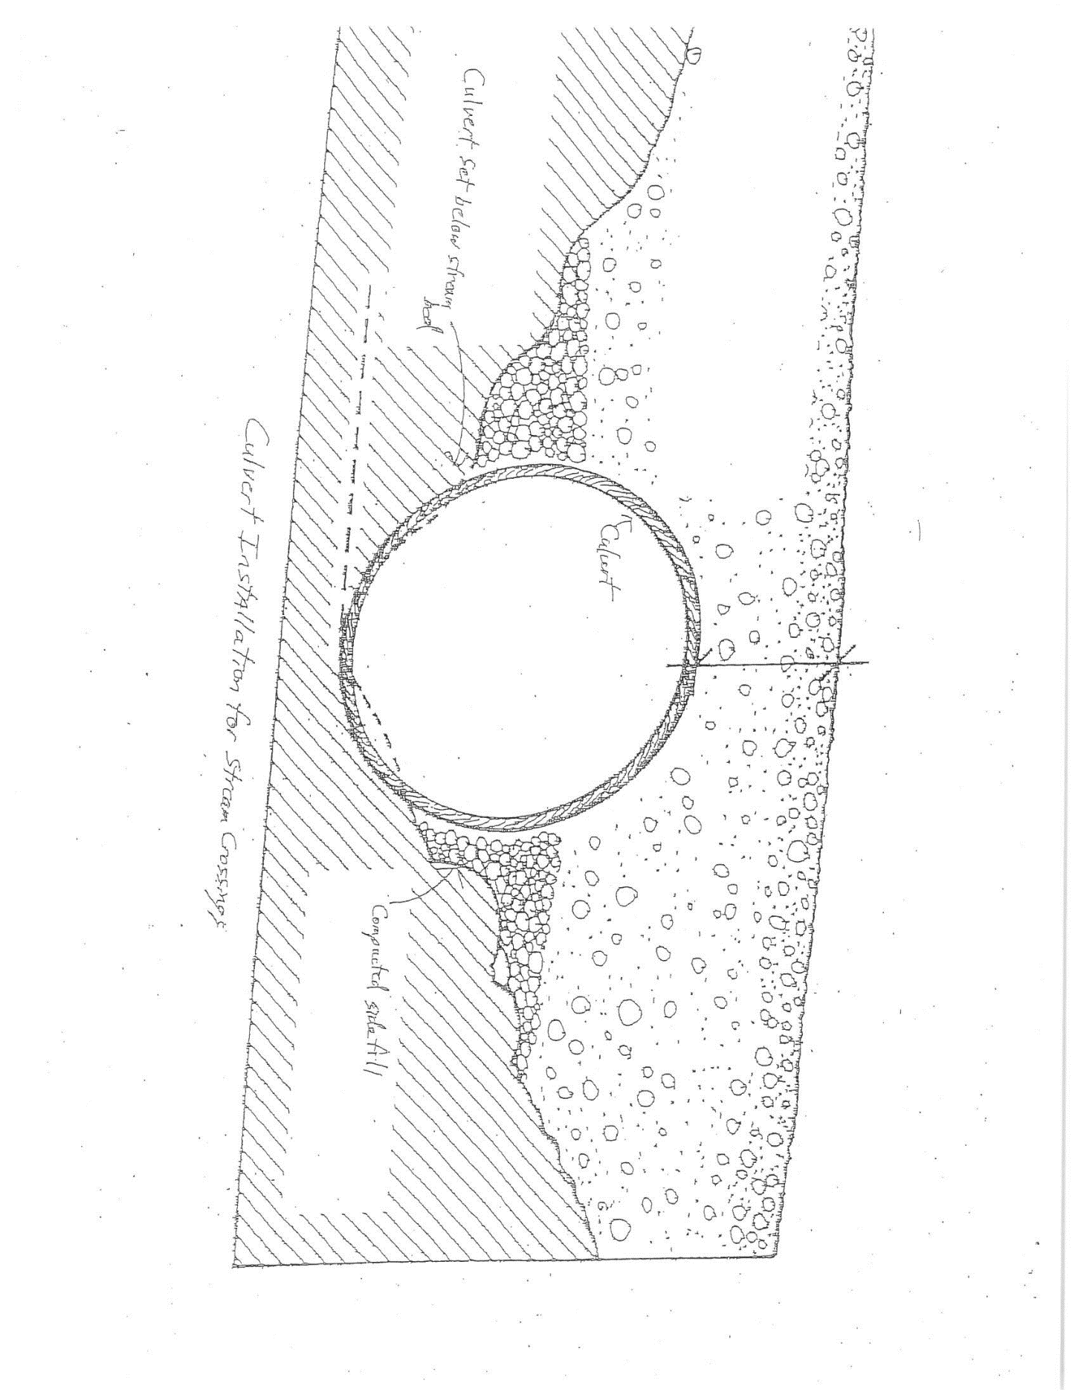

APPENDIX M – CULVERT INSTALLATION BMP – DIAGRAM 1

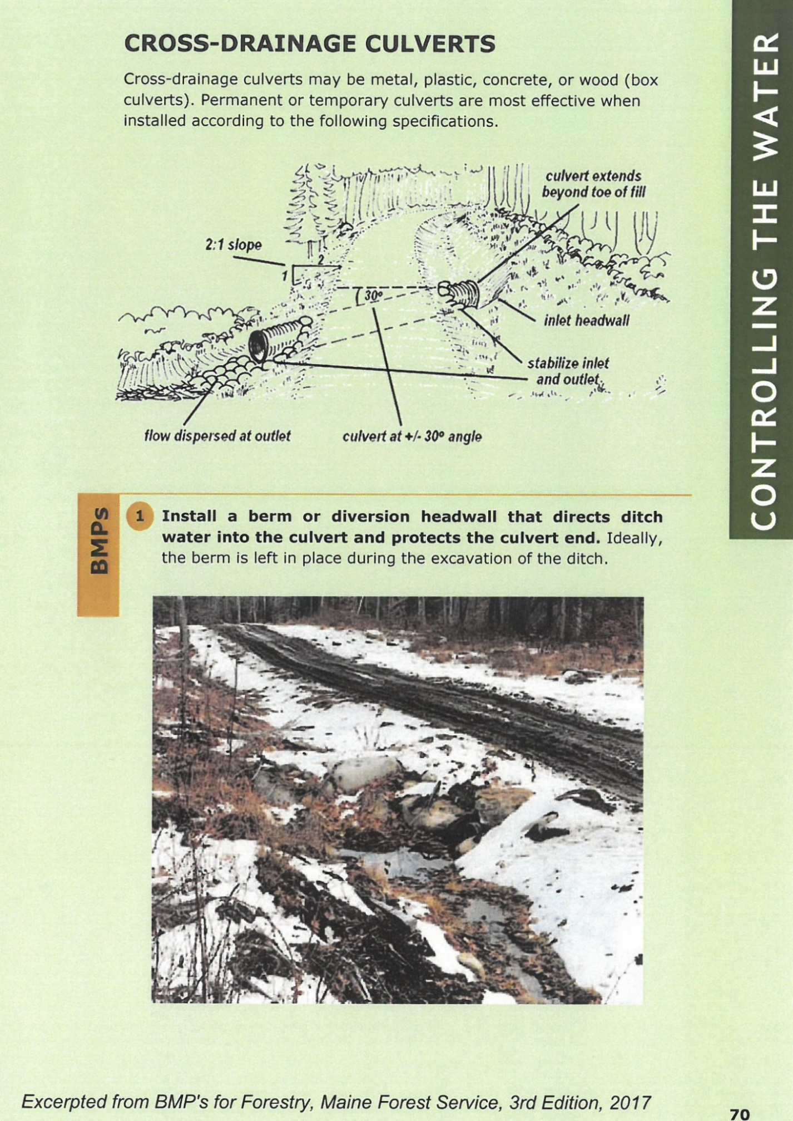
APPENDIX N – CULVERT INSTALLATION BMP – DIAGRAM 2

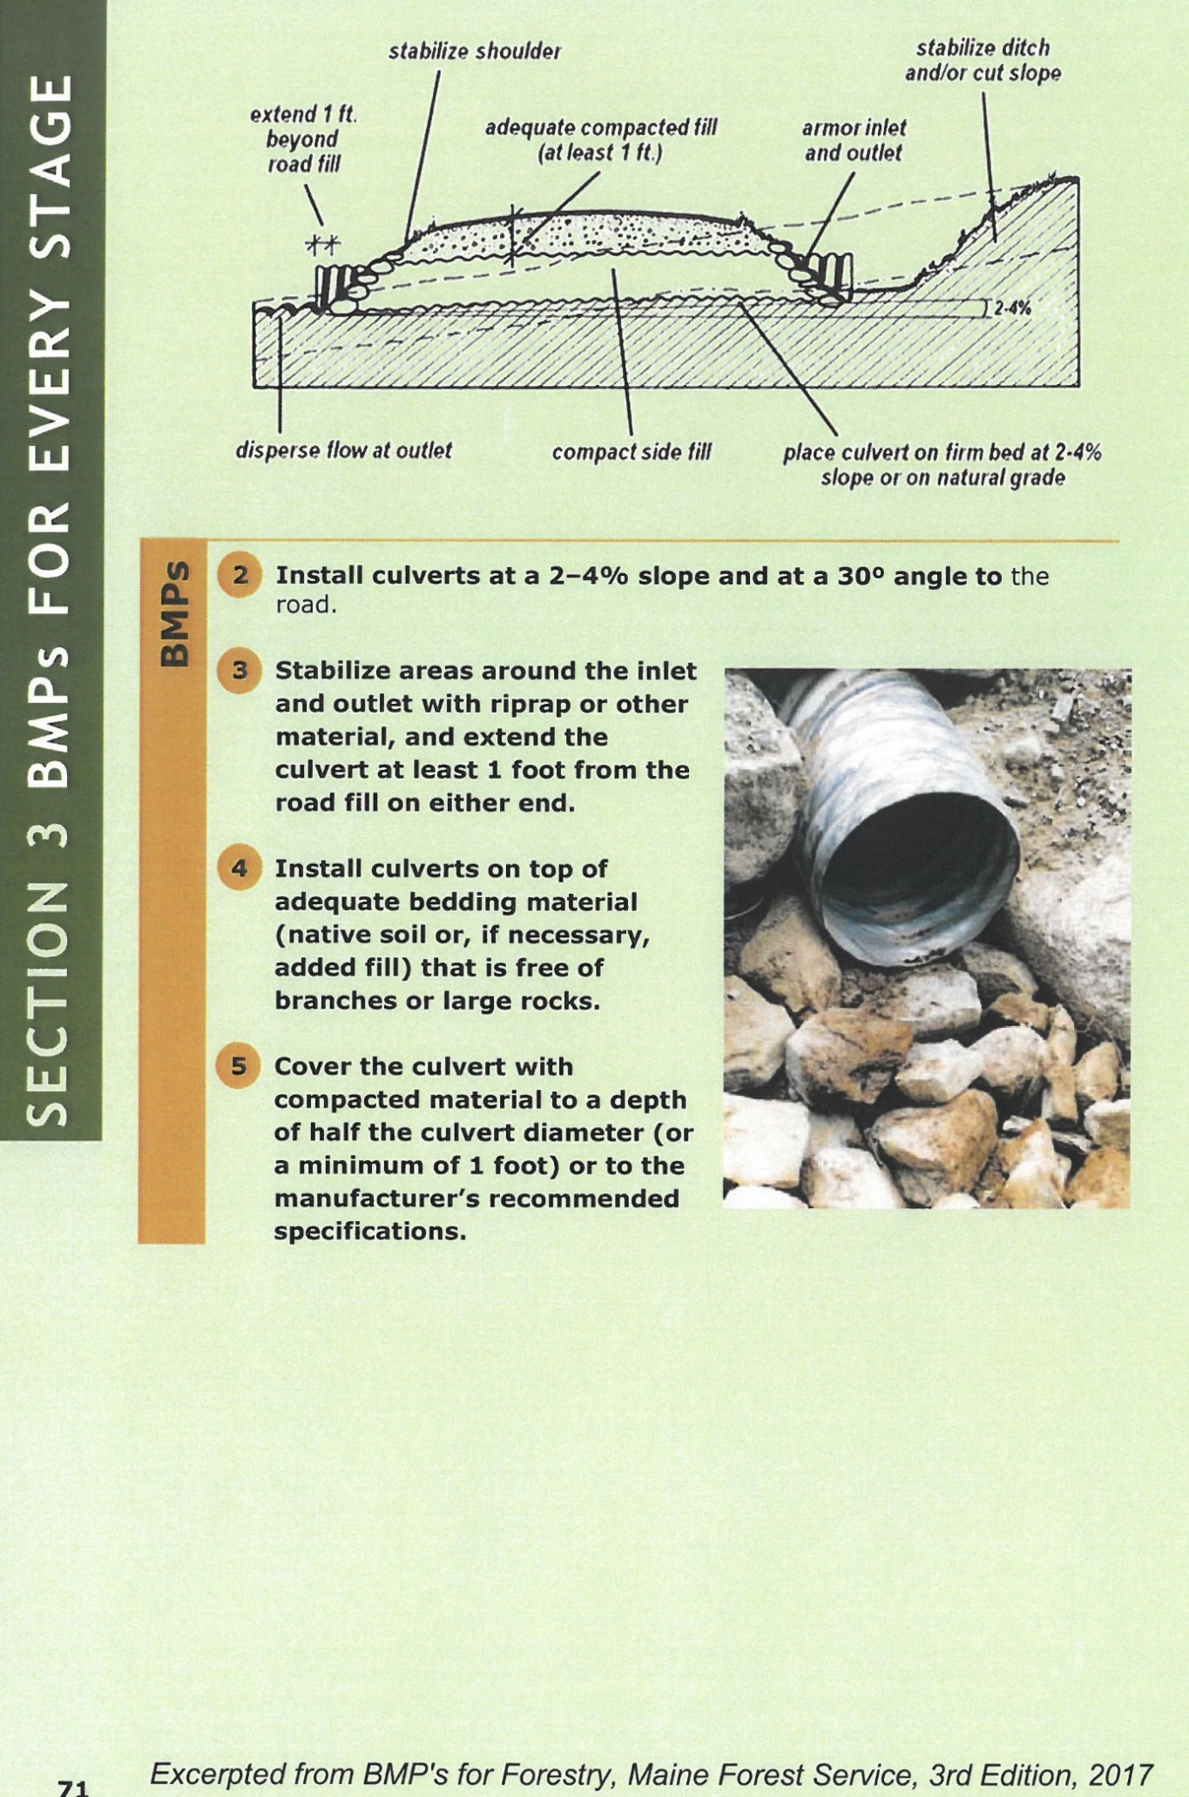

APPENDIX O – DESIRABLE MINIMUM DIMENSIONS OF A LOW-VOLUME GRAVEL ROAD

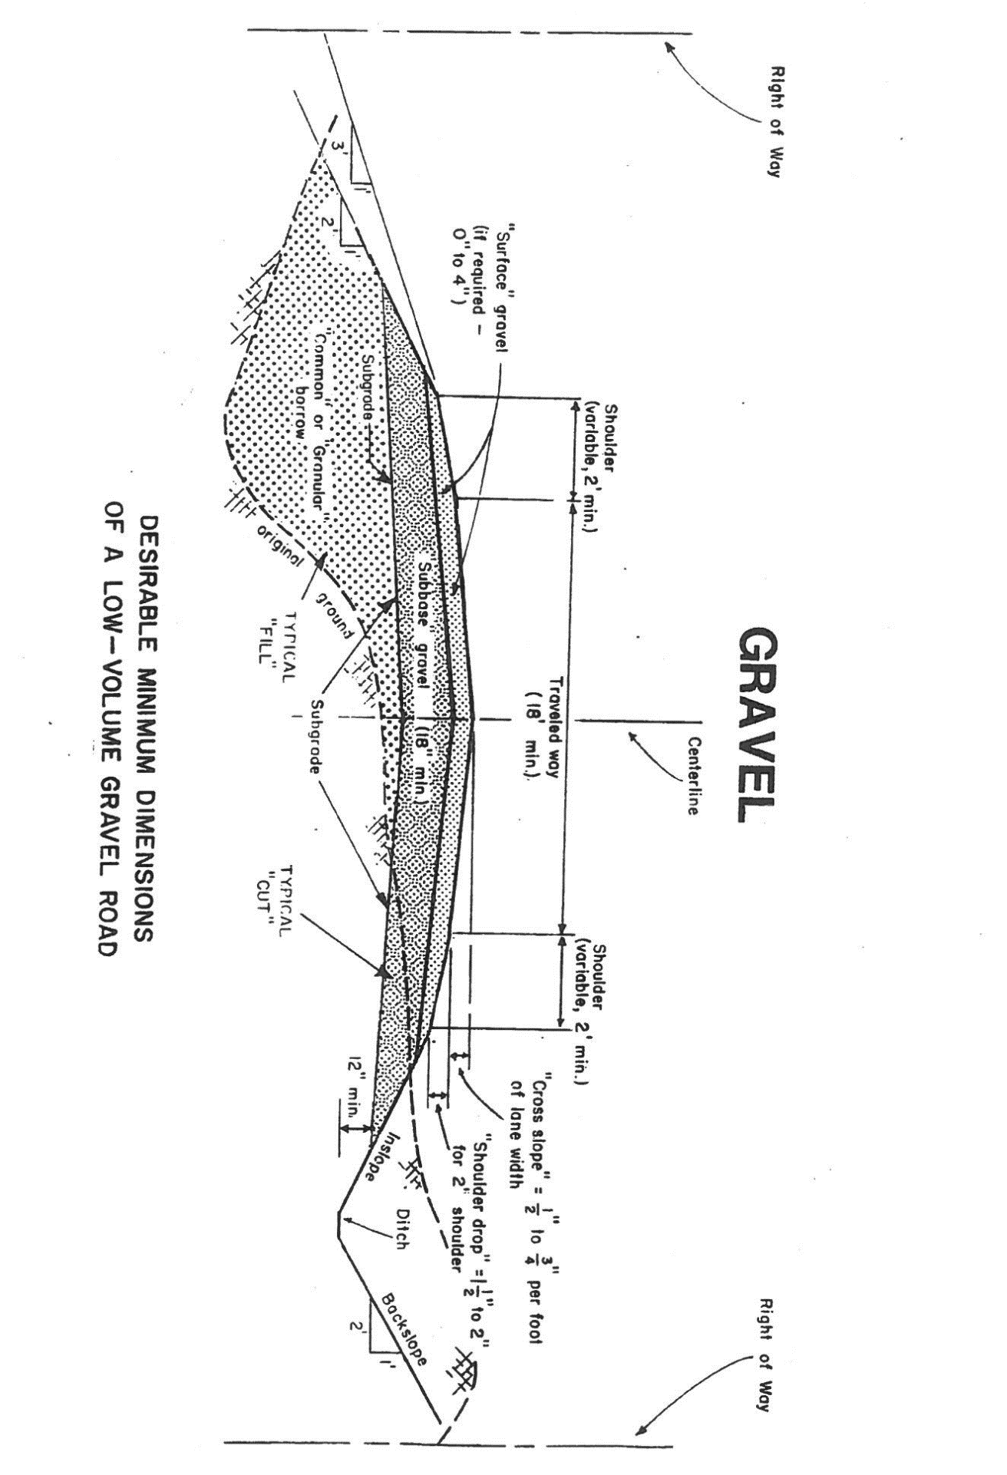

APPENDIX P - GRAVEL PIT MANAGEMENT STANDARDS AND SIGN-OFF FORM

Applicability: These standards apply to all operations undertaken that extract material from gravel pits owned by the Bureau of Parks & Lands. Any exceptions to these standards must be approved by the Contract Administrator and may require a permit.

Standards:
- Protection of Surface Water
  - Best management practices shall be employed to ensure that the pit area is internally drained such that neither runoff nor eroded materials exit the pit area.
  - A 100’ vegetative buffer strip shall be maintained between all protected natural resources including flowing water, body of standing water, wetland or significant wildlife habitat.
  - Stumping and stripping of topsoil shall be limited to that which is required to provide for currently planned projects.
- Protection of Groundwater
  - A two-foot buffer shall be maintained above the seasonal high-water table.
  - Refueling must occur in an approved location outside the pit area or any buffer strips.
  - Equipment to be used within the pit area must be free of fluid leaks.
  - No fuel, petroleum products, salt or chemicals shall be stored within the pit area or any buffer strips.
  - Spill kits or absorbent material shall be readily available.
  - All spills of hazardous material shall be reported to the contract administrator immediately.
- Adjacent Ownerships
  - No extraction shall occur within 250 feet of any property line or public roadway.
- Pit Operation Management
  - Any stockpiled material such as topsoil, screenings or processed aggregate shall be placed in a location that is pre-approved by the Contract Administrator.
  - All topsoil shall be stockpiled for future pit reclamation. The stockpile shall be stabilized with seed and mulch.
  - All test holes shall be promptly filled back in.
  - A natural vegetative screen shall be maintained between the extraction area and any road.
  - Stumps shall be buried in an onsite location outside of any buffers, protected natural resources and above the high-water table in a location designated by the Contract Administrator.

By signing this document, I acknowledge that I have reviewed and agree to follow the Gravel Pit Management Standards.

Name (Print): | Title:
Authorized Signature: | Date:

APPENDIX Q - SEEDING AND MULCHING STANDARDS AND SIGN-OFF FORM

SEEDING

Description: This work shall consist of applying seed on all exposed soils or as authorized by the Contract Administrator.
- Rate: Seed shall be sown at a rate of 4 pounds per 1000 square feet.
- Seed Bed Preparation: Raking or loosening of the soil is not necessary unless the soil has been compacted so as to impede root penetration and germination. (i.e. ditches that have been smoothed with an excavator bucket will require raking)
- Sowing Seed: Seed of the required mixture and quality shall be sown by a mechanical seeder or other method which will sow the seed uniformly at the required rate.
- Time of Seeding: The recommended seeding time is from April 1st to September 30th. The preferred time is prior to June 15th and after September 1st.
- Mulch: Mulch shall be applied directly after sowing.

MULCH

Description: This work shall consist of furnishing and applying hay for covering slopes and other areas with mulch as described, over seed or as authorized.
- Acceptable Material: Hay mulch shall consist of long fibered hay, reasonably free from noxious weeds and other undesirable material. No material shall be used which is so wet, decayed or compacted as to inhibit even and uniform spreading.
- Rate: Unless otherwise directed, mulch shall be applied at the rate of 1.5 to 2 tons per acre. Too heavy an application of mulch shall be avoided. Lumps and thick mulch material shall be thinned.

By signing this document, I acknowledge that I have reviewed and agree to follow the Seeding and Mulching Standards.

Name (Print): | Title:
Authorized Signature: | Date:

APPENDIX R – SPILL CONTROL AND REPORTING PROCEDURES AND SIGN-OFF FORM
This procedure applies to all chemicals and petroleum products and other potentially hazardous materials that are brought onto or used on the Bureau of Parks & Lands. Contractors, sub-contractors, contractor and/or sub-contractor employees and permittees are responsible for compliance with the following safety and environmental policies and procedures.
- Definitions:

Spill: An unintended spill or leak of any amount or any chemical or petroleum product into the environment.

Reportable Spill: Any release of 1 gallon or more of any chemical or petroleum product that comes into contact with the ground or that enters or may enter a watercourse or other sensitive site. (Sensitive sites include, but are not limited to, areas near potable water supplies, open water or wetlands.)
- Prevention:

Oils, fuels, hydraulic fluids, coolants, etc. are hazardous materials common to timber harvest operations. Avoiding spills is the best way to minimize impacts on personal safety and the environment.

The contractor shall not services skidders, trucks, or any other equipment at locations where pollution of water of the State of Maine is likely to occur.

- Use appropriate containers for collecting and storing oils, fuels, coolants or hazardous wastes. Store these materials in designated areas and remove them from the site when no longer needed.
- All equipment used will be kept clean and in good condition. Inspect hoses, fuel trucks, fuel tanks, etc. routinely for leaks and make necessary repairs immediately.
- Maintain and repair all equipment at a minimum distance of 330 feet or 100 meters from watercourses.
- Place mobile fuel storage tanks a minimum of 330 feet or 100 meters from watercourses and position them safely and securely. Inspect and maintain storage tanks regularly.

Spill kits or other absorbent materials for mopping up spills will be kept readily available. Hay or sawdust may be adequate for very small spills. Commercially available waste containment kits should be kept on hand for larger spills.
- Spill Response Procedures:

- Ensure the safety of all personnel. User personal protective equipment appropriate for the situation.
- Stop the spill. Act quickly to shut off pumps, close valves, etc.
- Contain the spill. Block off culverts or ditches as necessary to prevent material from reaching surface waters. Surround the spill with absorbent materials. If a commercial spill kit is not available, hay, sawdust, earth, peat, straw, sand or other absorbent material may be used.
- Clean up the spill. Remove contaminated materials from the site and dispose of properly.
- Correct the problem that caused the spill to prevent recurrence.
- If a product reaches surface waters, contain the material as best you can, clean up as much as possible, and report the event as quickly as practical.
- For reportable spills, as defined above, complete the Hazardous Materials Accidental Spill Report within 8 hours of occurrence.

- Numbers to call for Reportable Spills:

Bureau of Parks & Lands – Northern Region: 768-6892

Regional Manager Cell Phone Number: 316-8327

State of Maine Emergency (Oil/Fuel Spills): (800) 482-0777

State of Maine Emergency (Chemical Spills): (800) 452-4664

Department of Environmental Protection / Presque Isle Office: (207) 764-0477

Department of Environmental Protection / Bangor Office: (207) 941-4570

Accidental spills > 1 gallon will be reported on this form within 8 hours of occurrence.

Accidental spills > 3 gallons will be reported on this form within 8 hours of occurrence and will also be reported via a spill report delivered to Bureau personnel within 24 hours of occurrence.

Date | Time of Spill | Cause of Spill | Material of Spill and Location | Estimated Volume | Clean-up Action Taken | Company/  Crew Initials
By signing this document, I acknowledge that I have reviewed and agree to follow the Spill Control and Reporting Procedures.

Name (Print): | Title:
Authorized Signature: | Date:

APPENDIX S - ROAD MAINTENANCE CONTRACTOR EVALUATION REPORT

