Identifying Markings

- ½ - ¾ inch long
- Dark smoky brown wings
- One cream/yellow band on second segment of abdomen (near “waist”)
- Three large cream/yellow spots on face

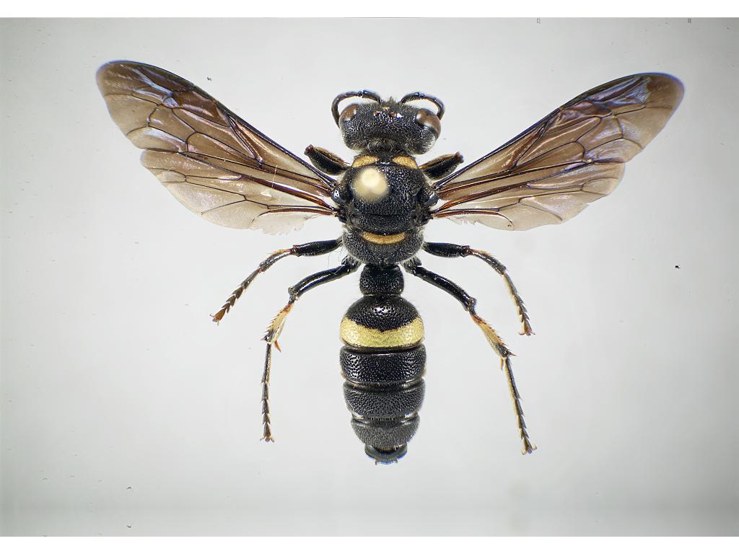

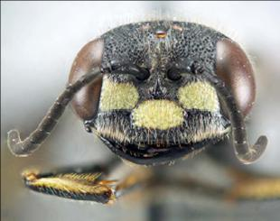
Markings of Female Cerceris fumipennis
(photos by P. Careless)

Cerceris is active in
eastern North America during
July and August

(Cerceris is pronounced: 'ser-ser-iss)
How to Identify Nests

- Round hole the diameter of a pencil
- Holes go straight down (not angled into the ground)
- Surrounded by a circle of excavated soil (not all to one side like a dog would dig)
- Often tucked beside or partially under a clump of grass
- Nests may be clustered together in a colony. Colonies may contain 5-500 nests.

Cerceris Nests
(photos by P. Careless)

To be suitable for EAB monitoring, a colony should be within 1000 yards (1000 m) of ash trees
Biosurveillance

- Visit your colony mid-day, 3-4 sunny days during July and select as many nests as you can keep an eye on.
- At each nest, pin the ‘collar’ to the ground with golf tee, placing the second hole over the nest entrance.
- Wasps without prey can come and go easily through the hole (A). A wasp carrying prey will not fit through the hole (B).
- For 1-3 hours, watch as wasps return to nests. Wasps with prey can be netted in flight or caught as they try to pass through the collar. Take prey and release wasp.
- Collect a total of 50 beetles over 3-4 visits. Place beetles from each day in a baggie labeled with place and date. Beetles found on the ground may be included. Place in freezer and mail to us at end of summer.
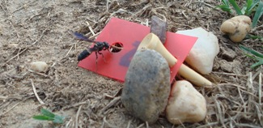
A - Wasp Entering Nest Through Collar
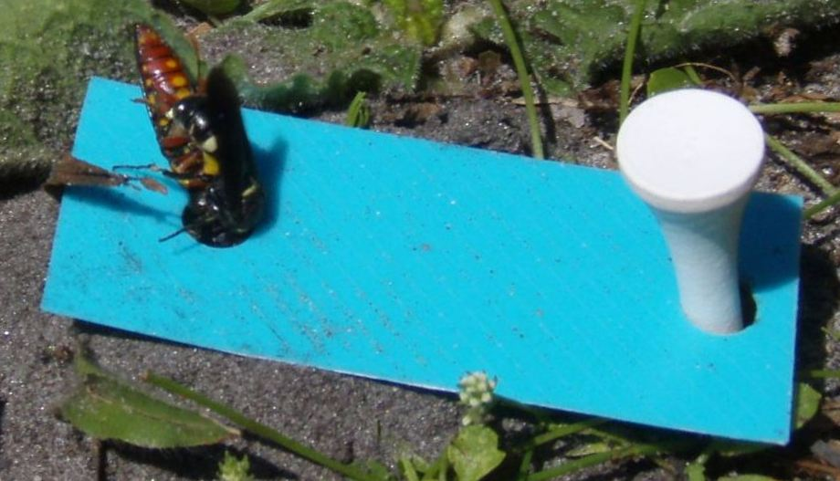
B - Wasp Unable to Enter With Prey
(photos by P. Careless & M. Bohne)
Promising Nest Sites

- Hard packed sandy soil
- Areas of human disturbance (baseball diamonds, old sand pits, trail and road edges, informal parking lots, fire-pits, etc.)
- Full sunshine
- Sparse vegetation (about 50% hard-packed soil and 50% short vegetation)
- Near a wooded area, about 200 yards (200m) or less
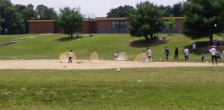
Typical Cerceris Colony Sites
(photos by P. Careless & C. Teerling)
What is Emerald Ash Borer?

- Small metallic green beetle (1/2” long, 1/8” wide)
- An exotic beetle from Asia
- Larva tunnels under the bark
- Attacks and kills all species of ash
- First found in Michigan in 2002
- Spreading VERY rapidly across the USA and Canada (primarily in firewood)
- Early detection is difficult. This wasp and WaspWatchers can help.

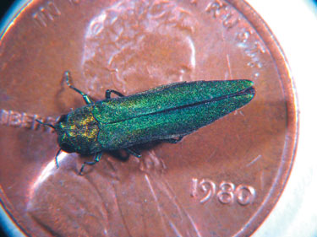
Emerald Ash Borer

For more information, visit our website at
www.cerceris.info
In the United States, Colleen Teerling colleen.teerling@maine.gov
ph: 207 287-3096
In Canada, Philip Careless pcareles@uoguelph.ca
Thanks to…


WaspWatcher

How to find the wasp that hunts emerald ash borer

This native wasp is not known to sting humans, even when handled.

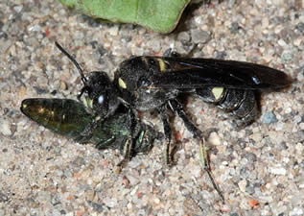
Female Cerceris fumipennis
with Emerald Ash Borer

Cerceris fumipennis is a solitary ground-nesting wasp. The female stocks her nest with buprestid beetles, including emerald ash borer (EAB) when present.

Biosurveillance (observing colonies of these native wasps and collecting some of the prey they bring back) is currently the most promising way to monitor for EAB. Researchers in the United States and Canada are looking for colonies of these wasps throughout the state, and could use your help.

