State of Maine
2018 Candidate’s Guide
to Ballot Access



State of Maine
Matthew Dunlap
Secretary of State

Office of the Secretary of State

I am pleased to present the 2018 edition of the State of Maine Candidate’s Guide to Ballot Access.

If you are considering becoming a candidate or already have decided to run for public office, I hope this guide will be helpful to you.

Public service through elected office is among the oldest and noblest traditions in our democratic system. While the decision to seek public office can be a highly personal one, I can attest that, once undertaken, it can be both a challenging and rewarding experience.

The Secretary of State’s Division of Elections is available to assist you with any questions regarding the conduct of elections. They can be reached at (207) 624-7650, Monday through Friday, 8:00 AM – 5:00 PM. The Commission on Governmental Ethics and Election Practices is also available to assist you with any questions regarding campaign finance laws and reporting requirements. The Commission can be reached by calling (207) 287-4179, Monday through Friday, 8:00 AM – 5:00 PM.

If you have any questions, or if I can be of further assistance to you, please do not hesitate to contact me personally at (207) 626-8400.

Sincerely,
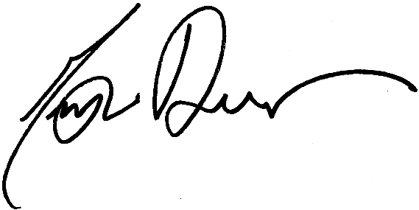

Matthew Dunlap
Secretary of State

Table of Contents

Chapter Description Page
Directory 1
Introduction 2
Status of Ranked-Choice Voting (RCV) 3
One Becoming a Candidate 4
Who is a Candidate? 4
Offices and Requirements
• Federal and State Offices 5
• County Offices 6
Legal References 7

Two Getting on the Ballot: The Petition Process 8
All Candidates 8
Primary (Party) Candidates 8
Primary (Party) Petition Filing Checklist 9
Required Number of Signatures – Primary (Party) Candidates 10
Other Points Pertinent to Primary (Party) Candidate Petitions 10
Sample of Primary (Party) Candidate Petition 11
Completing Primary (Party) Candidate Petitions 11
• Instructions for Candidate Information Section 11
• Instructions for Collection of Signatures 12
• Instructions for Circulator’s Oath 13
• Instructions for Registrar’s Certification 13
• Instructions for Candidate’s Consent
and Certification of Enrollment 14
Restrictions on Candidate Withdrawal 15
Non-Party Candidates 16
Non-Party Petition Filing Checklist 16
Required Number of Signatures – Non-Party Candidates 17
Other Points Pertinent to Non-Party Candidate Petitions 17
Sample of Non-Party Candidate Petition 18
Completing Non-Party Candidate Petitions 18
• Instructions for Candidate Information Section 18
• Instructions for Collection of Signatures 19
• Instructions for Circulator’s Oath 20
• Instructions for Registrar’s Certification 20
• Instructions for Candidate’s Consent
and Certification of Unenrollment 21

Chapter Description Page
Restrictions on Candidate Withdrawal 22
Legal References 22
Three Write-in Candidates 23
Who is a Write-in Candidate? 23
Enrollment Qualifications of a Primary Write-in Candidate 23
Party Name or Designation of a Write-in Candidate 24 Minimum Number of Votes Needed in Primary Election 25
Minimum Number of Votes Needed in General Election 25
Casting a Write-in Vote 25
Legal References 26

Four Restricted Activity 27
Legal References 28

Five Placement of Political Signs 29
Letter from Department of Transportation 29

Six Voter Registration and Absentee Voting 31
Voter Registration 31
Voter Registration for Persons with Disabilities 31
Voter Registration Deadline 31
Absentee Voting 32
Legal References 33

Directory

Department of the Secretary of State
Division of Elections
Office Location: 111 Sewall Street, 4th Floor, Augusta
Mail: 101 State House Station
Augusta, ME 04333-0101
Telephone: (207) 624-7650 Fax: (207) 287-6545
Website: www.maine.gov/sos email: cec.elections@maine.gov

Commission on Governmental Ethics and Election Practices
Office Location: 45 Memorial Circle, Augusta
Mail: 135 State House Station
Augusta, ME 04333-0135
Telephone: (207) 287-4179 Fax: (207)287-6775
Website: www.maine.gov/ethics
Electronic Filing: www.mainecampaignfinance.com/PublicSite/homepage.aspx

Federal Elections Commission
999 E Street, N.W.
Washington, D.C. 20463
Telephone: (800) 424-9530 or (202) 694-1000
Website: www.fec.gov

Federal Communications Commission
Office of Political Programming
445 12th Street, S.W.
Washington, D.C. 20554
Telephone: (202) 418-1440 email: campaignlaw@fcc.gov
National Call Center (Toll Free): 888-225-5322
Website: https://www.fcc.gov/media/policy/political-programming#block-menu-block-4

Department of Transportation
Right of Way Maintenance Control Section
16 State House Station
Augusta, ME 04333-0016
Telephone: (207) 624-3611
Website: www.maine.gov/mdot/traffic/obds.htm

Introduction

Candidates have filing responsibilities and other requirements with both the Secretary of State’s office and the Commission on Governmental Ethics and Election Practices.

The Elections Division within the Department of the Secretary of State administers elections for federal, state and county offices. The Division advises election officials in more than 500 municipalities, as well as hundreds of state candidates, about election laws and procedures. For example, the Division accepts and reviews primary (party) and non-party candidate petitions. Through this petition process, candidates qualify to have their names placed on the ballot for either the primary or general election.

The Candidate’s Guide to Ballot Access is a useful reference for candidates and the general public. Each chapter describes the election requirements and references the authorizing statutes which may be viewed at the State’s web site at: http://www.mainelegislature.org/legis/statutes/

The Department of the Secretary of State has taken care to make this Guide concise and accurate. However, you should not substitute the information presented here for the applicable statutory provisions of the Election Law. The statutory requirements are controlling in the event of any omission in this publication. This Guide is current as of December 1, 2017. Its contents are subject to statutory changes enacted by the Legislature and rule changes approved under the Administrative Procedure Act.

The Commission on Governmental Ethics and Election Practices administers the campaign finance law and the Maine Clean Election Act (MCEA), a publicly-funded campaign financing option. Through the Commission, candidates register, declare their intention to run as a Maine Clean Election Act candidate or as a traditionally financed candidate and file the required campaign finance reports. The Commission is in the process of preparing guidebooks for legislative and county candidates running in 2018. These guidebooks will be posted on the Ethics Commission’s web site and can also be obtained by contacting the Commission. Below are some helpful links to the Ethics Commission’s web site:

- http://www.maine.gov/ethics/candidates/index.htm - Main page for Candidate resources, providing links to the guidebooks prepared by the Ethics Commission.

- http://www.maine.gov/ethics/candidates/forms/legis-mcea.htm- Forms and Guides for Legislative Candidates (MCEA)

- http://www.maine.gov/ethics/candidates/forms/legis-trad.htm - Forms and Guides for Legislative Candidates (Traditionally Financed)

Status of Ranked-Choice Voting (RCV)

As of the completion of this Candidate’s Guide on December 8, 2017, a people’s veto petition effort is circulating petitions that may result in the implementation of ranked-choice voting for the June 12, 2018 Primary Election.

If the people’s veto petitioners submit at least 61,123 valid signatures to the Secretary of State by
February 2, 2018, to suspend the recent law change enacted by the Legislature, then the primary elections for U.S. Senate, Governor, U.S. Congress, State Senate and Representative to the Legislature will be decided by a system of ranked-choice voting instead of by plurality. Additionally, the people’s veto ballot question will be presented to the voters at a Special Referendum Election on June 12, 2018, in order to determine whether the law change will be permanently vetoed.

- If the ballot question is approved in June, ranked-choice voting would be used for the offices of U.S. Senate and U.S. Congress for the general election.

- If the ballot question is not approved in June, PL 2017, c. 316 will take effect and ranked-choice voting will not be implemented, unless the voters amend the Maine Constitution to authorize ranked-choice voting prior to December 1, 2021.

Maine’s people’s veto referendum process is provided for by the Constitution of Maine, Article IV, Part Third and governed by Title 21-A M.R.S. Chapter 11.

Chapter One

Becoming a Candidate

Who is a Candidate?

A candidate is any one or a combination of the following:

- A person who has filed a petition and has qualified to be nominated by the Primary Election as a party candidate;

- A person who has filed a petition and has qualified as a “non-party” candidate;

- A person who has filed a declaration with the Secretary of State as a write-in candidate;

- A person who has received contributions or made expenditures with the intent of qualifying as a candidate; or

- A person who has given his or her consent for any other person to receive contributions or make
expenditures with the intent of qualifying as a candidate.

A person may be a candidate for only one federal, state or county office in any election and may choose only one method (primary election or non-party petition) to gain access to the printed general election ballot.

Exception: A person may be a candidate for a county charter commission and may also be a candidate for one additional office at the same election.

Offices and Requirements – Federal and State Offices

In addition to the residency requirements outlined below, no person may be a candidate unless, at the time of nomination for placement on the primary, general or special election ballot, that person is a resident of the district which the candidate seeks to represent.

Maine election law (21-A MRS §336(1) for party candidates and §355(1) for non-party candidates) now requires the Secretary of State to provide a separate consent form that includes a list of the statutory and constitutional requirements for the office sought by the candidate. (For more information, see page 14 for Primary Candidate’s Consent and page 21 for Non-party Candidate’s Consent.)

Office  Type | Office | Minimum Age | Citizenship:  Minimum  Number of Years | Residency | Statute  Reference

Federal | U.S. Senator | 30 | 9 | Resident of Maine | U.S. Constitution, Article I, §3
Federal | Representative to Congress | 25 | 7 | Resident of Maine | U.S. Constitution, Article I, §2
State | Governor | 30 | 15 | 5 years Maine resident | Maine Constitution, Article V, Part First,  §4
State | Senator | 25 | 5 | 1 year Maine resident; reside in district for 3 months before the election | Maine Constitution, Art. IV, Part Second,  §6
State | Representative to the Legislature | 21 | 5 | 1 year Maine resident; reside in district for 3 months before the election | Maine Constitution, Art. IV, Part First, §4

Offices and Requirements – County Offices

In addition to the residency requirements outlined below, no person may be a candidate unless, at the time of nomination for placement on the primary, general or special election ballot, that person is a resident of the district which the candidate seeks to represent.

Maine election law (21-A MRS §336(1) for party candidates and §355(1) for non-party candidates) now requires the Secretary of State to provide a separate consent form that includes a list of the statutory and constitutional requirements for the office sought by the candidate. (For more information, see page 14 for Primary Candidate’s Consent and page 21 for Non-party Candidate’s Consent.)

Somerset County enacted a county charter in 2010. Under the provisions of this charter, county officers (with the exception of District Attorney) are elected in a non-partisan election and appear only on the General Election ballot. Candidates follow the requirements for non-party candidates, except that the candidate does not have to be an unenrolled voter. Individuals running for a Somerset County office must request petitions drafted specifically for this county.

Knox County and Aroostook County follow a similar procedure for electing the Knox County Budget Committee and Aroostook County Finance Committee. Candidates for these offices also must request the petition specific for these offices.

Office Type | Office | Minimum Age | Citizenship:  Minimum  Number of Years | Residency | Statute  Reference | See Note
County | County Commissioner | 18 | A candidate for any County Office must be a resident and voter in the electoral district which the candidate seeks to represent as of the date that the candidate files nomination petitions in the year of the election. (21-A MRS §333 and §352). |  | 30-A MRS §61
County | County Treasurer | 18 |  |  | 30-A MRS §151
County | District  Attorney | 18 |  |  | 30-A MRS §251 | 1
County | Judge of Probate | 18 |  |  | Maine Constitution, Art. VI, §6;  4 MRS §301 | 1
County | Register of Probate | 18 |  |  | Maine Constitution, Art. VI, §6;  18-A MRS §1-501
County | Register of Deeds | 18 |  |  | 33 MRS §601
County | Sheriff | 18 |  |  | Maine Constitution, Art. IX, §10; 30-A MRS §371-B | 2

Notes from chart on previous page:

Note 1: Candidate must be an attorney, admitted to the general practice of law in Maine.

Note 2: Candidates for sheriff must file a “Candidate’s Consent for Sheriff” with the Secretary of State, along with the nomination papers, confirming compliance with the following qualifications:
1. Must swear to or affirm the Law Enforcement Code of Ethics;
2. Must never have been convicted of a Class C or higher crime;
3. Must apply to the Secretary of State for a criminal background investigation;
4. Must submit written certification from the Maine Criminal Justice Academy that the candidate has:
- Met the basic law enforcement training standards under Title 25 MRS §2804-C; or
- Met the basic corrections training standards under Title 25 MRS §2804-D; and
- Must swear or affirm that the candidate has at least 5 years of supervisory employment experience and must provide the name, address and telephone number for the relevant employer or employers.

Any person who was serving or who previously served in the office of sheriff on or before June 26, 1997 (the effective date of PL 1997, c. 37) is deemed to meet these minimum qualifications.

LEGAL REFERENCES

Definition of a Candidate 21-A MRSA § 1(5)
Limitations to Candidacy 21-A MRSA §§ 331 and 351
Qualification for County Office 21-A MRSA §§ 333 and 352

Legal References

Definition of a Candidate 21-A MRS § 1(5)
Limitations to Candidacy 21-A MRS §§ 331 and 351
Qualification for County Office 21-A MRS §§ 333 and 352

Chapter Two

Getting on the Ballot: The Petition Process

All Candidates
LEGAL REFERENCES

Definition of a Candidate 21-A MRSA § 1(5)
Limitations to Candidacy 21-A MRSA §§ 331 and 351
Qualification for County Office 21-A MRSA §§ 333 and 352

Petitions are available from the Department of the Secretary of State, Division of Elections, located at the Burton M. Cross State Office Building, 4th floor, 111 Sewall Street, Augusta, Maine. You may pick up the petitions in person, have another person obtain them for you or have the petitions mailed to you.

You may begin circulating petitions January 1, 2018, and they must be submitted by the applicable deadline for either primary (party) or non-party petitions. Once submitted to the Secretary of State, petitions will be reviewed to ensure that all required elements have been properly completed. If all requirements of law are met and the minimum number of signatures is submitted, the petitions will be accepted and filed by the Secretary of State. You will be notified of the acceptance of the petitions once the filing deadline and challenge period have passed.

Primary (Party) Candidates
Parties meeting the qualifications of 21-A MRS c. 5 are eligible to participate in the Primary Election on June 12, 2018. Parties currently qualified to participate in the 2018 Primary Election are:
- Democratic Party
- Green Independent Party
- Libertarian Party
- Republican Party
If you are changing enrollment from one party to another, you must file an application to change enrollment prior to January 1, 2018. If you are a primary (party) candidate and are not currently enrolled in a party (Unenrolled), you must enroll in the party named in the petition on or before March 15, 2018, or by the date you file your petitions, if earlier. Petitions must be filed with the Secretary of State on or before 5 p.m. on March 15, 2018. Before submitting your petitions to the Secretary of State, ensure that you have completed all the items in the “Primary (Party) Petition Filing Checklist” on page 9.
Note: If you move between January 1 and March 15, you cannot change parties and run as a primary candidate at the new residence.

Primary (Party) Petition Filing Checklist

- Collect at least the minimum number of signatures for the office you are seeking as indicated in the chart “Required Number of Signatures – Primary (Party) Candidates” provided on page 10. Signers must be Maine registered voters of the electoral district of the candidate and enrolled in the party named in the petition.
- Have each petition verified by its circulator – the “Circulator’s Oath” must be completed on each petition – see page 13 for further details.

- Have all signatures certified by the applicable registrar of voters prior to filing with the Secretary of State – see page 13 for further details.

- Sign the “Candidate’s Consent” section of the Candidate’s Consent and Certification of Enrollment (a separate form from the petition) before a Notary Public – see page 14 for further details.

- Have the Registrar of Voters in the municipality where you are registered to vote complete the “Certification of Candidate Enrollment” which is printed as part of the Candidate’s Consent and Certification of Enrollment form – see page 14 for further details.

- Present the petitions and the “Candidate’s Consent and Certification of Enrollment” to the Secretary of State for review on or before 5 p.m., March 15, 2018.

NOTE: The Secretary of State encourages candidates to file in advance of the
March 15, 2018 deadline to allow time for review of the petitions and correction of any deficiencies.

- Comply with the campaign finance law regarding registration, record keeping and reporting requirements. (Please refer to Commission on Governmental Ethics and Election Practices for information and reporting forms.)

Required Number of Signatures – Primary (Party) Candidates
The required number of valid signatures of registered voters on primary (party) petitions is:

Office | Minimum | Maximum
U.S. Senator | 2,000 | 3,000
Governor | 2,000 | 3,000
Representative to Congress | 1,000 | 1,500
State Senator | 100 | 150
Representative to the Legislature | 25 | 40
County Commissioner | 50 | 75
Other County Officers | 150 | 200

Other Points Pertinent to Primary
(Party) Candidate Petitions:

- Petition forms must be typed or printed in ink, except where an original signature is required.

- A separate petition form should be used for each municipality in which signatures are submitted. (This is for ease of municipal verification of voters, not an error that would invalidate the petition.)

- The circulator of a petition does not have to be a Maine resident or Maine registered voter. The circulator must personally witness every signature that is made to the petition, and be able to take an oath to that effect.

- A voter may sign for more than 1 candidate running for the same office in a federal, state or county election. However, a voter may sign each candidate’s petition only once.

- To ensure that the registrar will be able to certify a voter’s signature, the voter should sign a petition in the same manner as the voter is registered to vote. However, immaterial irregularities will not invalidate a signature as long as the registrar can determine that the signer is the voter on the municipality’s list. Immaterial irregularities include, but are not limited to, misspelling, inclusion or omission of initials and substitution or initials or nicknames for given names.

Sample of Primary (Party) Candidate Petition
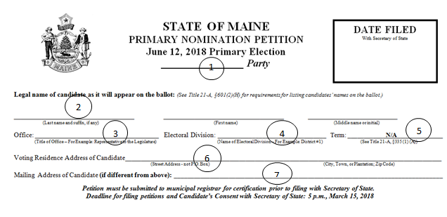

Completing Primary (Party) Candidate Petitions

Instructions for Candidate Information Section

- Write the name of the qualified party in which the candidate is enrolled.
- Write the candidate’s legal name on the petition in one of the following forms:
a. last name, first name, middle name
b. last name, first name, middle initial
c. last name, first initial, middle name
d. last name, first name

The name should be completed as it will appear on the ballot and must be in one of the forms listed above, as required by 21-A MRS §601(2)(H). The candidate must also sign the Candidate’s Consent in the same manner. A candidate’s name listed on the ballot must be the candidate’s legal name and must be the name approved by the Probate Court, if applicable, pursuant to 18-A MRS §1-701, or in the absence of a court order, the name consistently used by the candidate during the last 2 years in filings with governmental agencies and other legal transactions.
See 21-A MRS §601(2)(B-1).

- Write the exact title of the office sought, i.e., Representative to Congress, State Senator, Representative to the Legislature, etc.

- Write the electoral division to be represented, i.e., District 1, Androscoggin County, etc.
- Write the term of office only when 2 U.S. Senators are to be nominated (not applicable in 2018).
- Write the residence address where the candidate is registered to vote.
- Write the mailing address of the candidate, if different.
Note: The information required on the petition must be completed prior to circulation. If a petition missing required information is filed with the Secretary of State, it may be rejected.

Instructions for Collection of Signatures
For Registrar  use only | SIGNATURE OF VOTER  (Not Printed Name) | DATE  SIGNED | ACTUAL STREET ADDRESS  (Not P.O. Box) | MUNICIPALITY  (Where Registered) | PRINTED NAME OF VOTER
1.

2.

3.

- The petition may be signed only by voters who reside in the electoral district in which the nomination is sought and who are enrolled in the party named in the petition. The voter must sign his or her name personally, except that a voter who is physically unable to sign the petition and who is registered to vote as provided in 21-A MRS §153-A(3), may direct another Maine registered voter to sign the petition in the voter’s presence. The individual assisting the voter who is physically unable to sign, must sign the voter’s name on one line and then sign the individual’s own name on another line and attest that the individual is signing on the voter’s behalf. The assistant must complete the rest of the information on both lines (for the voter and the assistant).

- The printed name of the voter, the date signed, the street address and the municipality may be completed by either the voter or the circulator. Ditto marks are permitted only for street address and municipality of registration. Signatures may not be collected prior to January 1, 2018.

Instructions for the Circulator’s Oath
Circulator’s Oath: After the circulator has gathered all of the signatures on a particular petition form, the circulator must take oath before a notary public that:
- The circulator personally witnessed all of the signatures to the petition;
- Each signature is that of the person whose name it purports to be;
- Each signer is a registered voter of the electoral district named on the petition and enrolled in the party designated on the petition; and
- If a voter was unable to sign due to a physical disability, that the voter authorized another voter to sign at the voter’s direction and in the voter’s presence.

The circulator must take the oath for each petition circulated. Once the circulator has taken the oath before a notary, no signatures may be added to that petition form.

Instructions for the Registrar’s Certification

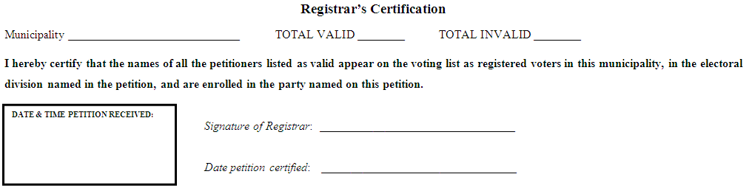

Registrar’s Certification: The registrar of voters or municipal clerk must certify that each person whose signature appears on the petition is registered to vote in that municipality, in the electoral district named on the petition, and is enrolled in the party designated on the petition.
Instructions for the Candidate’s Consent and Certification of Enrollment
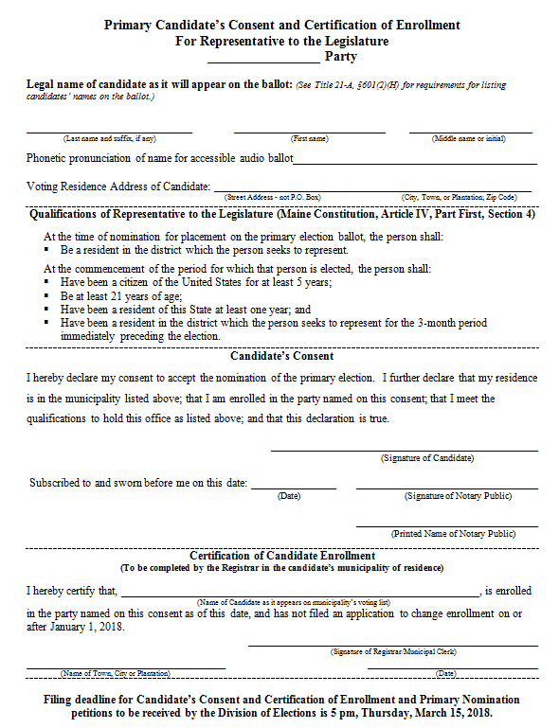

_____________________________________________________________________________________________

NOTE - This is a sample form only. You must obtain the correct consent and enrollment form from the Division of Elections for the specific office you are seeking.

Candidate’s Consent: The candidate’s consent is a separate form from the petition. The consent forms are customized with the qualifications of each office, so candidates must ensure they meet the qualifications for the office named on the consent and that the consent form submitted is the correct one for the office sought.
NEW – Please complete the “Phonetic pronunciation” following the candidate’s name section, so that the audio for the candidate’s name will be pronounced correctly on the accessible ballot. Example: If your name is Colin Boucher, write your name phonetically “KΟ-Lin BOW-cher” or “Kollin Bushy” as you would like it to be pronounced in the audio ballot.

The candidate must sign, before a notary public, the candidate’s consent form, which includes a statement that the candidate will accept the nomination of the Primary Election, a declaration of the candidate’s municipality of residence and party designation, and a statement that the candidate meets the qualifications of the office sought. The signature of the candidate on the consent form must appear the same as the name of the candidate on the petition form(s).

Certification of Candidate Enrollment: The certification of enrollment is included as part of the candidate’s consent form. The registrar of voters or municipal clerk in the candidate’s municipality of residence must certify that the candidate is enrolled in the party named on the petition as of the date the petition is certified (and no later than March 15, 2018).

Restrictions on Candidate Withdrawal
A candidate for an office on the primary ballot may withdraw by submitting a written notice, signed by the candidate, to the Secretary of State.
The deadline for withdrawal in order to have the candidate’s name removed from the ballot is 70 days before the primary election (by 5 p.m. Tuesday, April 3, 2018).
If a primary candidate submits a withdrawal notice to the Secretary of State less than 70 days before the primary, the candidate's name will not be removed from the ballot. However, the Secretary of State will instruct the local election officials in the candidate's electoral district to distribute notices with absentee ballots requested after that date and to post a notice at each voting place informing voters that the candidate has withdrawn and that a vote for that candidate will not be counted. Notice of the late withdrawal also will be posted on the Secretary of State's publicly accessible website.
See 21-A MRS §371
A candidate nominated by a party at the primary election must withdraw on or before 5 p.m. on the
2nd Monday in July (July 9, 2018) preceding the general election in order to be replaced by the
party no later than 5 p.m. on the 4th Monday in July (July 23, 2018) preceding the general
election.
See 21-A MRS §374-A(3)

Non-Party Candidates
Appendix A – 4
Example of Petition Verification and Certification

If you wish to be a non-party candidate and are enrolled in a party, you must withdraw from that party on or before to March 1, 2018, or by the date you file your petitions, if earlier, and must not have changed parties after January 1, 2018. Petitions must be filed with the Secretary of State on or before 5:00 p.m. on June 1, 2018. Before submitting your petitions to the Secretary of State, ensure that you have completed all the items in the “Non-Party Petition Filing Checklist” below.

Non-Party Petition Filing Checklist

- Collect at least the minimum number of signatures for the office you are seeking as indicated in the chart “Required Number of Signatures – Non-Party Candidates” provided on page 17. Signers must be Maine registered voters of the electoral district of the candidate.

- Have each petition verified by its circulator – the “Circulator’s Oath” must be completed on each petition – see page 20 for further details.

- Have all signatures certified by the applicable registrar of voters prior to filing with the Secretary of State – see page 20 for further details. Petitions must be submitted to the appropriate registrars for certification by 5 p.m., May 25, 2018.

- Sign the “Candidate’s Consent” section of the Non-Party Candidate’s Consent and Certification of Unenrollment (a separate form from the petition) before a Notary Public – see page 21 and 22 for further details.

- Have the Registrar of Voters in the municipality where you are registered to vote complete the “Certification of Candidate Unenrollment” which is printed as part of the Candidate’s Consent and Certification of Unenrollment form – see page 21 for further details.

- Present the petitions and the “Non-party Candidate’s Consent and Certification of Unenrollment” to the Secretary of State for review on or before 5 p.m., June 1, 2018.

NOTE: The Secretary of State encourages candidates to file in advance of the June 1, 2018 deadline to allow time for review of the petitions and correction of any deficiencies.

- Comply with the campaign finance law regarding registration, record keeping and reporting requirements. (Please refer to Commission on Governmental Ethics and Election Practices for information and reporting forms.)

Required Number of Signatures – Non-Party Candidates

The required number of valid signatures of registered voters on non-party petitions is:

Office | Minimum | Maximum
United States Senator | 4,000 | 6,000
Governor | 4,000 | 6,000
Representative to Congress | 2,000 | 3,000
State Senator | 200 | 300
Representative to the Legislature | 50 | 80
County Commissioner | 100 | 150
Other County Officers | 300 | 400
Other Points Pertinent to
Non-Party Candidate Petitions:

- Petition forms must be typed or printed in ink, except where an original signature is required.

- A separate petition form should be used for each municipality in which signatures are submitted. (This is for ease of municipal verification of voters, not an error that would invalidate the petition.)

- The circulator of a petition does not have to be a Maine resident or Maine registered voter. The circulator must personally witness every signature that is made to the petition, and be able to take an oath to that effect.

- A voter may sign for more than 1 candidate running for the same office in a federal, state or county election. However, a voter may sign each candidate’s petition only once.

- To ensure that the registrar will be able to certify a voter’s signature, the voter should sign a petition in the same manner as the voter is registered to vote; however, immaterial irregularities will not invalidate a signature as long as the registrar can determine that the signer is the voter on the municipality’s list. Immaterial irregularities include, but are not limited to, misspelling, inclusion or omission of initials and substitution or initials or nicknames for given names.
Sample of Non-Party Candidate Petition

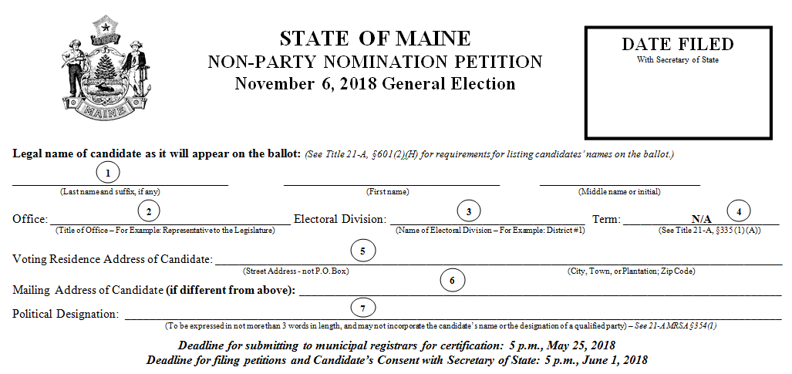

Completing Non-Party Candidate Petitions

Instructions for Candidate Information Section

- Write the candidate’s legal name on the petition in one of the following forms:
a. last name, first name, middle name
b. last name, first name, middle initial
c. last name, first initial, middle name
d. last name, first name

The name should be completed as it will appear on the ballot and must be in one of the forms listed above, as required by 21-A MRS §601(2)(H). The candidate must also sign the Candidate’s Consent in the same manner. A candidate’s name listed on the ballot must be the candidate’s legal name and must be the name approved by the Probate Court, if applicable, pursuant to 18-A MRS §1-701, or in the absence of a court order, the name consistently used by the candidate during the last 2 years in filings with governmental agencies and other legal transactions.
See 21-A MRS §601(2)(B-1)

- Write the exact title of the office sought, i.e., Representative to Congress, State Senator, Representative to the Legislature, etc.
- Write the electoral division to be represented, i.e., District 1, Androscoggin County, etc.
- Write the term of office only when 2 U.S. Senators are to be nominated (not applicable in 2018).
- Write the residence address where the candidate is registered to vote.
- Write the mailing address of the candidate, if different.
- State the candidate’s political designation which may not exceed 3 words in length and may not incorporate the candidate’s name or the designation or an abbreviation of the designation of a party that is qualified to nominate candidates by primary election, and may not consist of or comprise language that is obscene, contemptuous, profane or prejudicial, promotes abusive or unlawful activity or violates any other provision of Maine law with respect to names.

Instructions for Collection of Signatures
For Registrar  use only | SIGNATURE OF VOTER  (Not Printed Name) | DATE  SIGNED | ACTUAL STREET ADDRESS  (Not P.O. Box) | MUNICIPALITY  (Where Registered) | PRINTED NAME OF VOTER
1.

2.

3.

- The petition may be signed only by voters who reside in the electoral district in which the nomination is sought. The voter must sign his or her name personally, except that a voter who is physically unable to sign the petition and who is registered to vote as provided in
21-A MRS §153-A(3), may direct another Maine registered voter to sign the petition in the voter’s presence. The individual assisting the voter who is physically unable to sign, must sign the voter’s name on one line and then sign the individual’s own name on another line and attest that the individual is signing on the voter’s behalf. The assistant must complete the rest of the information on both lines (for the voter and the assistant).

- The printed name of the voter, the date signed, the street address and the municipality may be completed by either the voter or the circulator. Ditto marks are permitted only for street address and municipality of registration. Signatures may not be collected prior to January 1, 2018.

Instructions for the Circulator’s Oath
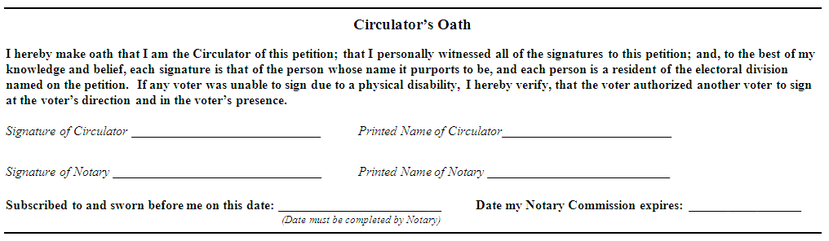
Circulator’s Oath: After the circulator has gathered all of the signatures on a particular petition form, the circulator must take an oath before a notary public that:
- The circulator personally witnessed all of the signatures to the petition;
- Each signature is that of the person whose name it purports to be;
- Each signer is a registered voter of the electoral district named on the petition and enrolled in the party designated on the petition; and
- If a voter was unable to sign due to a physical disability, that the voter authorized another voter to sign at the voter’s direction and in the voter’s presence.
The circulator must take the oath for each petition circulated. Once the circulator has taken the oath before a notary, no signatures may be added to that petition form.

Instructions for the Registrar’s Certification

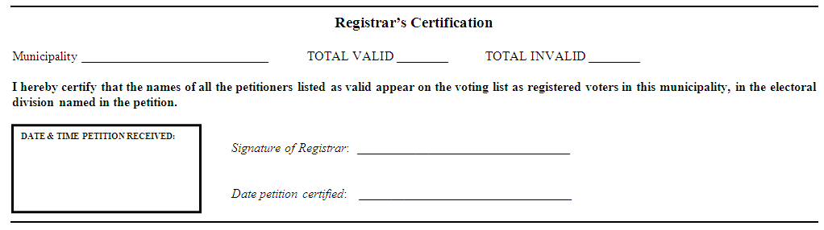

Registrar’s Certification: The registrar of voters or municipal clerk must certify that each person whose signature appears on the petition is registered to vote in that municipality, in the electoral district named on the petition.

Instructions for the Candidate’s Consent and
Certification of Candidate Unenrollment
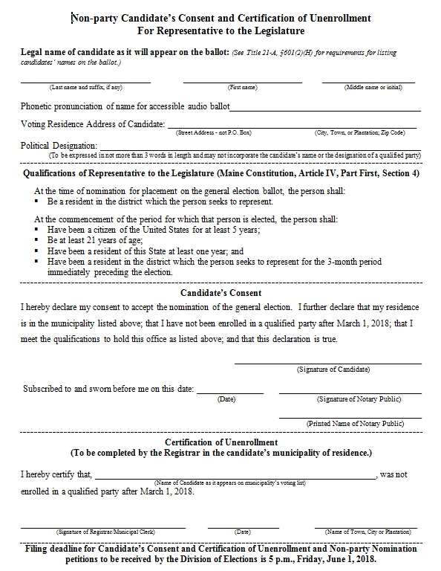
NOTE – This is a sample form only. You must obtain the correct consent and certification of unenrollment form for the specific office you are seeking from the Division of Elections.

Candidate’s Consent: The candidate’s consent is a separate form from the petition. The consent forms are customized with the qualifications of each office, so candidates must ensure they meet the qualifications for the office named on the consent and that the consent form submitted is the correct one for the office sought.
NEW – Please complete the “Phonetic pronunciation” following the candidate’s name section, so that the audio for the candidate’s name will be pronounced correctly on the accessible ballot. Example: If your name is Colin Boucher, write your name phonetically “KΟ-Lin BOW-cher” or “Kollin Bushy” as you like it to be pronounced in the audio ballot.

The candidate must sign, before a notary public, the candidate’s consent form, which includes a statement that the candidate will accept the nomination for the general election, a declaration of the candidate’s municipality of residence and that the candidate was not enrolled in a party at the time of certification (and after March 1, 2018), and a statement that the candidate meets the qualifications of the office sought. The signature of the candidate on the consent form must appear the same as the name of the candidate on the petition form(s).

Certification of Candidate Unenrollment: The certification of unenrollment is included on the candidate’s consent form. The registrar of voters or municipal clerk in the candidate’s municipality of residence must certify that the candidate was not enrolled in a party as of the date the petition is certified (and no later than March 1, 2018).
Restriction on Candidate Withdrawal
A candidate for an office on the general election ballot may withdraw by submitting a written notice, signed by the candidate, to the Secretary of State.
The deadline for withdrawal in order to have the candidate’s name removed from the ballot is 70 days before the general election (by 5 p.m. Tuesday, August 28, 2018).
If a general election candidate submits a withdrawal notice to the Secretary of State less than 70 days before the general election, the candidate's name will not be removed from the ballot. However, the Secretary of State will instruct the local election officials in the candidate's electoral district to distribute notices with absentee ballots requested after that date and to post a notice at each voting place informing voters that the candidate has withdrawn and that a vote for that candidate will not be counted. Notice of the late withdrawal also will be posted on the Secretary of State's publicly accessible website.
See 21-A MRS §374-A(3)

Legal References

Qualification of (Party) Candidates - Primary Election 21-A MRS § 334
Primary Petition Requirements 21-A MRS § 335
Consent of Primary (Party) Candidate 21-A MRS § 336
Qualification of Candidate - Nomination by Petition 21-A MRS § 353
Nomination by Petition (Non-party) Requirements 21-A MRS § 354
Consent of Petition (Non-party) Candidate 21-A MRS § 355
Deadline for Withdrawal - Primary 21-A MRS § 371
Withdrawal of Candidates - General Election 21-A MRS § 374-A
Requirements for Candidate’s Name on Ballot 21-A MRS § 601(2)

Chapter Three

Write-in Candidates

Who is a Write-in Candidate?
A “write-in candidate” is a person:
- Whose name is not printed on the ballot; and
- Who otherwise fulfills the qualifications for the office designated; and
- Who receives one or more valid write-in votes for an office listed on a primary, general or special election ballot; and
- Who has filed a “Declaration of Write-in Candidacy” no later than 60 days prior to the election, which is April 13, 2018 for the Primary Election and September 7, 2018 for the General Election.
Declaration forms are available from the Secretary of State, Division of Elections and on the Secretary of State’s website: www.maine.gov/sos/cec/elec/write-in.htm .

NOTE: Declaration forms for the General Election are not available until after the Primary Election.

Enrollment Qualifications of a Primary Write-in Candidate
A write-in candidate for the primary election must:
- Be enrolled, on or before March 15, 2018, in the party in which the candidate is seeking a write-in nomination; and
- Meet the same qualifications as a candidate filing a petition for nomination by primary election under 21-A MRS §144(3).

Party Name or Designation of a Write-in Candidate
A write-in candidate for the primary election must indicate which party’s nomination the candidate is seeking by checking the appropriate box on the “Declaration of Write-in Candidacy”.

A write-in candidate for the general election may indicate a party or political designation by writing that party or political designation in the appropriate space on the “Declaration of Write-in Candidacy”. The candidate may indicate the name of a qualified party (Democratic, Green Independent, Libertarian or Republican), or choose a political designation that meets the following requirements:
- May not exceed three words in length;
- May not incorporate the candidate’s name, or the designation or an abbreviation of the designation of a party that is qualified to nominate candidates by primary election; and
- May not consist of or comprise language that is obscene, contemptuous, profane or prejudicial, promotes abusive or unlawful activity or violates any other provision of Maine law with respect to names.

NOTE: A candidate who intends to form a new party about that person’s candidacy must use the political designation for the proposed party.

Minimum Number of Votes Needed in Primary Election
A write-in candidate in the primary election must receive a minimum number of votes for nomination. The minimum number of votes needed to win the nomination is twice the minimum number of signatures required on a primary petition for that office. If more than one person receives the minimum number of votes for an office, the person receiving the greatest number of votes is nominated.

Office | Primary Election – Minimum Number of Valid Votes Needed for Nomination
United States Senator |  | 4,000
Governor |  | 4,000
Representative to Congress |  | 2,000
State Senator |  | 200
Representative to the Legislature |  | 50
County Commissioner |  | 100
Other County Offices |  | 300

Minimum Number of Votes Needed in General Election
In the general election, a candidate needs to receive at least one (1) vote. The person who receives the greatest number of votes is elected.

Casting a Write-in Vote
A voter must mark the write-in indicator (oval) as instructed on the ballot and the voter must also write the name of the candidate in the blank space provided at the end of the list of candidates for that office. The use of stickers is not allowed to cast a write-in vote for any ballot.

Legal References

Definition of Write-in Candidate 21-A MRS § 1(51)
Casting a Write-in Vote - Primary Election 21-A MRS § 691(2)
Casting a Write-in Vote - General Election 21-A MRS § 692(2)
Determination of Write-in Candidate 21-A MRS § 722-A
Write-in Votes Required - Primary Election 21-A MRS § 723(1)(A)

Chapter Four

Restricted Activity

Restricted Activity at the Voting Place
The voting place is the building in which ballots are cast at an election. See 21-A MRS §1(49)
The guardrail enclosure is the area within 6 feet of the voting booths and the ballot box.
.
On Election Day, certain activities are restricted at voting places, as follows:
- Interference with the voters’ free passage;
- Influence or attempting to influence another person’s
decision regarding a candidate or question that is on the ballot for the election that day, on public property within 250
feet of the entrance to the voting place or the registrar’s office;
- The use of cellular phones, voice pagers or similar devices to make audible communication
within the voting place that influences or attempts to influence a voter’s decision regarding a candidate or ballot issue;
- Within the guardrail enclosure, only the clerk, the election officials and not more than 2 voters in excess of the number of voting booths are allowed. Party workers and others may remain in the voting place outside the guardrail enclosure as long as they do not attempt to influence voters or interfere with their free passage.
- Candidates are permitted within the voting place and may communicate orally with voters, as long as they do not attempt to influence their vote. Candidates may state their name but may not state the name of the office sought or ask a person to vote for them.
- Campaign buttons may be worn only by persons who are present in the voting place solely for the purpose of voting. The longest dimension of the button may not exceed 3 inches. Everyone else is prohibited from wearing campaign buttons of any size. Badges or stickers containing a candidate’s name or promoting a question on the ballot are likewise prohibited.

The warden is the presiding officer at the voting place and is responsible for the enforcement of the law governing voting and counting procedures. The jurisdiction of the warden includes the voting place and the area within 250 feet of the entrance to the voting place. The municipal clerk is the supervisor of elections and is responsible for advising the warden on election laws and procedures.
The warden is the presiding officer at the voting place and is responsible for the enforcement of the law governing voting and counting procedures. The jurisdiction of the warden includes the voting place and the area within 250 feet of the entrance to the voting place. The municipal clerk is the supervisor of elections and is responsible for advising the warden on election laws and procedures.

Legal References

Definition of Municipal Clerk 21-A MRS § 1(9)
Definition of Warden 21-A MRS § 1(50)
Positions at Voting Place 21-A MRS § 681
Political Activities (Restrictions) 21-A MRS § 682

Unlawful Removal of Political Signs 23 MRSA § 1917-A
Chapter Five

Placement of Political Signs – Letter from MaineDOT

Dear Candidate:
It is campaign season again and the Maine Department of Transportation would like to take this opportunity to offer some information regarding the placement of political signs. MaineDOT understands and appreciates the potential impact of strategically placed political signs as well as the substantial investment that candidates make in purchasing these signs.
In the past, Maine sign law allowed political signs to be placed within the public right of way up to 6 weeks prior to an election. During the most recent legislative session, changes were made to the statute to allow non-commercial signage, which includes campaign signs, for only up to 6 weeks during any one calendar year. The new law further states that signs bearing the same or substantially the same message may be placed no closer than 30 feet from one another-- See 23 M.R.S.A. § 1913-A, as amended by P.L. 2015, c. 403.These changes were put into place to conform with a recent Supreme Court ruling and to deal with the public concerns regarding the overall density of signs along the roadway. The most recent law change also requires sign owners to place their name and contact information, as well as the 6 week time frame for which the sign owner intends to have the sign up.
Maine’s roadways offer an enormous opportunity to place a great many signs, but there are some areas within the state’s roadway system that are off limits to non-commercial signage, including campaign signs. These areas are comprised of the Maine Interstate system, including the Maine Turnpike Authority system, and all the various interchanges and ramps along the interstate system. The Interstate system and its interchanges have been designated as “control of access” areas. The term “control of access” indicates that this section of highway is being controlled from development. Typically no new entrances such as driveways or side roads or the like will be allowed within these sections. All types of signs are restricted in these sections with the exception being the State of Maine may install a sign within a control of access area for the purposes of the highway system. All other types of signs are prohibited within the control of access areas.
There are various reasons for the prohibition of signs within the control of access sections but the main reason is safety. The interstate system and its connecting interchanges are not the only “control of access” areas within Maine’s many road ways. There are several control of access sections along Maine routed highways as well. Many of these non-interstate control of access sections are located within some of Maine’s busiest roads, such as Rte. 202 in Winthrop and Rte. 3 in South China. Control of access areas may have a very high volume of car and truck traffic as well as a high speed limit that could create a potential hazard for pedestrians attempting to install signs along the roadways.
Here are some questions that campaign personnel may ask regarding the placement of political signs:
How do I recognize a “control of access” section?
- MaineDOT is continuing the process of installing signs at each of the control of access areas to indicate where the sections begin and end. The signs will provide information such as “C.O.A. Area-No Signs” with arrows indicating which direction the control of access boundaries extend.
- Unsigned areas may be recognized by the limited access points into the highway and often a wildlife deterrent fence set 30 to 50 feet off the edge of pavement.
What will happen to my sign if it has been placed in within a control of access section?
- MaineDOT personnel have been advised to remove all types of signs from within the control of access areas. Maintenance crews have also been instructed to safely store the signs until the owner of the sign (business, campaign) can be contacted and arrangements can be made for pick up.
Does MaineDOT enforce these sign placement restrictions state wide?
- MaineDOT is committed to providing the equitable enforcement of these areas state wide. All signs that are installed within control of access areas will be removed as soon as possible by department personnel.
What do I need to know about placing my sign along the roadway?
- The first thing to consider in placement is the safety of the traveling public. Please do not install your signs in an area that will limit sight line of anyone trying to pull out of a side road or driveway. All signs that block a driver’s sight distance will be removed for the public’s safety. Removed signs will be held at the closest MaineDOT maintenance lot to be picked up by the candidate.
In summary, when placing political signs, the important areas to remember are the interstate system with the connecting interchanges and ramps, including the Maine Turnpike Authority system, and the control of access areas, these areas are all off limits to all signs, regardless of content or viewpoint. Also, your individual signs can be no closer than 30 feet from one another, and can be put up for only 6 weeks during one calendar year. These signs must contain the owner’s contact information and the 6 week time frame for which the sign owner intends for the sign to be up. MaineDOT will continue to provide information as necessary to help individuals with questions.
For more information regarding the appropriate placement of political signs, please contact the Department’s Legislative Liaison, Meghan Russo at Meghan.russo@maine.gov or 624-3558.
MaineDOT appreciates your cooperation in this effort.
Sincerely,
Steve Landry
Maine State Traffic Engineer
MaineDOT

NOTE: Legislation may be introduced during the Second Regular Session of the 128th Legislature to change the laws regarding placement of political signs as referenced in this letter. Please check back after adjournment of the Legislature to determine if any requirements have changed.
Chapter Six

Voter Registration and Absentee Voting

Voter Registration
A person must meet the following qualifications to be eligible to register to vote:
- Must be a United States citizen;
- Must be at least 17 years of age; and
- Must be a resident of the municipality where registering to vote.
A person must be at least 18 years of age in order to vote, except that 17 years olds (who will be 18 years old by the General Election) may register and, if enrolled in a qualified party, participate in party caucuses and vote for candidates in the June Primary Election.

Voter Registration for Persons with Disabilities
Title 21-A MRS §153-A provides a process for people with disabilities who are unable to sign their names to register to vote and sign candidate petitions and Maine Clean Election Act (MCEA) forms. The law defines a signature to include a signature stamp and a signature written by another voter under the alternative registration procedure, and a mark. Any voter who wishes to register to vote under this process must file an Alternative Registration Signature Statement with the registrar of voters in the municipality where the person resides.
A person who registers during the closed period, beginning at the close of business on the 21st day before Election Day and including Election Day, must register in person and show proof of identity and residency, or cast a challenged ballot.

Voter Registration Deadline
All applications for voter registration and party enrollment delivered by mail or by a third person (a person other than the voter) must be received by the registrar no later than the close of business 21 days before election day. Any applicant who is a new Maine registered voter and mails the application to the municipal registrar of voters must include a copy of the applicant’s Maine driver license or a utility bill or government document showing the applicant’s name and residence address or provide the Maine driver license/state ID number or last 4 digits of the social security number to be matched and verified by the registrar.

An application for voter registration by a person, who otherwise qualifies as an absentee voter, may be accepted by the clerk at any time. The receipt of a completed absentee ballot application by the clerk establishes a presumption of qualification, sufficient for the clerk to issue an absentee ballot to the voter, along with a voter registration application. The voter must complete and return the voter registration application to the registrar, separate from the absentee ballot, by 8 p.m. on election day, in order for the absentee ballot to be counted.

Absentee Voting
Any registered voter may cast an absentee ballot instead of voting in person at the voting place on election day. The voter does not need to have a specific reason or be unable to vote at the polls on election day to ask for and receive an absentee ballot.
The deadline to request an absentee ballot is the close of business on the third business day before election day (i.e. close of business on Thursday for an election held on a Tuesday). There are four (4) instances under which a voter may request an absentee ballot after the deadline. The voter must complete and sign a special circumstances application stating that the voter meets one of the following qualifications:
- The voter has an unexpected absence from the municipality during the entire time the polls are open on election day;
- The voter has a physical disability;
- The voter is unable to leave their home or treatment facility due to an incapacity or illness; or,
- The voter has an inability to travel to the polls because the voter is a resident of a coastal island.
During the 45 days preceding an election (or as soon as absentee ballots are provided to the municipality by the State) and during the time when the clerk’s office is open and may be conducting absentee voting, the display or distribution of any advertising material intended to influence a voter’s choice regarding a candidate or ballot issue for that election is prohibited within the clerk’s office and on public property within 250 feet of the entrance to the clerk’s office or on the property on which the clerk’s office stands.
A candidate or members of the candidate’s immediate family may not handle or deliver absentee ballots (except their own ballots). Immediate family member means a person’s spouse, parent, grandparent, child, grandchild, sister, half-sister, brother, half-brother, stepparent, step grandparent, stepchild, step grandchild, stepsister, stepbrother, mother-in-law, father-in-law, brother-in-law, sister-in-law, son-in-law, daughter-in-law, guardian, former guardian, domestic partner, the half-brother or half-sister of a person’s spouse, or the spouse of a person’s half-brother or half-sister.
Absentee ballots delivered by a third person (someone other than the voter or an immediate family member of the voter) must be properly witnessed. A third person may not have more than 5 absentee ballots from a single municipality in their possession at any one time.
An absentee voter may not be influenced or observed in the marking of his or her ballot by any other person, except that a voter may request assistance from an aide in reading or marking his or her ballot because of physical disability, illiteracy or religious faith. In this event, another individual must act as witness, but may not observe how the ballot is marked by the absentee voter or aide.

Legal References

Voter Eligibility 21-A MRS §§ 111-115
Voter Registration and Enrollment Requirements 21-A MRS §§ 121-145
Alternative Registration Procedure for Voters with Disabilities 21-A MRS § 153-A
Absentee Voting 21-A MRS §§ 751-783
Special Circumstances (After Deadline) Absentee Ballot Request 21-A MRS § 753-B(2)(D)

If the people’s veto petition that is currently being circulated (see page 3) submits enough valid signatures by February 2, 2018, to suspend a recent law change, then the 2018 primary elections for U.S. Senate, Gubernatorial, Congressional and Legislative candidates of all parties will be decided by a system of ranked-choice voting instead of by plurality.
If the people’s veto petition that is currently being circulated submits enough valid signatures by February 2, 2018 and the veto is approved at the June 12, 2018 Referendum election, the recently enacted laws to delay implementation of RCV will be vetoed, meaning that Maine’s General elections for U.S. Senate and U.S. Congress will be decided by a system of ranked-choice voting instead of by plurality beginning in November, 2018.

