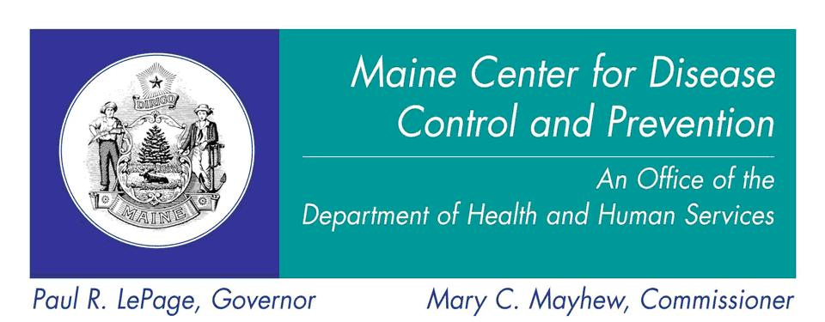

Requirements for Community Mass Immunization Clinics
Using State Supplied Tdap Vaccine

- Children under the age of 19 years are eligible to receive free Tdap vaccine supply from the State of Maine

- Store and handle Tdap Vaccine according to the most up to date guidance from US CDC and Maine CDC as per ImmPact Vaccine Provider Agreement.

- Review the patient’s vaccine history to determine if they currently need a Tdap vaccine according to the US CDC and APIC Recommendations, Summary of DTaP and Tdap Vaccine Recommendations across the Lifespan.

- Conduct a health screen to confirm that there are no contraindications to vaccination in the Community Mass Immunization Clinic setting

- Obtain and retain patient/guardian consent (see attached consent form)
  - Note: The consent form provided with this Toolkit must be used for all children receiving state-supplied Tdap vaccine

- Record all Tdap doses administered in the Community Mass Immunization Clinic into ImmPact as per ImmPact Vaccine Provider Agreement

- Report Adverse Events to FDA’s Vaccine Adverse Event Reporting System (VAERS) http://vaers.hhs.gov/index

- Provide information (record of vaccination) to the patient and instruct them to inform their usual healthcare provider of the Tdap vaccination.

